**Python Online Judge System**

**System Design Specification (SDS)**

**Version 2.0**

**2019-04-14**

Michael Yuepeng LONG, 1730026075

Virgil Wenbo ZHAO, 1730026155

Jessice Jianxin LIU, 1730026069

Charm Qiaomu ZHANG, 1730026149

**Computer Science and Technology Program**

**United International College**

1. Document Change Log

|  |  |  |  |
| --- | --- | --- | --- |
| ***Change Date*** | ***Changed By*** | ***Version*** | ***Change Description*** |
| 2019-04-14 | Yuepeng LONG | 1.0 | Prepared Document |
| 2019-05-20 | Wenbo Zhao, Jianxin Liu | 2.0 | Modify the UI interface and features |
| 2019-05-26 | Qiaomu Zhang | 3.0 | Add some UI interfaces |
|  |  |  |  |
|  |  |  |  |
|  |  |  |  |
|  |  |  |  |
|  |  |  |  |
|  |  |  |  |
|  |  |  |  |

1. Table of Contents

1. Document Change Log 2

2. Table of Contents 3

3. Design Overview 4

4. Tools and Standards 5

4.1. Tools 5

4.2. Standards 5

5. User Interface Design 6

5.1. Usage Scenario 1 6

5.2. Usage Scenario 2 6

6. Database Design 7

7. Diagrams 8

1. Design Overview

The purpose of this system is to provide a platform for teachers and students in the Python programming class. Students can complete the Python programming problems set by the teacher. The system automatically evaluates pieces of code from students and help students correct them. At the same time, teachers can also use this system to arrange tasks with DDL and get each student's grades based on task statistics.

The system will interact with all users as web pages. The background is implemented using Flask and MariaDB, and the front end uses the Bootstrap framework.

1. Tools and Standards

## Tools

Main components:

* HTML 5
* jQuery
* Bootstrap v4
* Tabler 0.0.34
* Python 3.7
* Flask 1.0.2
* Redis 4.0.9
* MariaDB

Packages in Python 3:

* pymysql
* python-dotenv
* Flask_SQLAlchemy
* Flask_Migrate
* Flask_Script
* Flask_Login
* Flask_WTF
* flask_uploads
* flask_rq2
* pillow

## Standards

* Testing on latest stable version of Google Chrome browser (66.0.3359.117 (64-bit) or later) and Mozilla Firefox browser (59.0.2 (64-bit) or later), no longer support IE 8 / IE 9.
* Using HTML5 standard.
* Using UTF-8 encoding standard.

1. User Interface Design

## Login & Homepage

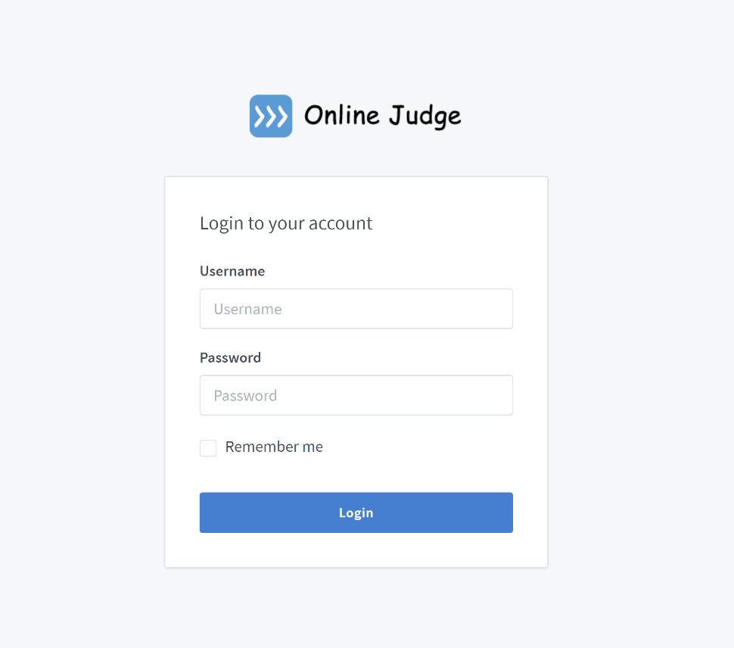

*Figure 1 Login page*

This page is a login page. A form with a username input box, password input box, and a submit button will be displayed on the page. The password entry area will use "*" instead of the raw input.

Users are not allowed to register by themselves. Accounts are registered by administrators only (See Section 5.5).

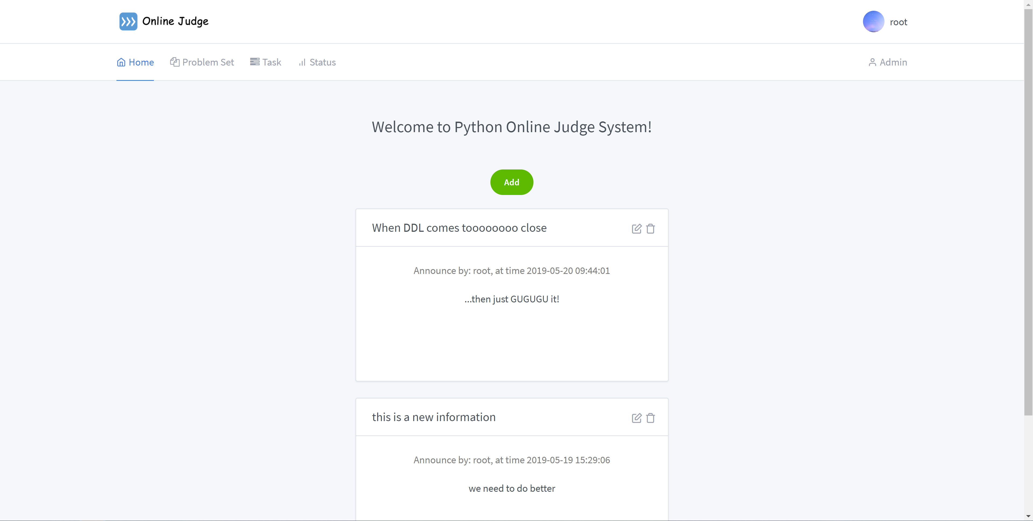

*Figure 2 Home page*

This is the home page, and the upper part is the navigation bar that is available for each page afterwards. Students can see some announcements issued by the teacher, and teachers can add new announcements while browsing the announcements.

## Problem Set

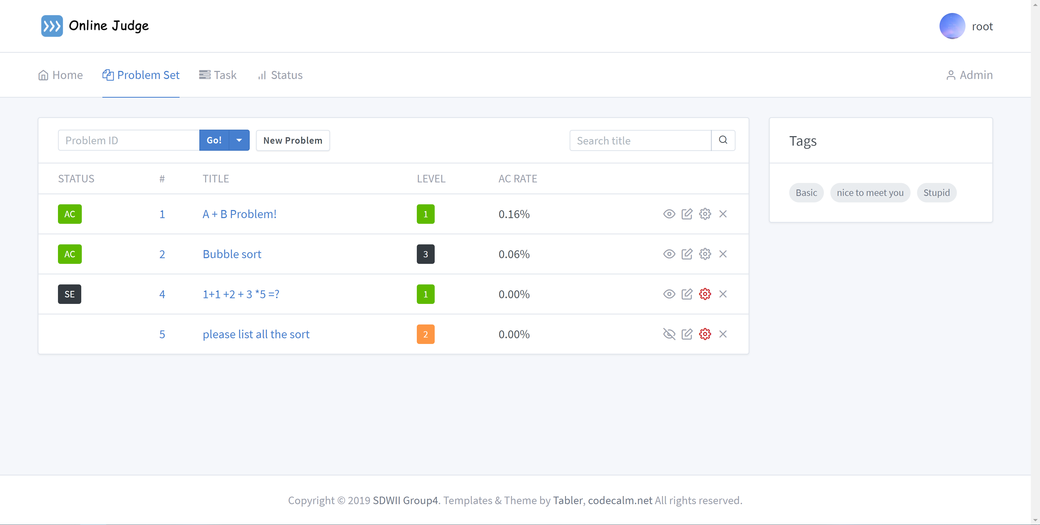

*Figure 3 Problem Set page*

After login, users can via the navigation bar to browse problem set. Problems have their own tags for users to filter. Users not only can click the tags in the right to get all the corresponding problems, but also can input the keyword in the search blanket to look for specific problems.

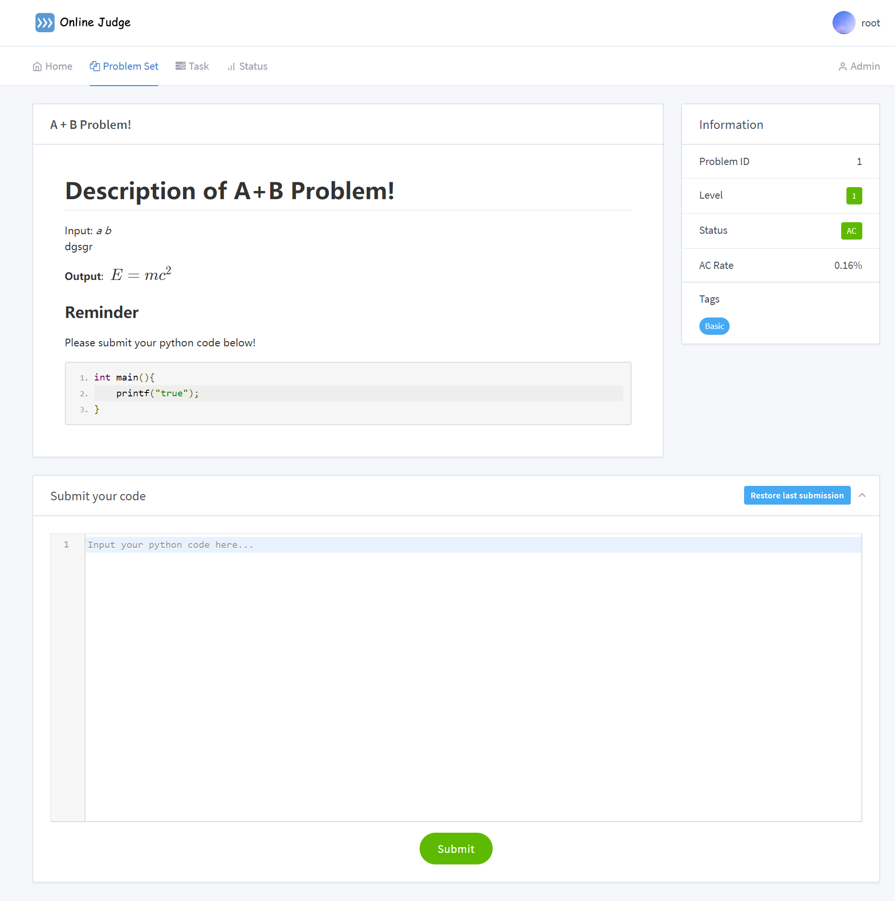

*Figure 4 Problem page*

For each problem, there will be a title and a description (no sample input or output). To the right part of this page, there are information, such as tags, level and problem id. User can submit their own solution many times for one problem. After submission, system will run the test code for the submitted code and give a score back. Teachers and administrators can also change the description and the official solution of problems and adjust the test code for a problem (It will be mentioned in 5.5). Problems may be included in a task for a group of users to finish (It will be mentioned in 5.3).

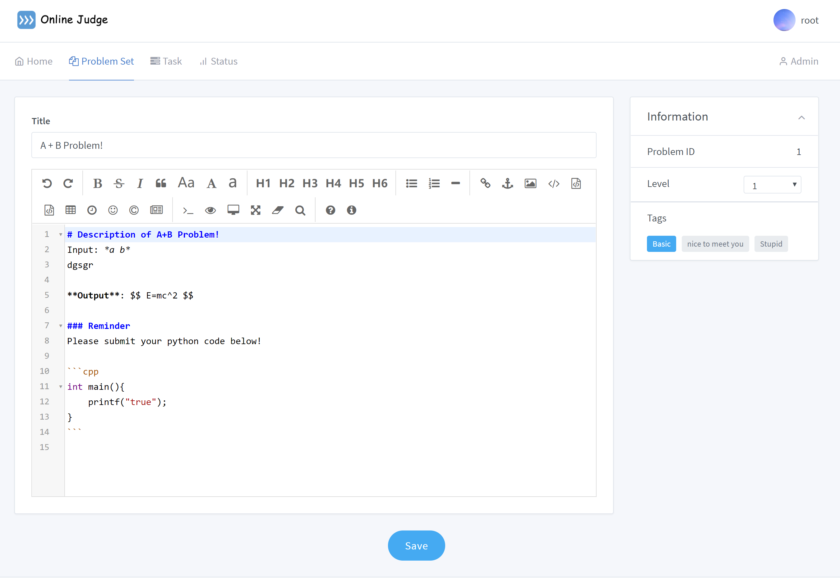

*Figure 5 Submition*

This is a page that submits code that users can write or change their own code and save them. You can find this page in the Problem Set. You can use these icons when writing code, and he will help you write code better. You can also see a description of the problem and other information.

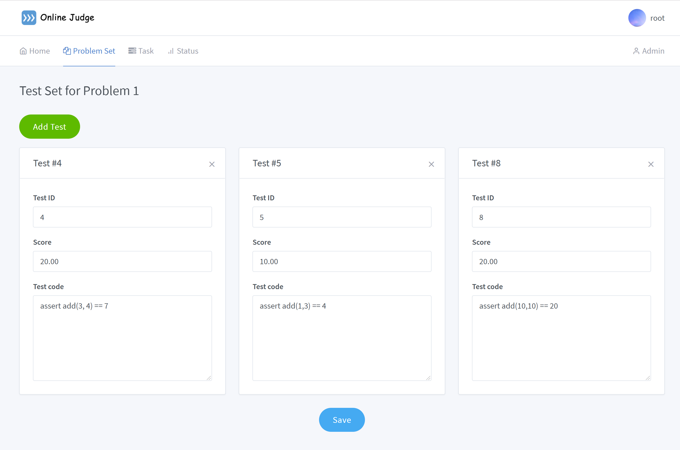

*Figure 6 Test page*

This is a test set page. When the teacher sets a topic for the student, the test set corresponding to the title should be added. In this interface, the teacher can view the tests currently included and add new tests. These tests will be used to verify that the student's submitted questions are correct and pass the test rate, and to rate the students.

## Task

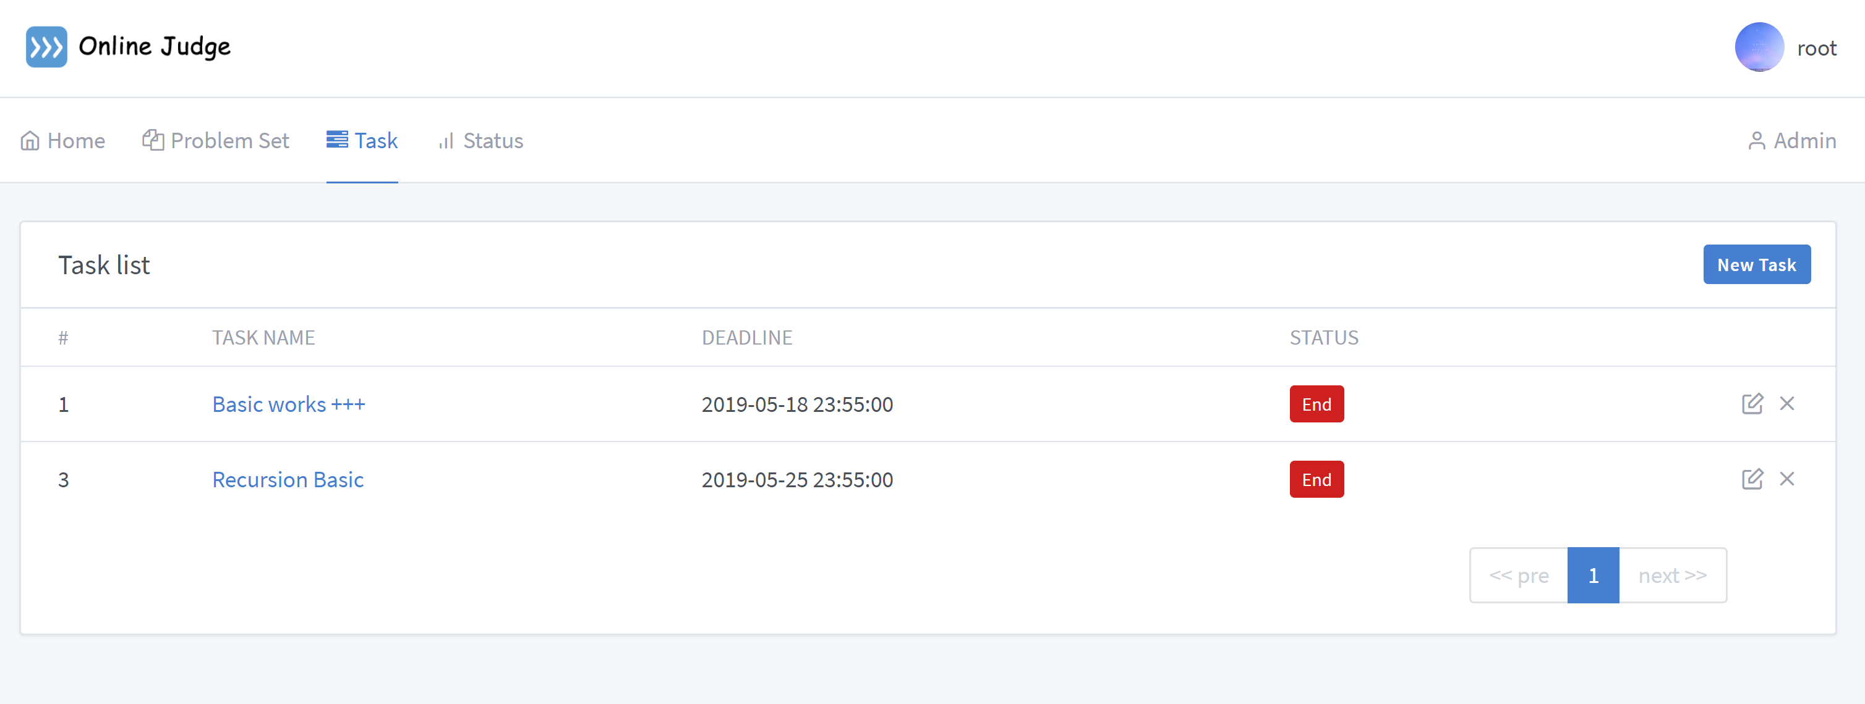

*Figure 7 Taskt page*

This page is a Task page. There is a form for the students to get all the tasks that they need to finish. And students can click into one of the tasks get the details, including all problems related to the task. Then student can solve the problems in the task. There will be DDL for each task, and each student is required to submit the answer to each question in the task before DDL. If the submission is submitted after DDL, the score will be zero. Students of each group can only see the tasks assigned to their group (See 5.5 for the definition of group).

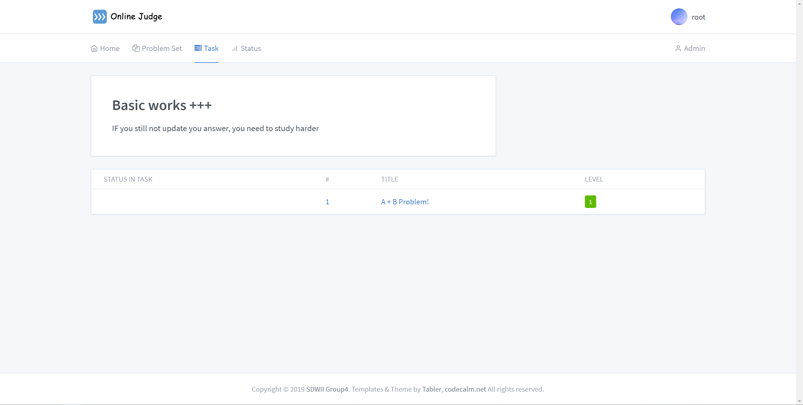

*Figure 8 Problem in the Task*

This is a task-problem page. In last page, when you click a task, the page will jump into this page. In this page, you will find the description of task. And this description is filled and edited by teachers. Under the description, you can find the problems that this task contains. And the problems’ information like number, title and tags.

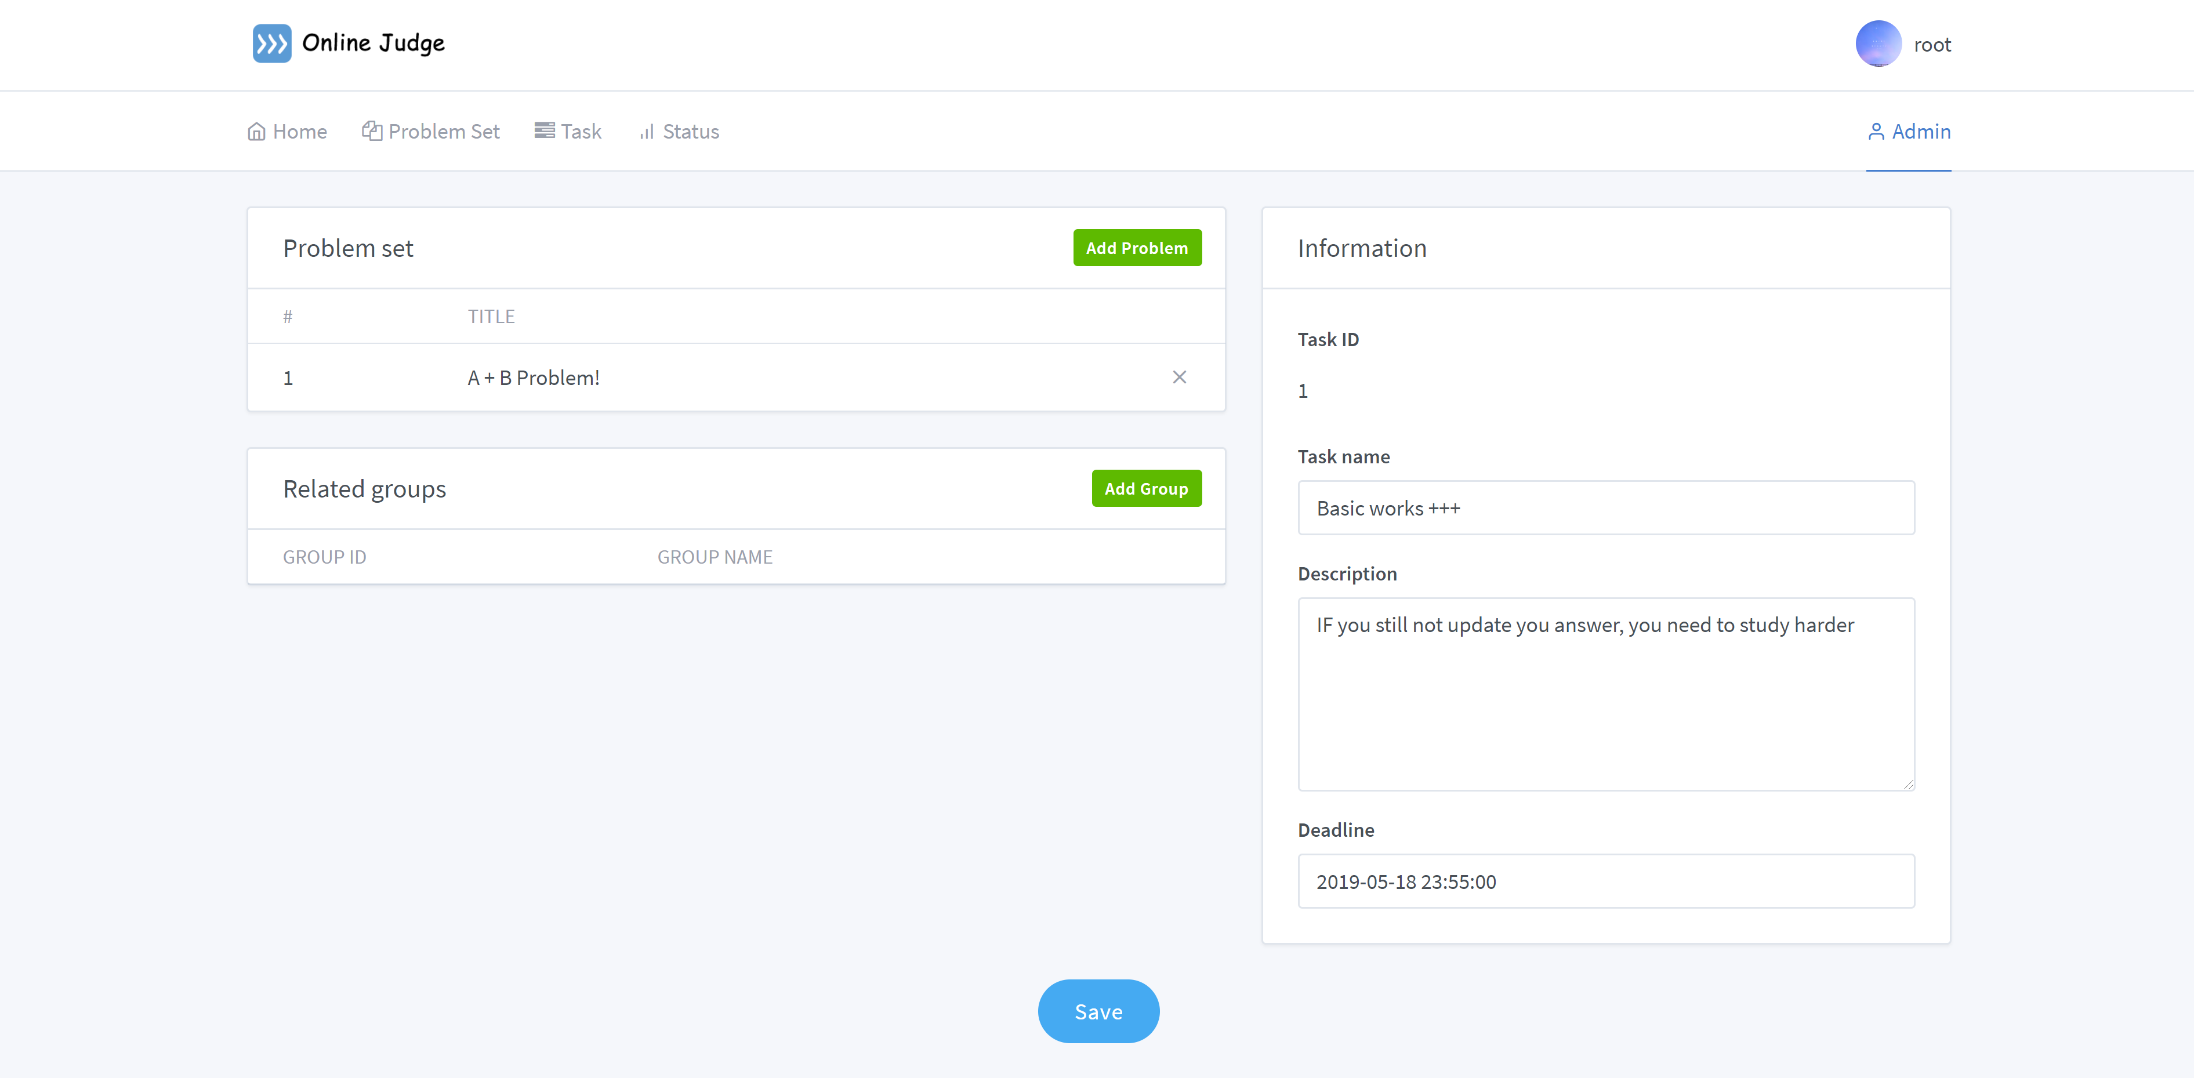

*Figure 9 User Group page*

This is a page that is used to view the problem set and related groups. In left part, you can see a problem list that need to be done. Due to different groups can be distributed to different tasks. So the related groups is used to view that. In right part, some information can be viewed. It contains tasks’ ID, tasks’ name, the description and deadline of tasks.

## Submissions & Status

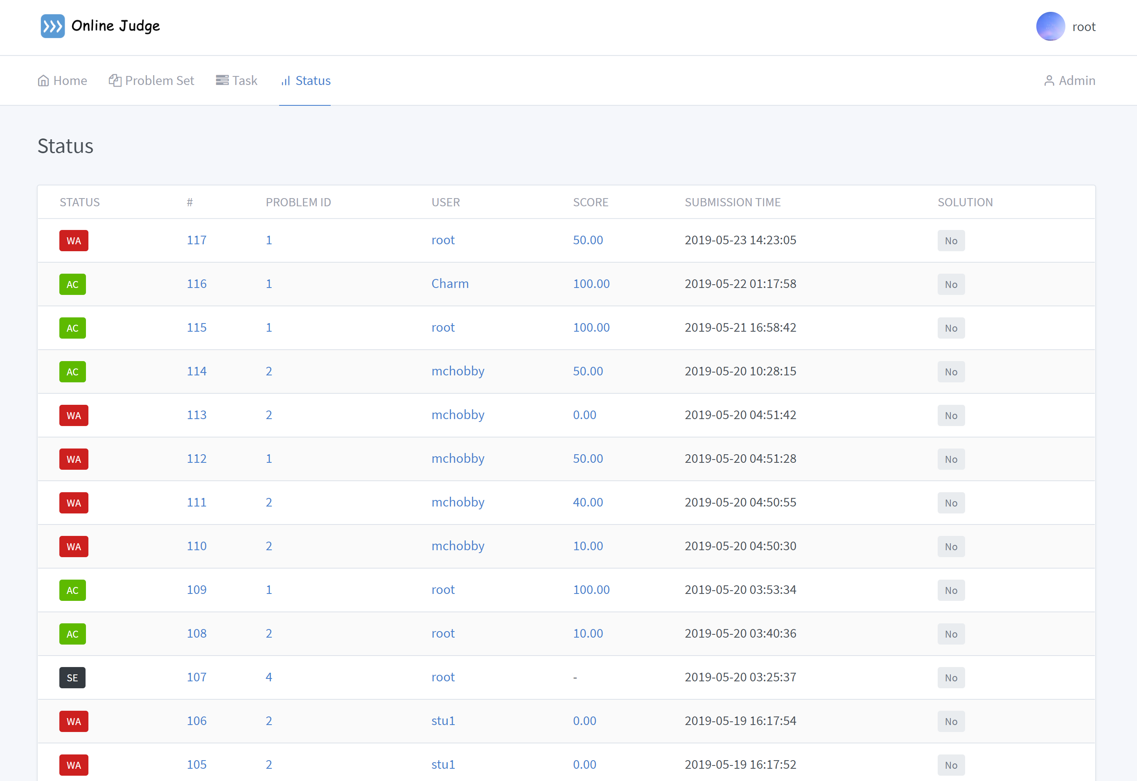

*Figure 10 Status page*

This is submissions and status page. Users can submit their code through our website, this process can be repeated many times, but must be before the deadline, if the deadline is exceeded, the submission window will not be related to the task, and administrator will get the scores of every student after deadline.

We will use the test code corresponding to the question to evaluate the user's code, our system will automatically according to the passing of the test code rating. Each time a user submits a submission, if the problem is in one of the ongoing task, the score of that submission is hidden and the user can view it after the deadline.

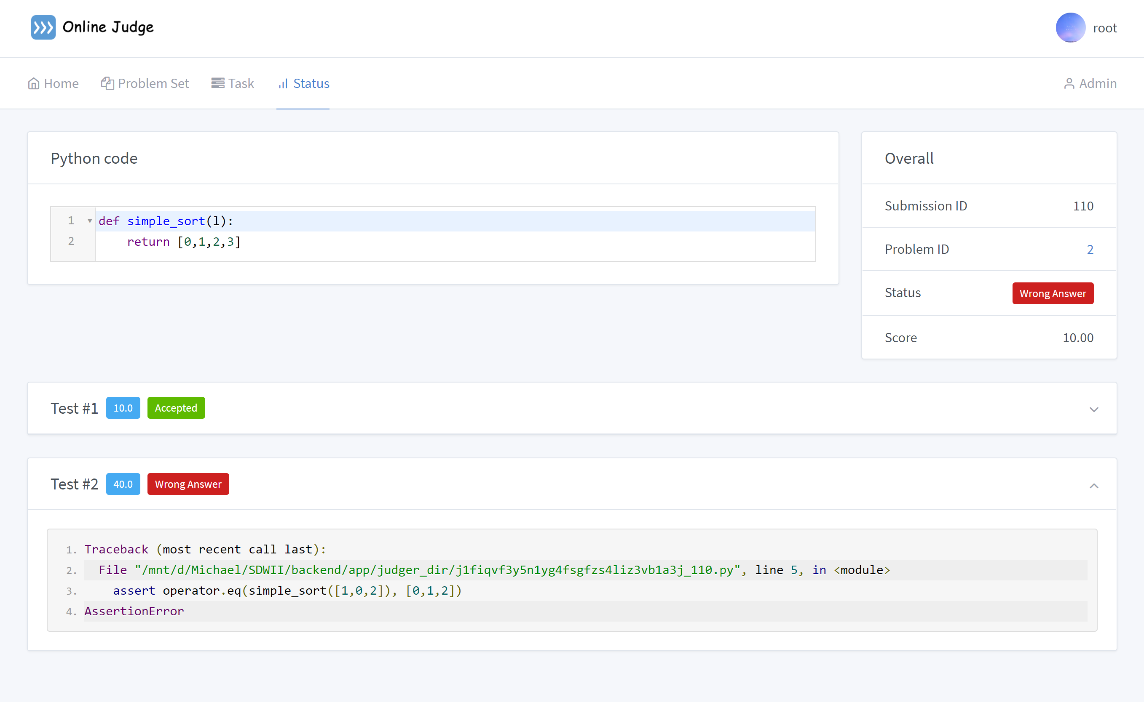

*Figure 11* Test-outcome *page*

This is a test-outcome page. In this interface, you can see the code that needs to be tested. And the test set test results for the code. You can check which (or which) tests did not pass the code you wrote. In the upper right corner of the interface, you can see an Overall. It is the overall result of this test, you can see the test status of the problem and the test score.

## User profile

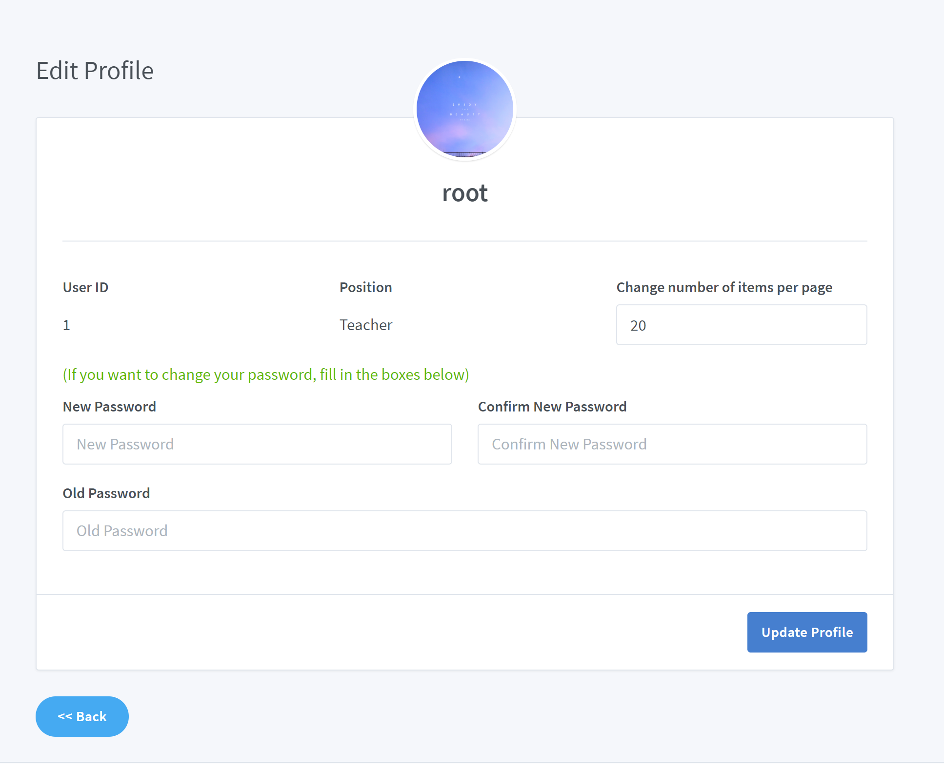

*Figure 11* Edit Profile *page*

This is a edit profile page. You can change your old information here. But when you edit password, you need confirm your new password and fill your old password. Some information can not be changed. Such as the ID and your position.

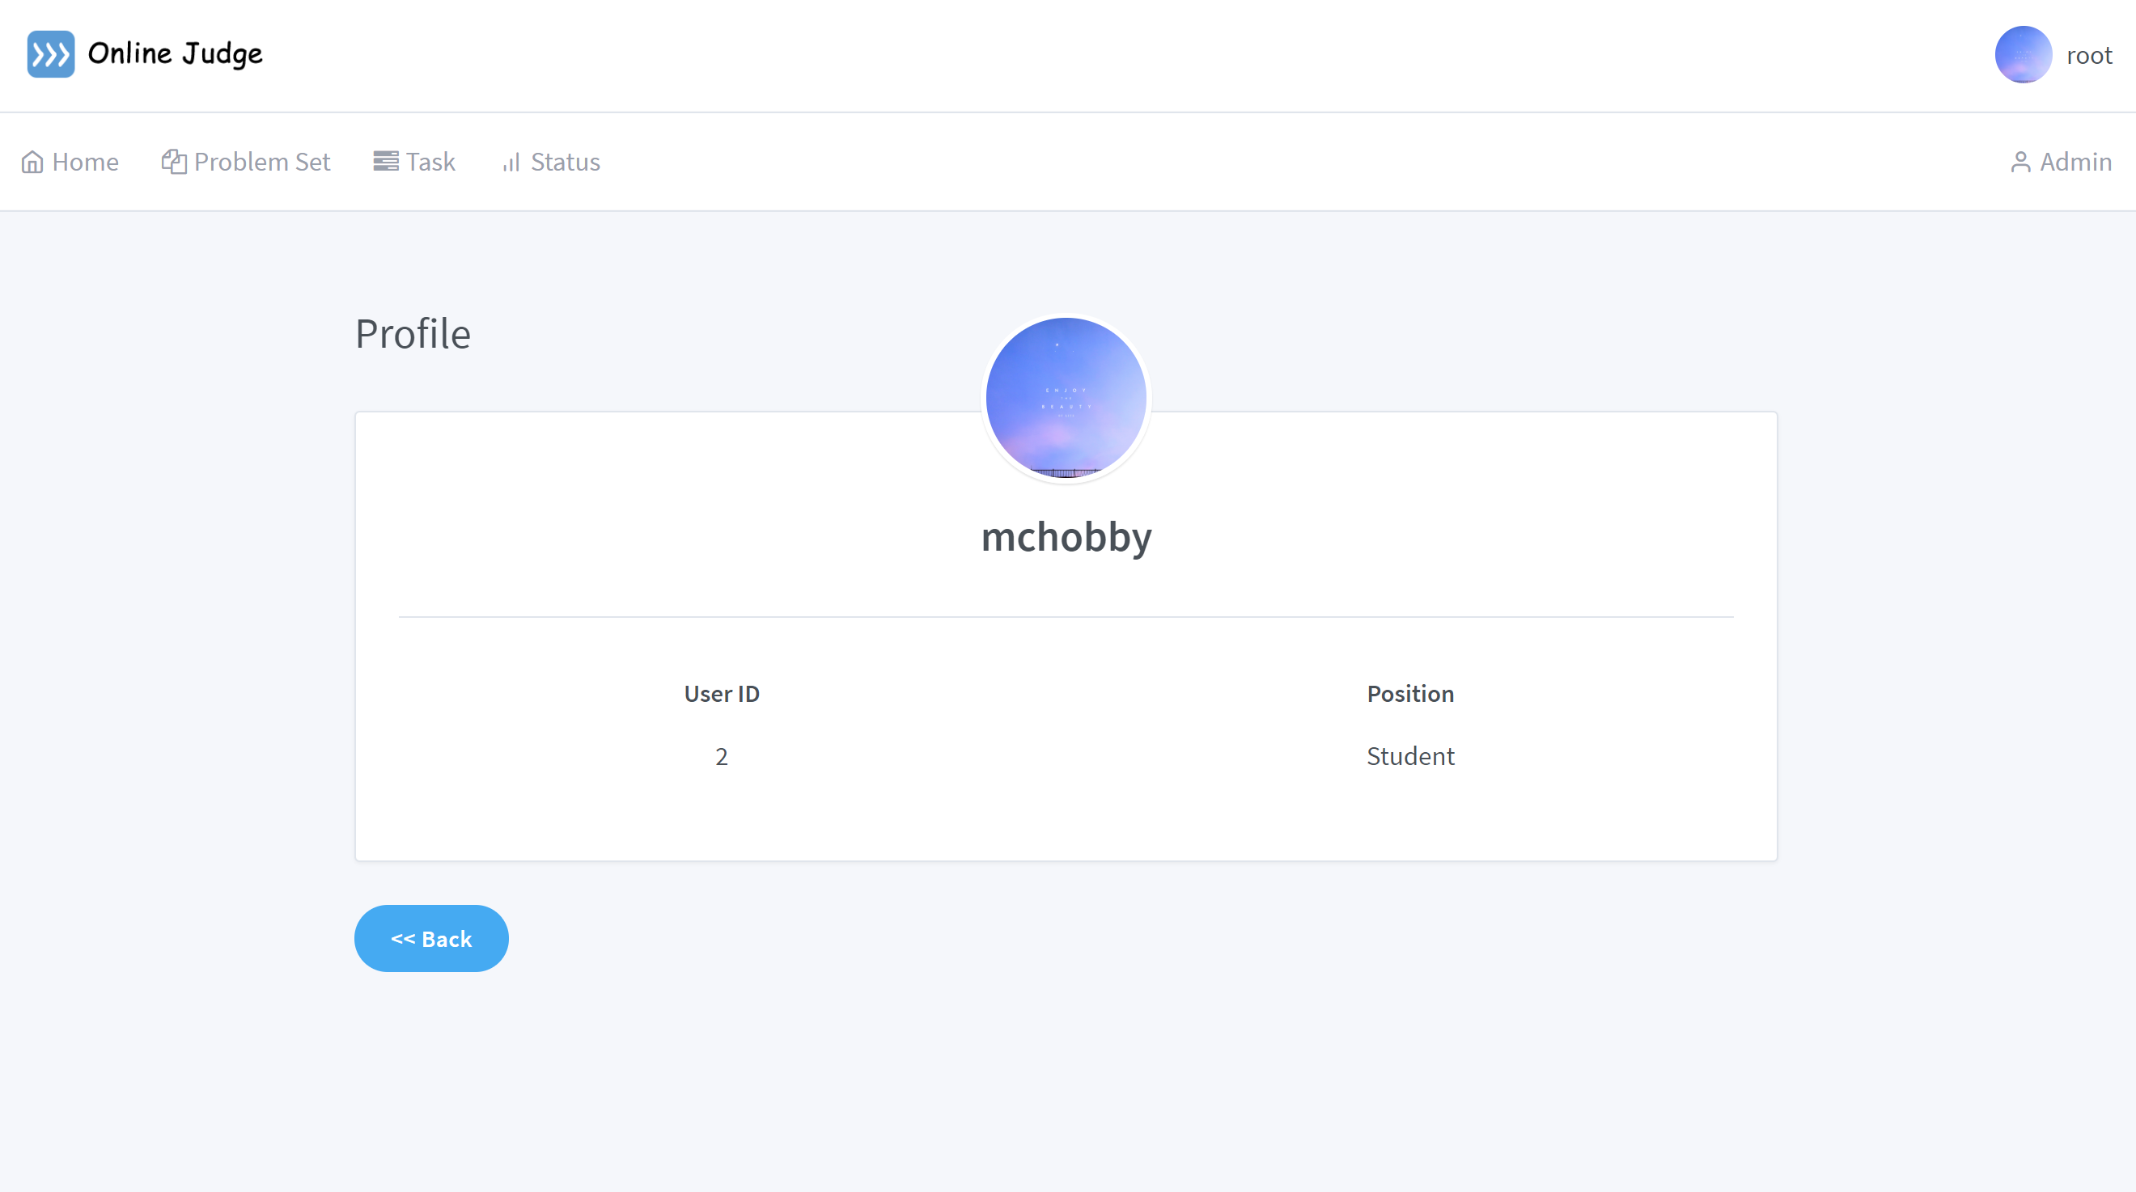

*Figure 12* Profile *page*

This is a profile page. In this page, the users can view their information. Such as users’ ID and name. And users can change some information. However, the position cannot be modified by student.

## Admin Panel

The admin panel allows administrators to modify the system. The administrator means teacher. When using the teacher’s account to login, there will be an admin panel appearing in the navigation bar.

Administrators(teachers) are allowed to:

* Add, modify and delete problems
* Set submissions as the solution for a problem
* Modify test set for a problem (by adding or deleting tests from the test set)
* Create new task and set DDL for a group of students
* Manage group members
* View existing members
* Add, modify, delete tags
* Update test code
* Add and delete users

Admin User page:

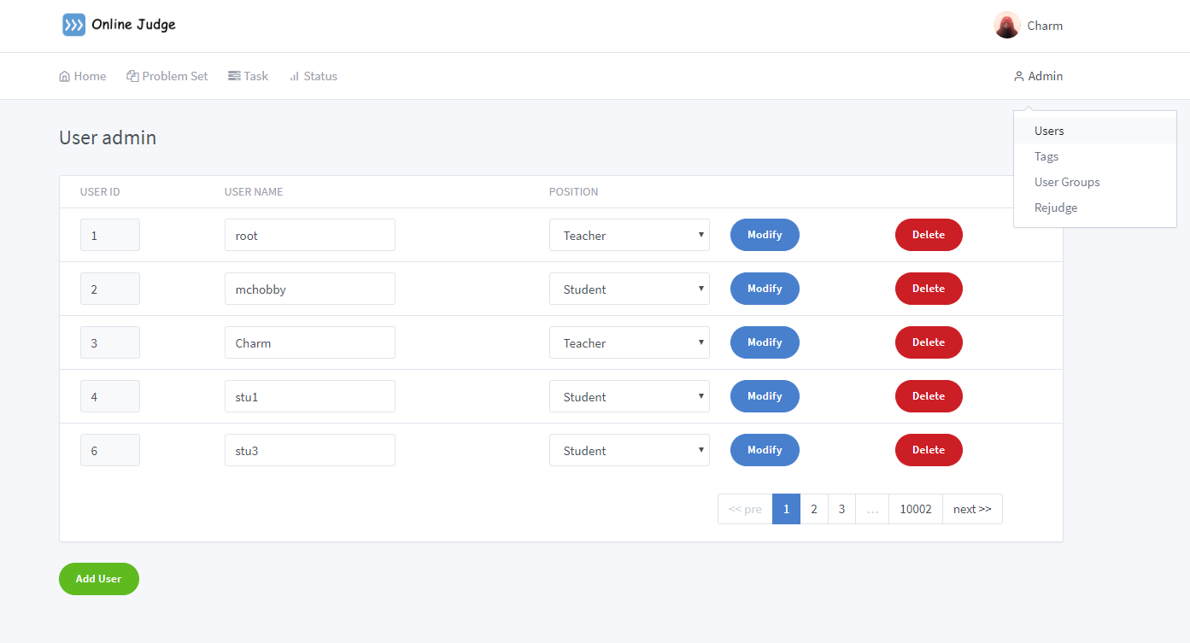

Admin User group page:

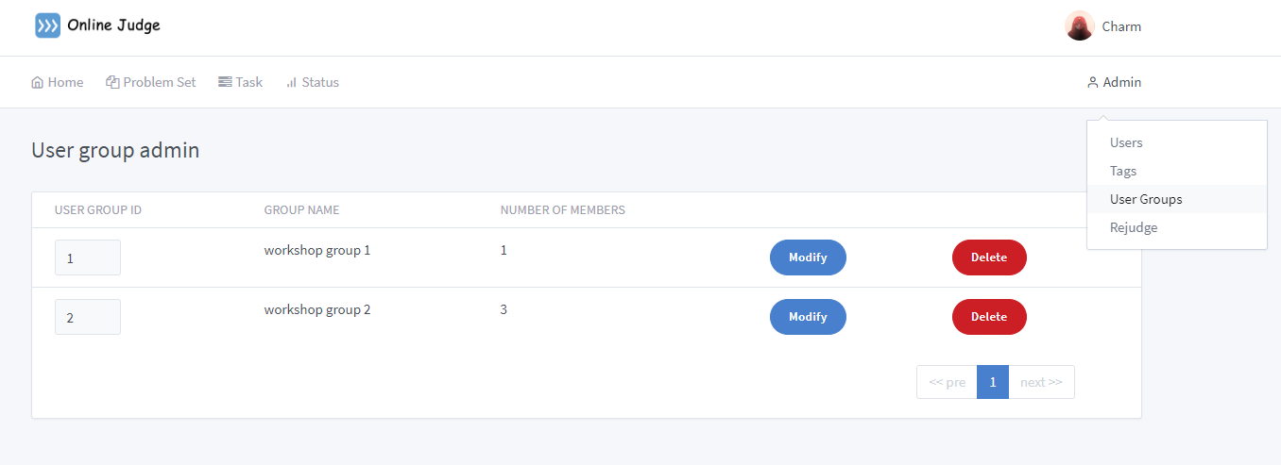

Admin tags page:

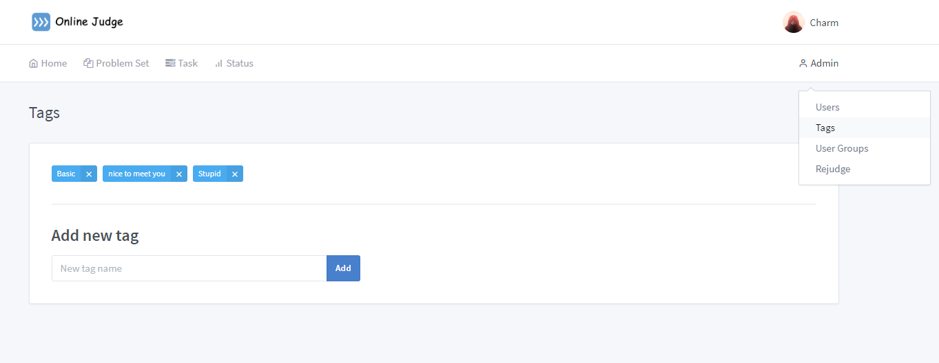

Re-judge page:

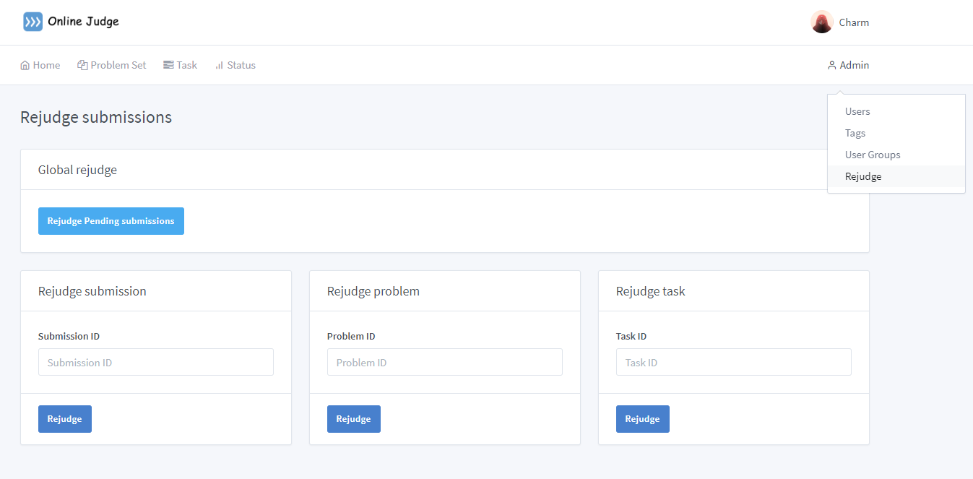

1. 图片包含 文字, 地图

   描述已自动生成Database Design

The E-R diagram is shown below.

1. Diagrams

