**Python Online Judge System**

**Software Requirement Specification (SRS)**

**2019-03-31**

**Prepared by: Group 4 in 1001**

**Michael Yuepeng LONG, 1730026075**

**Virgil Wenbo ZHAO, 1730026155**

**Jessice Jianxin LIU, 1730026069**

**Charm Qiaomu ZHANG, 1730026149**

**Computer Science and Technology Program**

**United International College**

1. Table of Contents

**2. Introduction** **3**

2.1. Purpose 3

2.2. Document Conventions 3

2.3. Project Scope 3

**3. System Features** **4**

3.1. Announcement 4

3.2. Problem Set 4

3.3. User Group 4

3.4. Task 5

3.5. Online Test 5

3.6. Status 5

**4. External Interface Requirements** **6**

4.1. User Interfaces 6

4.2. Hardware Interfaces 14

4.3. Communications Interfaces 14

**5. Other Nonfunctional Requirements** **15**

5.1. Performance Requirements 15

5.2. Security Requirements 15

5.3. Software Quality Attributes 15

1. Introduction

Purpose

This document describes the stakeholders’ requirement and functional description of a Python, C, JAVA and other languages’ code and many problems in maths problems online evaluation system. It mainly describes system functions, user interfaces, performance requirements, security requirements, quality attributes, etc.

Document Conventions

This document will be written primarily in Arial fonts. The Times New Roman font will be used for the title level number. The body content is 11 font size. Important content will be marked in bold.

Project Scope

The target users of this system are teachers and students who teach and learn Python programming. Teacher set up code exercise problems for the students on the system. After the students submit the code, the system automatically tests and scores the students' code according to the test code preset by the teacher, thus helping the teacher to quickly assess the student's learning progress.

At the same time, the teacher can also divide the students into multiple groups, arrange a homework composed of multiple exercise problems for a group, and set a deadline for submission to help students improve their programming skills efficiently.

1. System Features

Announcement

3.1.1 Description

The teacher can post an announcement on the homepage to remind the classmates. For example, remind students to submit their assignments, test time, or write some encouraging words to the students.

3.1.2 Functional Requirements

REQ-1: The teacher can post an announcement on the homepage.

REQ-2: The teacher can change and cancel an announcement on the homepage,but students cannot.

Problem Set

3.2.1 Description

The teacher can add any questions that they need; the student solves the problem and submits the corresponding codes; the system automatically evaluates and scores the student's submission code according to the test code provided by the teacher.

3.2.2 Functional Requirements

REQ-1: The teacher can add a problem, including title, problem description, sample test code, template submission code, hidden test code, and related tags. Students can see information other than the hidden test code.

REQ-2: Students can view a problem, submit a piece of Python code for this problem, and view the results of the submitted code in this question.

REQ-3: Students can search for all problems with a certain tag.

REQ-4: The submitted Python code will be automatically evaluated by the system. For each set of test code set by the teacher, determine if the student's code is working properly and produces the correct result.

REQ-5: The teacher can set some of submissions to be solutions of one problem. Solutions become public and can be viewed by all students.

User Group

3.3.1 Description

The teacher can divide the students into multiple groups and send and receive the work in a unified manner. Team members can only view their own group's assignments

3.3.2 Functional Requirements

REQ-1: Teachers can set up students as members of certain groups.

REQ-2: Teachers can arrange assignments for a group and set deadlines.

REQ-3: Teachers can change group members or remove a member.

REQ-4: Teachers can change group information, such as a description of the group.

Task

3.3.1 Description

A task is a collection of problems. A task often contains many problems. A teacher can set the tasks

3.3.2 Functional Requirements

REQ-1: Existing topics can be added to a new task by teachers.

REQ-2: Teachers can arrange and set deadlines. The students can find it.

REQ-3: Modify the collection of task by teachers.

Online Test

3.4.1 Description

All students can submit arbitrary code and test code to the system for evaluation by the system.

3.4.2 Functional Requirements

REQ-1: Teachers can provide a number of test codes

REQ-2: All students can submit arbitrary code and test code to the system for immediate evaluation by the system.

Status

3.4.1 Description

The status is used to update grades and the status of the submitted assignment.

3.4.2 Functional Requirements

REQ-1: Students can find score by test codes

REQ-2: Students can check the correctness of the assignments submitted and the status of the corrections in this interface.

1. External Interface Requirements

User Interfaces

The system user interface is built using the standard components of Bootstrap v4. All pages will contain navigation bar and login user information. Some functions will be only seen by teachers.

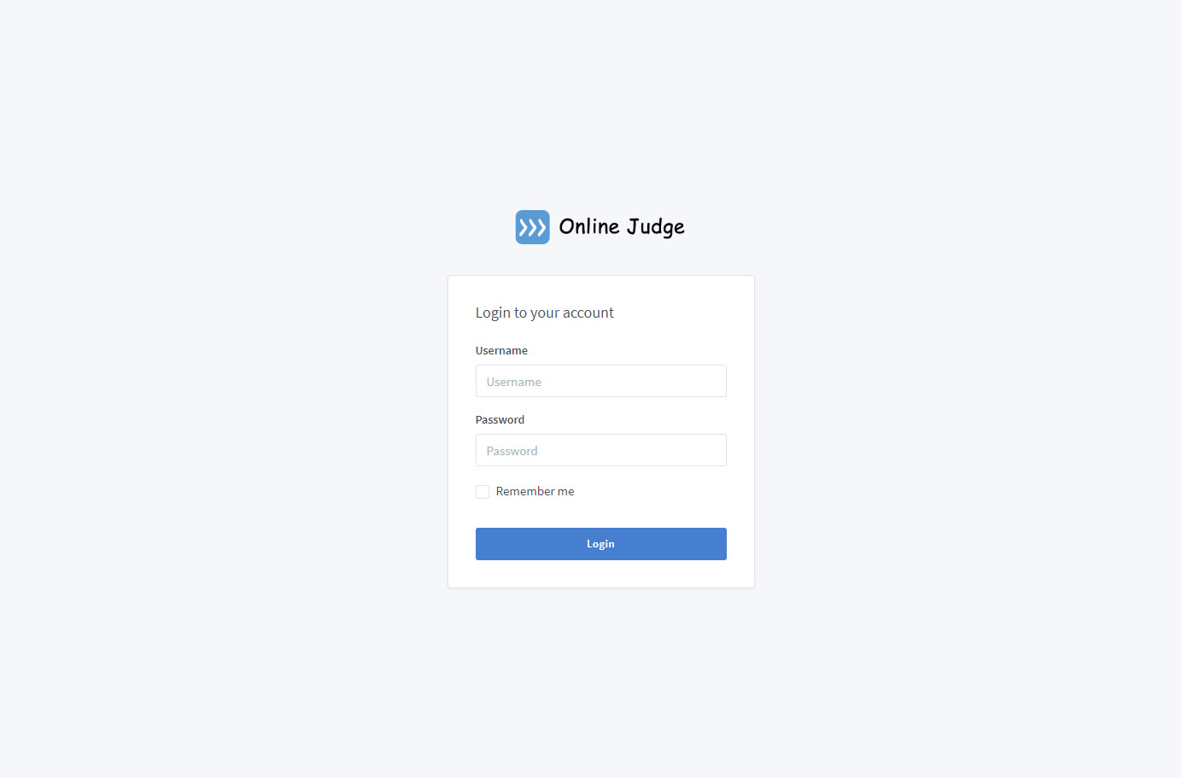Login page:

Homepage:

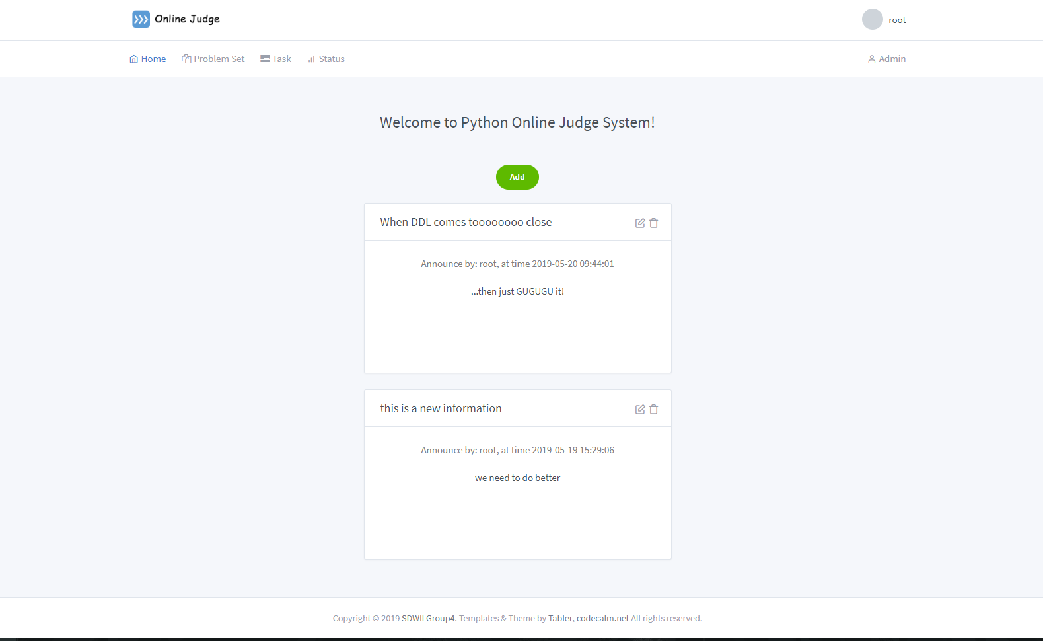

Add announcement:

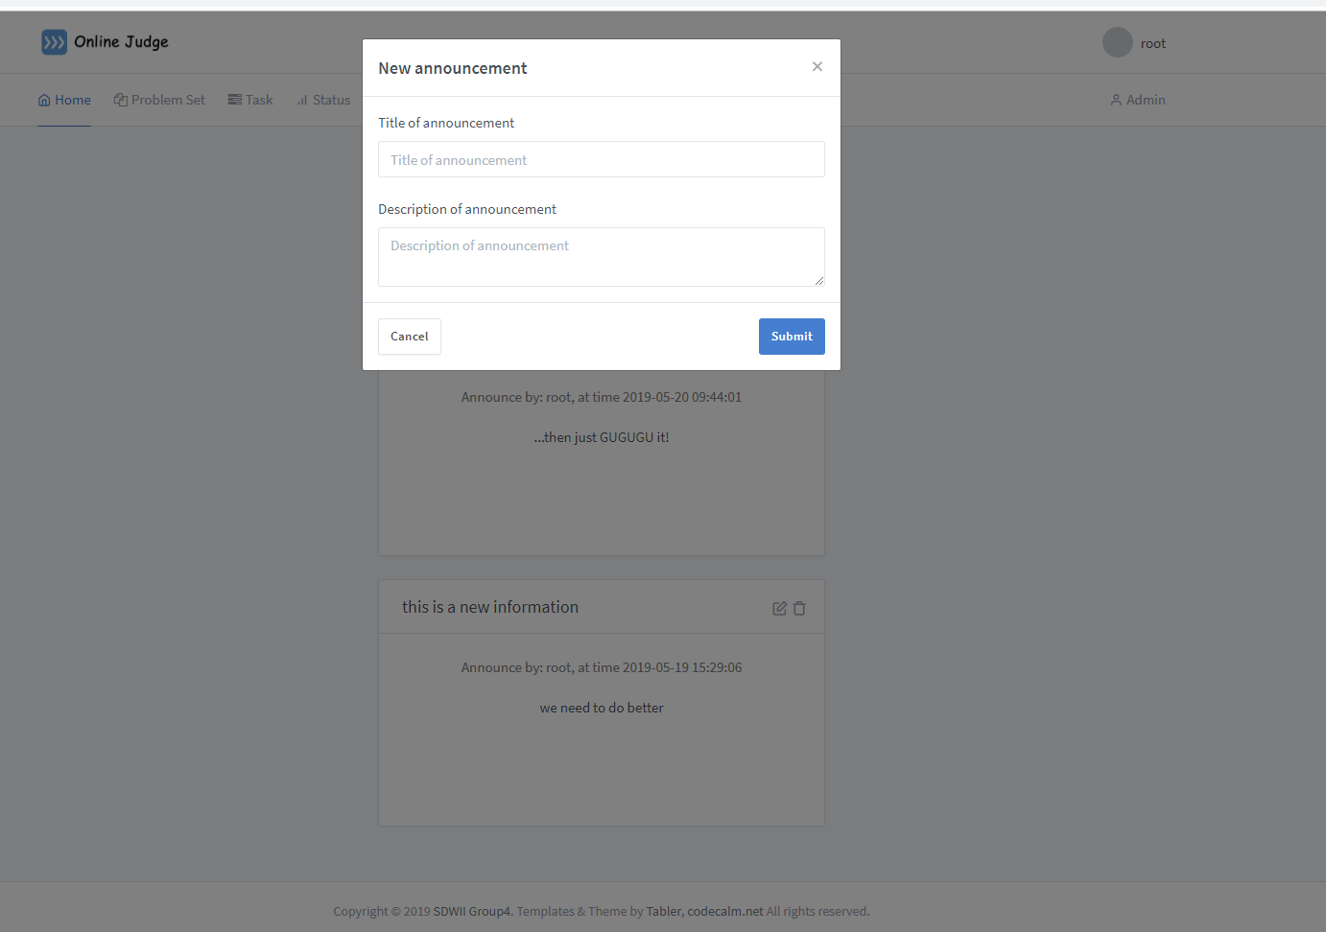

User admin:

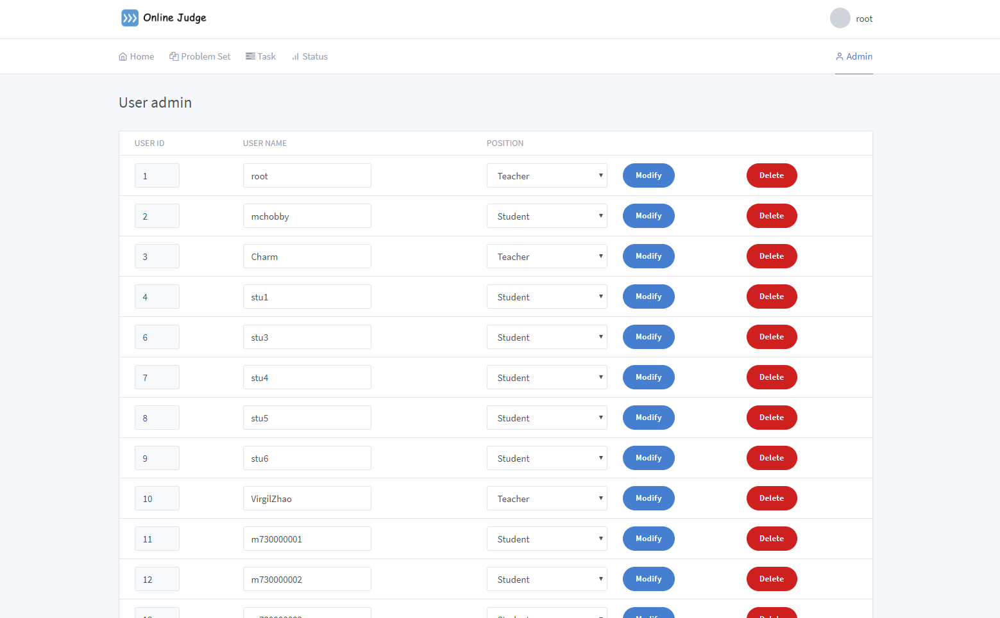

Profile:

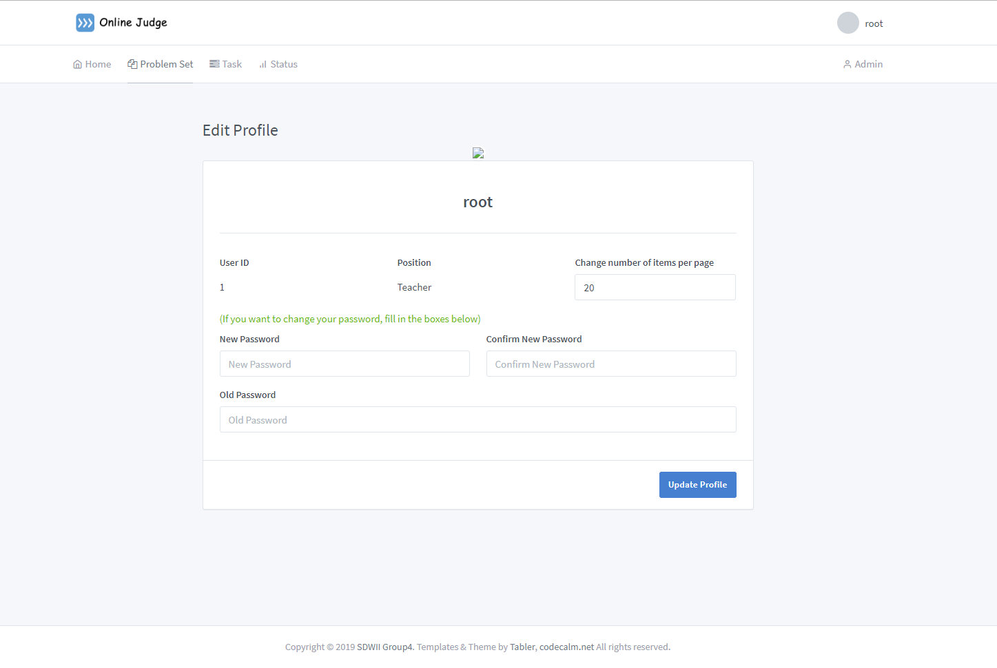

Problem page:

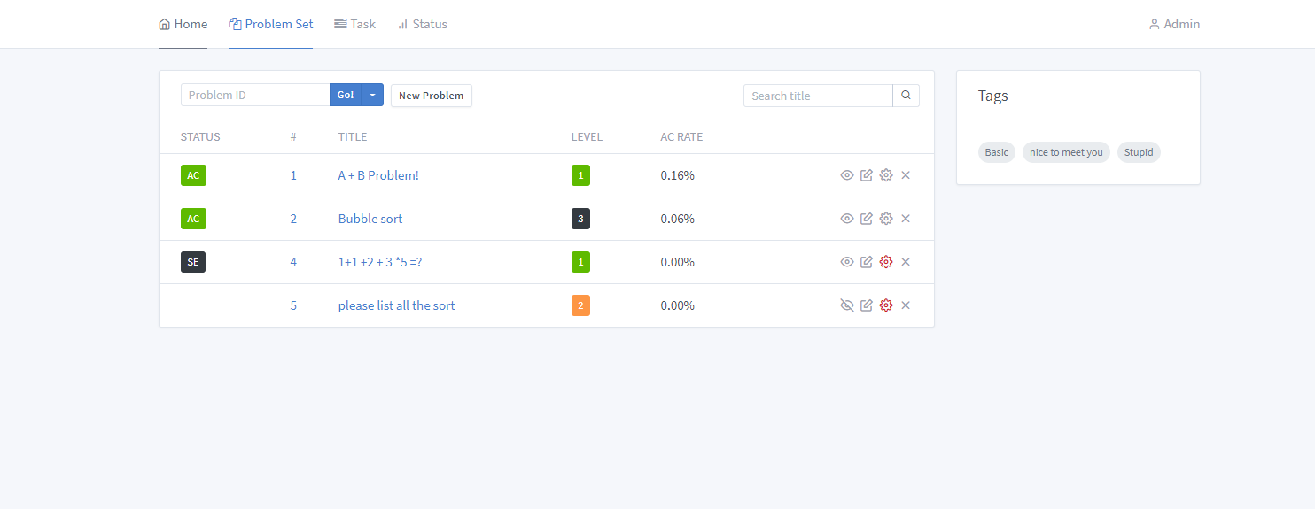

Task Page:

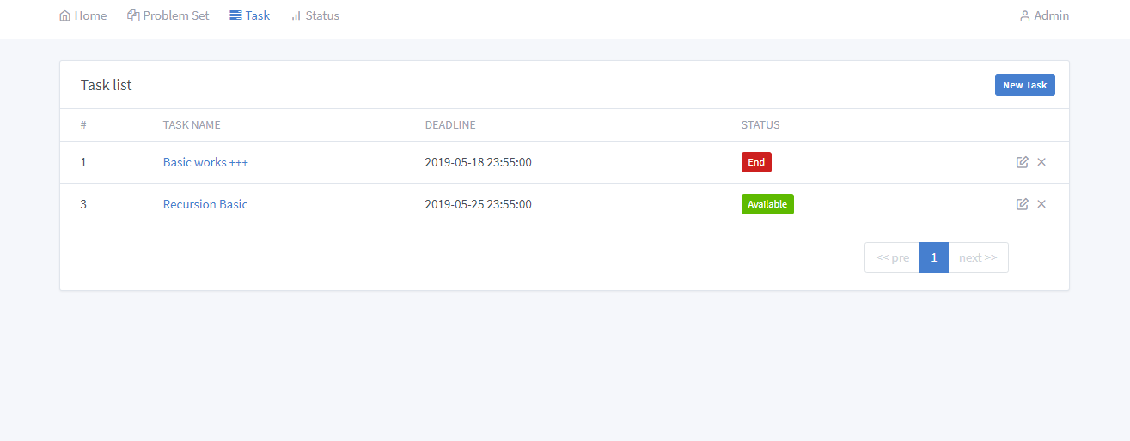

Problem description & submit:

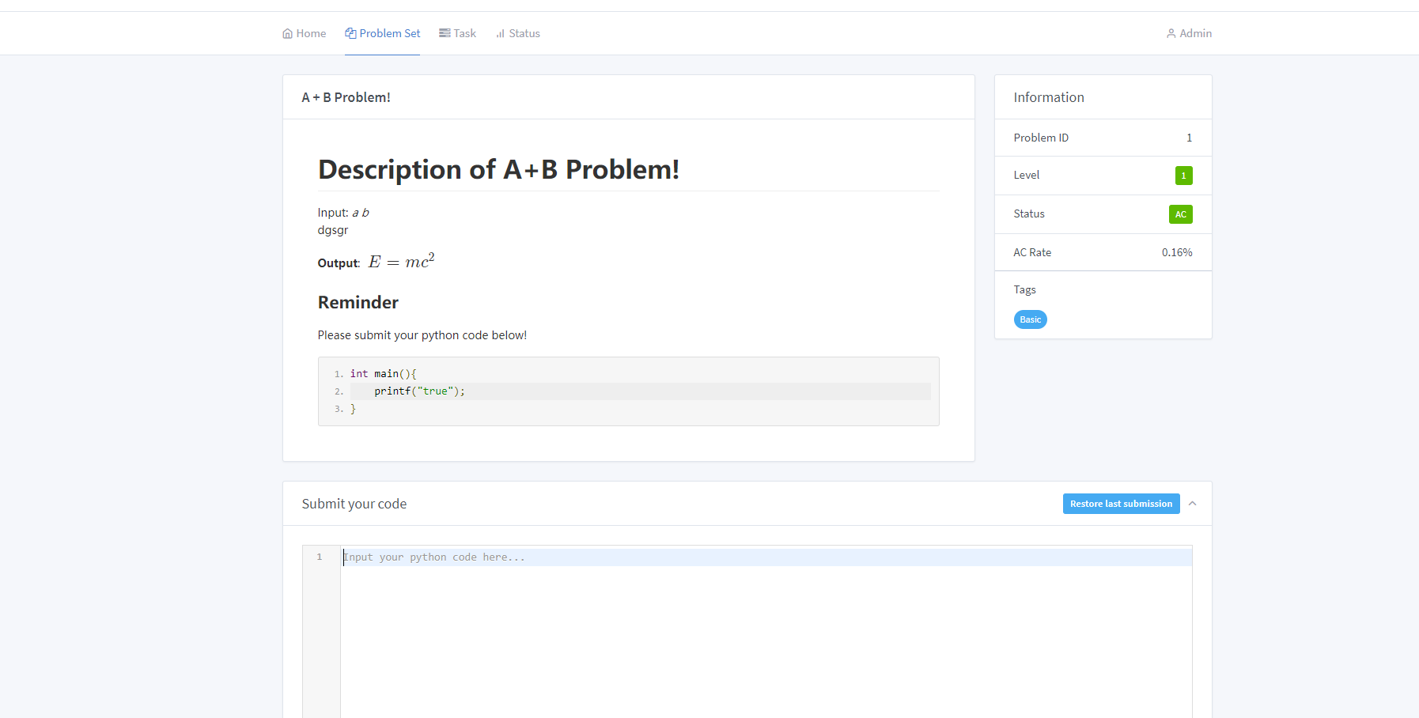

Tags Page:

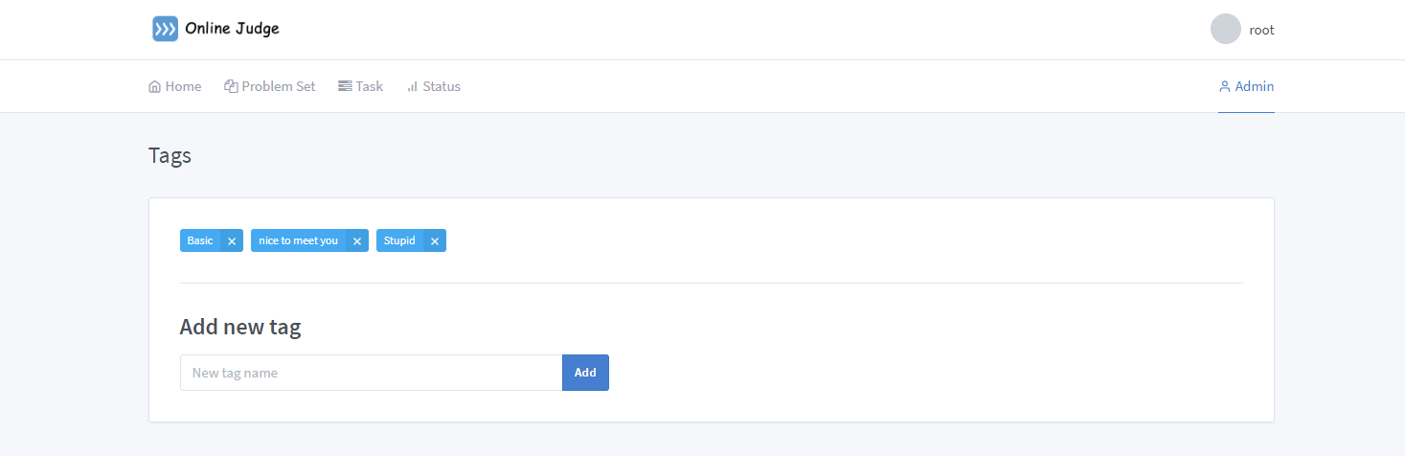

Group page:

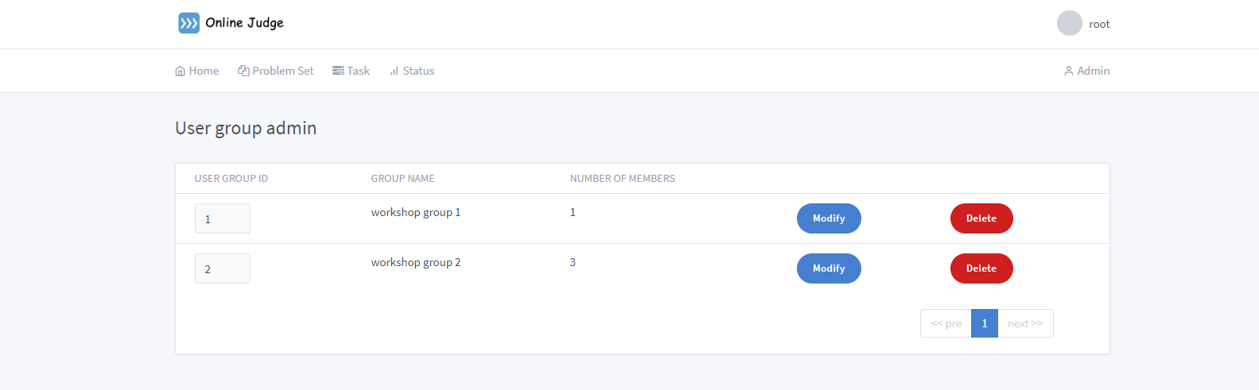

Judge page:

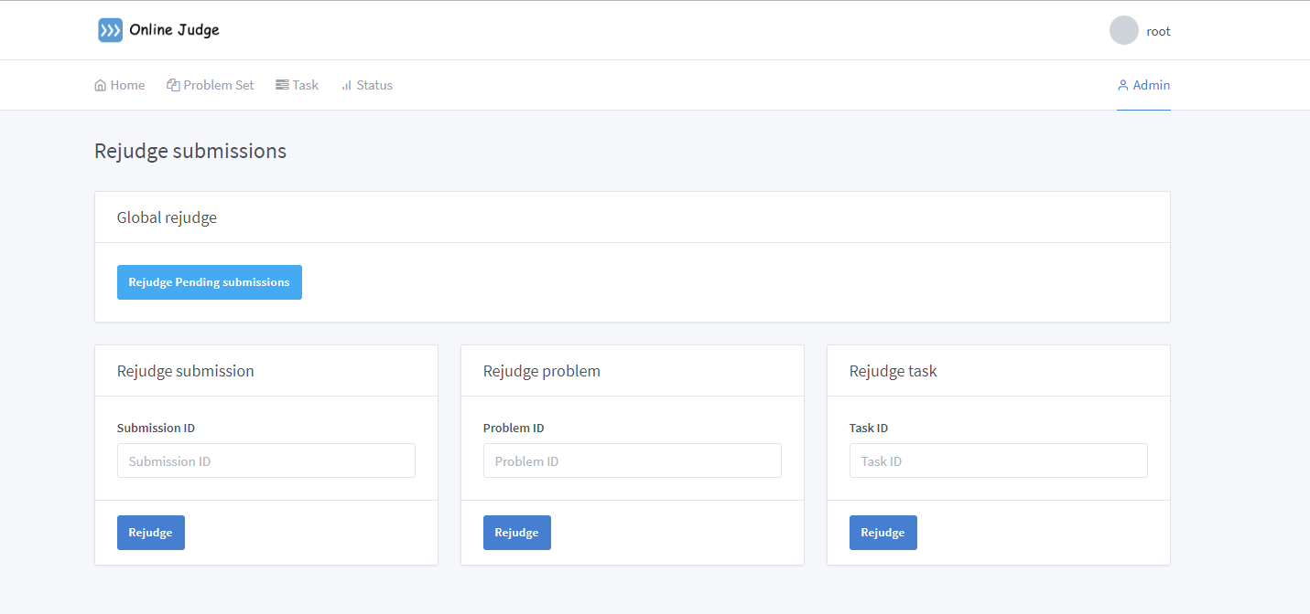

Status Page:

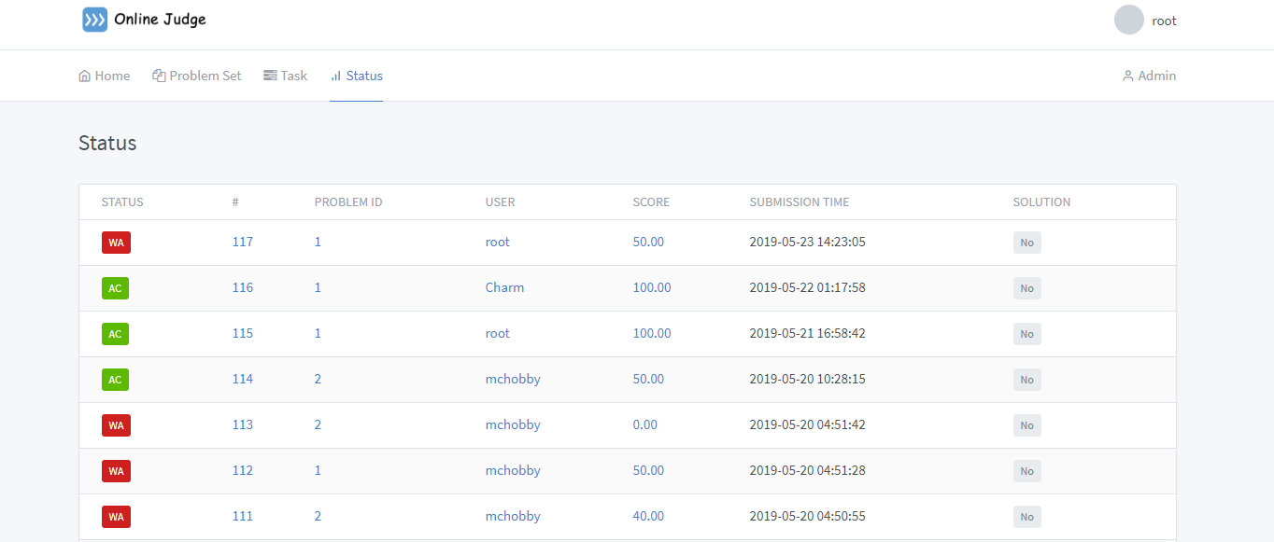

Hardware Interfaces

No special hardware requirements.

Communications Interfaces

All traffic will be run through HTTPS to secure data transmission.

1. Other Nonfunctional Requirements

Performance Requirements

Any page needs to be loaded within 3 seconds.

Security Requirements

All user passwords need at least 8 bits with upper-case or lower-case letters and numbers.

Software Quality Attributes

The system guarantees that the availability rate is not less than 99.9%.