PORTFOLIO DESIGN

1. MENU



1. MENU HOVER



1. HOME



1. HOME HOVER



1. ABOUT ME



1. ABOUT ME HOVER



1. EXPERIENCE

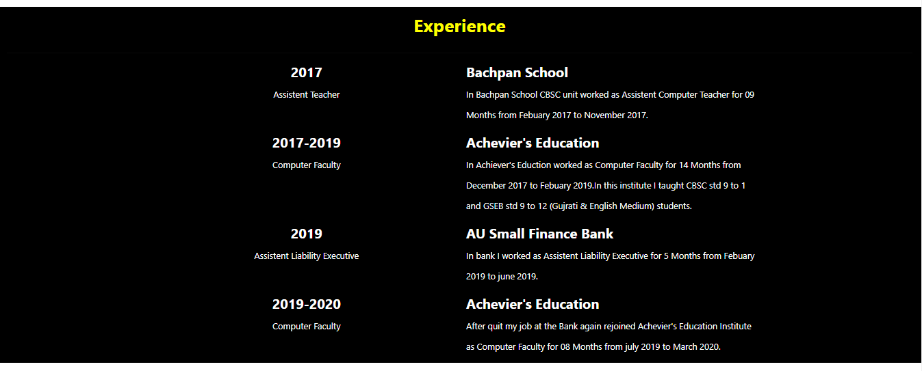

1. EXPERIENCE HOVER

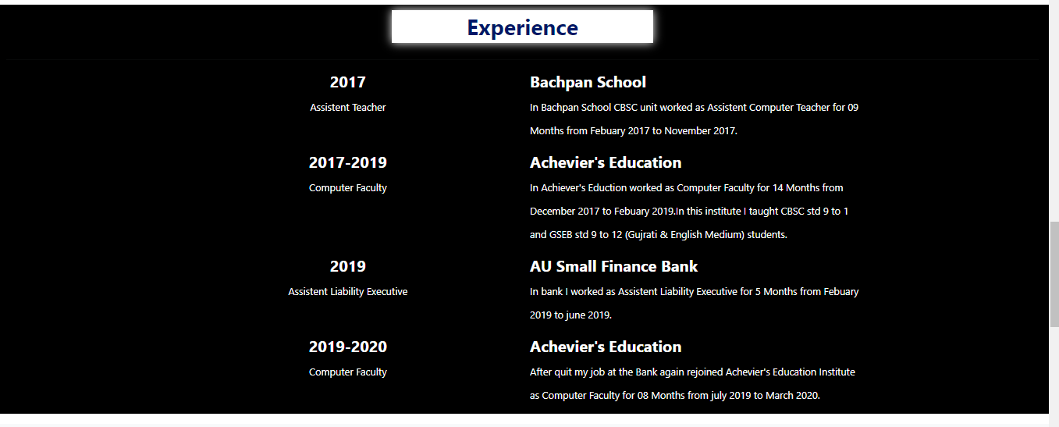

1. MY SKILLS

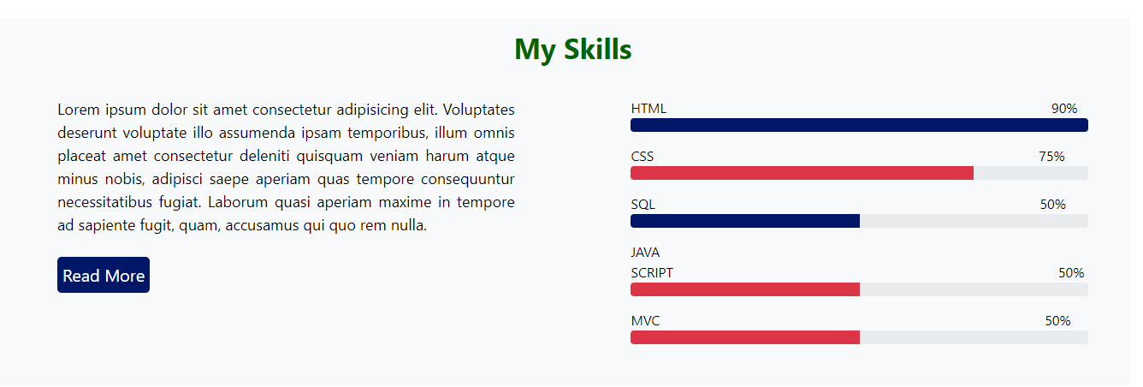

1. PROJECT

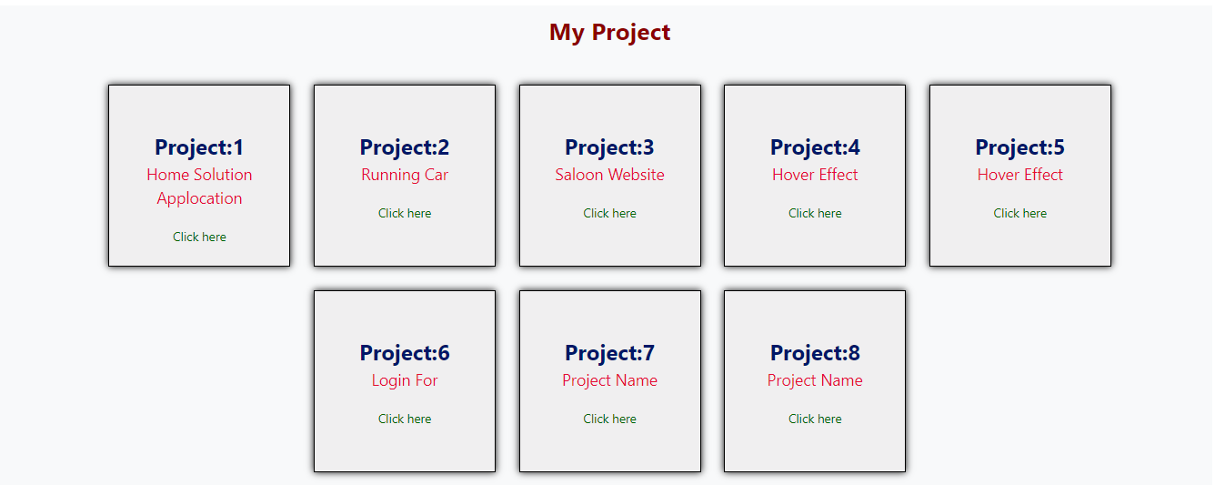

1. CONATCT ME

