1. Write a program in Python to allow the error of syntax to be handled using exception handling.

HINT: Use SyntaxError

try:  
 a = "t"  
 print("output",int(a))  
  
except Exception as e:  
 print("output error", e)  
  
  
try:  
  
 print('Addition',( 2 + o))  
 print(type(c))  
  
except:  
 print("SyntaxError")

2. Write a program in Python to allow the user to open a file by using the argv module. If the

entered name is incorrect throw an exception and ask them to enter the name again. Make sure

to use read only mode.

import sys  
import getopt  
filename = sys.argv[1]  
  
with open(filename, 'r') as f:  
 a = f.readline()  
 print(a)  
  
  
a = a.strip()  
  
while True:  
 if sys.argv[2] != a:  
 sys.argv [2] = input("enter right name: ")  
 else:  
 break

3. Write a program to handle an error if the user entered a number more than four digits it should

return “The length is too short/long !!! Please provide only four digits”

digit = int(input("please type your digit"))  
if digit >= 0000 and digit <= 9999:  
 print("that is a correct digit")  
else:   
 print("The length is too short/long !!! Please provide only four digits")

try:  
 digit = int(input("please type your digit"))  
 assert digit >= 0000 and digit <= 9999  
except:  
 print("The length is too short/long !!! Please provide only four digits")  
else:  
 print("that is a correct digit")

try:  
 digit = int(input("please type your digit"))  
 assert digit >= 0000 and digit <= 9999  
 print("that is a correct digit")  
except:  
 print("The length is too short/long !!! Please provide only four digits")

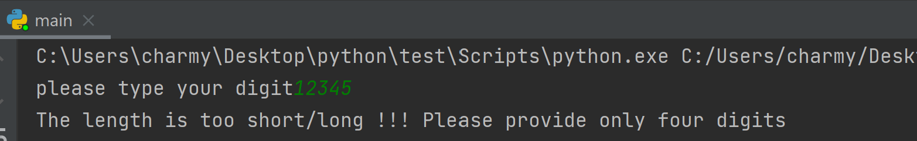

4. Create a login page backend to ask users to enter the username and password. Make sure to

ask for a Re-Type Password and if the password is incorrect give chance to enter it again but it

should not be more than 3 times.

print('Enter vaild username and password to login into the system ')  
count=0  
while count < 3:  
 username = input('Enter username: ')  
 password = input('Enter password: ')  
 if password=='0000' and username=='CharmyPadmani':  
 print('Access granted')  
 break  
 else:  
 print('Access denied. Try again.')  
 count += 1

5. Go through the link provided below to understand finally and raise concept:

https://www.programiz.com/python-programming/exception-handling

6. Read doc.txt file using Python File handling concept and return only the even length string from

the file. Consider the content of doc.txt as given below:

Hello I am a file

Where you need to return the data string

Which is of even length

Make sure you return the content in The same link as it is present.

myfile = open("doc.txt",'r')  
for line in myfile:  
 line = line.strip() # Strip the leading/trailing whitespaces and newline  
 if len(line)%2==0:  
 print(line)  
 print(len(line))  
  
myfile.close()

