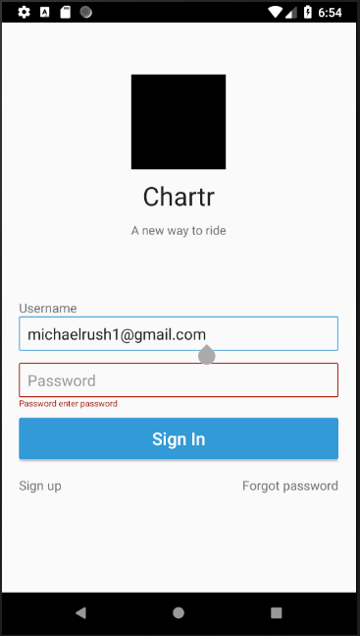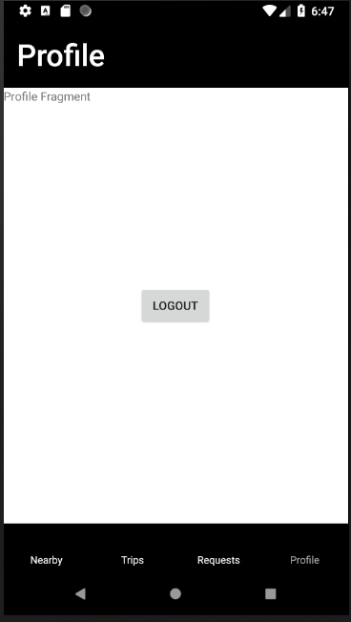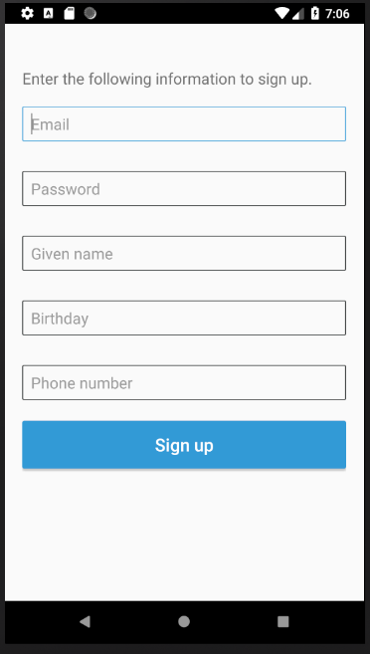

The home screen for the chartr app. Clicking sign up in the bottom left brings you to the screen on the right. Enter Your username and password to log in once the account is created.

The signup screen to create an account for the chart app. An email, password(requires 1 capital letter, 1 symbol and 1 number), your name, birthday, and phone number(+1 then rest of number). Click sign up when done.

This is the profile screen, currently it only allows you to log out using the logout button. Brings you to the sign in screen

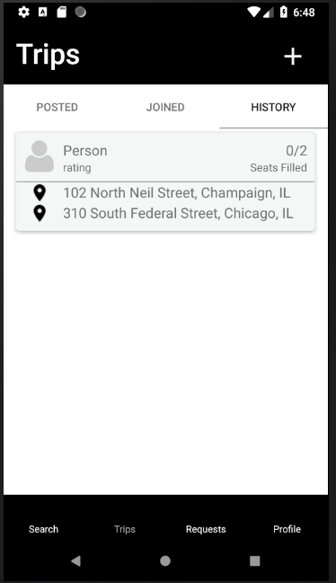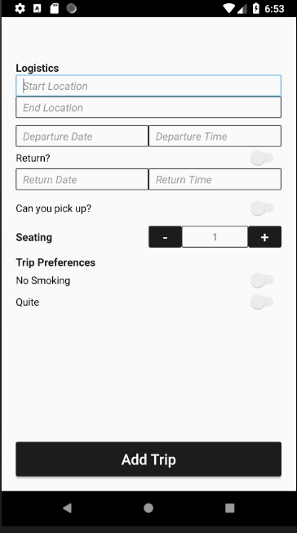

The History tab when clicked on shows past trips that you have taken. The plus button in the top right brings up the add trip screen shown on the right.

The add trip screen allows one to specify where they are going and when. Requires a start and end location with a departure/return dates and times. The number of seats available. There are four switches that are willing to return, can pick up, nonsmoking, and quite.

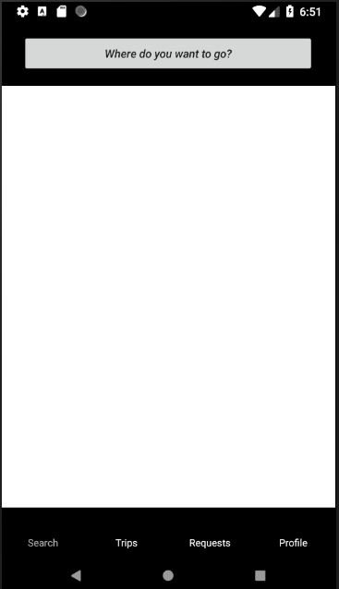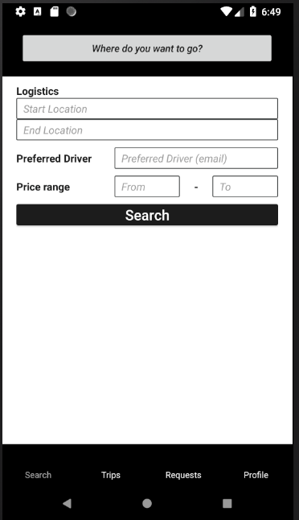

The search fields will pop up and allow the user to search for a ride. Enter the start and end destinations, a preferred driver email, and the price range.

The search tab located in the bottom of the screen brings up the screen shown above. Then to search for a trip click the button on the top of the screen.