MAJOR-1 PROJECT

SYNOPSIS

# For

**AdaptiPlan:** Intelligent Scenario Modeling for Climate Change Mitigation using Computational Statistical Models

# Submitted By

|  |  |  |
| --- | --- | --- |
| **Specialization** | **SAP ID** | **Name** |
| AIML Hons. | 500090912 | Charu Gupta |
| AIML Hons. | 500094127 | Lakshay Agarwal |



Artificial Intelligence Cluster

School of Computer Science

UPES Dehradun – 248007, Uttarakhand

Dr. Tanupriya Choudhury Dr. Anil Kumar

### Project Mentor Cluster Head

**Index**

|  |  |  |
| --- | --- | --- |
| **S. No.** | **Title** | **Pages** |
| 1 | Abstract | 3 |
| 2 | Introduction | 3 |
| 3 | Literature Review | 4 |
| 4 | Problem Statement | 5 |
| 5 | Objective | 5 |
| 6 | Methodology | 5 |
| 7 | SEPM Model | 6 |
| 8 | Gantt Chart | 7 |
| 9 | References | 7 |

**Synopsis Report**

**Project Title**

AdaptiPlan: Intelligent Scenario Modeling for Climate Change Mitigation Using LSTM, ARIMA and Monte Carlo Simulation

**Abstract**

The increasing impact of climate change presents complex challenges for predicting future environmental conditions and associated risks. This project conducts a comparative analysis of three predictive algorithms—LSTM, ARIMA, and Monte Carlo Simulation—using the ERA5 dataset to model future climate scenarios. By assessing the strengths of each algorithm in forecasting time series data, we aim to identify the most effective approach for reliable climate predictions. The results will be integrated into a web application, enabling users to simulate and analyze climate scenarios, aiding policymakers and industries in planning adaptation strategies.

*Key Words: LSTM, ARIMA, Monte Carlo Simulation*

**Introduction**

In recent years, the increasing frequency and intensity of climate change impacts have made it essential to develop reliable tools for predicting future environmental scenarios. Industries, policymakers, and researchers are now looking for advanced solutions that can forecast these changes and assist in making data-driven decisions for effective adaptation strategies. This project is inspired by the need to provide a dependable platform that can simulate climate scenarios and analyze potential risks.

By combining technical expertise in machine learning and stochastic modeling, this project will develop a web application that forecasts climate scenarios using cutting-edge algorithms such as LSTM, ARIMA, and Monte Carlo Simulation. The goal is to create a tool that provides accurate predictions and actionable insights, helping users navigate the challenges of climate change with confidence.

**Literature Review**

|  |  |
| --- | --- |
| Title | Inference |
| Prediction of Daily Climate Using Long Short-Term Memory (LSTM) Model [1] | The paper explores using Long Short-Term Memory (LSTM) networks to predict daily climate variables like temperature, leveraging historical data from Delhi of two years between 2013-2017. Traditional climate models are computationally intensive and may not capture local patterns well, but LSTM excels at processing time-dependent data. After preprocessing the data, LSTM model was trained, achieving good accuracy with a root mean squared error (RMSE) of 0.78. The results demonstrate the potential for LSTM networks to be applied to more complex climate variables and regions, offering more precise and localized climate forecasts in the future. |
| Use of the autoregressive integrated moving average (ARIMA) model to forecast near-term regional temperature and precipitation [2] | The paper explores ARIMA model, a statistical approach, to provide regional temperature and precipitation forecasts based on historical observations for 18 years. The ARIMA model was chosen due to its ability to account for temporal correlation and skewed distributions in climate data, improving forecasting accuracy over simpler methods like linear trends. The model was extended to estimate confidence intervals for temperature and precipitation extremes and simulate daily climate conditions. The predictions made by ARIMA model shows its reliability and adaptability for engineering applications, offering a robust alternative to traditional statistical forecasting methods. |
| A brief introduction to Monte Carlo simulation [3] | This paper gives introduction about Monte Carlo simulation on how it is becoming increasingly recognized for its powerful ability to manage uncertainty and variability in complex models. Unlike deterministic simulation, which offers a single outcome by assuming fixed parameters, Monte Carlo simulation explores a range of possible outcomes by incorporating random variations in the model's inputs. This method provides valuable insights into how different factors can influence results over time, making it a robust tool for understanding and predicting complex systems. Its versatility and effectiveness have made Monte Carlo simulation a staple in various fields, from finance to engineering, and it holds significant promise for enhancing decision-making processes. By capturing the full spectrum of potential scenarios, Monte Carlo simulation offers a deeper understanding of risk and uncertainty, which is increasingly important in today’s data-driven world. |
| LSTM-CM: a hybrid approach for natural drought prediction based on deep learning and climate models [4] | In this paper the hybrid LSTM-CM model developed in this study combines the strengths of both machine learning (LSTM-SA) and climate models (GS5) to improve drought prediction accuracy. By using the low bias of LSTM-SA and the strong physical simulation capabilities of GS5, LSTM-CM enhances drought forecasting, especially for 1-, 2-, and 3-month lead times, with improved skill scores ranging from 29.17% to 54.29%. This model shows better performance in detecting drought events with lower uncertainty than the stand-alone models, making it a promising tool for more reliable drought prediction. |
| Time series analysis of climate variables using seasonal ARIMA approach [5] | The research paper presents a new hybrid model, LSTM-CM, for predicting droughts by combining a long short-term memory (LSTM) model with a climate model (GloSea5). This model is compared against the standalone LSTM model (LSTM-SA) and the GloSea5 model (GS5) in terms of accuracy, bias, and overall performance. The results show that LSTM-CM outperforms both models by reducing bias, capturing the physical processes accurately, and improving prediction skill scores for 1-, 2-, and 3-month lead times. The LSTM-CM model effectively detects droughts with lower uncertainty, making it a reliable tool for drought forecasting. |
| Representing uncertainty in climate change scenarios: a Monte-Carlo approach [6] | The research paper presents a method for handling uncertainty in climate change scenarios using a Bayesian Monte-Carlo approach. This method accounts for uncertainties in future greenhouse gas emissions, climate sensitivity, and the limitations of climate models. The model uses various emissions scenarios and climate sensitivities to produce a range of possible future climate conditions. By applying these scenarios to impact models, such as those for hydrology, it provides a probability distribution of outcomes, helping decision-makers assess risks and plan for various future climate conditions. This approach enhances understanding and management of uncertainty in climate impact assessments. |

**Problem Statement**

The goal of this project is to predict future climate scenarios and assess potential risks using advanced machine learning and statistical methods. Specifically, we aim to compare three models LSTM, ARIMA, and Monte Carlo simulation to determine which one provides the most reliable and accurate predictions using time series climate data. The selected model will then be used to develop a web application that allows users to simulate and analyze climate scenarios, helping them make informed decisions for climate adaptation and risk management.

**Objectives**

**Main Objective:** The main objective of this project is to develop a predictive model for climate change impacts and integrate it into an interactive web application to assist users in making informed decisions for climate adaptation.

**Sub objectives:**

* Finding the dataset
* Implementing the models
* Evaluating and performing comparative analysis
* Building the web application using the best model

**Methodology:**

The methodology for AdaptiPlan can be outlined as follows:

* **Dataset Collection:** Collecting the ERA5 dataset using the CDS API to access and download the dataset in NetCDF or GRIB format. [7]
* **Model Implementation & Training:** Implementing and training three predictive models LSTM, ARIMA and Monte Carlo Simulation using the dataset to learn patterns and relationships necessary for forecasting future climate scenarios.
* **Model Comparison:** Comparing the different models based on the predictions made.
* **Web Application Development:** Building the web application using the model which performed the best on the dataset.

**SEPM:**

**Iterative Model**

We will be using the Iterative Model to implement our project. The iterative method begins with a basic implementation of a limited set of software requirements in the iterative model, then repeatedly improves the evolving versions until the entire system is built and prepared for deployment.

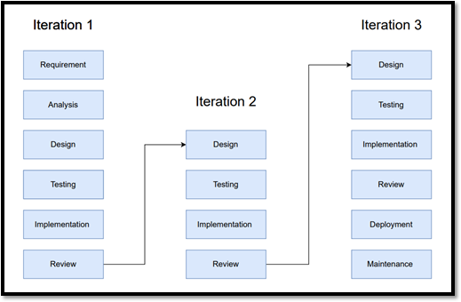It is not the goal of an iterative life cycle model to begin with a complete set of criteria. Instead, just a portion of the program is specified and implemented at the beginning, and then it is inspected to find any further requirements. After each iteration of the model, this procedure is repeated to create a new version of the program.

Fig. 1 Iterative Model

**Gantt Chart:**

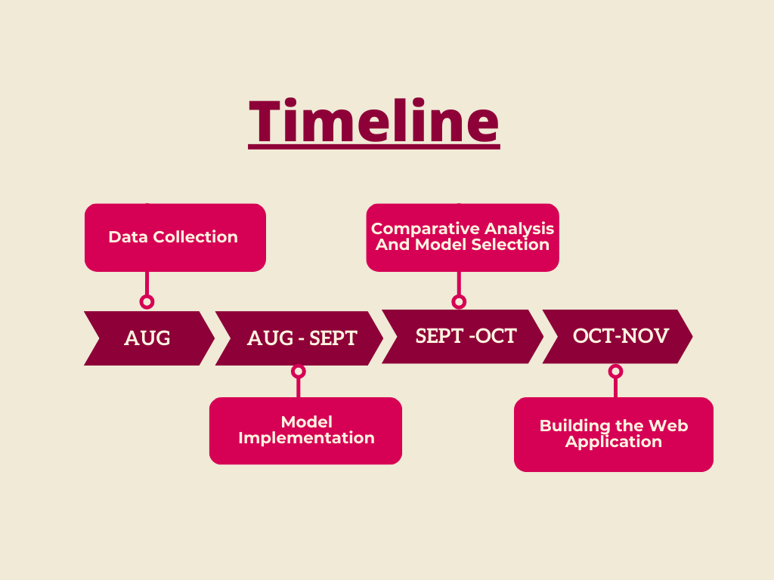

Fig. 2 Gantt Chart

**References:**

[1] Xu, J., Wang, Z., Li, X., Li, Z., & Li, Z. (2024). Prediction of Daily Climate Using Long Short-Term Memory (LSTM) Model. International Journal of Innovative Science and Research Technology, 83-90.

[2] Lai, Y., & Dzombak, D. A. (2020). Use of the autoregressive integrated moving average (ARIMA) model to forecast near-term regional temperature and precipitation. Weather and forecasting, 35(3), 959-976.

[3] Bonate, P. L. (2001). A brief introduction to Monte Carlo simulation. Clinical pharmacokinetics, 40, 15-22.

[4] Vo, T. Q., Kim, S. H., Nguyen, D. H., & Bae, D. H. (2023). LSTM-CM: a hybrid approach for natural drought prediction based on deep learning and climate models. *Stochastic Environmental Research and Risk Assessment*, *37*(6), 2035-2051.

[5] Dimri, T., Ahmad, S., & Sharif, M. (2020). Time series analysis of climate variables using seasonal ARIMA approach. *Journal of Earth System Science*, *129*, 1-16.

[6] New, M., & Hulme, M. (2000). Representing uncertainty in climate change scenarios: a Monte-Carlo approach. *Integrated assessment*, *1*(3), 203-213.

[7] [[https://cds.climate.copernicus.eu/cdsapp#!/dataset/reanalysis-era5-single-levels?tab=form](https://cds.climate.copernicus.eu/cdsapp)](https://cds.climate.copernicus.eu/cdsapp#!/dataset/reanalysis-era5-single-levels?tab=form)