MAJOR-1 PROJECT

SYNOPSIS

# For

**AdaptiPlan: Intelligent Scenario Modeling for**

**Climate Change Mitigation**

# Submitted By

|  |  |  |
| --- | --- | --- |
| **Specialization** | **SAP ID** | **Name** |
| AIML Hons. | 500090912 | Charu Gupta |
| AIML Hons. | 500094127 | Lakshay Agarwal |



Department of Artificial Intelligence School of Computer Science

University of Petroleum & Energy Studies Dehradun - 248007. Uttarakhand

Dr. Tanupriya Choudhury Dr. Anil Kumar

### Project Mentor Cluster Head

**Index**

|  |  |  |
| --- | --- | --- |
| **S. No.** | **Title** | **Pages** |
| 1 | Abstract |  |
| 2 | Introduction |  |
| 3 | Literature Review |  |
| 4 | Problem Statement |  |
| 5 | Objective |  |
| 6 | Methodology |  |
| 7 | SEPM Model |  |
| 8 | Gantt Chart |  |
| 9 | References |  |

**Synopsis Report**

**Project Title**

AdaptiPlan: Intelligent Scenario Modeling for Climate Change Mitigation.

**Abstract**

The increasing impact of climate change presents complex challenges for predicting future environmental conditions and associated risks. This project conducts a comparative analysis of three predictive algorithms—LSTM, ARIMA, and Monte Carlo Simulation—using the ERA5 dataset to model future climate scenarios. By assessing the strengths of each algorithm in forecasting time series data, we aim to identify the most effective approach for reliable climate predictions. The results will be integrated into a web application, enabling users to simulate and analyze climate scenarios, aiding policymakers and industries in planning adaptation strategies.

*Key Words: LSTM, ARIMA, Monte Carlo Simulation*

**Introduction**

In recent years, the increasing frequency and intensity of climate change impacts have made it essential to develop reliable tools for predicting future environmental scenarios. Industries, policymakers, and researchers are now looking for advanced solutions that can forecast these changes and assist in making data-driven decisions for effective adaptation strategies. This project is inspired by the need to provide a dependable platform that can simulate climate scenarios and analyze potential risks.

By combining technical expertise in machine learning and stochastic modeling, this project will develop a web application that forecasts climate scenarios using cutting-edge algorithms such as LSTM, ARIMA, and Monte Carlo Simulation. The goal is to create a tool that provides accurate predictions and actionable insights, helping users navigate the challenges of climate change with confidence.

**Literature Review**

|  |  |
| --- | --- |
| Title | Inference |
|  |  |
|  |  |
|  |  |
|  |  |
|  |  |
|  |  |

**Problem Statement**

The goal of this project is to predict future climate scenarios and assess potential risks using advanced machine learning and statistical methods. Specifically, we aim to compare three models LSTM, ARIMA, and Monte Carlo simulation to determine which one provides the most reliable and accurate predictions using time series climate data. The selected model will then be used to develop a web application that allows users to simulate and analyze climate scenarios, helping them make informed decisions for climate adaptation and risk management.

**Objectives**

**Main Objective:** The main objective of this project is to develop a predictive model for climate change impacts and integrate it into an interactive web application to assist users in making informed decisions for climate adaptation.

**Sub objectives:**

* Finding the dataset
* Implementing the models
* Evaluating and performing comparative analysis
* Building the web application using the best model

**Methodology:**

The methodology for Adaptiplan can be outlined as follows:

* **Dataset Collection:** Collecting the ERA5 dataset using the CDS API to access and download the dataset in NetCDF or GRIB format.
* **Model Implementation & Training:** Implementing and training three predictive models LSTM, ARIMA and Monte Carlo Simulation using the dataset to learn patterns and relationships necessary for forecasting future climate scenarios.
* **Model Comparison:** Comparing the different models based on the predictions made.
* **Web Application Development:** Building the web application using the model which performed the best on the dataset.

**SEPM:**

**Iterative Model**

We will be using the Iterative Model to implement our project. The iterative method begins with a basic implementation of a limited set of software requirements in the iterative model, then repeatedly improves the evolving versions until the entire system is built and prepared for deployment.

It is not the goal of an iterative life cycle model to begin with a complete set of criteria. Instead, just a portion of the program is specified and implemented at the beginning, and then it is inspected to find any further requirements. After each iteration of the model, this procedure is repeated to create a new version of the program.

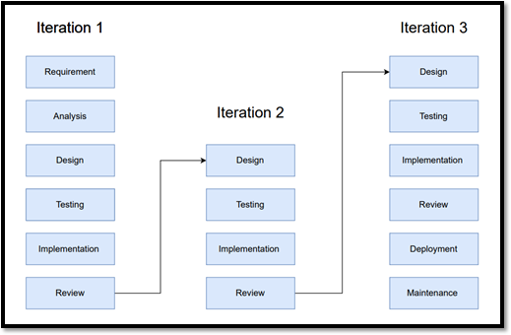

**Gantt Chart:**

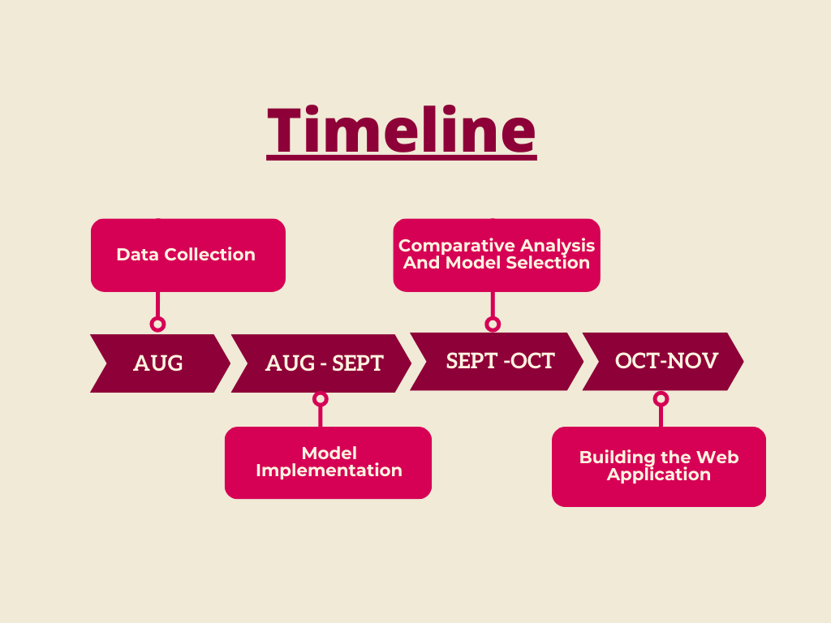

**References:**