

**MINOR-2 PROJECT SYNOPSIS**

**PCause: PCOS detection system based on deep learning model using ultrasound images**

Submitted By

|  |  |  |
| --- | --- | --- |
| **Specialization** | **SAP ID** | **Name** |
| AIML(HONS) | 500094127 | Lakshay Agarwal |
| AIML(HONS) | 500090912 | Charu Gupta |

Department of Artificial Intelligence

School Of Computer Science

UNIVERSITY OF PETROLEUM & ENERGY STUDIES,

DEHRADUN- 248007. Uttarakhand

Ms. Sugandha Sharma Dr. Anil Kumar

**Project Mentor** **Cluster Head**

**Content**

1. Abstract……………………………………….
2. Motivation ……………………………………
3. Literature Review…………………………….
4. Objective……………………………………...
5. Problem Statement……………………………
6. SWOT Analysis……………………………….
7. Methodology………………………………….
8. References……………………………………..
9. **Abstract**

PCause will be a smart system designed to detect Polycystic Ovary Syndrome (PCOS) using ultrasound images. It will utilize complex but easy-to-understand techniques to process and analyze these images. It will enhance and select important information from the images using a method called Principal Component Analysis (PCA). Then, it will add more variety to the data using a special method called Generative Adversarial Networks (GANs). This will help make the system better at recognizing PCOS from different types of ultrasound images.

This system will be a significant aid for doctors and patients dealing with PCOS in the future. It will find PCOS early, making it easier to treat. It will also assist doctors in planning treatments that are personalized for each patient. Additionally, it will be used for important research and to educate patients about their condition.

1. **Motivation**

The motivation behind this project stems from the aspiration to revolutionize PCOS diagnosis by using technologies of deep learning and image processing. By developing an automated PCOS detection system, we aim to enhance the accuracy and speed of diagnosis, and facilitating early intervention. Improved diagnostic capabilities not only empower healthcare professionals but also contribute to the overall well-being of women affected by PCOS, addressing a significant gap in current healthcare practices. Ultimately, our project seeks to make a meaningful impact on public health by advancing the early detection of PCOS, thereby improving the quality of life for affected women.

1. **Literature Review**

Th In [1], Principal Component Analysis (PCA) as a pivotal tool for enhancing image classification in computer vision. PCA efficiently reduces the dimensionality of high-dimensional datasets, improving interpretability and visualization. The integration of PCA with convolutional neural networks (CNNs) demonstrates its role in optimizing computational efficiency and accuracy in classifying diverse datasets. Overall, PCA emerges as a crucial technique, simplifying complex data representations and contributing to the advancement of image classification methodologies in artificial intelligence applications.

[2] underscores the potential of advanced deep learning models, including Alexnet, Inception V3, Resnet50, and VGG16, in enhancing the accuracy of Polycystic Ovary Syndrome (PCOS) diagnosis from ultrasound images. The utilization of transfer learning techniques, particularly in the medical field, showcases the effectiveness of pre-trained models in image analysis. Additionally, feature selection, image pre-processing, and evaluation metrics like precision, recall, sensitivity, specificity, and F1 score play crucial roles in fine-tuning and evaluating the models. This research contributes significantly to advancing automated PCOS diagnosis, offering potential benefits for timely and accurate medical interventions.

[3] proposes a pioneering approach for Polycystic Ovary Syndrome (PCOS) detection using a hybrid method that combines deep learning and traditional machine learning techniques. The study utilizes transfer learning with a pre-trained VGG16 model for feature extraction from ultrasound images. Compared to existing methods, the proposed approach achieves a remarkable accuracy in PCOS detection with efficient execution. While the method shows certain limitations that include a small dataset and challenges in explaining the model's decisions. The main aim of this research is to address such health issues and explore applications in detecting other clinical disorders.

Generative Adversarial Networks (GANs) in [4] uses image processing, emphasizing their role in generating realistic images through adversarial training. One of the impactful applications of Generative Adversarial Networks (GANs) in medical imaging, specifically in enhancing ultrasound image resolution. GANs integrated with deep learning models facilitate end-to-end encoding and decoding processes, enabling the generation of high-resolution images from routinely captured prostate ultrasound scans. Moreover, GANs are useful in creating different types of abnormalities in medical images, even when there are only a few examples available for each abnormality. The incorporation of deep convolutional GANs further enables the transformation of 2D images into 3D, expediting the analysis of medical images.

Using Convolutional Neural Networks (CNN) as an image classifier, utilizing feature extraction [5] attempts to effectively detect ovarian cysts in ultrasound images. The algorithm is trained on a dataset, using input ultrasound images as training data. It classifies test data within the dataset to determine if the ovary is affected, providing critical information on parameters such as area, solidity, extent, and perimeter affected by the cysts. This approach enhances diagnostic capabilities, showcasing the potential of CNNs in medical image analysis for precise identification and characterization of ovarian abnormalities, particularly in the context of disorders like Polycystic Ovary Syndrome (PCOS).

1. **Objectives**

The primary goal of this project can be categorized into the following points:

* **Feature Extraction from Image Dataset:** Utilize image processing techniques to identify and extract relevant features from the image dataset. This aims to enhance the model's accuracy and adaptability to variations in images.
* **Data Augmentation for Model Training:** Implement data augmentation strategies to expand the training dataset. This step is crucial for enhancing the model's generalization and performance by exposing it to a diverse set of images.
* **Conduct Comparative Analysis of Deep Learning Models:** Perform a comprehensive comparative analysis of various deep learning models. Evaluate their performance based on the accuracy of the results they produce. This analysis will provide insights into the effectiveness of different models under specific conditions.

1. **Problem Statement**

Polycystic Ovary Syndrome (PCOS) is a common hormonal disorder affecting women of reproductive age. Early detection and accurate diagnosis of PCOS are crucial for effective management and prevention of associated complications. However, existing diagnostic methods often rely on manual assessments and subjective criteria, leading to potential misdiagnosis or delayed intervention. The lack of a standardized and efficient diagnostic approach poses a significant challenge in providing timely and personalized healthcare for individuals with PCOS. Therefore, there is a pressing need for the development of an automated and accurate PCOS detection system that leverages advanced technologies, such as machine learning and image processing, to enhance early diagnosis, streamline treatment planning, and improve overall healthcare outcomes for individuals affected by PCOS.

1. **SWOT Analysis**

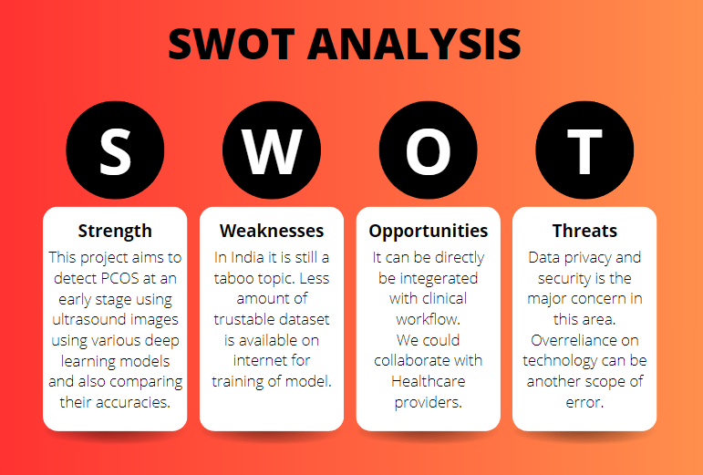

1. **Methodology**

* Reference Software model

We will be using the Iterative Model to implement our project. The iterative method begins with a basic implementation of a limited set of software requirements in the iterative model, then repeatedly improves the evolving versions until the entire system is built and prepared for deployment.

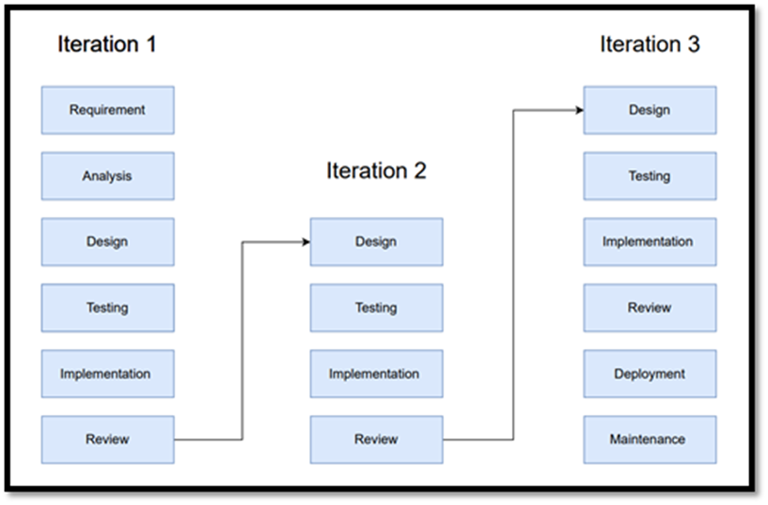

* Steps

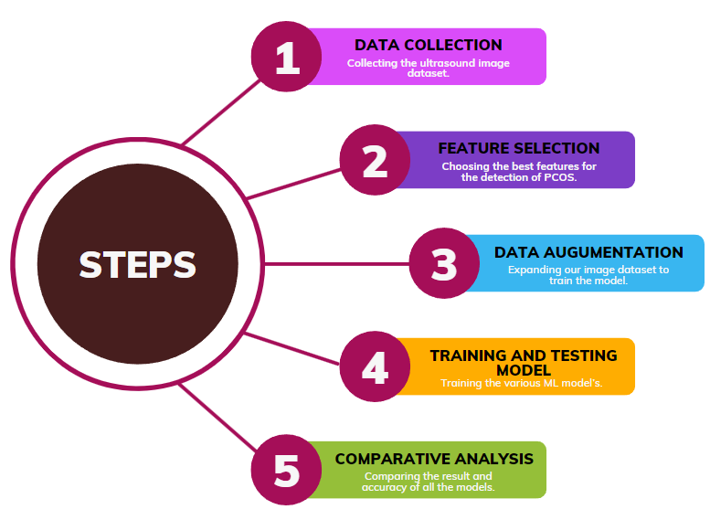

* Timeline

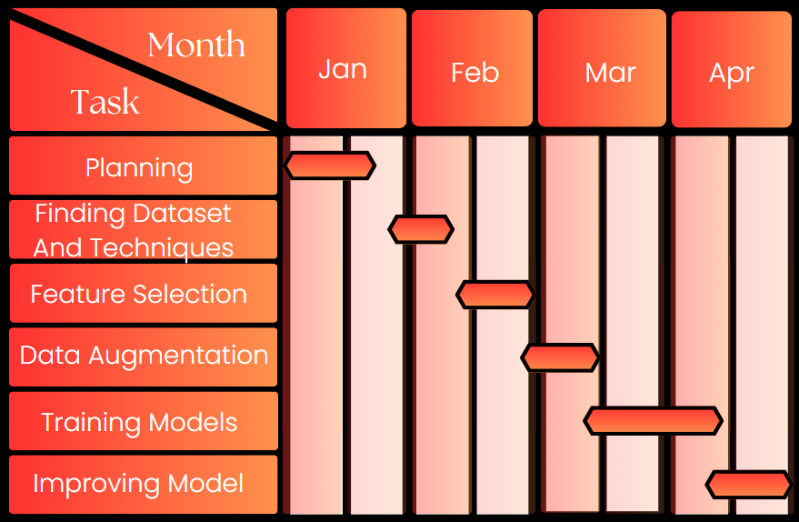

1. **References**

[[1]Aslam, S., & Rabie, T. F. (2023, February). Principal Component Analysis in Image Classification: A review. In 2023 Advances in Science and Engineering Technology International Conferences (ASET) (pp. 1-7). IEEE.](https://ieeexplore.ieee.org/stampPDF/getPDF.jsp?tp=&arnumber=10180847&ref=aHR0cHM6Ly9pZWVleHBsb3JlLmllZWUub3JnL2RvY3VtZW50LzEwMTgwODQ3&tag=1)

[[2] Chitra, P., Srilatha, K., Sumathi, M., Jayasudha, F. V., Bernatin, T., & Jagadeesh, M. (2023, March). Classification of Ultrasound PCOS Image using Deep Learning based Hybrid Models. In 2023 Second International Conference on Electronics and Renewable Systems (ICEARS) (pp. 1389-1394). IEEE.](https://ieeexplore.ieee.org/document/10085400)

[[3] Suha, S. A., & Islam, M. N. (2022). An extended machine learning technique for polycystic ovary syndrome detection using ovary ultrasound image. Scientific Reports, 12(1), 17123.](https://www.ncbi.nlm.nih.gov/pmc/articles/PMC9556522/)

[[4] Aggarwal, A., Mittal, M., & Battineni, G. (2021). Generative adversarial network: An overview of theory and applications. International Journal of Information Management Data Insights, 1(1), 100004.](https://www.researchgate.net/publication/348837975_Generative_adversarial_network_An_overview_of_theory_and_applications)

[[5] Sumathi, M., Chitra, P., Prabha, R. S., & Srilatha, K. (2021, February). Study and detection of PCOS related diseases using CNN. In IOP Conference Series: Materials Science and Engineering (Vol. 1070, No. 1, p. 012062). IOP Publishing.](https://iopscience.iop.org/article/10.1088/1757-899X/1070/1/012062/pdf)