--------------------------------------------------------------------------------------------------------------------------

Which product lines dominate overall sales?

-------------------------------------------------------------------------------------------------------------------------

SELECT p.product_line,

SUM(s.sales_amount) AS total_revenue,

ROUND(100.0 * SUM(s.sales_amount) / SUM(SUM(s.sales_amount)) OVER(), 2)

AS pct_contribution

FROM sales s

JOIN products p ON s.product_key = p.product_key

GROUP BY p.product_line

ORDER BY total_revenue DESC;

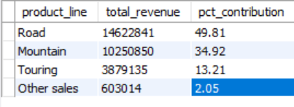

Insights:

Road Product line generates the most revenue in all years.

--------------------------------------------------------------------------------------------------------------------------

What is the revenue generated by each product?

--------------------------------------------------------------------------------------------------------------------------

WITH ranked_products AS (

SELECT p.product_name,

SUM(s.sales_amount) AS total_revenue,

RANK() OVER(ORDER BY SUM(s.sales_amount) DESC) AS rank_order,

SUM(SUM(s.sales_amount)) OVER() AS grand_total

FROM sales s

JOIN products p ON s.product_key = p.product_key

GROUP BY p.product_name

)

SELECT product_name,

total_revenue,

ROUND(100 * total_revenue / grand_total, 2) AS revenue_pct

FROM ranked_products

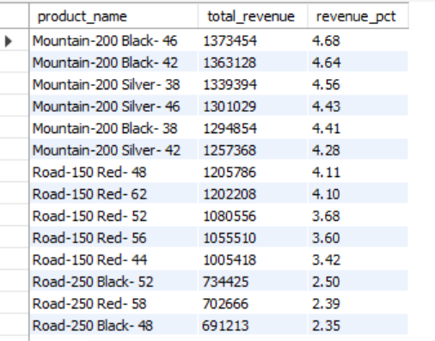

--------------------------------------------------------------------------------------------------------------------------

Are high-volume products always high-revenue?

--------------------------------------------------------------------------------------------------------------------------

SELECT p.product_name, SUM(s.quantity) AS total_units,

SUM(s.sales_amount) AS total_revenue

FROM sales s

JOIN products p ON s.product_key = p.product_key

GROUP BY p.product_name

ORDER BY total_units DESC;

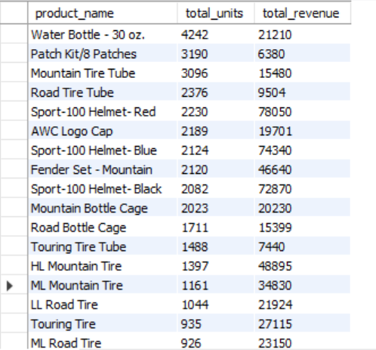

Insights:

No, high-volume products does not always generate high-revenue.

Total units of HL Mountain Tire were 1397 but still generated highest revenue.

--------------------------------------------------------------------------------------------------------------------------

Product subcategories with highest average profit margins

--------------------------------------------------------------------------------------------------------------------------

select

p.subcategory,

avg(s.sales_price - p.cost) as avg_profit_margin

from sales s

join products p on s.product_key = p.product_key

group by p.subcategory

order by avg_profit_margin desc;

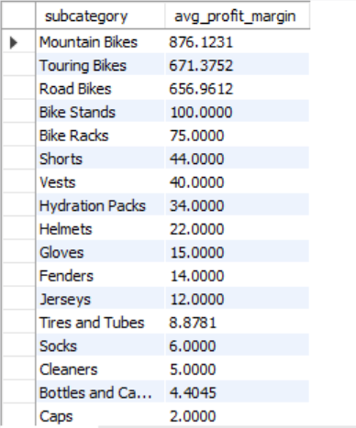

Insights:

Mountain Bikes have the maximum average profit margin whereas Caps have the lowest.

--------------------------------------------------------------------------------------------------------------------------

How much are sales growing each year?

--------------------------------------------------------------------------------------------------------------------------

WITH yearly_sales AS (

SELECT YEAR(order_date) AS year, SUM(sales_amount) AS total_sales

FROM sales

GROUP BY YEAR(order_date)

)

SELECT year, total_sales,

LAG(total_sales) OVER(ORDER BY year) AS prev_year_sales,

ROUND((total_sales - LAG(total_sales) OVER(ORDER BY year)) /

NULLIF(LAG(total_sales) OVER(ORDER BY year),0), 2) *100 AS growth_pct

FROM yearly_sales;

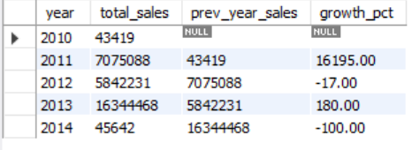

Insights:

The company’s year-on-year growth shows no clear upward trend.

Specifically, the growth rate declined in 2012, rebounded in 2013, and then dropped again in 2014.

This indicates that the business has been experiencing fluctuations rather than consistent growth.

--------------------------------------------------------------------------------------------------------------------------

Segmenting customers based on Recency, Frequency and Monetary

--------------------------------------------------------------------------------------------------------------------------

SELECT c.customer_id,

concat(c.first_name, ' ', c.last_name) as name,

DATEDIFF(CURDATE(), MAX(s.order_date)) AS recency,

COUNT(DISTINCT s.order_number) AS frequency,

SUM(s.sales_amount) AS monetary

FROM sales s

JOIN customers c ON s.customer_key = c.customer_key

GROUP BY c.customer_id, concat(c.first_name, ' ', c.last_name)

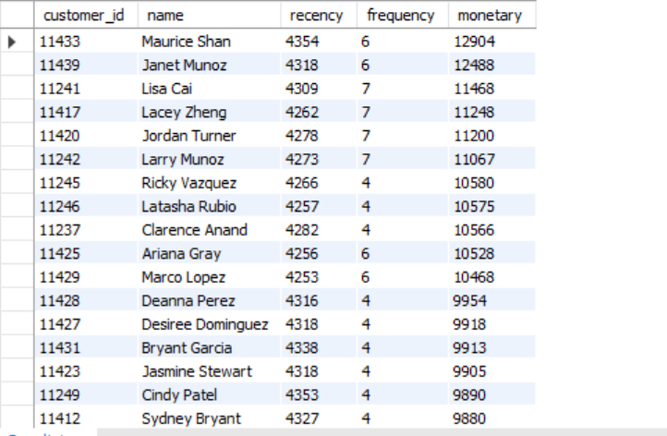

--------------------------------------------------------------------------------------------------------------------------

Which customers haven’t purchased recently?

--------------------------------------------------------------------------------------------------------------------------

SELECT c.customer_id, c.first_name, c.last_name,

MAX(s.order_date) AS last_order,

DATEDIFF(CURDATE(), MAX(s.order_date)) AS days_since_last_purchase

FROM customers c

JOIN sales s ON c.customer_key = s.customer_key

GROUP BY c.customer_id, c.first_name, c.last_name

ORDER BY days_since_last_purchase DESC;

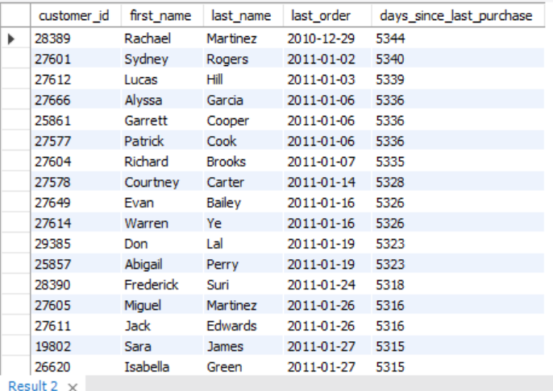

--------------------------------------------------------------------------------------------------------------------------

Which categories are most often delayed?

--------------------------------------------------------------------------------------------------------------------------

SELECT p.category,

ROUND(AVG(DATEDIFF(s.shipping_date, s.due_date)), 2) AS avg_delay_days

FROM sales s

JOIN products p ON s.product_key = p.product_key

WHERE s.shipping_date > s.due_date

GROUP BY p.category

ORDER BY avg_delay_days DESC;

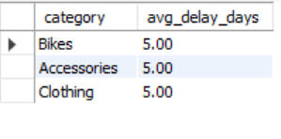

Insights:

Analysis shows that all product categories experience the same average delivery delay.

This suggests that the delay is not category-specific, but rather a systemic issue in the supply chain or logistics process.

--------------------------------------------------------------------------------------------------------------------------

Top 10 customers by total revenue with country and gender info

--------------------------------------------------------------------------------------------------------------------------

select

c.customer_key,

c.first_name,

c.last_name,

c.country,

c.gender,

sum(s.sales_amount) as total_spent

from sales s

join customers c on s.customer_key = c.customer_key

group by c.customer_key, c.first_name, c.last_name, c.country, c.gender

order by total_spent desc limit 10;

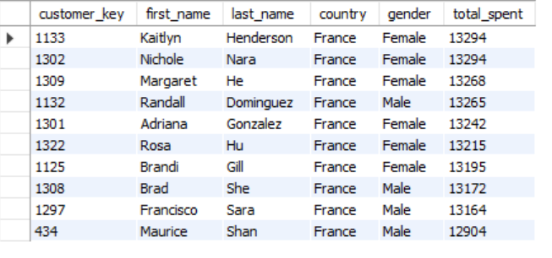

Insights:

Among all regions, France hosts the top 10 highest-spending customers.

This indicates that the French market contributes disproportionately to revenue compared to other regions.

-------------------------------------------------------------------------------------------------------------------------

Which geographies are most profitable?

--------------------------------------------------------------------------------------------------------------------------

SELECT c.country,

SUM(s.sales_amount - (p.cost * s.quantity)) AS total_profit

FROM sales s

JOIN products p ON s.product_key = p.product_key

JOIN customers c ON s.customer_key = c.customer_key

GROUP BY c.country

ORDER BY total_profit DESC;

LIMIT 10;

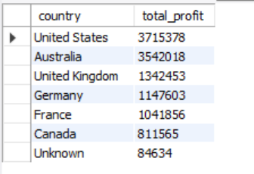

Insights:

United States emerges as the most profitable market, contributing the highest share to overall profit, whereas Canada is the least profitable market.

-------------------------------------------------------------------------------------------------------------------------

Customer purchasing patterns by age group and marital status

-------------------------------------------------------------------------------------------------------------------------

with customer_age as (

select

customer_key,

floor(datediff(current_date, birth_date) / 365) as age,

marital_status

from customers

),

age_groups as (

select

customer_key,

marital_status,

case

when age < 25 then 'Under 25'

when age between 25 and 40 then '25-40'

when age between 41 and 60 then '41-60'

else '60+'

end as age_group

from customer_age

),

sales_by_group as (

select

ag.age_group,

ag.marital_status,

sum(s.sales_amount) as total_sales,

count(distinct s.customer_key) as customer_count

from sales s

join age_groups ag on s.customer_key = ag.customer_key

group by ag.age_group, ag.marital_status

)

select * from sales_by_group

order by total_sales desc;

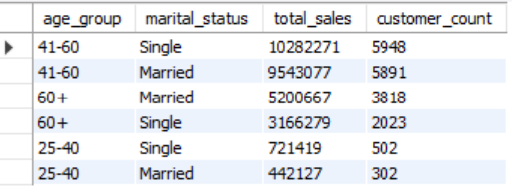

Insights:

The core customer base consists of single individuals aged 41–60, making up the majority of our sales.

In contrast, younger customers form a significantly smaller segment of our customer base.