--------------------------------------------------------------------------------------------------------------------------

Which product lines dominate overall sales?

-------------------------------------------------------------------------------------------------------------------------

SELECT p.product_line,

SUM(s.sales_amount) AS total_revenue,

ROUND(100.0 * SUM(s.sales_amount) / SUM(SUM(s.sales_amount)) OVER(), 2)

AS pct_contribution

FROM sales s

JOIN products p ON s.product_key = p.product_key

GROUP BY p.product_line

ORDER BY total_revenue DESC;

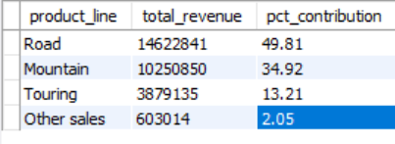

--------------------------------------------------------------------------------------------------------------------------

What is the revenue generated by each product?

--------------------------------------------------------------------------------------------------------------------------

WITH ranked_products AS (

SELECT p.product_name,

SUM(s.sales_amount) AS total_revenue,

RANK() OVER(ORDER BY SUM(s.sales_amount) DESC) AS rank_order,

SUM(SUM(s.sales_amount)) OVER() AS grand_total

FROM sales s

JOIN products p ON s.product_key = p.product_key

GROUP BY p.product_name

)

SELECT product_name,

total_revenue,

ROUND(100 * total_revenue / grand_total, 2) AS revenue_pct

FROM ranked_products

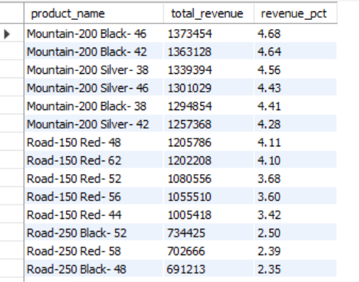

--------------------------------------------------------------------------------------------------------------------------

Are high-volume products always high-revenue?

--------------------------------------------------------------------------------------------------------------------------

SELECT p.product_name, SUM(s.quantity) AS total_units,

SUM(s.sales_amount) AS total_revenue

FROM sales s

JOIN products p ON s.product_key = p.product_key

GROUP BY p.product_name

ORDER BY total_units DESC;

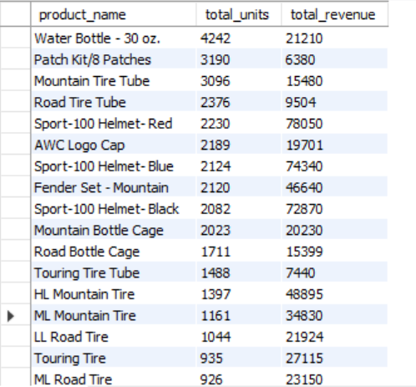

--------------------------------------------------------------------------------------------------------------------------

Product subcategories with highest average profit margins

--------------------------------------------------------------------------------------------------------------------------

select

p.subcategory,

avg(s.sales_price - p.cost) as avg_profit_margin

from sales s

join products p on s.product_key = p.product_key

group by p.subcategory

order by avg_profit_margin desc;

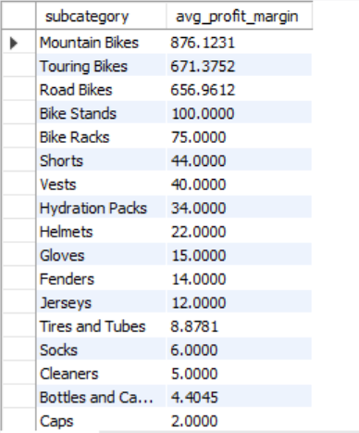

--------------------------------------------------------------------------------------------------------------------------

How much are sales growing each year?

--------------------------------------------------------------------------------------------------------------------------

WITH yearly_sales AS (

SELECT YEAR(order_date) AS year, SUM(sales_amount) AS total_sales

FROM sales

GROUP BY YEAR(order_date)

)

SELECT year, total_sales,

LAG(total_sales) OVER(ORDER BY year) AS prev_year_sales,

ROUND((total_sales - LAG(total_sales) OVER(ORDER BY year)) /

NULLIF(LAG(total_sales) OVER(ORDER BY year),0), 2) *100 AS growth_pct

FROM yearly_sales;

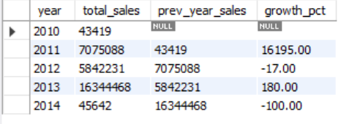

--------------------------------------------------------------------------------------------------------------------------

Segmenting customers based on Recency, Frequency and Monetary

--------------------------------------------------------------------------------------------------------------------------

SELECT c.customer_id,

concat(c.first_name, ' ', c.last_name) as name,

DATEDIFF(CURDATE(), MAX(s.order_date)) AS recency,

COUNT(DISTINCT s.order_number) AS frequency,

SUM(s.sales_amount) AS monetary

FROM sales s

JOIN customers c ON s.customer_key = c.customer_key

GROUP BY c.customer_id, concat(c.first_name, ' ', c.last_name)

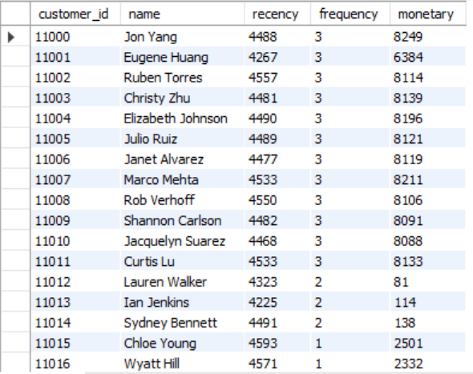

--------------------------------------------------------------------------------------------------------------------------

Which customers haven’t purchased recently?

--------------------------------------------------------------------------------------------------------------------------

SELECT c.customer_id, c.first_name, c.last_name,

MAX(s.order_date) AS last_order,

DATEDIFF(CURDATE(), MAX(s.order_date)) AS days_since_last_purchase

FROM customers c

JOIN sales s ON c.customer_key = s.customer_key

GROUP BY c.customer_id, c.first_name, c.last_name

ORDER BY days_since_last_purchase DESC;

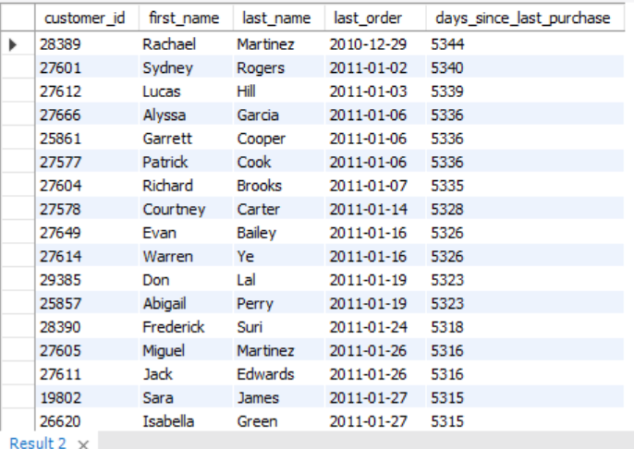

--------------------------------------------------------------------------------------------------------------------------

Which categories are most often delayed?

--------------------------------------------------------------------------------------------------------------------------

SELECT p.category,

ROUND(AVG(DATEDIFF(s.shipping_date, s.due_date)), 2) AS avg_delay_days

FROM sales s

JOIN products p ON s.product_key = p.product_key

WHERE s.shipping_date > s.due_date

GROUP BY p.category

ORDER BY avg_delay_days DESC;

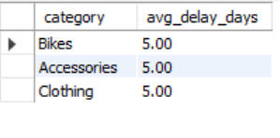

--------------------------------------------------------------------------------------------------------------------------

Top 10 customers by total revenue with country and gender info

--------------------------------------------------------------------------------------------------------------------------

select

c.customer_key,

c.first_name,

c.last_name,

c.country,

c.gender,

sum(s.sales_amount) as total_spent

from sales s

join customers c on s.customer_key = c.customer_key

group by c.customer_key, c.first_name, c.last_name, c.country, c.gender

order by total_spent desc limit 10;

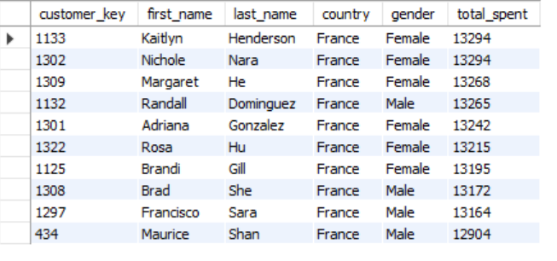

-------------------------------------------------------------------------------------------------------------------------

Which geographies are most profitable?

--------------------------------------------------------------------------------------------------------------------------

SELECT c.country,

SUM(s.sales_amount - (p.cost * s.quantity)) AS total_profit

FROM sales s

JOIN products p ON s.product_key = p.product_key

JOIN customers c ON s.customer_key = c.customer_key

GROUP BY c.country

ORDER BY total_profit DESC;

LIMIT 10;

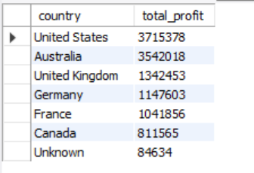

-------------------------------------------------------------------------------------------------------------------------

Customer purchasing patterns by age group and marital status

-------------------------------------------------------------------------------------------------------------------------

with customer_age as (

select

customer_key,

floor(datediff(current_date, birth_date) / 365) as age,

marital_status

from customers

),

age_groups as (

select

customer_key,

marital_status,

case

when age < 25 then 'Under 25'

when age between 25 and 40 then '25-40'

when age between 41 and 60 then '41-60'

else '60+'

end as age_group

from customer_age

),

sales_by_group as (

select

ag.age_group,

ag.marital_status,

sum(s.sales_amount) as total_sales,

count(distinct s.customer_key) as customer_count

from sales s

join age_groups ag on s.customer_key = ag.customer_key

group by ag.age_group, ag.marital_status

)

select * from sales_by_group

order by total_sales desc;

