**Cloud Application**

**Development**

**Big Data Analytics**

**Phase 2 : Innovation**

**Submitted by**

**CHARULATHA.A**

**Thangavel Engineering college**

Abstract

Advances in the field of technology enabled individuals and businesses to collect large amounts of data (structured and unstructured) from various sources like never before. Data from social media, user-generated, internet, health care, manufacturing, supply chain, financial institution, and sensors have grown exponentially. This paper’s objective is to review how big data drive and impact innovation, competitive advantage, productivity, and decision support. Methodology: A comprehensive literature review on big data and identifying the impact of big data analytics on innovation, competitive advantage, productivity, and decision support are studied. The reviewed literature created the foundation for studying, a model that was developed based on an extensive review of literature as well as case studies and future forecast by market leaders. Big data is the latest buzzword among businesses. A new model is suggested identifying big data and the correlation between innovation, competitive advantage, productivity, and decision support. Findings: A review of scholarly literature and existing case studies finds that there is a gap between existing frameworks and the integration of big data into various business and management functions and objectives. The findings are interesting that literature is rich with concepts and frameworks for achieving the end goal for business or management function along with framework but very little is available in the literature on the question of how to integrate big data analytics into those frameworks. This paper finds that a key question is missing i.e., what are the essential steps that businesses should perform to implement and integrate big data analytics into existing frameworks to fully exploit the big data potential. Research Limitations/Implications: The research was limited to a review of selective literature focused on in-depth understanding of big data. Additionally, it focuses on how big data leads to innovation, competitive advantage, productivity, and decision support. Although there are many other related fields of studies where big data impact can be studied but is not part of this study effort. Future studies can lead to more in-depth studies of other related areas of studies. Practical Implications: The review of the literature suggested that “Big Data” is playing an important role in innovations, creating competitive advantage, enhancing productivity, and assisting in data-driven decisions. Businesses are taking advantage of the customer insights that are innovating products and services which are very customer-centric, keeping the competition on the run, improving productivity at all levels, and making educated decisions every day. The future will be driven by smarter big data solutions and insights. Originality/Value: The study provides evidence that big data is the catalyst for innovation, creates competitive advantage, enhances productivity, and assists in decision making. The methodology is to review scholarly literature and case studies. It supports the need for developing new models, implementation frameworks for better insights, and patterns. The big data implementation methodologies, framework, and governance have been ignored in empirical research.

Keywords :

Big Data, Innovation, Competitive Advantage, Decision Making

1. Introduction

The term Big Data is defined as large pools of data. The four characteristics of Big Data are volume, velocity, variety, and value . The paper aims to review how Big Data is influencing innovation, competitive advantage, improving productivity, and assisting decision-makers.

Figure 1Highlights the 4 essentials of big data. International Data Corporation (IDC) forecasts worldwide revenues for big data and big data analytics (BDA). Commercial purchases of BDA-related hardware, software, and services are expected to maintain a compound annual growth rate (CAGR) of 11.9% through 2020 when revenues will be more than $210 billion. The world is more connected today; large volumes of data are generated everyday.

Data volume is growing at an exponential rate by 2020 and well beyond. According to an IDC research paper from 2005 to 2020, the digital universe will grow by a factor of 300, from 130 exabytes to 40,000 exabytes. Big data and data insights have the potential to impact and change every industry and business process in the next few years . The growth of the digital universe is about to double every year until 2020 . With the term Big Data, the first thing coming to mind is the size of the data and the question arises: What is big data? The 3V’s volume, velocity, and variety have emerged as the key characteristics of Big Data . Volume refers to a large amount of data businesses generate or collected over time. It includes structured as well as 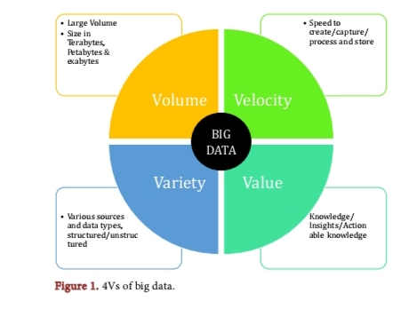unstructured

Data. The growth rate of data is incredible doubling each year. Velocity refers to the speed at which data from various sources generated and processed. Businesses are more into real-time processing as compared to delayed or batched processing. Gartner (2015) forecasted that 20.8 billion devices will be connected worldwide by 2020. Variety refers to several types of data, depending on the application system structured, semi-structured, and unstructured i.e. photo, audio, video, clickstream, and from sensors . Large volumes of big data bring many opportunities besides a handful of

Challenges; businesses are achieving better insights into their data customer, products, and processes. Data insights are enabling businesses for rapid innovation which are customer-centric, improved performance, better decision making, and keeping the competition on the run . The advancement in the technologies and data volumes has led to improvements in the functional capabilities of businesses, new avenues have been identified. New innovative and disruptive strategies are applied by businesses to break away from traditional approaches to redefine innovation, competition, and productivity. Business starting early with big data will defiantly have an added advantage.

Data is a critical component of business performance, as well as its advantage of decisions supported by data, which are better quality than its competition. Such decisions are more accurate. High-quality volumes of data is a very valuable asset, it is not only valuable and rare, and by the same token other business cannot reproduce it as well as there is no substitute to it, it can give businesses a sustained advantage. Many businesses are rushing to take advantage of big data to set up their strategy and competing on data. Big data insights are impacting nearly every aspect of our lives and society, including mobile services, retail, manufacturing, financial services, life sciences,and physical sciences . Businesses are always quick to take advantage of the latest tools (big data analytics) to innovate, successfully outperform the competition, and minimize the threat of new entrants. Big data has a similar power to transform our lives, as historically it is proved that information technology investment and innovations have enhanced competitive performance and productivity. Big data insights reveal many dimensions that were never explored before, businesses are learning how their products are used by the individuals, such interesting insights are guiding the beginning of new services and design guidelines for future products. Redistributed Manufacture (RDM) takes advantage of many factors like 3D printing, assistive manufacturing, and big data offering numerous benefits over the existing system. The supply chain landscape is rapidly changing to operate effectively and efficiently. Tech America Foundation’s Federal Big Data Commission in Executive Summary and Key Findings noted that Big Data has the potential to transform government and society itself. It further added Big Data as an opportunity for government agencies that seek to exploit it to enhance the business of government (TechAmerica Foundation’s Federal Big Data Commission, 2012). Obama White House on May 23, 2012, started the initiative Digital Government Strategy, among the three main objectives, Big Data was emphasized by highlighting that unlocking the power of government data to spur innovation across our Nation and improve the quality of services for the American people (Office of Management and Budget, The Executive Office of the President, n.d.). Research Method In the research presented here, the focus is on combining the most important “previously established studies and concepts” that I have identified in the academic literature based on which I provide a synthesis that “advances our understanding” . A comprehensive literature review on Big Data and its influence on innovation, competitive advantage, productivity, and decision support has created a theoretical basis for these papers. Using a literature review, models were developed and evaluated using existing available scholarly literature. Big data is a buzzword in today’s business world, businesses are looking for new ways to harness the data to innovate. The results of the review reveal that big data analytics have a mark on all four variables under discussion. The research methods used in this study follow the principles outlined by. It is a comprehensive literature review on big data. Over one hundred articles have been reviewed in relevant journals such as ELSEVIER, MIS Quarterly, ProQuest, Taylor & Francis, and others which created a theoretical foundation of the paper. The contribution of the study is intended to review and summarize the theoretical and empirical knowledge that should inspire new discussions and directions for further research activity Ways to Leverage the Big Data Big Data can be leveraged in many ways; however, the focus of this paper is to review innovation, competitive advantage, productivity, and decision making with Big Data. Figure 2,illustrates the research themes from the Big Data perspective, which are discussed in this paper.

2.Innovation

IBM Institute for Business Value in collaboration with the Economist Intelligence Unit conducted (2014 IBM Innovation Survey) a latent class cluster analysis of 341 respondents’ usage of big data and analytics tools for innovation. The analysis revealed organizations using big data and analytics within their innovation processes are 36 percent more likely to beat their competitors in terms of revenue growth and operating efficiency. Indeed, outperforming organizations are 23 percent more likely to use big data tools compared to others, and almost 79 percent more likely to use analytics tools (2014 IBM Innovation Survey, 2015). Big data analytic tools are a must to analyze big data, without tools big data is just the data and by the same token without big data analytic tools, there is no analysis. Big data and big data analytical tools together have good potential for innovation (Stubbs, 2014). For the sake of clarification, Invention is a unique, original creation, however; not necessarily innovations are completely new or novel many innovations are additions or improvements to existing products, processes, or knowledge. Big data insights are improving, exiting processes, products, and knowledge. By analyzing online reviews/customer feedback (Amazon, Best Buy, Walmart,etc.,) customer-driven design insights are enabling innovation. To start with product attributes are identified from online reviews. Based on insights various models are built to improve the existing products and services . Consumer opinion data is widely available from websites to social media. The usage of big data varies from business to business, well established businesses are leveraging big data to streamline processes, improve customer services, and create efficiencies. New businesses are thriving in the marketplace by offering new ways to collect, store, and analyze the data. Many startup businesses are identifying new ways to use sensors and capture the data they produce, to add value to existing products and services. 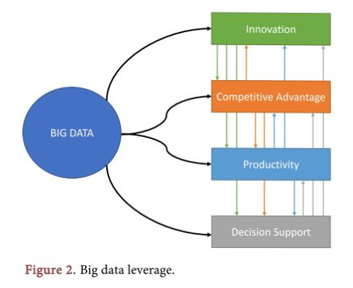The government can use big data as a more meaningful way to understand its citizens and bring smart solutions resulting in a smart nation and happy citizens.

The cost of storage is way down compared to the past, computing capabilities are expanding at a rapid pace, with an ease of access to services like Amazon Web Services aka AWS enabled companies to move in the direction of big data analytics. As businesses are transforming as a result of new insights, businesses are changing more innovative strategies.

To address how big data is leading the innovation is beyond the scope of this paper, Figure 3illustrates the sub-topics discussed in this paper. Henry David

Thoreau (an American essayist, poet, philosopher, abolitionist, naturalist) said “It’s not what you look at that matters, it’s what you see.”

2.1 Innovative Product and services

There are many sectors in which Big Data is making difference, a few to name are aerospace, biomedicine, Internet of Things (IoT), functional

Interactions

(human brain), clinical practices, education, vaccinology, social policy, and many more. Big data benefits are well understood in data-driven R&D, developing in goods (products) and services, data-driven processes, data-driven marketing, and developing new organizations i.e. data-driven organizations. The cost of data storage is very low. Business (private/public) small or large, government departments are moving or already moved their business online. The shift of social and economic activities to the Internet resulted in tremendous volumes of data generation … millions of gigabytes every second. To comprehend the volume, consider social networking site, according to CNN Facebook had 2.13 billion monthly active users around the world, as of December 31, 2017. The company estimates that it had an average of 1.4 billion daily active users, as of December 31, 2017. According to Pew Research national survey, 68% of adult Internet users used Facebook as of March 1, 2018 (Bullas, 2011; C.N.N. Library, 2018). Customer-centric products and services are very successful in the marketplace. Introducing a successful product or service feedback from stakeholders as well as consumers is a must. Unstructured data from social media, emails, research papers, tweets, news, help companies listen to their customers and stakeholders along with competitors. Insights from all the sources will help the business to incorporate customer feedback or customer preferences and

needs. At the same changes can be applied quickly to existing products and services (Glinska, 2016).

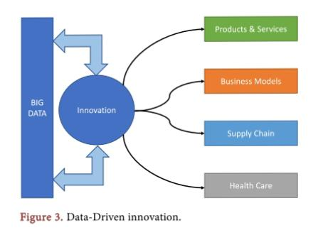Future innovations will be data-driven, data is a new source of growth. The

Internet of Things (IoT) is a growing future technology model intended as a global network of devices or machines with the capability to interact with each other. IoT is one of the most desirable future technology with rapid growth (Lee & Lee, 2015). The IoT is an environment in which applications and services are driven by data collected from devices. Devices act as sensors that interface with the real world. The predictions are the IoT is soon to be part of everybody’s life. Future innovations and growth are data-driven, the innovations in the ecosystem of IoT will touch almost every sector like health, education, agriculture, transportations, manufacturing, smart grids, and domestic home applications (OECD Science, Technology and Industry Scoreboard 2017 | READ Online, 2017). With the growth of big data analytics, consumer analytics got maximum focus, data stored in repositories and real-time data on consumers, helped businesses to better understand their consumers, engage in various marketing activities, have better insights on the next generation of products and services. Davenport et al. (2012) in the MIT Sloan management review said that big

Data is much more than that. Indeed, companies that learn to take advantage of big data will use real-time information from sensors, radio frequency identification, and other identifying devices to under their environments at a more granular level, to create new products and services.

2.2 Business Model Transformation

Business models are often seen as an intermediately between a company’s strategy and its business processes (Morris, Schindehutte, & Allen, 2005). Big data insights are enabling businesses to innovate business processes and

Rethink business models and come up with new strategies. Figure 4 ,highlights how strategy is transformed into a business model and then further down into a business process model. Companies like GE and Siemens not only selling their electric grids and medical equipment but also their customers beyond regular

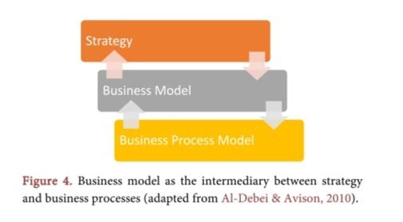

Annual maintenances on how to add value, improved efficiencies applying analytics on data collected from these devices. Uber and many others are great examples of how mobile devices, cloud technology, and data analytics have disrupted the cab industry all around the world. Big data-driven business models are creating new markets, new strategic and economic perspectives. Data is at the heart of the core logic of business model innovation (Cheah & Wang, 2017). Information driven business models are making their impact on all the domains of various business models. Businesses can aggregate the manufacturing floor data and can combine it with the supply chain for manufacturing customers and sells software tools to improve the performance (McGuire, Manyika, & Chui, 2012). According to the 2014 IBM Innovation Survey 341 respondents, 79% said they

Are leveraging data and analytic tools to create new business models. Big data analytics help create data transparency, in promoting innovative business models (Tan et al., 2017). We are living in a data era; the data revolution is impacting every aspect of society and people’s lives. The success of businesses is no longer just dependent on the latest technologies but on identifying a new way of doing business based on the data insights. Constantly learning and applying radical customizations, experimentation, and changing business models are the name of the game (Jiang & Chai, 2016). With the growth of big data insights, the firm centric view of business models

Is needed to transit to new data-driven models, of course, it is easy to say but have huge challenges in the transition, advancing technologies and rate of adoption of these technologies are overturning old-style business models (Bankvall, Dubois, & Lind, 2017). Amazon’s online bookstore is an excellent model of precision marketing using BDA (Guo & Guan, 2015).

2.3 Supply Chain Improvements

Kumar et al. (2016) discussed that Big data has the potential to revolutionize the art of supply chain design. Big data insights are taking the supply chain to the next level. Plant operations generate huge volumes of data, big data analytics can be applied resulting better understanding of current operations compared to baseline or most optimal range for a system or piece of equipment. The proactive approach minimizes the disruptions or equipment failures, resulting in overall improved operation. Emerging supply chain solutions bundled with big data and intelligent manufacturing is the future, businesses are modernizing (Ramsey, 2014). The analysis of data collected from various sources during manufacturing and applying big data analytics deliver actionable insights. Lamba and Singh (2017) in their research paper highlights that the properties

Of big data can be utilized to gain critical and fundamental insights towards optimizing the operations and supply chain. Big data has significantly important in process improvement, managing logistics, inventory management, and cost optimization. Data gathered from the production floor of factories is increasingly growing, data is flowing from all the various sources. However, the nature of such datasets is complex, traditional data processing applications are not sufficient enough to process them. Big data analytics have played a transformational role in reducing production problems, reducing waste. Predictive manufacturing and maintenance are increasingly becoming popular. Advances in big data analytics have led to the development of new supply

Chain methods and techniques for the value-added solution. For example, the bullwhip effect in the supply chain which refers to a swing in inventories in response to customer demand creates supply chain inefficiencies discussed the potential of big data on the improvement of various processes, and to mitigate the effect of bullwhip as big data “velocity” bears the greatest potential to enhance performance by operationalizing the big data in control engineering analyses.

* 1. Health Care Transformation

The health care sector is one the largest producer of data from simple office visits to complex treatments, from simple blood-work of the lab to complex MRI data, the volume is huge. Improving quality care and offering efficiency in the health care delivery system, combining patient data with practitioner data will be critical . Big data analytics can generate new knowledge by analyzing the huge volumes

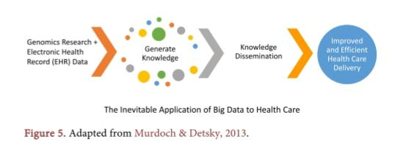Of patient data. Once new knowledge is generated, insights can be delivered directly to practitioners using big data, resulting in improved and efficient health care delivery.Figure5 , attempts to illustrate the process of gathering data, generating knowledge, and distributing knowledge for better patient outcomes.

A well-working example of the above model can be studied in Israel. In Israel,

Every citizen is entitled to a wide-range of health-care services. Health-care services are provided by 4 non-profit national health services and insurance funds. Early 1990’s these providers started working on the integration of their health records in their clinics. Data repositories served as a platform for data-driven innovation and quickly translated into practice. Data repositories enabled a unique opportunity as test grounds for new data-driven care models. Israel is an early adopter of big data analytics, telemedicine, and online patient engagement . Big data analytics will have a significant role to play across the health-care

Field, although health-care is not at the forefront of big data analytics. suggested how predictive analytics can be used in health care. Some of suggestions are to use predictive analytics for identifying and manage six use cases which are high-cost patients, readmissions, triage, decompensations (when a patient’s condition worsens), adverse events, and treatment of optimization for a disease affecting multiple organ systems. Past few years affordable health care law has enforced health-care providers to implement Electronic Health Record (HER), and data volume has increased. Big data analytics can be applied to improve quality and efficiency. Affordable care act encourages accountable care, stakes are high for clinics, insurers, purchasers, and patients to collect, analyze and exchange health-care information to eliminate waste and learn better treatments without harming patients wrote in his research paper that the combination of a strong epidemiologic foundation (relating to the branch of medicine which deals with the incidence, distribution, and control of diseases), robust knowledge integration, principles of evidence-based medicine (EBM) (is the conscientious, explicit, judicious and reasonable use of modern, best evidence in making decisions about the care of individual patients), and an expanded translation research agenda can put Big Data on the right course.