Payroll Clarity PRD
Charu Gupta · 8 October 2026 · All examples are illustrative

Problem
After a customer submits payroll inputs, they have almost no visibility until pay day. They can’t tell if payroll is on track, whether anything needs them, or when it will be final. Most errors start as input problems that were knowable days earlier, but surface only after an employee is paid wrongly, usually as a support ticket.
Three problems carry most of the risk: knowing what is due and by when, getting inputs in, where errors enter, and reviewing before approval, where they slip through.
Goal: catch issues as data arrives and route each one to the person who can fix it, before input finalisation.

Assumptions and scope
- The customer is fully onboarded: entities, pay schedules, country rules and the payroll calendar are configured. Existing employees are already in the system.
- Input channels already work: the HR tool connector, document attachments in the HR tool, and employee self-service for time off and expenses.
- New joiners still arrive every cycle and their data may be incomplete. Connectors can still fail during a cycle, so connector health is in scope.
- V1 covers 4 countries on a standard monthly calendar: India, UK, Germany and Brazil. Off-calendar countries (for example semi-monthly pay in the Philippines) are out of scope.
- Monthly cycle: input finalisation Oct 15 for every input, including new joiners, bonuses and changes. Approval Oct 22, funding Oct 23, pay date Oct 28. Dates move for holidays and weekends.
- The customer’s HR tool can show an embedded Payroll tab; where it can’t, the same views run in Multiplier’s own dashboard.
- V1 is desktop web only; a mobile experience comes in V2.
- An employee with no changes this cycle is paid on their last approved data.
- Pay amounts always come from the payroll engine. AI may read documents, explain or flag, never decide a number.
- Out of scope: customer onboarding, connector setup, payroll calculations and payments.

Users
User | Who they are and their day-to-day | Main question | Pain points
Customer HR / payroll admin | HR generalist or People Ops lead at a 50–500 person company, often owning both HR and payroll. Onboards and offboards employees, collects changes from managers, keeps the HR tool up to date, submits payroll inputs and approves the register each month. | Is anything wrong, and what must I fix by when? | No status after submitting; learns about errors from employees. Turns scattered documents into inputs by hand, against a cutoff. Different cutoffs and rules per country. Reviews the register line by line; tedious in busy months, so wrong details get approved.
Customer finance | Finance manager or controller. Plans headcount budgets, pays the payroll invoice, reconciles payroll to the books. | How much must I fund, by when, and why did it change? | Surprise invoices and unexplained cost changes. Currency moves change the total. Late funding found at the last minute.
Employees | Staff paid through Multiplier in their own country. Submit time off and expenses, check payslips, rely on pay arriving on time. | Will I be paid correctly and on time? | Find errors only on pay day. Chase HR for answers. Wait for a fix in the next cycle or an off-cycle payment.
Multiplier payroll specialists | In-country payroll experts. Validate inputs, run gross-to-net, apply country rules, file statutory returns. | Which customers are at risk this cycle? | Chase customers manually for missing data. Find problems close to cutoff. Corrections add work and filing changes.
Multiplier support / CSM | Support agents and account managers handling payroll questions and the customer relationship. | Why is this customer unhappy, and how do I fix it? | Tickets arrive after the damage is done. No shared view of a customer’s cycle. Time spent on avoidable “where is my payroll” questions.
Stakeholders: inside Multiplier, Foundations (connectors, notifications, compliance engine), Core Experiences (Clarity, onboarding), payroll operations, support and legal. Outside, the HR and benefits tools that hold source data, payment partners and tax authorities.

User journey
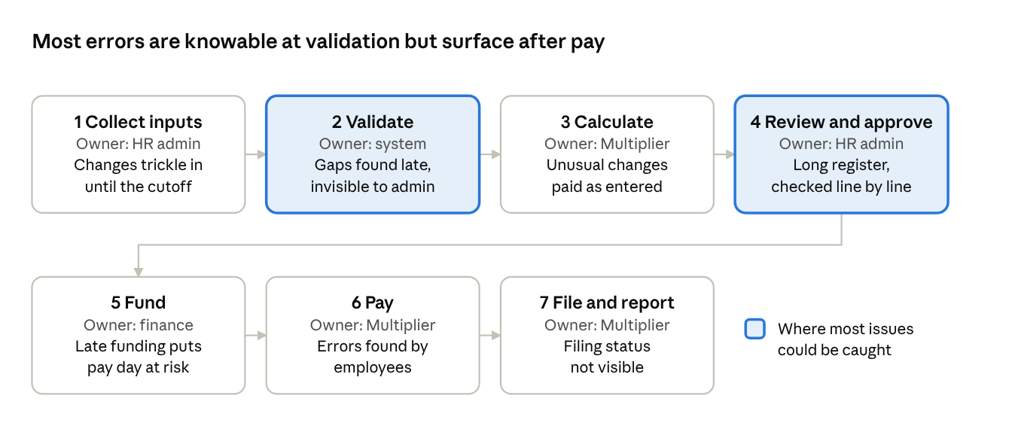
Validation and review are where most issues could be caught. Today, problems found there are invisible to the admin until it is too late.

Core problem 1: knowing what is due, and by when
Each step of the cycle has its own deadline, and the admin has to remember all of them across countries, every month, alongside their day job. Nothing tells them what is due next.
Action | Deadline | If missed
Add new joiners with complete data | Input finalisation (Oct 15) | Joiner paid next month, or through an off-cycle payment
Submit and ratify changes (raises, bonuses, amendments) | Input finalisation (Oct 15) | Change moves to next cycle or an off-cycle run
Fix flagged errors | Input finalisation (Oct 15) | Affected employees held or paid on old data
Review and approve the register | Approval (Oct 22) | Run is delayed
Add funds against the invoice | Funding (Oct 23), finance | Pay day at risk for everyone
What good looks like: an action list ordered by deadline, and email reminders before each one (Slack in V2), sent even before the admin opens the tool.

Core problem 2: getting inputs in
Inputs are entered as changes, not one line per employee. They arrive in five ways:
How | What goes in | What the admin does | Typical use
HR tool connector | Changes sync as they’re made in the HR tool | Updates the HR tool as usual | Leavers, salary and job changes
Documents attached in the HR tool | Offer letters and bonus letters, read by Multiplier | Adds the employee in the HR tool and attaches the letter | New joiners, one-off bonuses
Bulk upload | Spreadsheet template, one row per change | Fills it from an appraisal sheet and uploads | Appraisal month, commissions
Manual entry | A form per employee per change | Opens the record and enters the item | Corrections, allowances
Self-service | Time off and expenses, approved by managers | Usually nothing | Leave, expenses, overtime
Much of this starts as raw documents (offer letters, bonus letters, appraisal sheets, email approvals) that the admin turns into structured inputs by hand.
Where errors enter: missing data in documents, copy-paste mistakes in uploads, bonuses entered as base salary, unmapped fields in connectors, approvals after cutoff.
What good looks like: read documents automatically, map them to payroll fields, validate at the moment of input, and tell the admin straight away whether the change makes this month’s payroll.

Core problem 3: reviewing before approval
The payroll register has one line per employee, each with 10–20 fields. In an appraisal month at a 5,000-employee company:
Reason a line changed | Share | Lines
Salary changes | 10% | 500
Joiners and leavers | 2–4% | 100–200
Bonuses, commissions, overtime | 5–10% | 250–500
Unpaid leave, expenses, allowances | 5–10% | 250–500
Lines with some change |  | ~1,100–1,700
At 1–2 minutes a line, that’s 20–40 hours of review in the days before approval. The admin checks the register against five to ten scattered sources in Excel: last month’s register, HR records and contracts, appraisal sheets, bonus files, joiner and leaver lists, leave and expense tools, benefits, budget and approval emails. Wrong details get missed and approved; the most dangerous have no matching source at all.
What good looks like: exception-first review. Match each change to its source automatically and show only lines with no matching source or an unexpected difference: roughly 20–50 lines instead of 1,100+.

Solution and V1 scope
V1 is a Payroll tab inside the customer’s HR tool, built on a shared issue model. Validation runs as data arrives; every issue has a severity, owner, affected employees and deadline; routing tells the right person before each deadline.
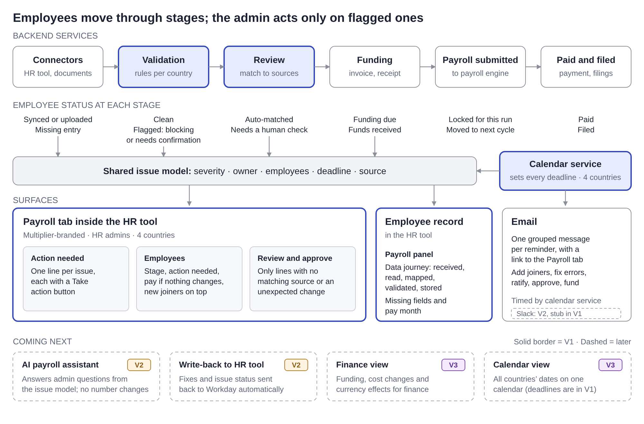
Flowdiagram
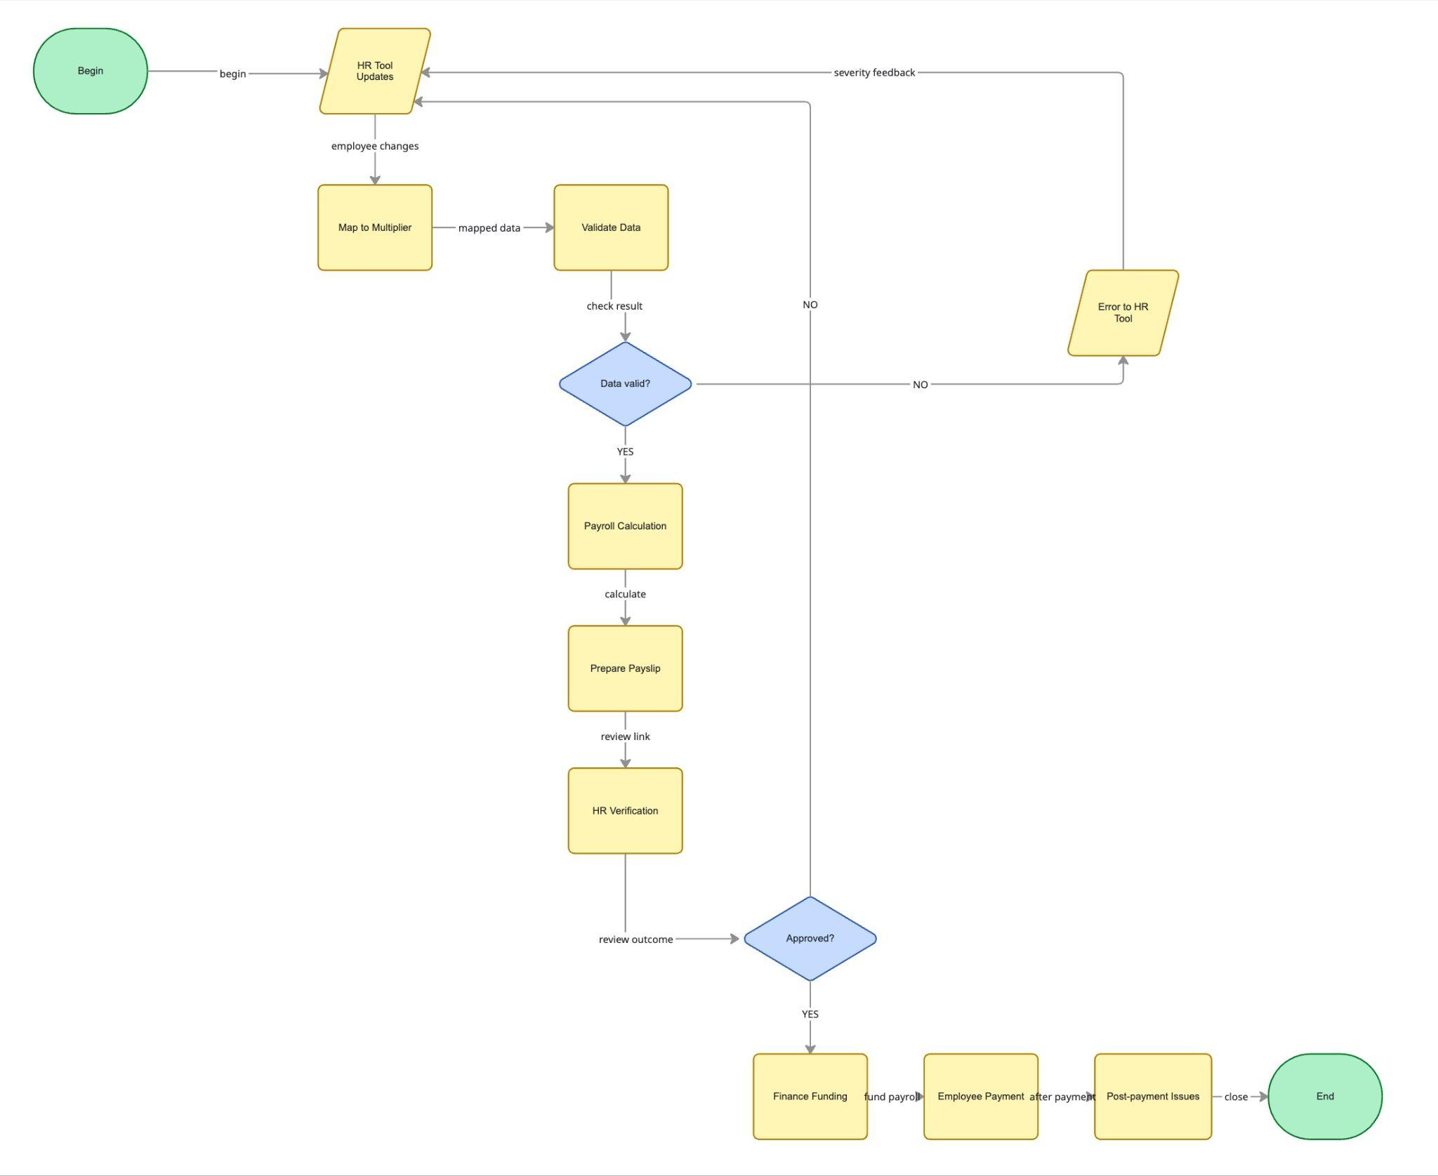

Surfaces
Payroll tab in the HR tool. Multiplier-branded, under Payroll in whichever HR tool the customer uses. HR admins only. 4 countries.
View | What it shows
Overview | One status line, the stage tracker, country status and an “Up next” list ordered by deadline
Action needed | Flagged errors and missing entries: why, impact, owner, fix-by date, and a fix link to the source
Employees | Every employee’s stage and whether action is needed; for unchanged employees, what they will be paid. New employees at the top with the date added
Review and approve | Changed lines, lines matched to a source, and only the lines that need a human check
Payroll panel on the employee record in the HR tool. Data enters where the admin already works: People › Add employee, or an existing employee’s profile. Because Multiplier is connected, a Multiplier-branded Payroll panel on that record shows the data journey for a new joiner or bonus: received, document read, fields mapped, validated, stored, with the mapping table, missing fields and the pay month. The Payroll tab’s Employees view links to it.
Email reminders: add new joiners, fix flagged errors, ratify changes, review and approve, add funds (to finance). Each is timed by the calendar service and escalates as the deadline gets closer.
Where action happens
Channel | How issues appear | What the admin can do
Payroll tab | One line per issue, each with its own owner, deadline and a Take action button | Fix the issue there, or follow the link to the source (for example Workday)
Email | Issues grouped into one message per reminder (for example “4 actions due before Oct 15”), each listed briefly | Nothing is fixed in the message; one link opens the Payroll tab
Info icon on each issue | Placeholder in this release: shows “Guided steps coming soon” | Guided, step-by-step help to fix the issue comes in V2 with the AI assistant

Data journey for a new joiner or bonus
The admin adds the employee in the HR tool and attaches the offer letter (or attaches a bonus letter to an existing employee). This happens outside the Payroll tab; Multiplier receives it through the connector and shows the result on the employee’s record in the HR tool. Multiplier then:
- Receives the new record and attachment through the connector
- Reads the document and extracts start date, salary, currency and role, each with a confidence level
- Maps fields from the HR tool and the document to Multiplier’s payroll fields
- Validates required fields for the country and compares the date added with input finalisation
- Stores the record in the right cycle and flags what is missing
Pay timing rule shown on the employee row
Situation | Flag
Added before Oct 15, all required fields present | Paid in October payroll
Added before Oct 15, data missing | Missing PAN and bank details; fix by Oct 15 to be paid in October, otherwise November
Added after Oct 15 | Added after cutoff; paid in November, or request an off-cycle payment

Architecture: stage-based services
Service | What it does | Employee status it sets
Calendar | Holds each country’s dates and sets the deadline on every issue | None
Connectors | Pulls records, changes and attachments from the HR tool | Received; missing entry
Validation | Reads documents, maps fields, applies per-country rules | Clean; flagged as blocking or needs confirmation
Review | Matches each change to its source | Auto-matched; needs a human check
Funding | Tracks the invoice and payment | Funding due; funds received
Payroll submitted | Locks inputs and hands them to the payroll engine | This run; next cycle
Paid and filed | Confirms payment and statutory filings | Paid; filed

Roadmap
Area | Version | Why
Payroll tab: overview, action needed, employees, review; Payroll panel with the data journey on the HR tool’s employee record | V1 | Answers what’s due, what needs me, what happens if I do nothing
Calendar service (backend), email reminders | V1 | Every deadline and reminder depends on it
Mobile experience | V2 | V1 is desktop web only; admins do payroll work at a desk, and email reminders already reach them on mobile
Slack reminders | V2, stub in V1 | Same grouped message as email; shown as a disabled option in the prototype
Document reading and field mapping for offer and bonus letters | V1 | Removes manual typing, the main source of input errors
AI explanation for unusual changes | V1, one case | Prove trust first; numbers stay deterministic
AI payroll assistant | V2 | Answers admin questions from the same issue model
Write-back to the HR tool | V2 | Fixes and issue status sent back automatically
Finance view | V3 | Funding, cost changes and currency for finance
Calendar view on screen | V3 | Deadlines already show in the action list and reminders
Guided fix steps (info icon on each issue) | V3, placeholder in V1 | Builds on the AI assistant once it is proven
Alternatives considered
Option | Decision | Reason
Notifications only | Rejected | Fixes alerts, not confidence
Standalone Multiplier dashboard as the main surface | Rejected as default | The admin lives in the HR tool; a separate login is easy to forget
Hold the whole payroll until every issue is fixed | Rejected | Punishes everyone for one missing tax ID
Payroll tab in the HR tool on a shared issue model | Chosen | Meets the admin where they work; every later surface reuses the model

How issues reach the right person
Issue | Severity | Owner | First alert | Escalation
Missing tax ID or bank details | Blocking, that employee only | HR admin | In-app and email with a link to the Payroll tab | Daily reminder; 2 days before cutoff, backup admin and payroll specialist
Inputs not submitted for a country | Deadline risk, that country | Country HR owner | Email and countdown, 3 days before cutoff | Day before: escalation email to owner and admin
Unusual change (salary up 3x) | Needs confirmation | HR admin | In-app with a plain-language explanation | Email if unconfirmed by cutoff; paid only after confirmation
Added after cutoff | Moves to next cycle | HR admin | Flag on the employee row | Option to request an off-cycle payment
Funding not received | Blocking risk, whole run | Finance | Email; status visible to admin | Past due: finance, admin and account manager
Rules: one owner per issue; reminders group issues into one message and link to the Payroll tab, where each issue is fixed with its own Take action button; never hold the whole payroll, only the affected employees; interrupt only for blocking issues, digest the rest; fix links point to the source; every decision is logged.

Metrics
North star: % of employees paid correctly and on time, with no correction needed afterwards (counted 30 days after pay day). Payments can’t be rolled back, so a later correction counts as a failure.
Type | Metric
Input | % of inputs clean at submission
Input | % of issues resolved before input finalisation
Input | % of issues detected at data arrival rather than at calculation
Input | Median time from detection to resolution
Input | % of cycles funded on time
Customer view | % of payroll runs with zero issues reaching employees
Guardrail | On-time payroll rate; employees held unnecessarily; alerts ignored
A metric that can mislead: fewer support tickets can mean admins gave up. Read it alongside corrections.

Prototype and demo
Simulated, not built: the connector, document reading, field mapping and database return fixed results. Data lives in the page and resets on refresh. The HR tool is a mock. A prototype date control (Oct 12, 13, 14, 17, 22) shows how the screens change.
Scene | Date | What is shown | Point
1 | Oct 12 | Reminder email, then the Overview: 4 actions before Oct 15 | Reminders reach the admin first
2 | Oct 12 | Fix Lena’s missing tax ID; count drops to 3 | Hold one employee, not the run
3 | Oct 12 | Confirm James’s salary change with the AI explanation | AI explains, the human decides
4 | Oct 13 | Add Priya in the HR tool with her offer letter; see her row and data journey with PAN and bank details missing | Documents read, mapped and validated on arrival
5 | Oct 13 | Attach James’s bonus letter; saved as a one-off | Bonus no longer entered as salary
6 | Oct 17 | Add Arjun after the cutoff; flagged “paid in November” | Pay timing is clear immediately
7 | Oct 22 | Review: 38 changed, 32 matched, 6 to check; approve | Exception-first review
User stories and expected output
Story | Expected output
As an HR admin, I get reminders before each deadline | Oct 12 email lists 4 actions; Oct 14 escalation for Brazil; funding reminder goes to finance
I see what’s due on one screen | Status “4 actions need you before Oct 15”; “Up next” sorted by deadline
I fix a blocking issue quickly | Only Lena held; after the fix, count drops to 3 and Germany turns on track
I add a new joiner from an offer letter | Priya appears at the top, added Oct 13; data journey shows mapped fields and missing PAN and bank details
I add a bonus from a bonus letter | James shows “Bonus £8,000 (one-off) · October”; salary flag resolved
I know at once if something missed the cutoff | Arjun, added Oct 17, flagged “paid in November” with an off-cycle option
I see what unchanged employees will be paid | “Will be paid ₹X, same as September”
I review only what needs me | 6 lines to check; approve disabled until blocking items are resolved
Demo data: 120 employees (India 50, UK 30, Germany 22, Brazil 18); issues for Lena Fischer (Germany), James Patel (UK), Brazil inputs and India joiners; offer letters for Priya Nair and Arjun Mehta; a bonus letter for James Patel; 38 review lines; 5 reminder emails.

Open questions
- What share of payroll errors starts as input data versus calculation?
- Which issue types drive the most payroll support tickets?
- Does the Clarity initiative already define a shared issue or task model?
- Which channel do admins prefer for urgent alerts: email, Slack or in-app?

