Base Infrastructure Creation

Successful deployment of VPC, Aurora Postgres Serverless, and S3 bucket using Terraform | 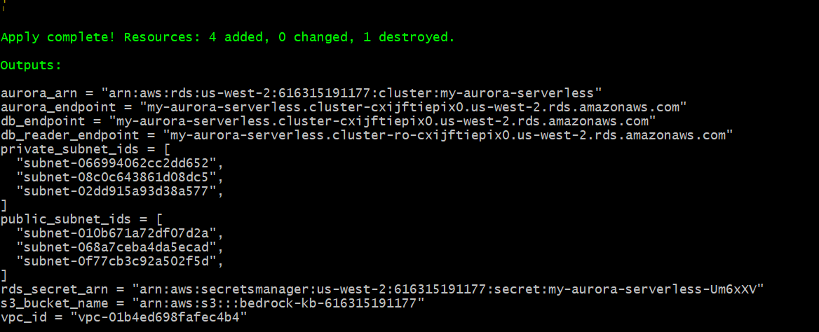  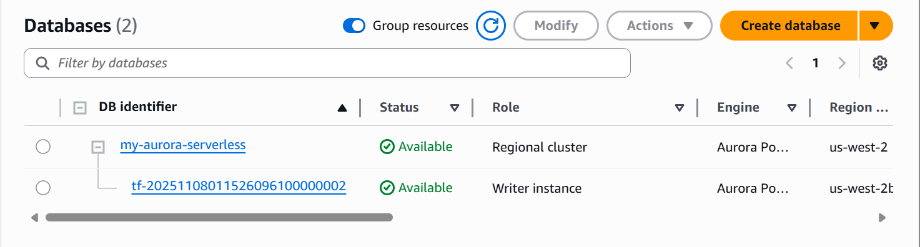  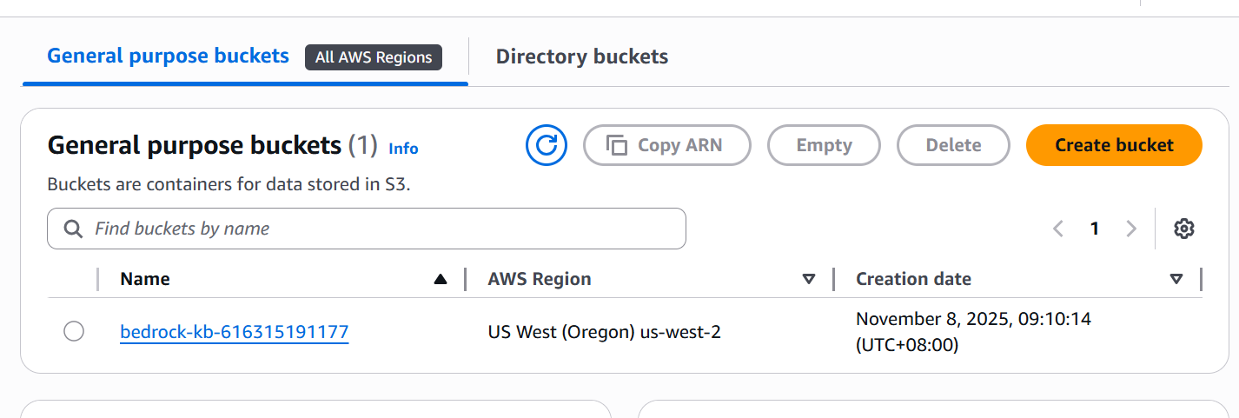  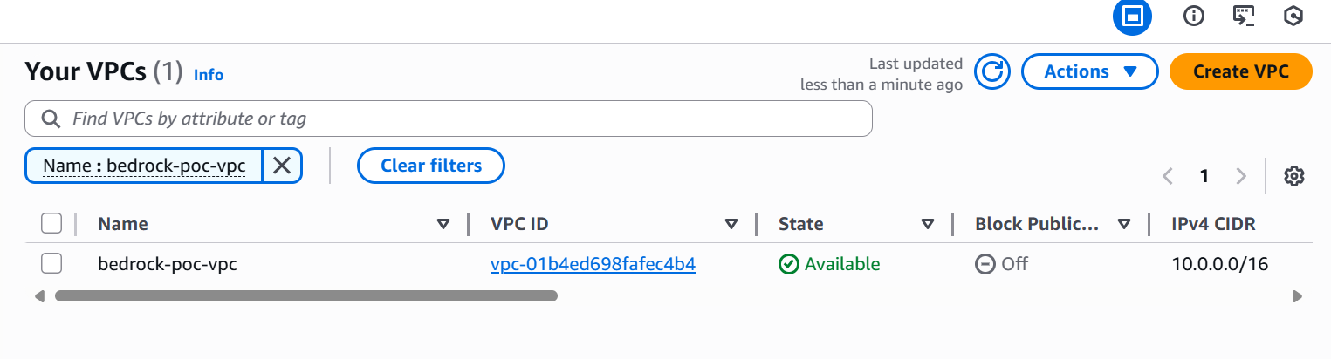
Proper configuration and security settings | 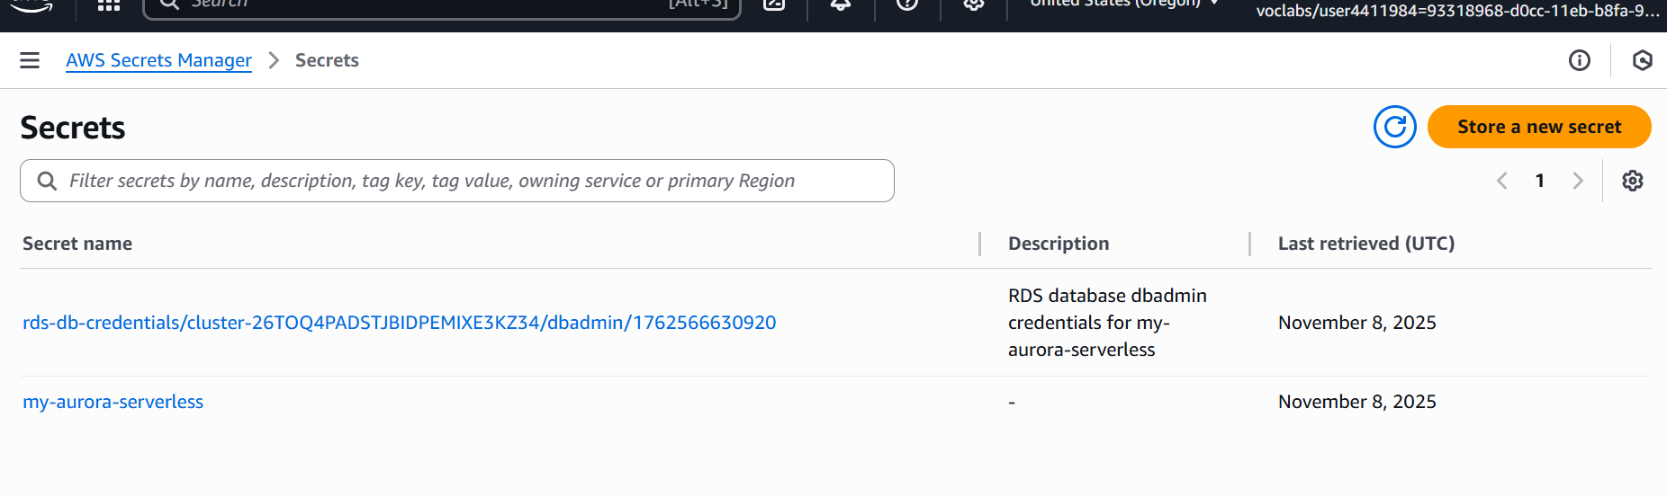
Database properly configured for vector storage. | 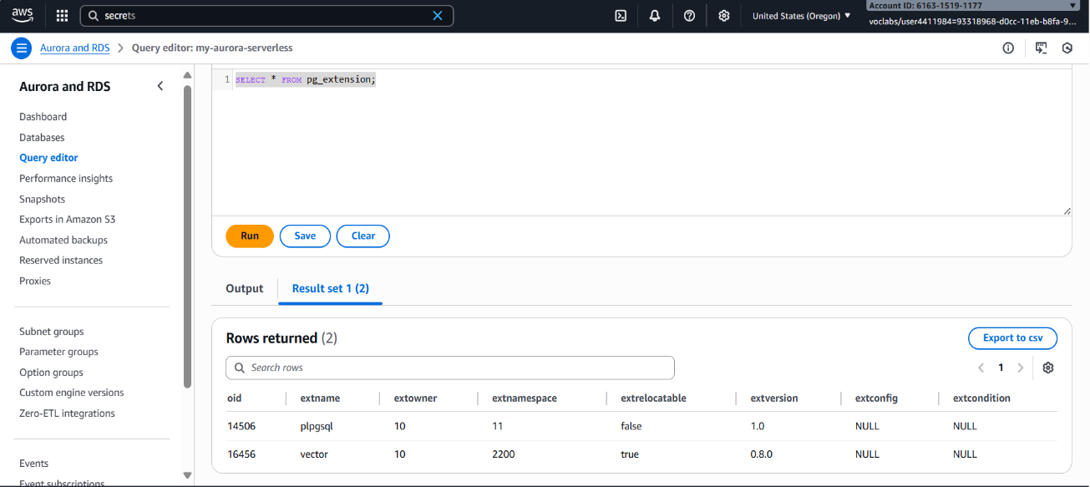  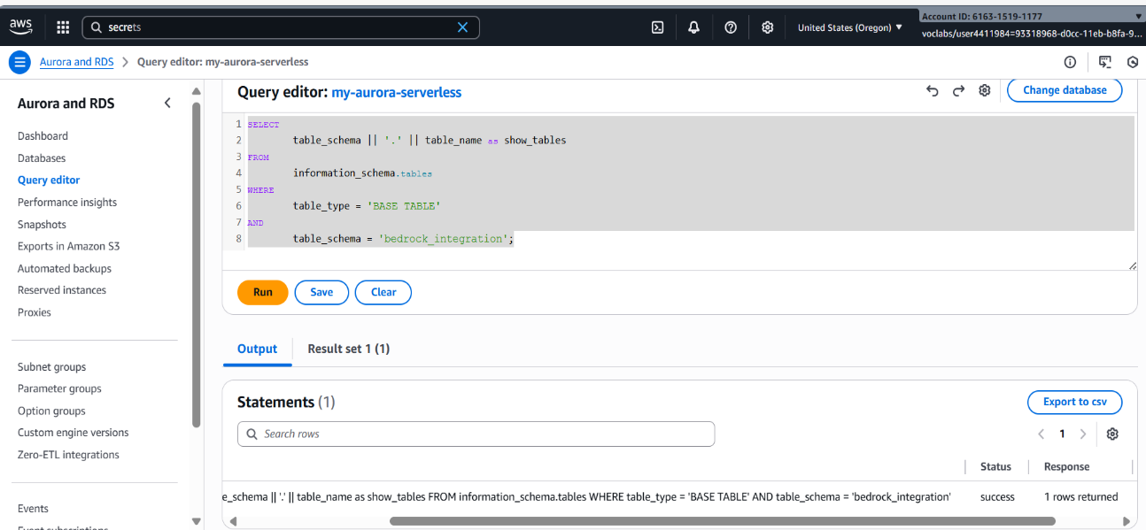  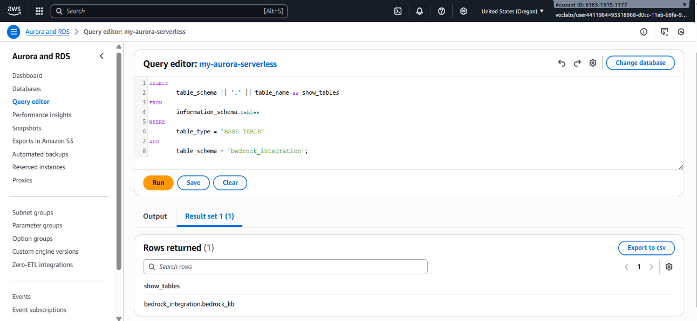  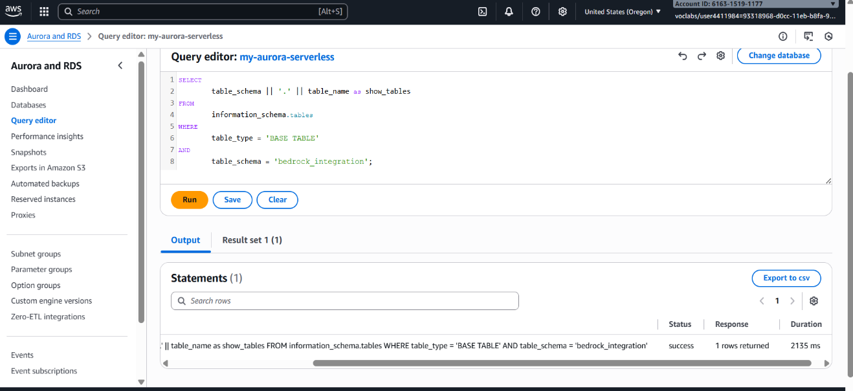 | Proper configuration and security settings | 

Knowledge Base Deployment and Data Sync

Knowledge base successfully deployed | 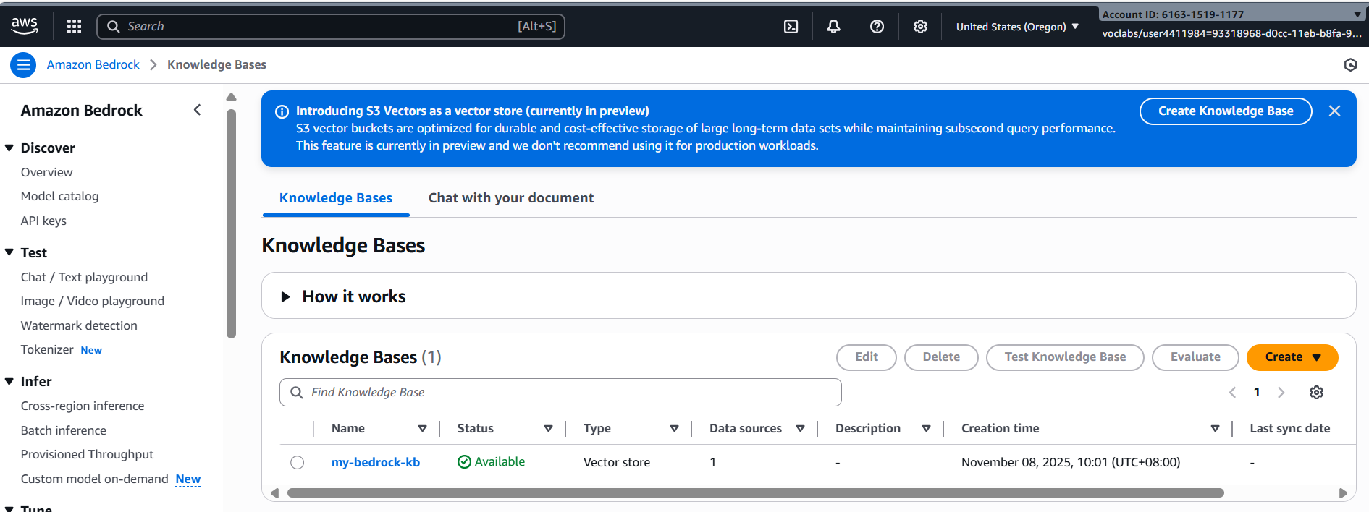
Data from S3 bucket correctly synchronized | 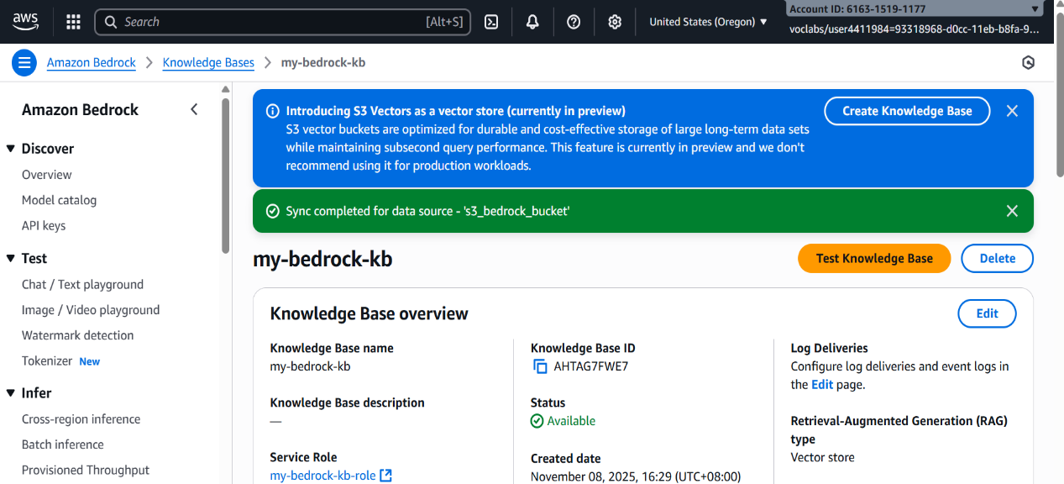  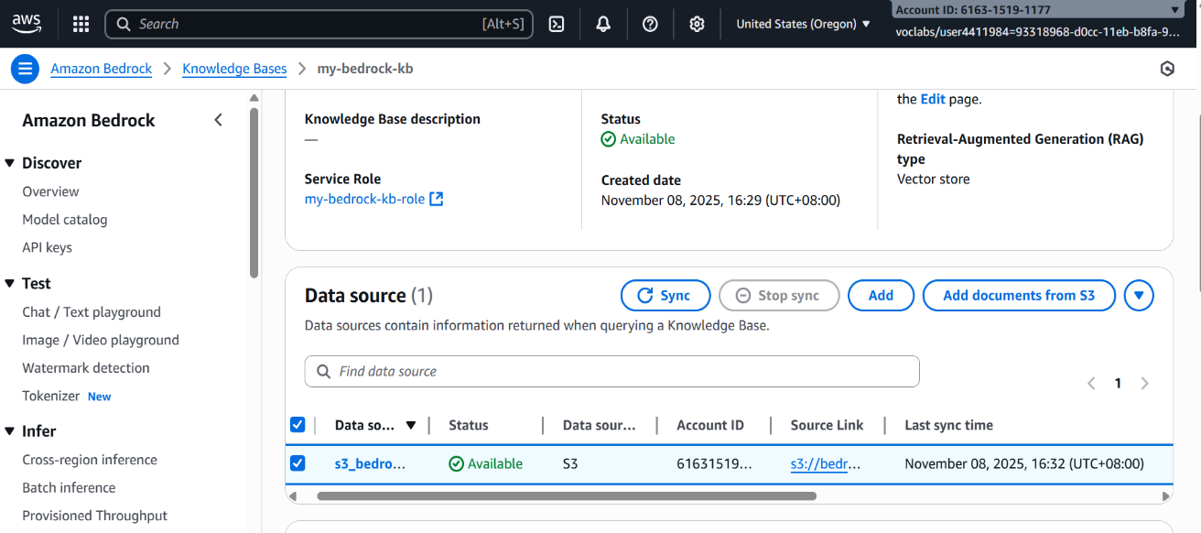  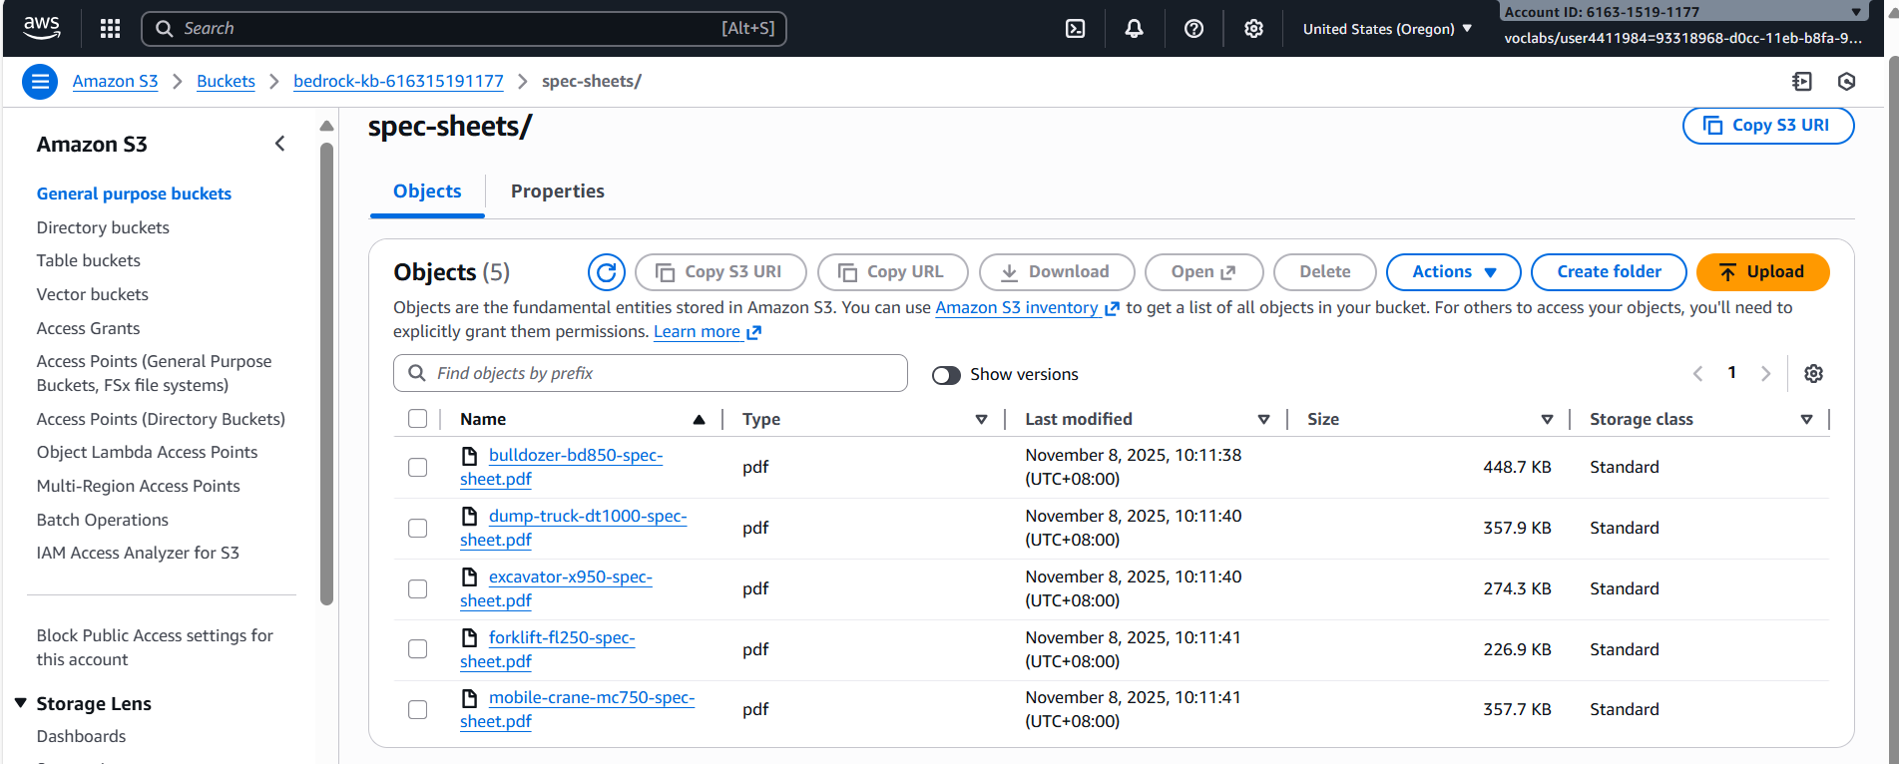

Python Integration with Bedrock

Python function implemented to query the knowledge base | 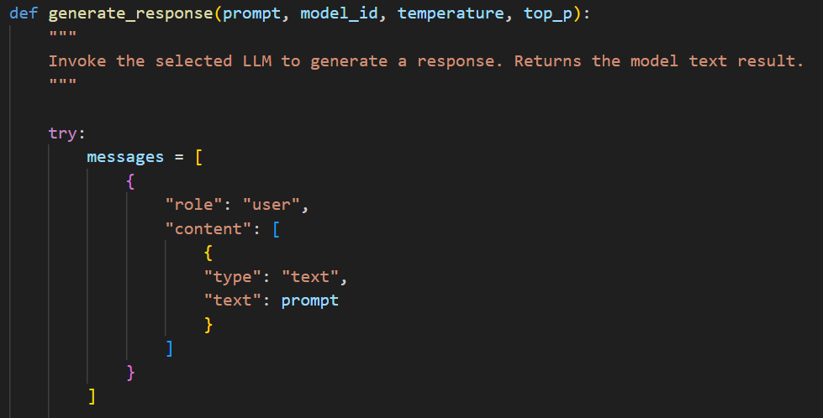
Successful invocation of the model in bedrock_utils.py | 
Correct implementation of valid_prompt function in bedrock_utils.py | 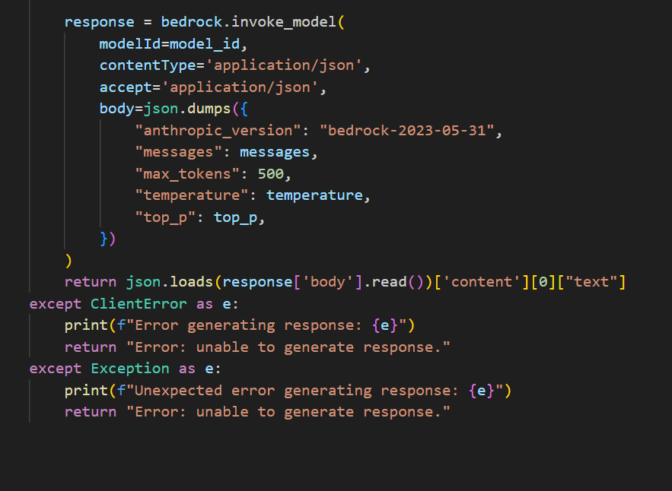

Model Parameters

Clear and accurate explanation of how temperature and top_p affect AI responses | Temperature and top_p are parameters that control randomness in AI-generated responses.  Temperature adjusts how likely the model is to pick fewer probable words. A low temperature (close to 0) makes responses more deterministic, focusing on the most likely words, while a high temperature (closer to 1 or above) increases variability and creativity, sometimes at the cost of accuracy or coherence.
 | Top_p (nucleus sampling) sets a probability threshold. Instead of choosing from all possible words, the model only considers the smallest group of words whose combined probability exceeds p. For example, with top_p = 0.9, the model samples only from the top 90% of the probability mass. Lower values restrict the choice to highly likely words, producing safer and more focused text, while higher values allow more variety. Used together, temperature and top_p let you balance creativity and reliability in model outputs.

