EXPERIMENT -1

AIM: Create a program in to demonstrate geometric transformation - image rotation, scaling and translation in python.
THEORY:
Geometric transformations are fundamental operations in the field of computer graphics and digital image processing. These transformations are used to modify the spatial properties of an image such as its position, size, and orientation. They are widely applied in image editing software, computer vision systems, medical imaging, satellite image analysis, pattern recognition, and animation. In this experiment, three basic geometric transformations-translation, scaling, and rotation are studied and implemented using Python.
Translation:
Translation is a geometric transformation that shifts an image from one location to another along the horizontal (x-axis) and vertical (y-axis) directions. During translation, the shape, size, and orientation of the image remain unchanged; only its position is altered. Each pixel of the image is moved by a fixed distance specified by translation parameters $t_{x}$and $t_{y}$. Translation is commonly used in image alignment, object tracking, and motion analysis. Mathematically, translation is represented using an affine transformation matrix that adds a constant offset to the pixel coordinates.
Scaling:
Scaling is the process of resizing an image by increasing or decreasing its dimensions. It is achieved by multiplying the original pixel coordinates by scaling factors along the x and y directions. When the scaling factor is greater than one, the image is enlarged, and when it is less than one, the image is reduced in size. Uniform scaling maintains the aspect ratio of the image, while non-uniform scaling may distort it. Scaling is an important operation in image zooming, resolution adjustment, and feature extraction applications.
Rotation:
Rotation is a transformation that rotates an image by a specified angle around a fixed point, usually the center of the image. The rotation angle determines the degree and direction of rotation. Rotation changes the orientation of the image while preserving its shape and size. This transformation is extensively used in object recognition, image registration, and pattern matching. Rotation is mathematically performed using trigonometric functions such as sine and cosine arranged in a rotation matrix.
SOURCE CODE:
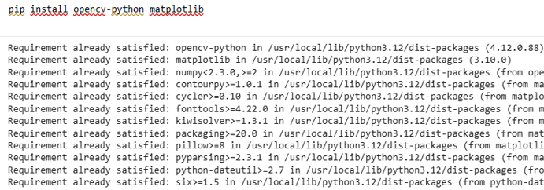
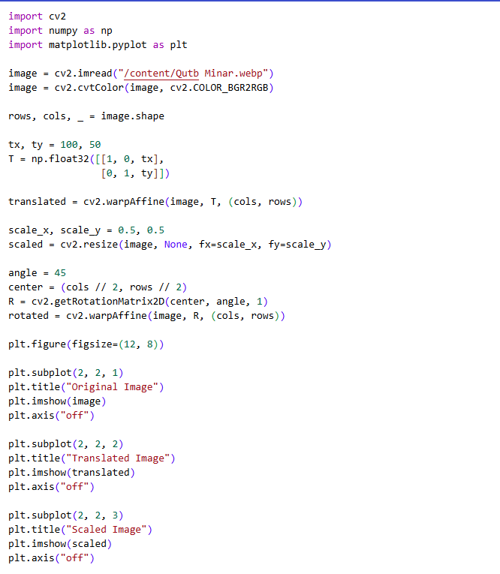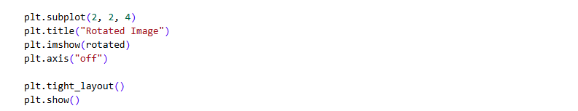

OUTPUT:
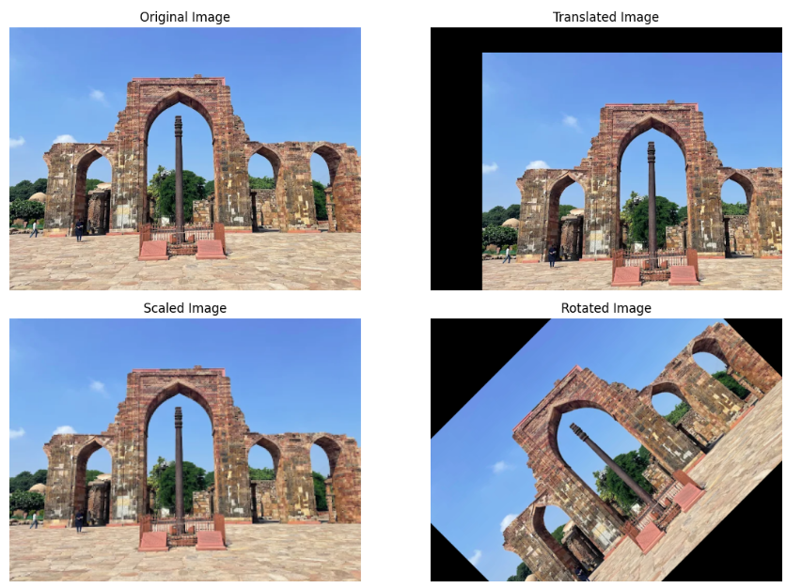

LEARNING OUTCOME:

EXPERIMENT -2

AIM: Computation of Mean, Standard Deviation, Correlation coefficient of the given image.
THEORY:
A digital color image is made up of pixels, and each pixel contains three color components: Red (R), Green (G), and Blue (B). Statistical measures such as mean, standard deviation, and correlation coefficient are used to analyze the brightness, contrast, and relationship between color channels in an image.
1. Mean (Average Intensity)
The mean is the average value of pixel intensities in a color channel. It represents the overall brightness of the image.
$$μ=\frac{1}{N}∑x_{i}$$
- Higher mean → brighter image
- Lower mean → darker image
- Calculated separately for R, G, and B channels

2. Standard Deviation (Contrast Measure)
The standard deviation measures how much the pixel values vary from the mean. It indicates the contrast of the image.
$$σ=\sqrt{\frac{1}{N}∑(x_{i}-μ)^{2}}$$
- Higher standard deviation → higher contrast
- Lower standard deviation → smoother or low-contrast image

3. Correlation Coefficient (Channel Relationship)
The correlation coefficient measures the relationship between two color channels (R–G, R–B, G–B).
$$r=\frac{∑(x_{i}-μ_{X})(y_{i}-μ_{Y})}{\sqrt{∑(x_{i}-μ_{X})^{2}∑(y_{i}-μ_{Y})^{2}}}$$
- $r=+1$→ strong positive correlation
- $r=0$→ no correlation
- $r=-1$→ strong negative correlation

SOURCE CODE:
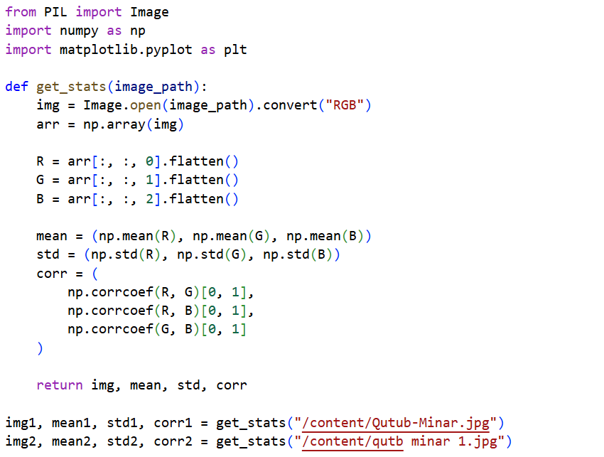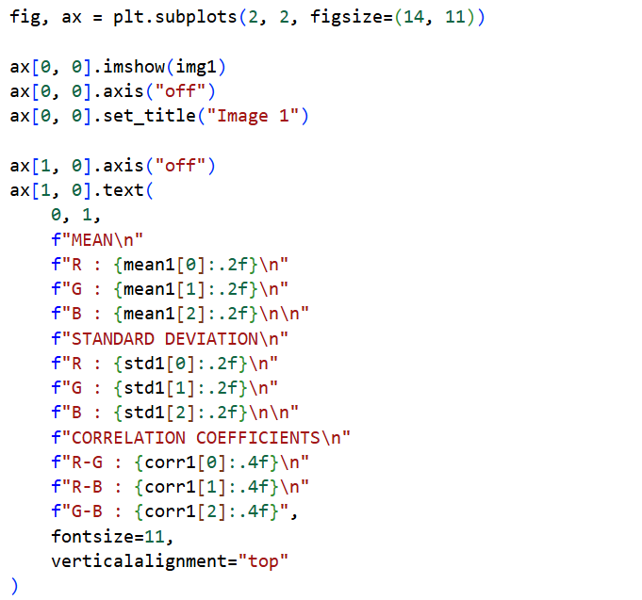
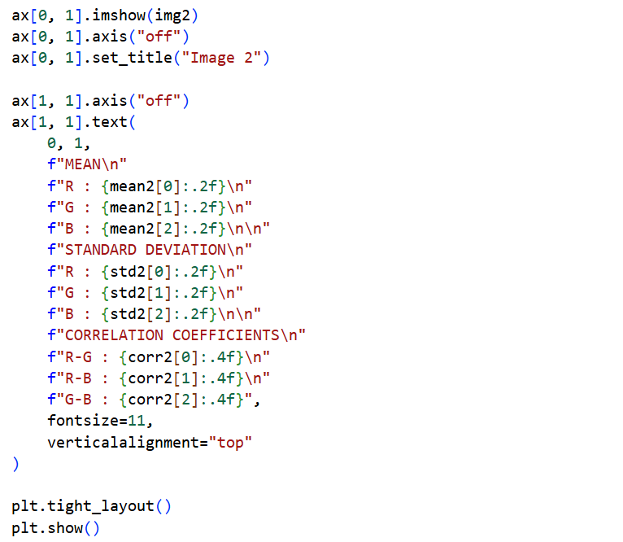
OUTPUT:
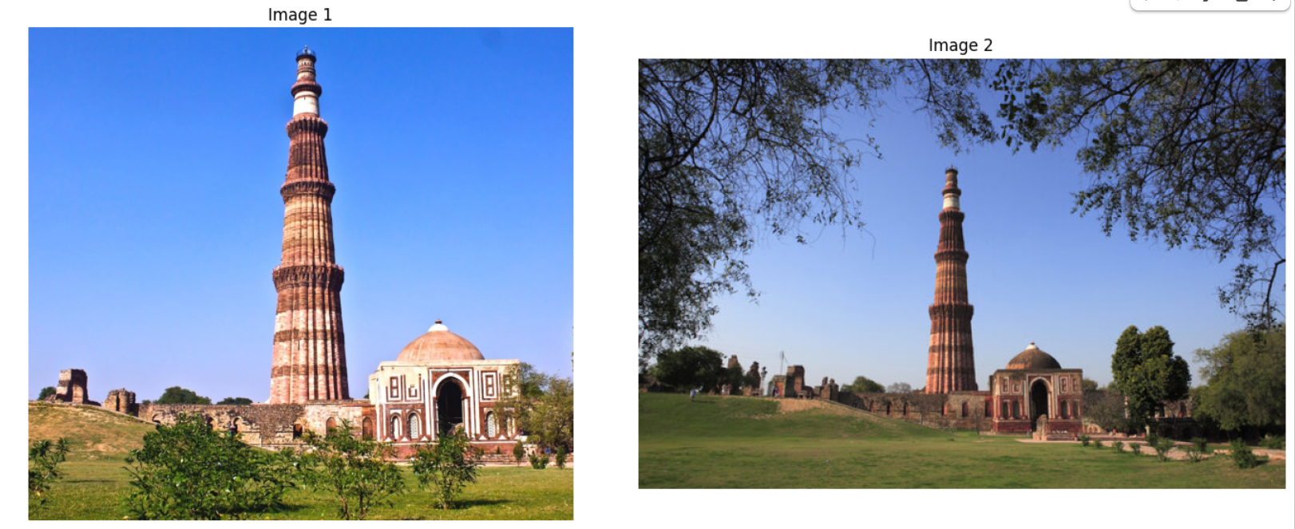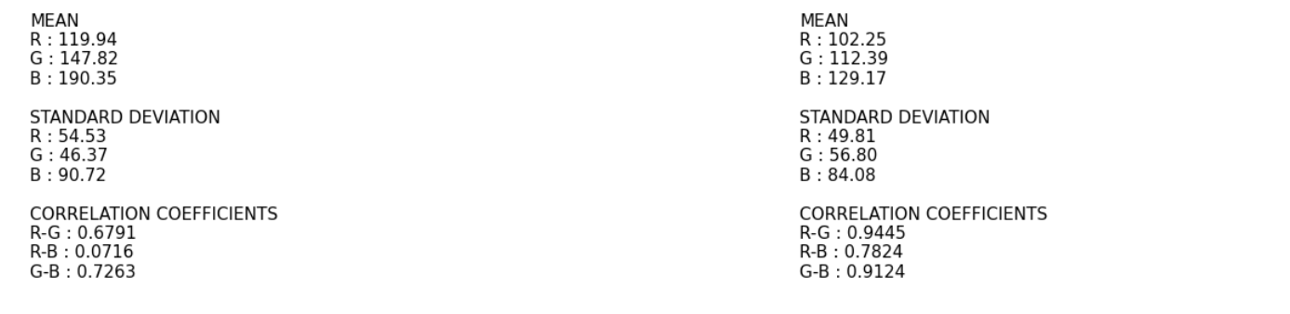
LEARNING OUTCOME:

EXPERIMENT-3

AIM:Create a program in python to demonstrate the implementation of image smoothening filters (Mean and Median filtering of an image).
THEORY:
Image smoothing is a spatial domain image processing technique used to reduce noise and unwanted variations in pixel intensity values. Noise may occur due to faulty sensors, transmission errors, or environmental conditions. Smoothing improves image quality and prepares the image for further processing such as edge detection and segmentation.
Mean Filter:
Mean filter is a linear spatial filter that smoothens an image by replacing each pixel value with the average of its neighboring pixel values within a fixed-size window.
Features:
- Linear filter
- Uses averaging operation
- Reduces random and Gaussian noise
- Simple and easy to implement
- Causes blurring of edges
$$g(x,y)=\frac{1}{k^{2}}\sum_{i=-n}^{n}{\sum_{j=-n}^{n}{f(x+i,y+j)}}$$

Median Filter:
Median filter is a non-linear spatial filter that smoothens an image by replacing the central pixel value with the median of neighboring pixel values.
Features:
- Non-linear filter
- Removes salt and pepper noise
- Preserves edges
- Eliminates extreme noise values
- Suitable for impulse noise

$$g(x,y)=\text{median}\{f(x+i,y+j)\}$$

SOURCE CODE:
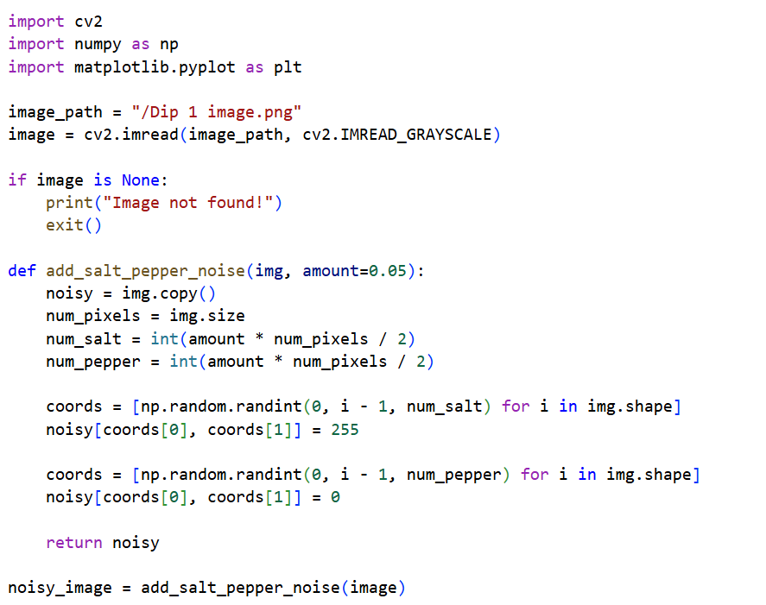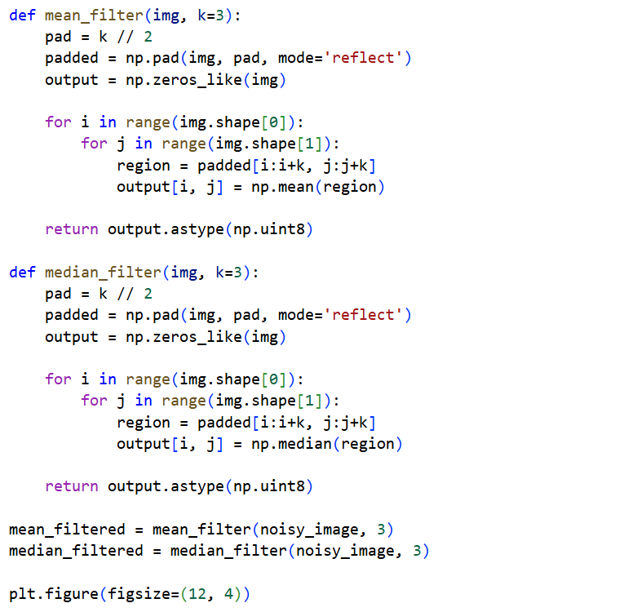
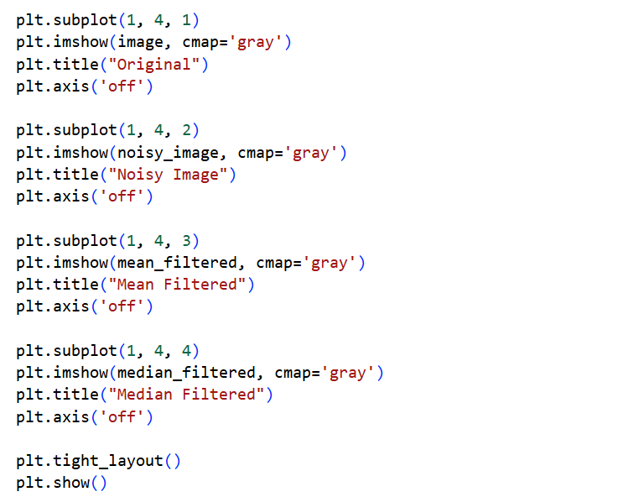

OUTPUT:
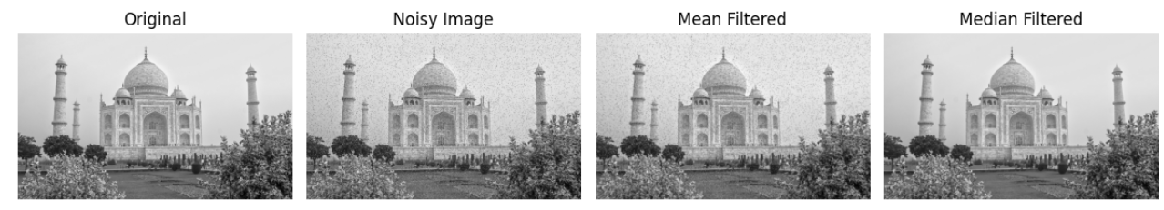
LEARNING OUTCOME:

EXPERIMENT -

AIM: Implementation of Image Sharpening Filters and Edge Detection using Gradient Filters.
THEORY:
Image processing plays a vital role in computer vision by improving image quality and extracting meaningful information. Two commonly used operations are image sharpening and edge detection. Image sharpening enhances fine details and clarity, while edge detection identifies boundaries of objects by detecting sudden changes in pixel intensity.
Image Sharpening:
Image sharpening is used to enhance edges and small details present in an image. It works by increasing the contrast between neighboring pixels, making the image appear clearer and more detailed.

Kernel-Based Sharpening:
Kernel-based sharpening uses a convolution mask to enhance edges. The center pixel is emphasized while surrounding pixels are suppressed, resulting in improved sharpness. This method is simple and effective for enhancing edges and textures.

Unsharp Masking:
Unsharp masking is a widely used sharpening technique. In this method, a blurred version of the image is subtracted from the original image to obtain edge details, which are then added back to the original image to produce a sharper image.

Grayscale Conversion:
Before performing edge detection, the image is converted into grayscale. Grayscale images contain only intensity information, which simplifies calculations and improves the efficiency of gradient-based edge detection.

Edge Detection using Gradient Filters:
Edge detection identifies regions in an image where there is a sudden change in intensity. Gradient filters measure these changes in horizontal and vertical directions.

Gradient Magnitude:
The overall strength of edges is obtained by combining horizontal and vertical gradients using the gradient magnitude formula:
$$G=\sqrt{G_{x}^{2}+G_{y}^{2}}$$
This produces an image where strong edges appear brighter.

SOURCE CODE:
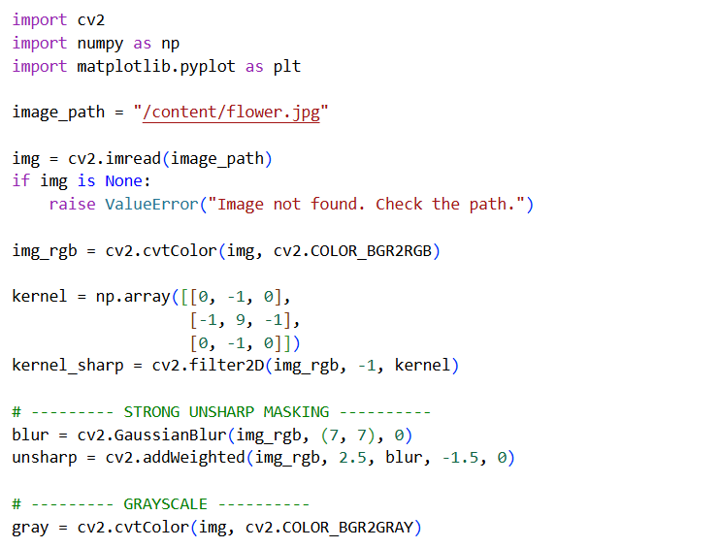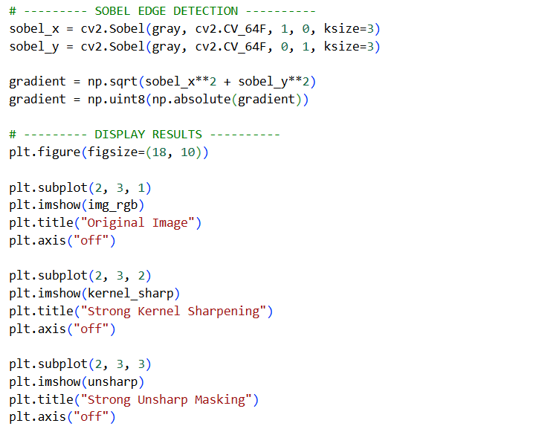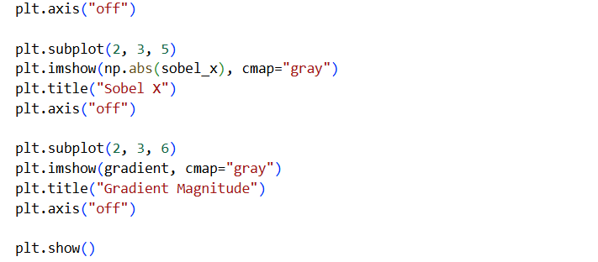
OUTPUT:
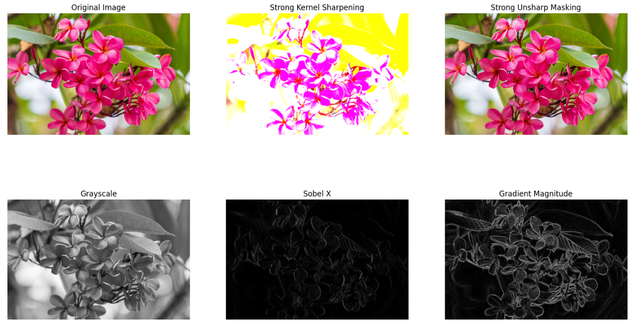

LEARNING OUTCOME:

EXPERIMENT-2

AIM: Display of FFT(1-D & 2-D) of an image and apply Two-dimensional Fourier transform using DFT and masking with DFT.

THEORY:
The Fourier Transform (FT) is a mathematical technique used to convert an image from the spatial domain (pixel values) into the frequency domain (representation of image details in terms of frequencies).
1. Discrete Fourier Transform (DFT)
Since digital images are discrete, we use the Discrete Fourier Transform (DFT). For a 2D image $f(x,y)$, the DFT is given by:
$$F(u,v)=\sum_{x=0}^{M-1}{\sum_{y=0}^{N-1}{f(x,y) }}e^{-j2π\left(\frac{ux}{M} + \frac{vy}{N}\right)}$$
- $f(x,y)$: input image
- $F(u,v)$: frequency domain representation
- $M,N$: image dimensions
- $u,v$: frequency coordinates
The result is a complex function containing:
- Magnitude → strength of frequency components
- Phase → position information
2. 1-D Fourier Transform
The 1-D FFT is applied to a flattened version of the image (converted into a 1D signal). It shows how pixel intensity varies with frequency.
- Helps analyze overall frequency distribution
- High peaks indicate dominant frequencies in the image
3. 2-D Fourier Transform
The 2-D FFT is applied directly on the image to transform it into frequency space.
- Low frequencies → represent smooth regions (background)
- High frequencies → represent edges and fine details
To make interpretation easier, the result is shifted using FFT shift, so that:
- Low frequencies appear at the center
- High frequencies move to the edges
4. Magnitude Spectrum
The magnitude of the Fourier Transform is computed as:
$$∣F(u,v)∣=\sqrt{R^{2}+I^{2}}$$
where:
- $R$= real part
- $I$= imaginary part
Since values vary widely, a log transformation is applied:
$$\text{Magnitude Spectrum}=log⁡(1+∣F(u,v)∣)$$
This improves visualization of frequency components.

5. Filtering using DFT (Masking)
In frequency domain, filtering is done by multiplying the DFT with a mask.
Low-Pass Filter (LPF)
- Allows low frequencies to pass
- Blocks high frequencies
- Produces a smooth/blurred image
High-Pass Filter (HPF)
- Allows high frequencies to pass
- Blocks low frequencies
- Produces an image with enhanced edges

6. Inverse DFT
After filtering, the image is converted back to spatial domain using Inverse DFT:
$$f(x,y)=\sum_{u=0}^{M-1}{\sum_{v=0}^{N-1}{F(u,v) }}e^{j2π\left(\frac{ux}{M} + \frac{vy}{N}\right)}$$
This gives the final processed image.

SOURCE CODE:
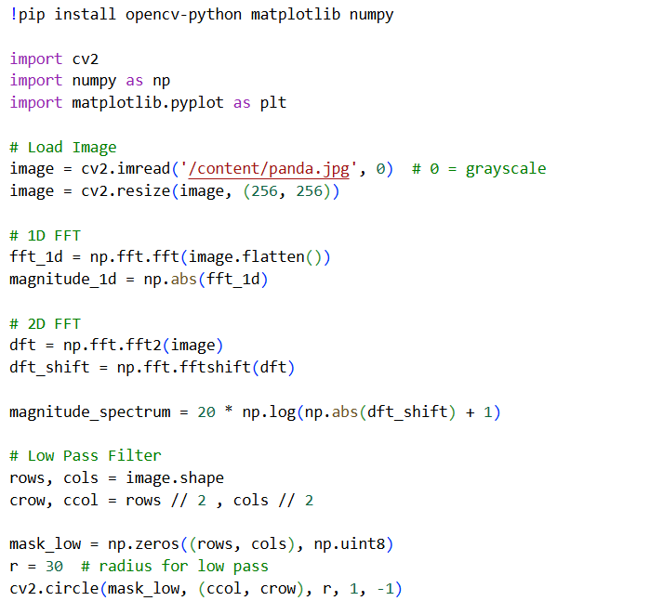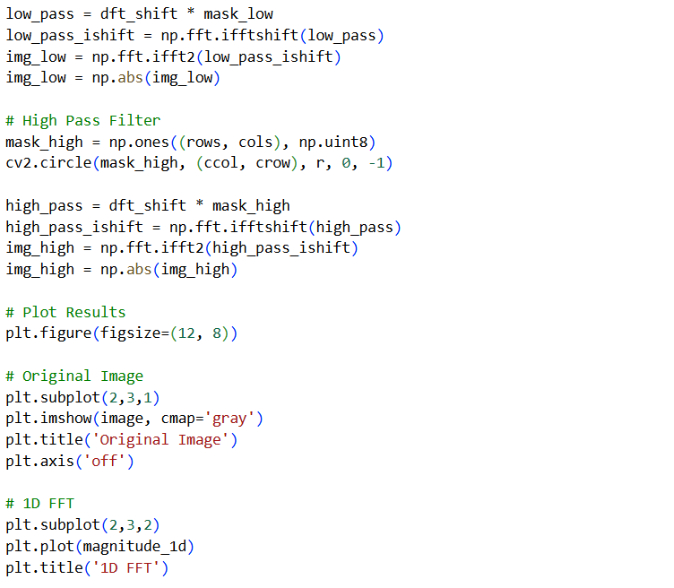
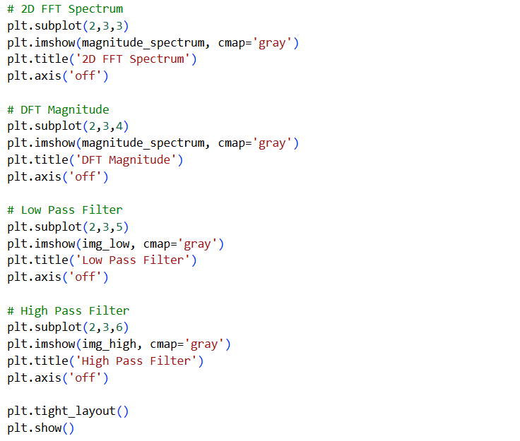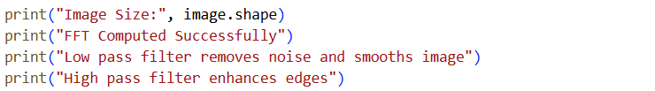
OUTPUT:
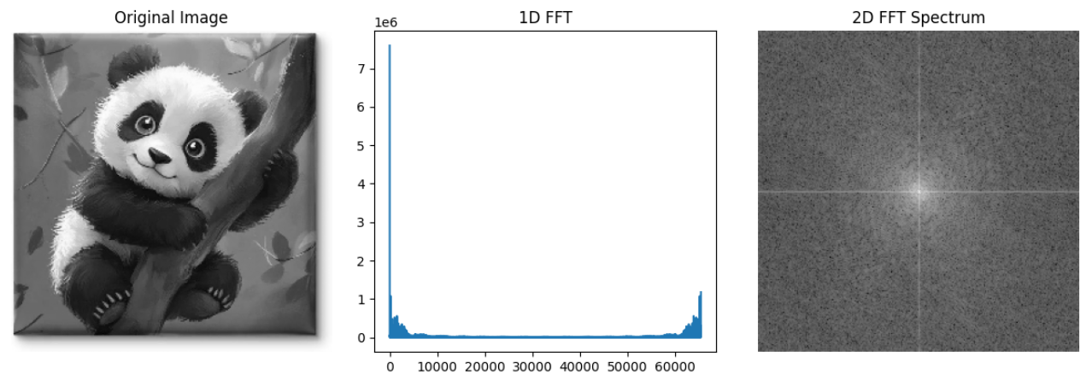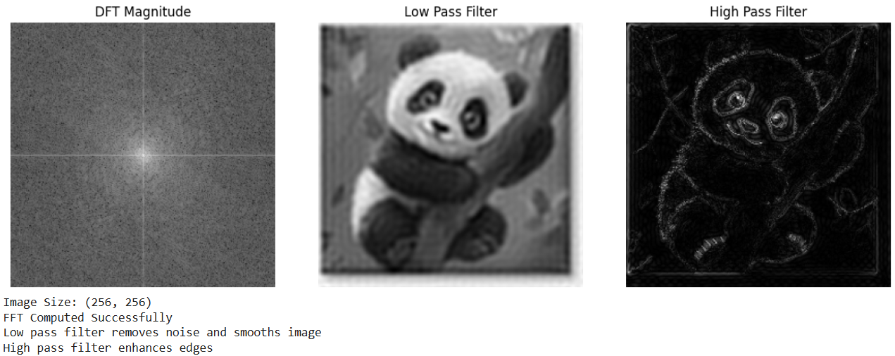
LEARNING OUTCOME:
EXPERIMENT-3

AIM: Write a program for Contrast stretching of a low contrast image, Histogram, Histogram Equalization and display of bit planes of an image.
THEORY:
Digital image enhancement techniques are used to improve the visual quality of an image or to make it more suitable for analysis. In this experiment, methods like contrast stretching, histogram analysis, histogram equalization, and bit plane slicing are used.
1. Contrast Stretching
Contrast stretching is a technique used to improve the contrast of a low-contrast image by expanding the range of intensity values.
- In low contrast images, pixel values are concentrated in a narrow range.
- Contrast stretching spreads these values over the full range (0–255).
The transformation is given by:
$$s=\frac{\left(r − r_{min}\right)}{\left(r_{max} − r_{min}\right)}×(L-1)$$
Where:
- $r$= input pixel value
- $s$= output pixel value
- $r_{min},r_{max}$= minimum and maximum intensity values
- $L$= number of gray levels (usually 256)

This enhances visibility of details in dark or bright regions.
2. Histogram of an Image
A histogram represents the distribution of pixel intensities in an image.
- X-axis → intensity levels (0 to 255)
- Y-axis → number of pixels
It helps in understanding:
- Brightness
- Contrast
- Dynamic range of the image

3. Histogram Equalization
Histogram equalization is used to enhance contrast automatically by redistributing pixel intensities.
- It spreads frequently occurring intensity values.
- Produces a more uniform histogram.
The transformation function is:
$$s=(L-1)\sum_{i=0}^{r}{p(}r_{i})$$
Where:
- $p(r_{i})$= probability of intensity level $r_{i}$
Result:
- Improves global contrast
- Enhances details in both dark and bright regions
4. Bit Plane Slicing
A digital image is composed of 8 bits per pixel (for grayscale images). Each bit represents a separate plane.
- Bit Plane 0 → Least Significant Bit (LSB)
- Bit Plane 7 → Most Significant Bit (MSB)
Key points:
- Lower bit planes contain fine details and noise
- Higher bit planes contain important structural information
Bit plane slicing separates an image into these 8 binary images.
5. Applications
- Image enhancement
- Medical Image Analysis
- Remote Sensing
- Pattern Recognition
- Computer Vision
- Image Compression

SOURCE CODE:
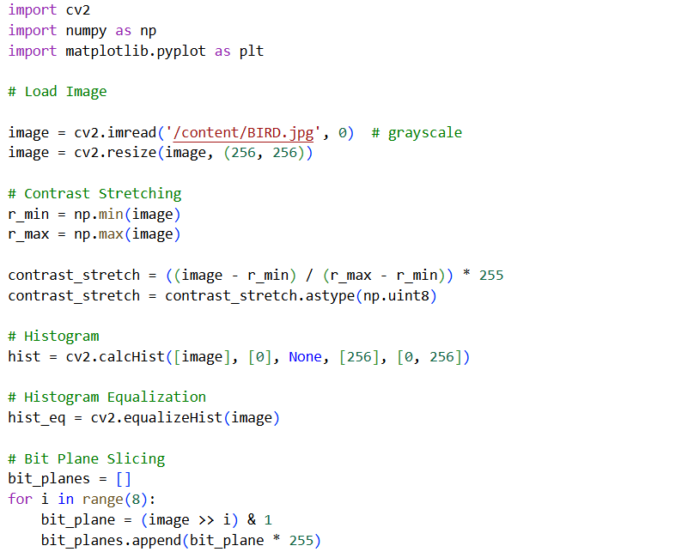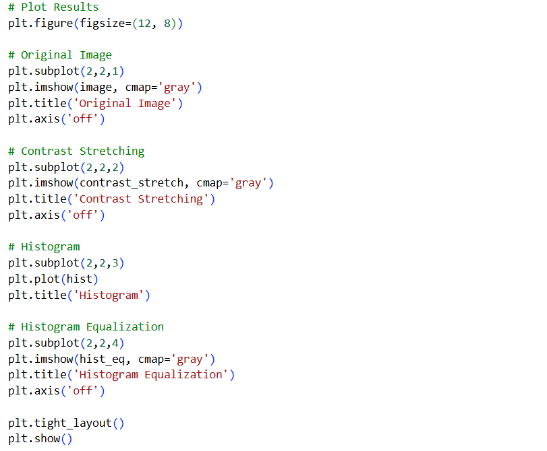

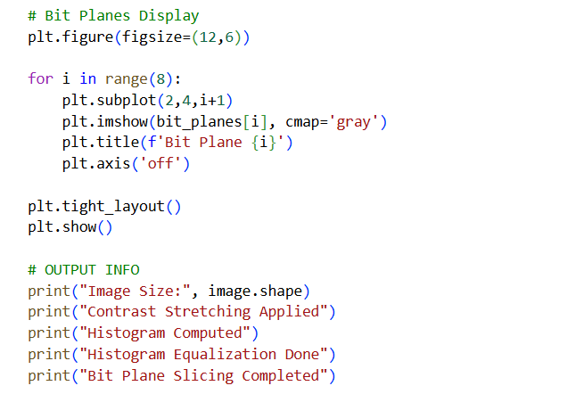

OUTPUT:
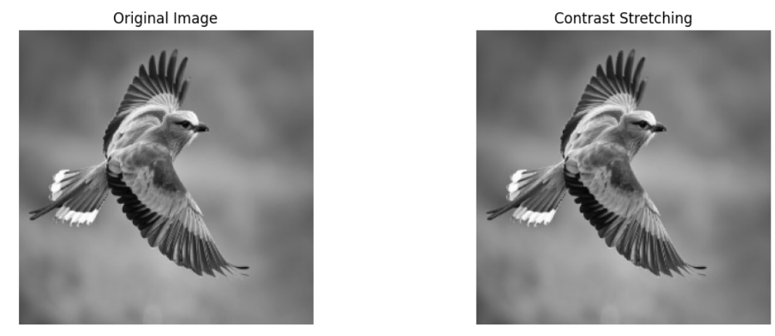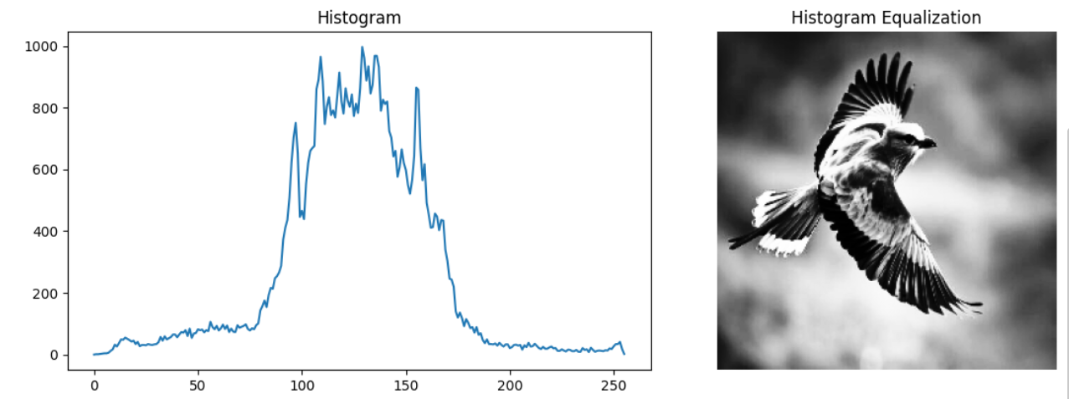

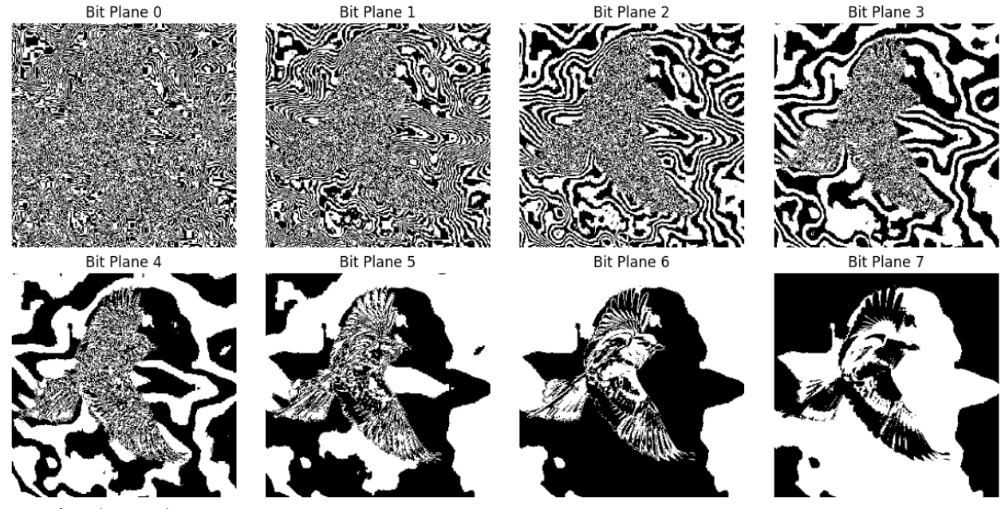

LEARNING OUTCOME:

EXPERIMENT-7
AIM: Implementation of Image Compression using DCT,DPCM and Huffman Coding.
THEORY:
Image compression is an essential technique in digital image processing used to reduce the amount of data required to represent an image while maintaining acceptable visual quality. Since a digital image consists of pixel intensity values arranged in a matrix, directly storing these values requires a large amount of memory. Image compression techniques reduce redundancy in the image data so that it can be stored or transmitted more efficiently. Compression plays a crucial role in applications such as multimedia communication, image storage, medical imaging systems, satellite imaging, and web applications where efficient bandwidth and storage usage are important.
The combination of Discrete Cosine Transform (DCT), Differential Pulse Code Modulation (DPCM), and Huffman coding forms the basis of many lossy image compression standards, including JPEG.
1. Discrete Cosine Transform (DCT)
DCT converts an image from spatial domain → frequency domain.
- It separates image into:
  - Low-frequency components → important (overall structure)
  - High-frequency components → less important (details/noise)
The 2D DCT is given by:
$$F(u,v)=\frac{1}{4}C(u)C(v)\sum_{x=0}^{N-1}{\sum_{y=0}^{N-1}{f(x,y)cos⁡}}\left[\frac{(2x+1)uπ}{2N}\right]cos⁡\left[\frac{(2y+1)vπ}{2N}\right]$$
Used in JPEG compression
2. Quantization (Lossy Step)
- After DCT, coefficients are divided by a quantization matrix
- Small values become zero → reduces data
This step causes loss of information (lossy compression)
3. DPCM (Differential Pulse Code Modulation)
DPCM encodes the difference between adjacent pixels instead of actual values.
$$e(n)=x(n)-x(n-1)$$
- Reduces redundancy
- Differences are usually small → easier to compress
4. Huffman Coding
Huffman coding is a lossless compression technique.
- Assigns:
  - Short codes → frequent values
  - Long codes → rare values
Minimizes total number of bits required
5. Compression Process
- Convert image to grayscale
- Apply DCT
- Apply Quantization
- Apply DPCM (optional step)
- Encode using Huffman Coding
6. Performance Metrics
Mean Square Error (MSE)
$$MSE=\frac{1}{MN}∑(I-I^{'})^{2}$$
Peak Signal-to-Noise Ratio (PSNR)
$$PSNR=10{log⁡}_{10}\left(\frac{{255}^{2}}{MSE}\right)$$
- Higher PSNR → better quality

SOURCE CODE:
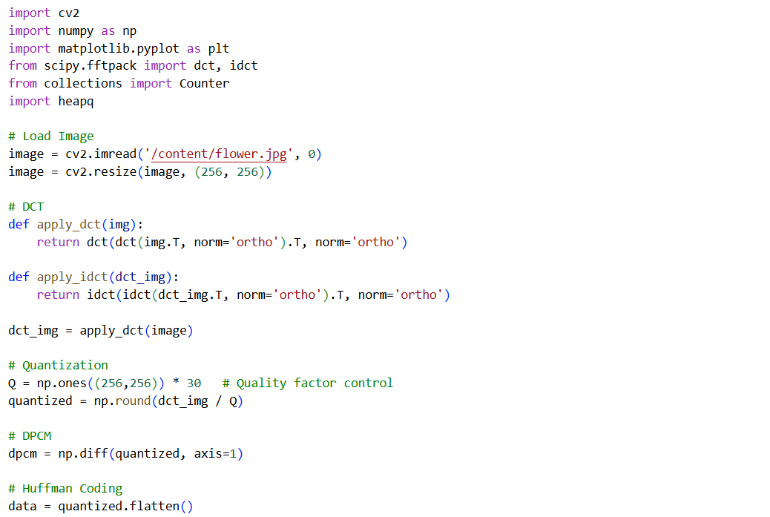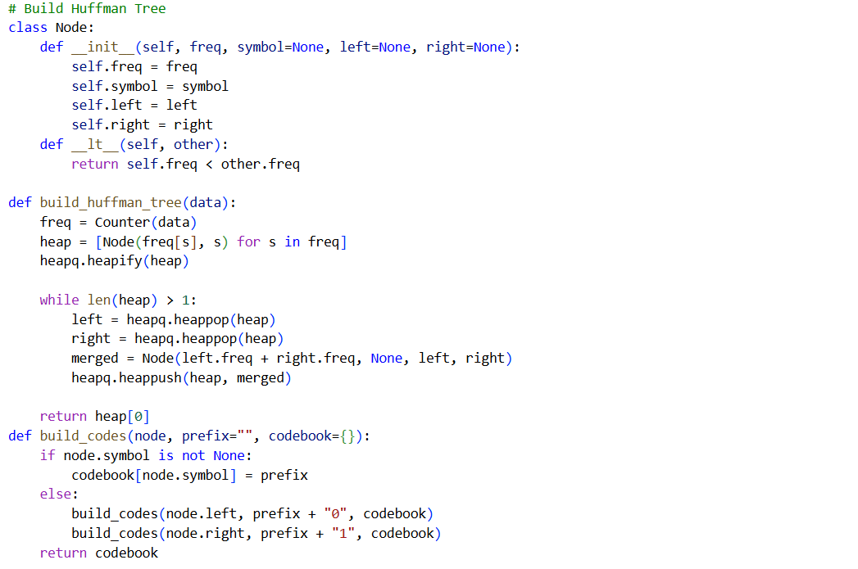
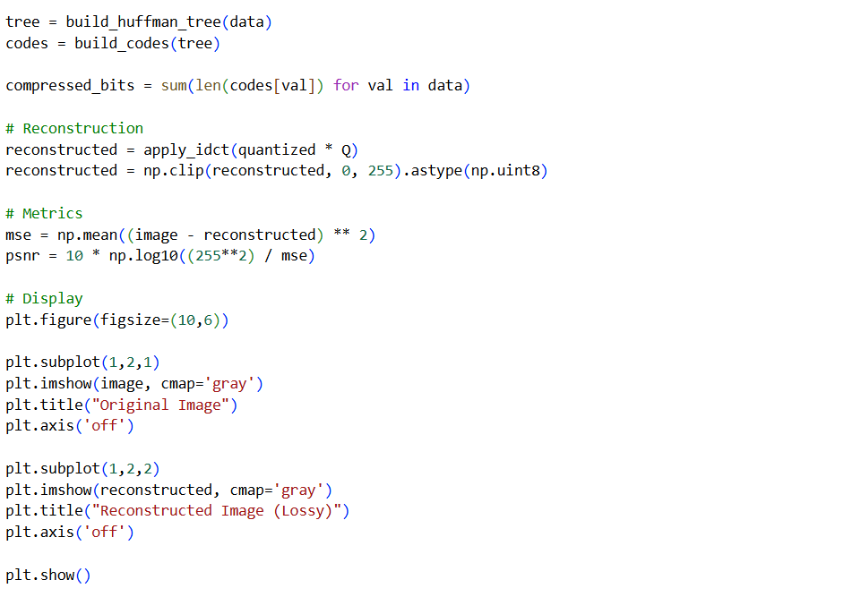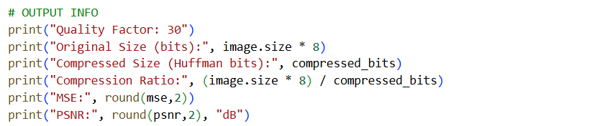
OUTPUT:
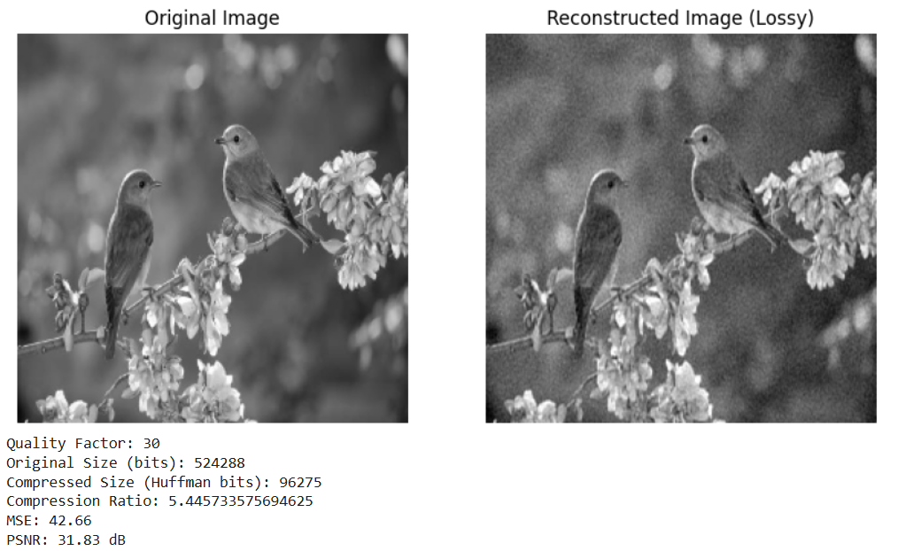
LEARNING OUTCOME:
EXPERIMENT-8
AIM: Implementation of Image Restoration Techniques.
THEORY:
Image restoration is a process in digital image processing that focuses on recovering an original image from its degraded version. Degradation of images may occur due to various factors such as blur, noise, motion, defocus, or atmospheric disturbances. The main objective of image restoration is not just to improve the appearance but to reconstruct the original image as accurately as possible using mathematical models.
1. Image Degradation Model
In image restoration, the degradation process is modeled mathematically as:
$$g(x,y)=h(x,y)*f(x,y)+n(x,y)$$Where:
- $f(x,y)$: original image
- $h(x,y)$: degradation function or Point Spread Function (PSF)
- $n(x,y)$: additive noise
- $g(x,y)$: degraded image
- $*$: convolution operation
In the frequency domain, this can be written as:
$$G(u,v)=H(u,v)⋅F(u,v)+N(u,v)$$The goal of restoration is to estimate the original image $f(x,y)$from the observed image $g(x,y)$.
2. Inverse Filtering
Inverse filtering is the simplest method used to restore an image. It works by reversing the degradation process in the frequency domain.
$$F(u,v)=\frac{G(u,v)}{H(u,v)}$$This method assumes that the degradation function $H(u,v)$is known.
Advantages:
- Simple and easy to implement
- Effective in absence of noise
Limitations:
- Highly sensitive to noise
- If $H(u,v)$is very small or zero, it leads to instability
3. Wiener Filtering
Wiener filtering is an advanced technique that minimizes the Mean Square Error (MSE) between the original and restored image. It considers both degradation and noise.
$$F(u,v)=\frac{H^{*}(u,v)}{∣H(u,v)∣^{2}+K}⋅G(u,v)$$Where:
- $H^{*}(u,v)$: complex conjugate of degradation function
- $K$: noise-to-signal ratio
Advantages:
- Handles both blur and noise
- Produces stable and reliable results
Limitation:
- Requires estimation of noise and signal power

4. Constrained Least Squares (CLS) Filtering
CLS filtering improves restoration by adding a constraint that controls smoothness of the image. It helps in reducing noise amplification while preserving important details.
$$F(u,v)=\frac{H^{*}(u,v)}{∣H(u,v)∣^{2}+γ∣P(u,v)∣^{2}}⋅G(u,v)$$Where:
- $γ$: regularization parameter
- $P(u,v)$: Laplacian operator
Advantages:
- Reduces noise effectively
- Preserves edges better
Limitation:
- Requires proper selection of parameter $γ$

5. Performance Evaluation
Mean Square Error (MSE)
$$MSE=\frac{1}{MN}∑(f-\hat{f})^{2}$$
Peak Signal-to-Noise Ratio (PSNR)
$$PSNR=10{log⁡}_{10}\left(\frac{{255}^{2}}{MSE}\right)$$SOURCE CODE:
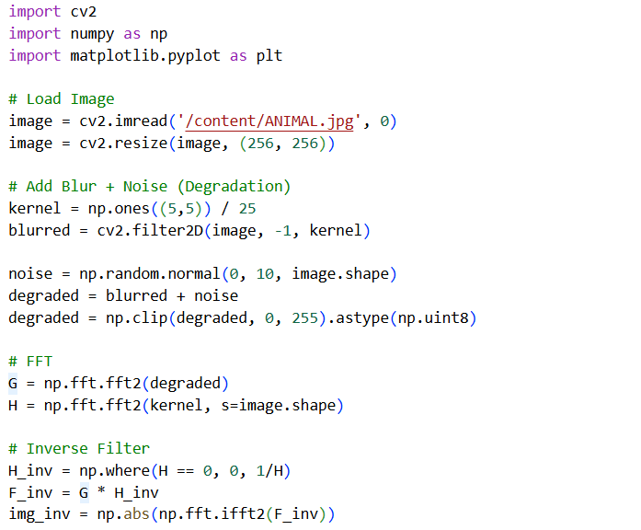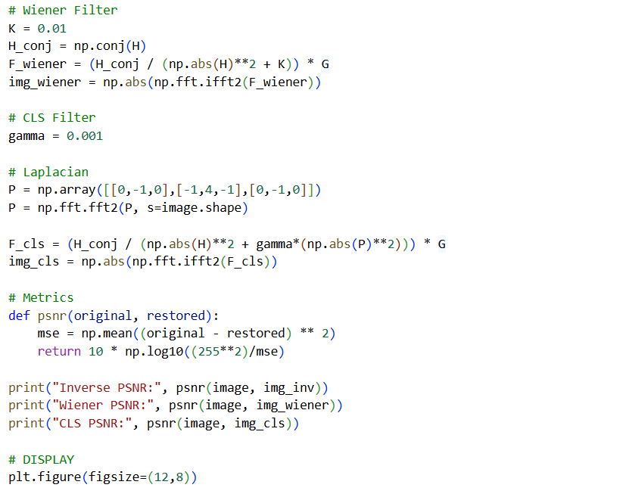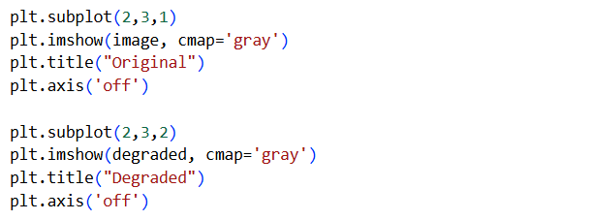
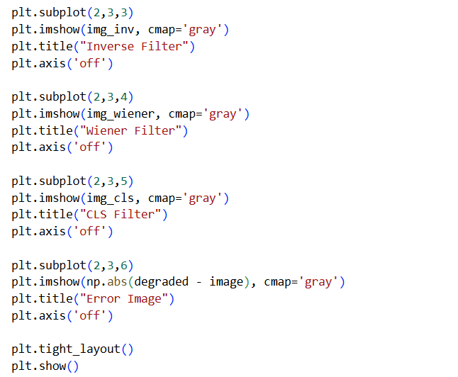
OUTPUT:
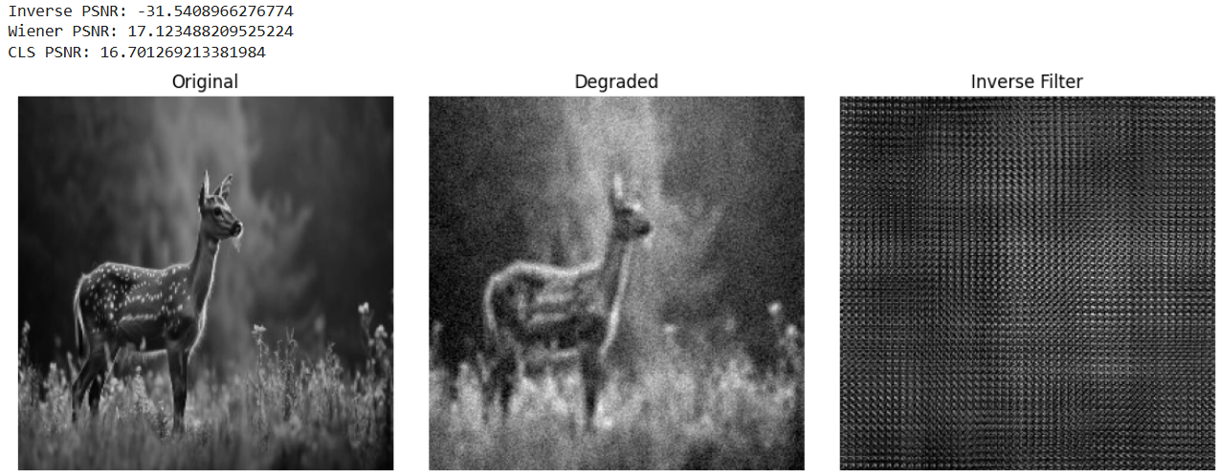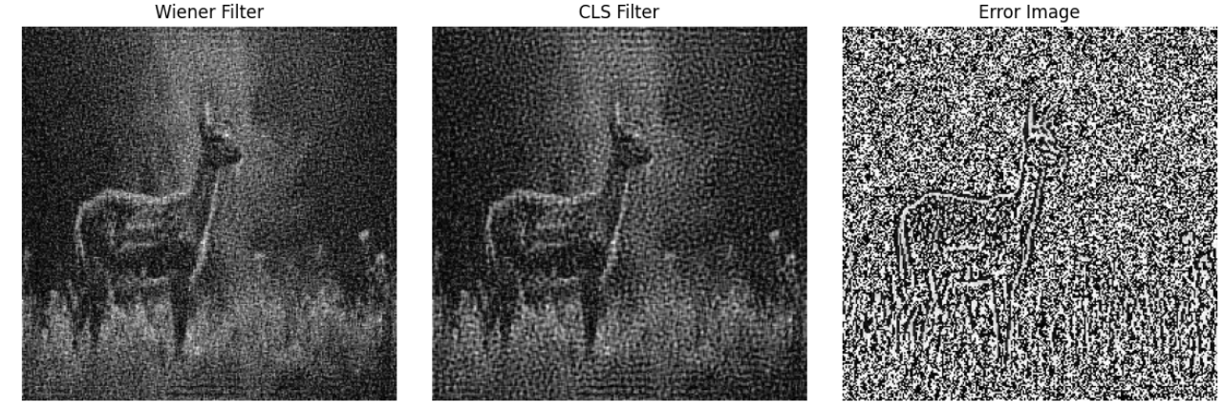
LEARNING OUTCOME:

EXPERIMENT-9
AIM: Implementation of Image Intensity Slicing techniques for image enhancement.
THEORY:
Intensity slicing involves dividing the entire range of intensity values into different intervals (slices) and then modifying or highlighting these slices based on predefined criteria. This allows selective enhancement of certain features in the image.
Mathematically, intensity slicing can be represented as a transformation function:
$$g(x,y)=T(f(x,y))$$Where:
- $f(x,y)$= input image
- $g(x,y)$= output image
- $T$= transformation function applied on intensity values
Types of Intensity Slicing Techniques
1. Binary Intensity Slicing (Thresholding)
Binary slicing is the most fundamental form of segmentation. It converts a grayscale image into a binary image using a threshold value $T$.
$$g(x,y)=\left\{\begin{matrix}255, & \text{if }f(x,y)>T \\ 0, & \text{if }f(x,y)≤T\end{matrix}\right.$$Key Points:
- Separates foreground and background
- Reduces image complexity
- Useful for object detection and segmentation
Limitation:
- Sensitive to noise and illumination changes
2. Gray Level Slicing
Gray level slicing enhances a specific range of intensities while either suppressing or preserving other values. It is particularly useful when the region of interest lies within a narrow intensity band.

There are two approaches:
(a) Without Background Preservation
$$g(x,y)=\left\{\begin{matrix}255, & \text{if }A≤f(x,y)≤B \\ 0, & \text{otherwise}\end{matrix}\right.$$
(b) With Background Preservation
$$g(x,y)=\left\{\begin{matrix}255, & \text{if }A≤f(x,y)≤B \\ f(x,y), & \text{otherwise}\end{matrix}\right.$$Key Points:
- Highlights specific features
- Improves visibility of low-contrast regions
- Common in medical imaging and satellite images

3. Pseudo Color (False Color) Slicing
Pseudo color slicing assigns artificial colors to grayscale intensity ranges to improve human interpretation. Since the human eye can distinguish colors more effectively than grayscale variations, this technique enhances perception.
Working:
- Divide intensity range into intervals
- Assign each interval a unique color (e.g., blue, green, red)
4.Role of Histogram in Intensity Slicing
A histogram represents the distribution of pixel intensities in an image. It is a plot of intensity values versus their frequency of occurrence.
Importance:
- Helps in selecting threshold values for slicing
- Indicates contrast level of the image
- Shows dominant intensity regions
5.Advantages of Intensity Slicing
- Simple and easy to implement
- Requires less computational power
- Enhances important features effectively
- Useful for preprocessing in image analysis tasks
SOURCE CODE:
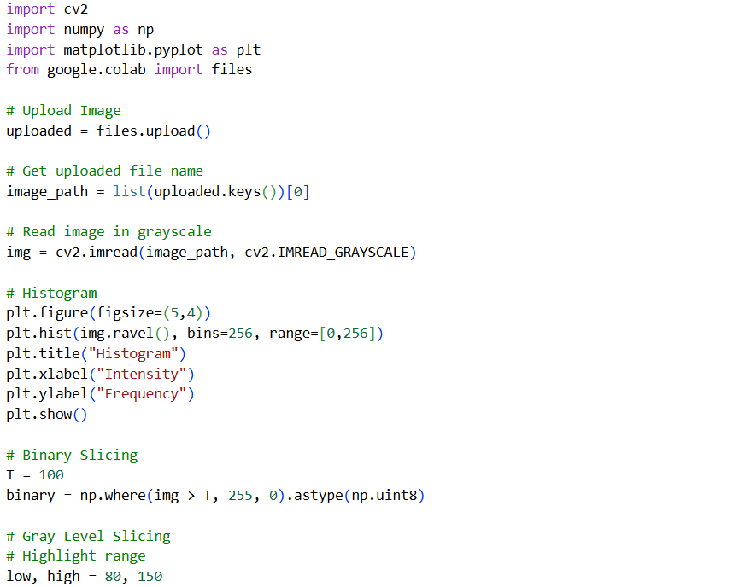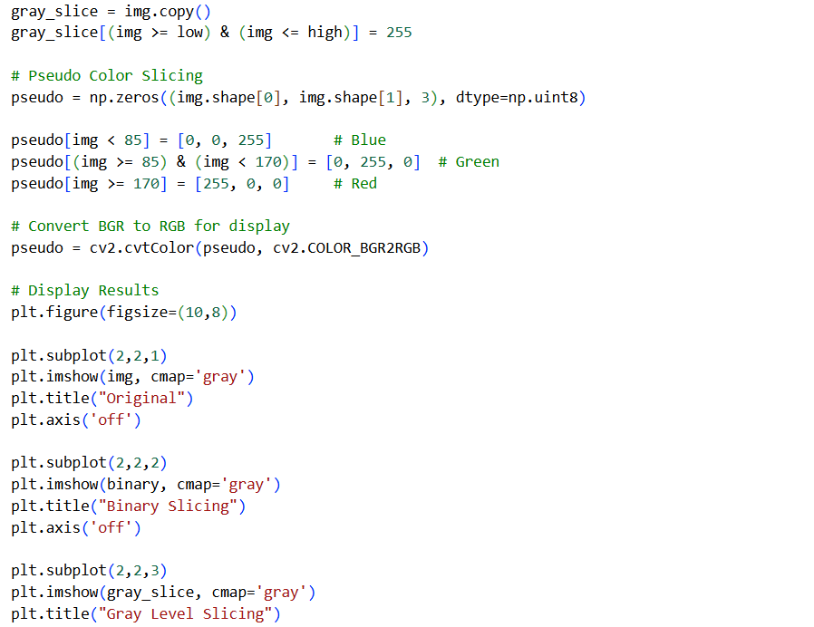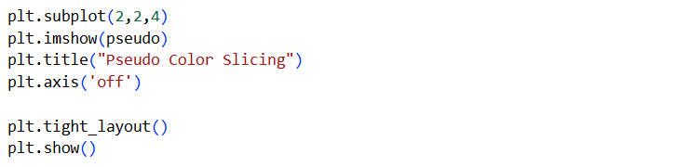
OUTPUT:
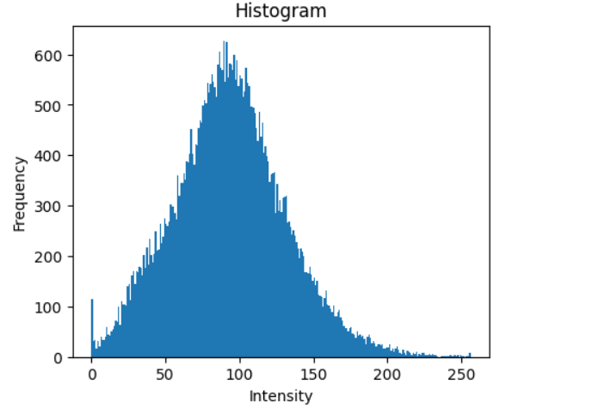
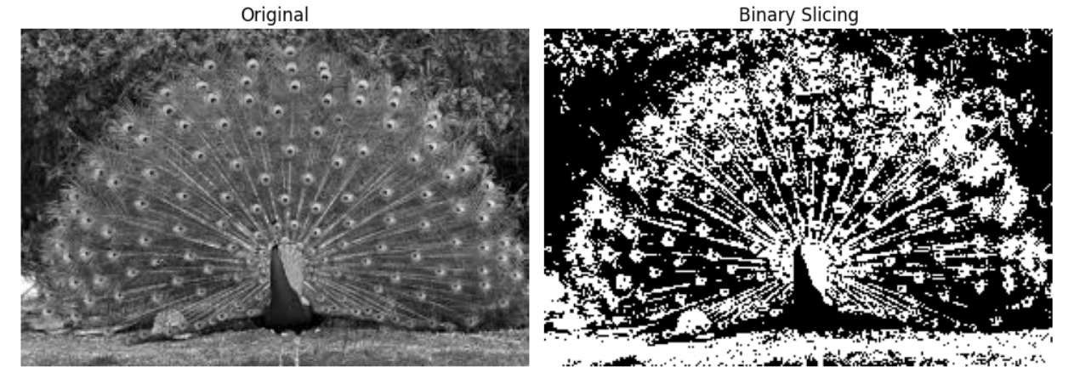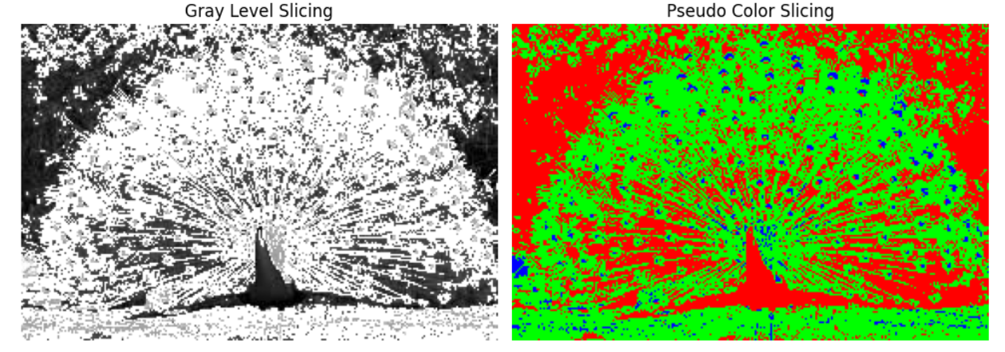
LEARNING OUTCOME:

EXPERIMENT-10
AIM: Study and Implementation Canny edge detection algorithm on images and compare it with existing edge detection algorithms.
THEORY:
Edge detection is a technique used in digital image processing to identify boundaries of objects within an image. These boundaries correspond to sharp changes in intensity values. Detecting edges helps in understanding the structure, shape, and features of objects.
Different edge detection algorithms exist, each with its own method of detecting intensity changes. In this experiment, Canny edge detection is studied and compared with other methods like Sobel, Prewitt, Roberts, and Laplacian of Gaussian (LoG).
Canny Edge Detection Algorithm
Canny is a multi-stage algorithm designed to detect edges accurately while reducing noise.
Steps:
- Noise Reduction
Gaussian filter is applied to smooth the image.
- Gradient Calculation
Intensity gradients are computed to detect edge strength and direction.
- Non-Maximum Suppression
Removes unwanted pixels and keeps thin edges.
- Double Thresholding
Classifies edges into strong and weak edges.
- Edge Tracking by Hysteresis
Weak edges connected to strong edges are preserved.
Other Edge Detection Techniques
1. Sobel Operator
- Uses first-order derivatives
- Detects edges in horizontal and vertical directions
- Produces thicker edges and is sensitive to noise
2. Prewitt Operator
- Similar to Sobel but simpler
- Less accurate for diagonal edges
- Also sensitive to noise
3. Roberts Operator
- Uses small 2×2 kernels
- Detects edges quickly
- Highly sensitive to noise and produces rough edges
4. Laplacian of Gaussian (LoG)
- Applies Gaussian smoothing followed by Laplacian
- Detects edges in all directions
- Produces more detailed but noisy edges
Edge Density
Edge density is a measure of the number of edge pixels in an image.
$$\text{Edge Density}=\frac{\text{Number of Edge Pixels}}{\text{Total Pixels}}×100$$
It helps in comparing different edge detection methods:
- Higher value → more edges (may include noise)
- Lower value → fewer but cleaner edges
Applications
- Object detection
- Image segmentation
- Medical image analysis
- Computer vision systems

SOURCE CODE:
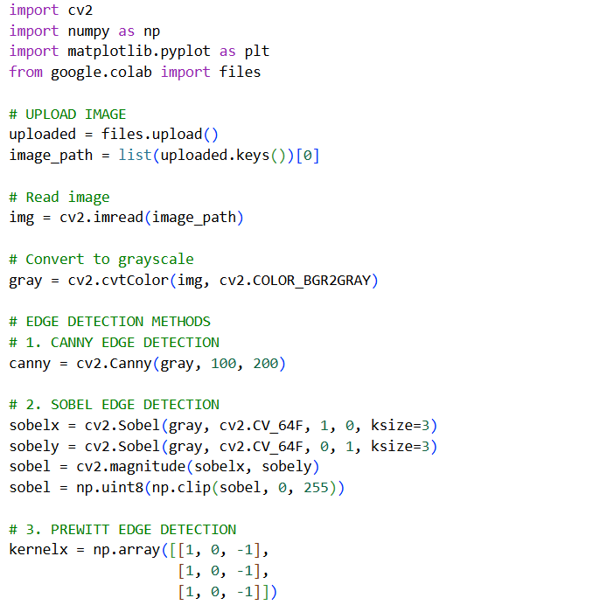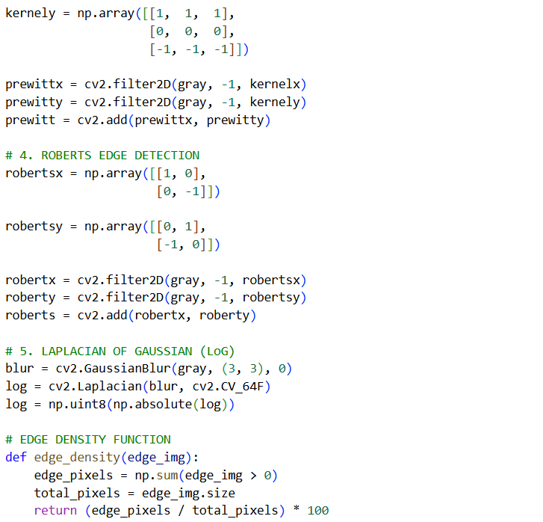
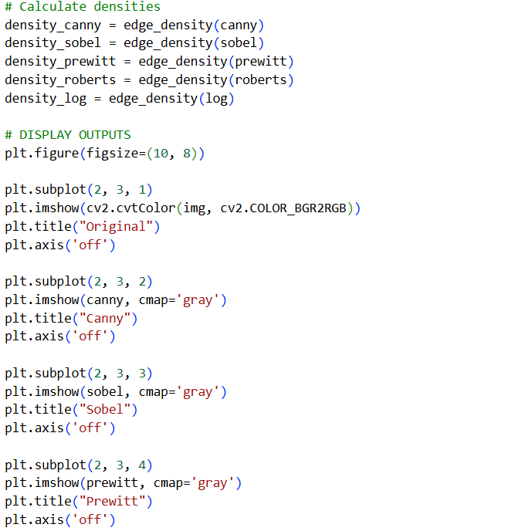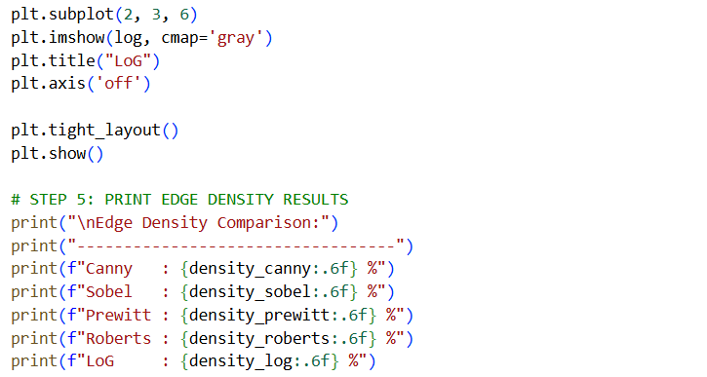

OUTPUT:
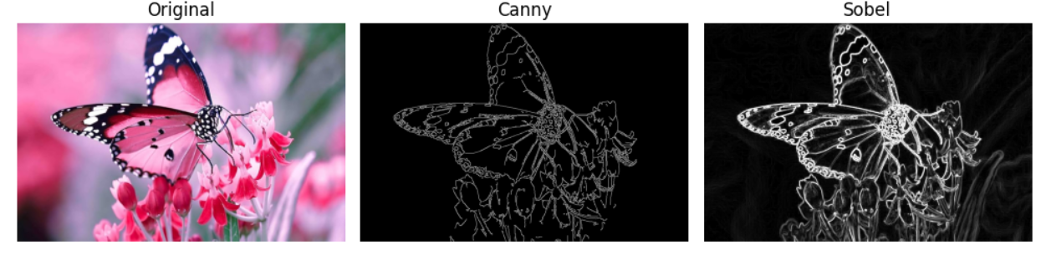

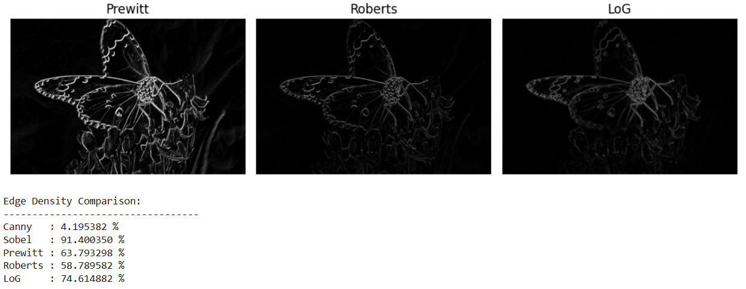
LEARNING OUTCOME:

