University of Pittsburgh

School of Computing and Information

INFSCI 2750: Cloud Computing

Spring 2019
Mini Project 1



Charu Sreedharan (chs263@pitt.edu)
Lakshmi Ravichandran (lar146@pitt.edu)
Sanzil Madye (ssm59@pitt.edu)

The objective of this mini project is to get familiar with setting up the Hadoop system and to start programming in Hadoop.

Part 1: Setting up Hadoop

The first part of the project requires setting up Hadoop on the VMs. Each member is assigned a VM of his own, in which we installed and ran Hadoop. The goal here is to build a Hadoop cluster. First, we made sure that Hadoop is set up properly on each VM by running single node set up. Then we proceeded to set a 3-node cluster with the help of the tutorials provided.

Master: 159.65.43.106
Slave: 68.183.153.175
Slave: 68.183.53.213

Master:

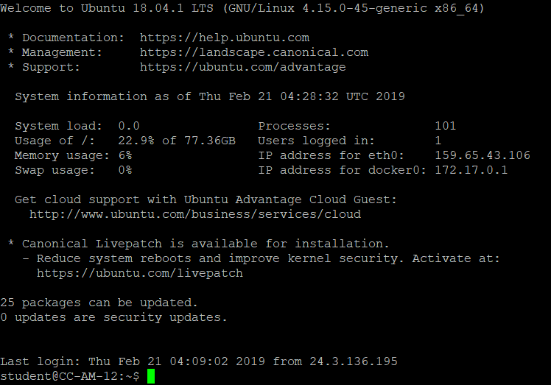

Slave:
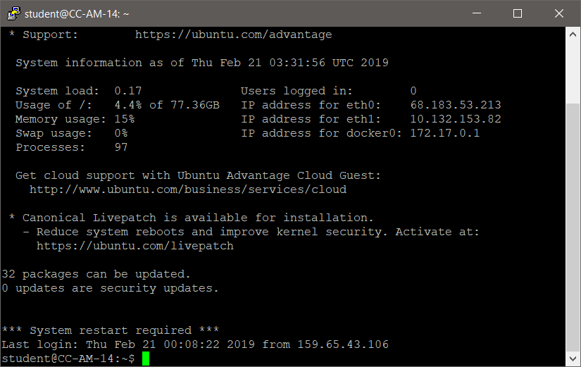

Slave :

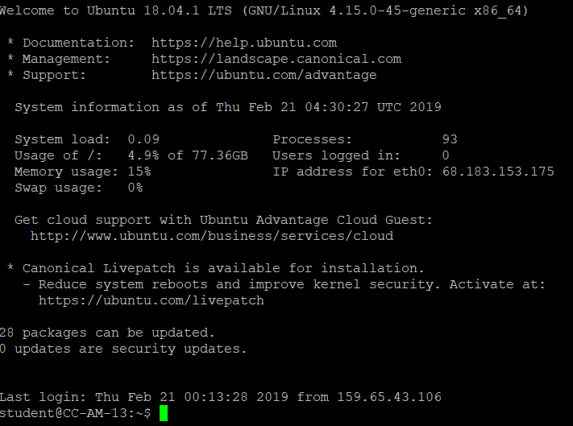

Monitor and Links
http://159.65.43.106:9870 HDFS
http://159.65.43.106:8088 YARN Resource manager
http://159.65.43.106:19888 MapReduce History

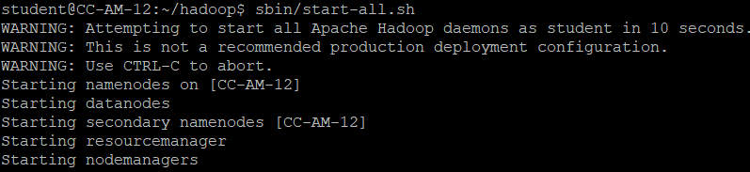

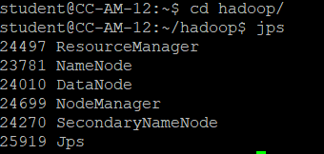

Part 2 – Docker

The file Dockerfile serves as the main build script for the image building process.

Below is the output after building docker image with name “hadoop”

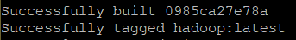

This creates the container and starts hadoop set up in pseudo environment

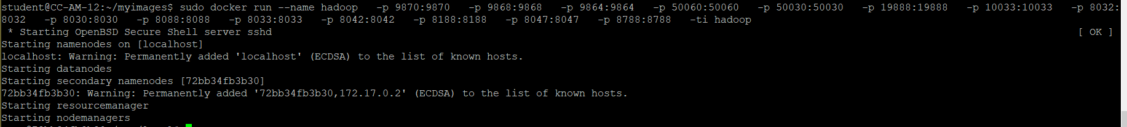

Output of map reduce wordcount program using hadoop in a docker container

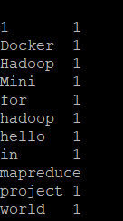

Part 3: Developing a Hadoop program (N-Gram)

- We wrote a program for n-gram, tested it on simple string like “Helloworld” whose result is known.

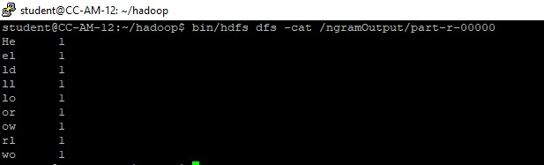

Part 4: Developing a Hadoop program to analyze real logs

MapReduce programs to analyze a real anonymous log to answer several questions based on the log.

Problems:


- How many hits were made to the website item “/assets/img/home-logo.png”?

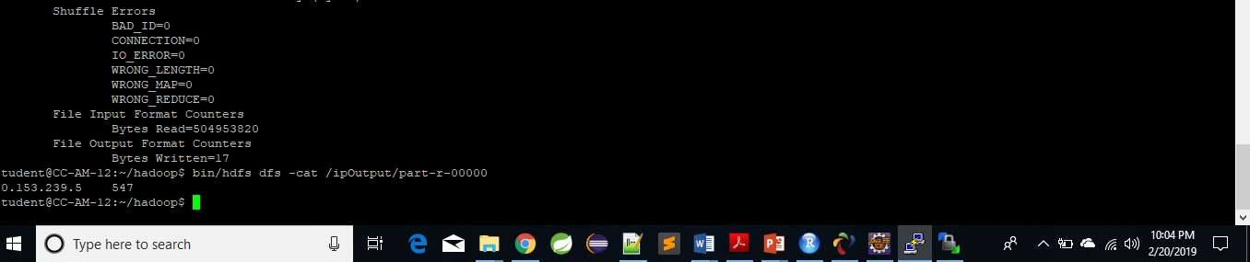
- How many hits were made from the IP: 10.153.239.5

- Which path in the website had been hit most? How many hits were made to the path?
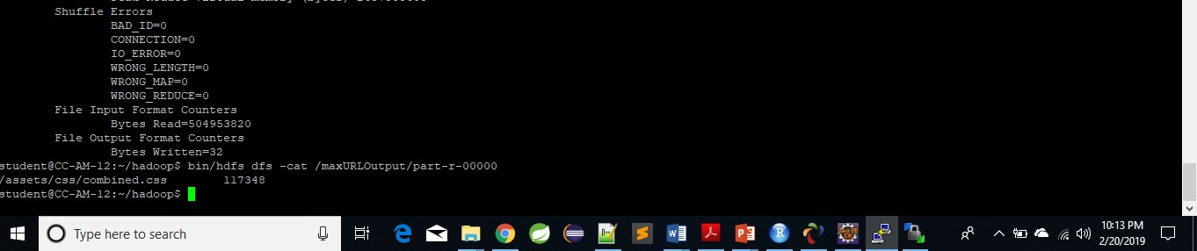

- Which IP accesses the website the most? How many accesses were made by it?
