727721EUIT023 – CHARUKEAS T

**Software Testing using Selenium**

**Coding Contest – 2**

**Code:**

package com.selenium.test1.SoloExercises;

import org.openqa.selenium.By;

import org.openqa.selenium.WebDriver;

import org.openqa.selenium.WebElement;

import org.openqa.selenium.edge.EdgeDriver;

import org.testng.annotations.Test;

import io.github.bonigarcia.wdm.WebDriverManager;

public class CC2 {

*@Test*

public void function() throws Exception {

WebDriverManager.*edgedriver*().setup();

WebDriver driver=new EdgeDriver();

driver.get("https://www.yatra.com/hotels");

driver.manage().window().maximize();

driver.findElement(By.*id*("booking_engine_flights")).click();

driver.findElement(By.*xpath*("//*[@id=\"BE_flight_form_wrapper\"]/div[1]/div[1]/ul[1]/li[2]/a")).click();

WebElement departFrom = driver.findElement(By.*xpath*("//*[@id=\"BE_flight_origin_city\"]"));

departFrom.click();

Thread.*sleep*(3000);

WebElement departFromvalue=driver.findElement(By.*xpath*("//*[@id=\"BE_flight_form_wrapper\"]/div[1]/div[2]/ul/li[1]/ul/li[1]/div/div/ul/div/div/div/li[3]/div[1]/p[1]"));

departFromvalue.click();

WebElement arrivalAt = driver.findElement(By.*id*("BE_flight_arrival_city"));

arrivalAt.click();

Thread.*sleep*(3000);

WebElement arrivalAtvalue=driver.findElement(By.*xpath*("//*[@id=\"BE_flight_form_wrapper\"]/div[1]/div[2]/ul/li[1]/ul/li[3]/div/div/ul/div/div/div/li[4]"));

arrivalAtvalue.click();

driver.findElement(By.*id*("BE_flight_origin_date")).click();

Thread.*sleep*(3000);

driver.findElement(By.*xpath*("//*[@id=\"25/04/2023\"]")).click();

Thread.*sleep*(3000);

driver.findElement(By.*xpath*("//*[@id=\"27/04/2023\"]")).click();

driver.findElement(By.*className*("chkbox-disabled")).click();

driver.findElement(By.*id*("BE_flight_flsearch_btn")).click();

}

}

**ScreenShot:**

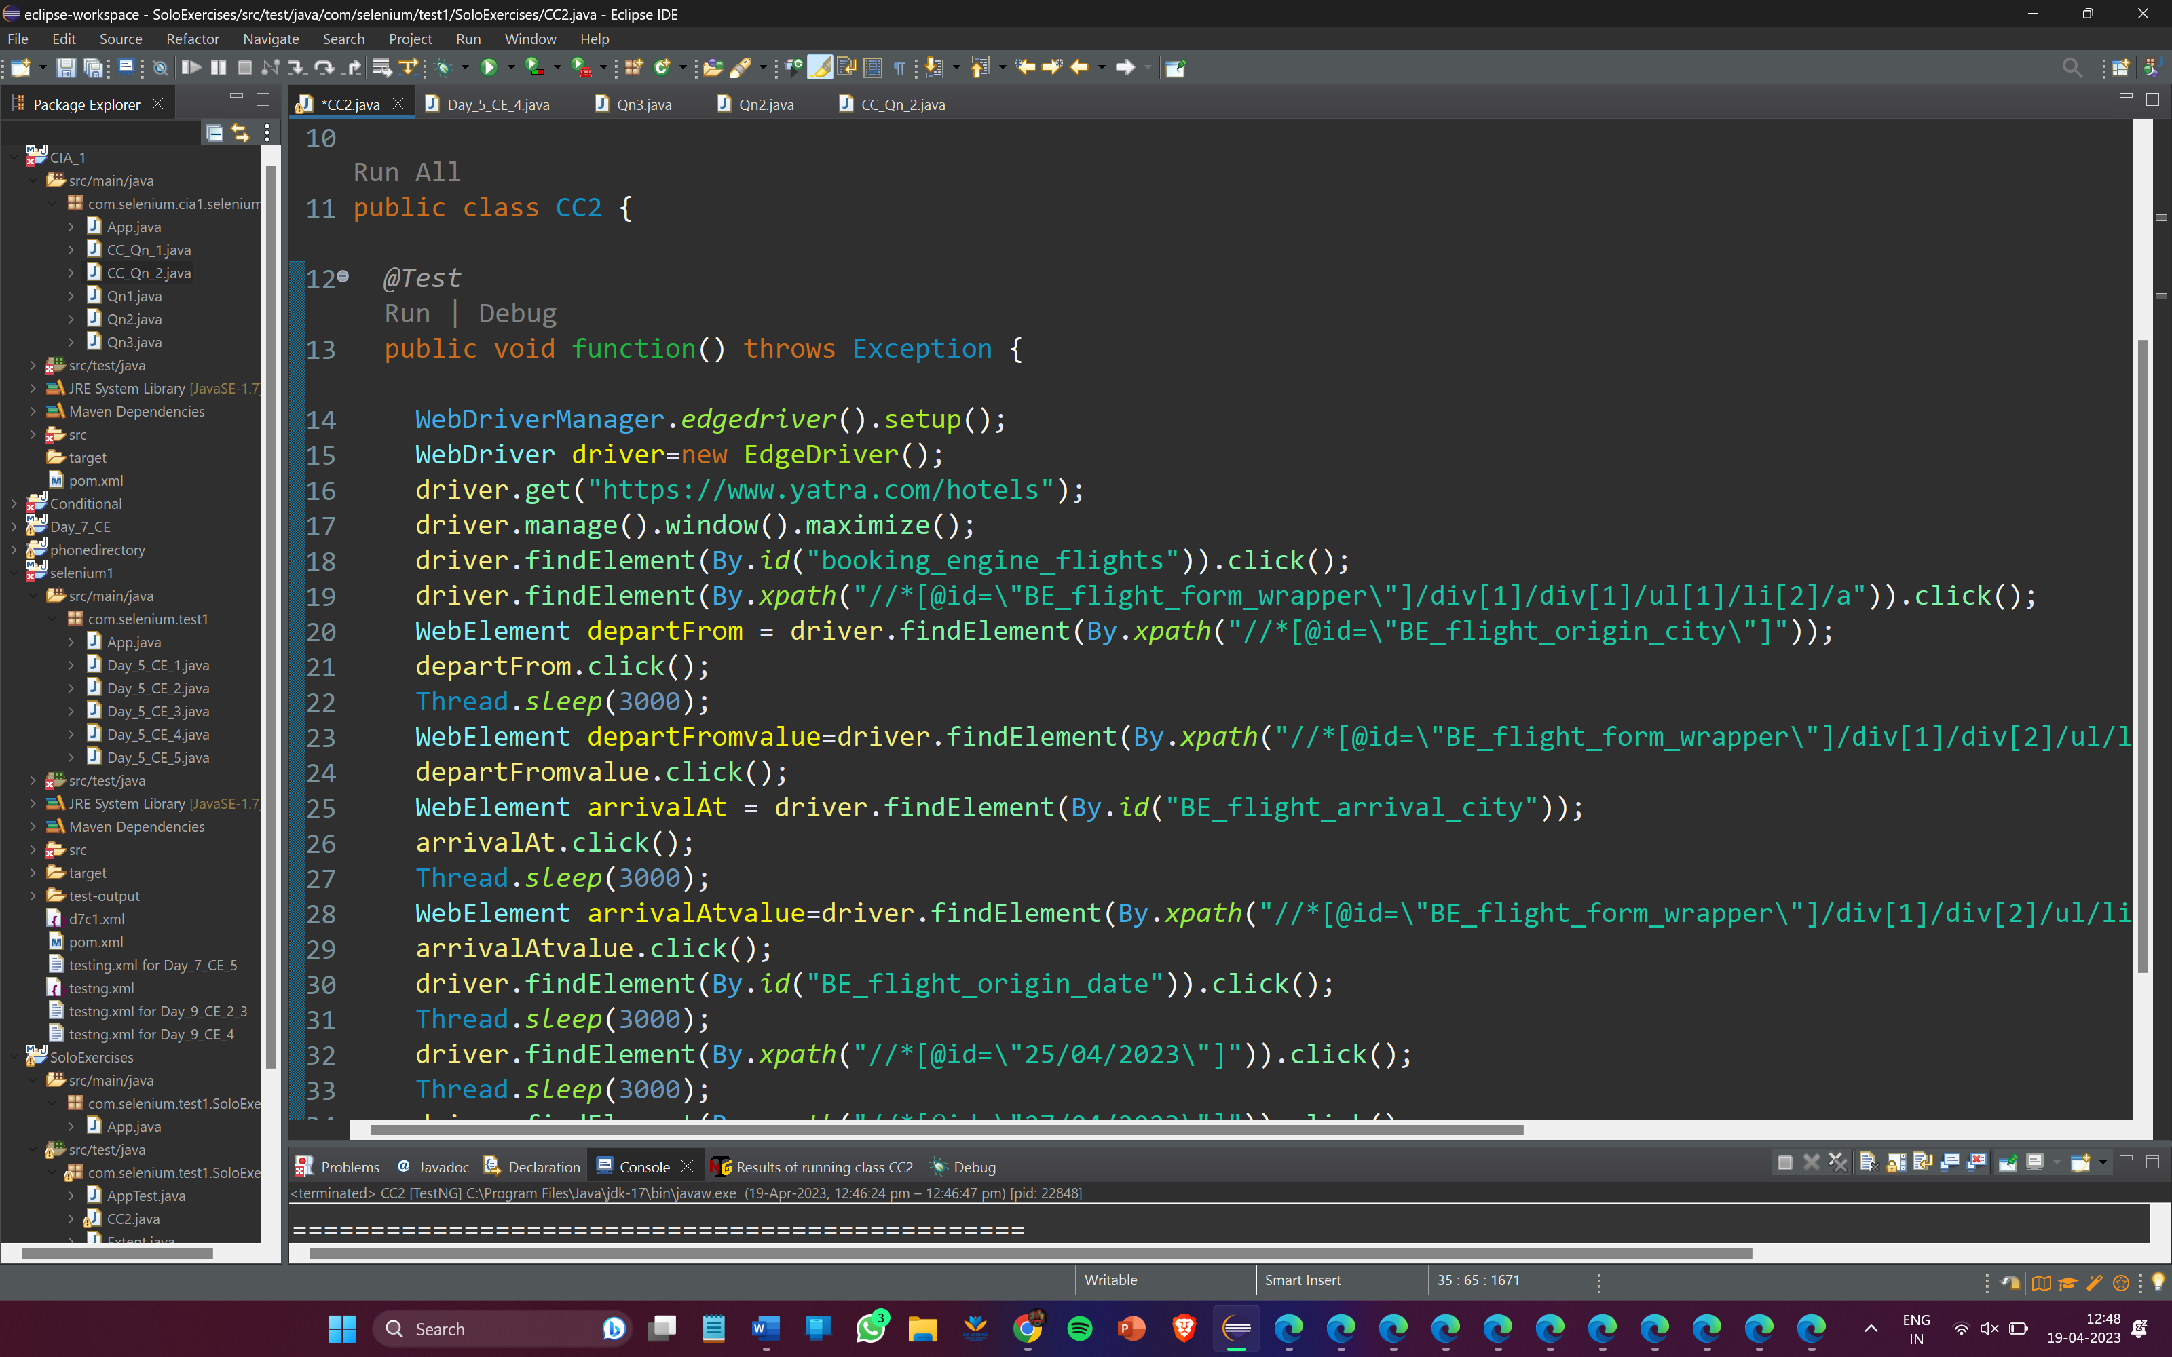

**Output:**

