**Power BI**

**Project Report**

**Crime Against Women in India: Trends and Statistics**

**SUBMITTED TO: ELEVATE LABS**

**SUBMITTED BY: CHARUL MANISHI**

**ACKNOWLEDGEMENT**

I am writing to express my profound gratitude to Elevate Labs for their invaluable contributions to the successful completion of my project titled *"Crime Against Women in India: Trends and Statistics."*

I extend my heartfelt thanks to all the staff members of the Elevate Labs for their continuous guidance, advice, and encouragement. Their expertise played a crucial role in helping me navigate the complexities of analysing and interpreting crime data effectively.

Finally, I acknowledge that this project was independently completed by me, and no external assistance was involved in its execution.

**CONTENTS**

1. Project description

2. Problem statement

Aim(solution)

3. Requirement analysis (tools and technologies required)

Software

Hardware

4. Dataset

Sources

Data cleaning

5. Output screenshots(dashboard)

6. Conclusion (Insights from analysis)

7. Future scope of the project

1. **Project Description**

The project, titled *"Crime Against Women in India: Trends and Statistics,"* delves into the critical issue of crimes against women in India, which continues to be a significant concern affecting social harmony and development. This project seeks to analyse and interpret large volumes of historical crime data to uncover patterns, trends, and correlations that can aid in addressing this persistent issue.

Through the use of Power BI, a leading business intelligence tool, the project transforms raw crime data into meaningful visualizations. These insights provide a comprehensive overview of crimes against women, such as rape, dowry deaths, cruelty by husbands/relatives, kidnapping, and other offenses. By dissecting the data at various levels—temporal (year-wise trends), spatial (state/UT-wise comparisons), and categorical (crime types)—the project aims to facilitate informed decision-making for stakeholders.

**Core Objectives:**

1. **Analyse Year-Wise Trends**: Explore how crime rates have fluctuated from 2001 onward to identify periods of significant change. Highlight the impact of events such as policy changes, legal amendments, or socio-economic developments.
2. **State-Wise Comparisons**: Identify regions with the highest and lowest crime rates to pinpoint areas needing immediate intervention. Provide granular insights for states like Uttar Pradesh, Madhya Pradesh, and Maharashtra, which consistently report higher crime numbers.
3. **Crime-Type Analysis**: Understand the prevalence and distribution of different crime categories. Particular attention is paid to categories like assault and cruelty, which make up a significant portion of crimes against women.
4. **Uncover Patterns and Hotspots**: Use data to identify potential hotspots for crimes against women, assisting in resource allocation for law enforcement and public safety initiatives.

**Significance of the Project:**

The project's findings are not limited to academic analysis but have practical implications for real-world applications. By providing stakeholders with clear and actionable data insights, this project aims to:

* Empower policymakers to create evidence-based interventions.
* Aid law enforcement agencies in deploying targeted efforts to combat specific crime types.
* Help non-governmental organizations (NGOs) focus on regions requiring immediate community-level support and awareness programs.

**Technical Aspects:**

The project utilizes Power BI's advanced visualization capabilities to create dynamic dashboards that present the data interactively. These dashboards allow users to:

* Drill down into specific states or years for detailed insights.
* Compare crime rates across different regions and identify patterns over time.
* View proportional representations of crime types for better understanding.

**Broader Impact:**

This project seeks to contribute to the larger discourse on women’s safety in India. By identifying trends and problem areas, it sheds light on systemic issues requiring collective efforts from the government, civil society, and individuals. Furthermore, it underscores the importance of data-driven decision-making in addressing societal challenges.

Ultimately, this project is a step toward building a safer, more equitable society where women can live without fear and enjoy their rightful dignity and freedom.

1. **Problem Statement (Aim)**

**Problem Identification:**

Crimes against women are a deeply rooted societal issue in India, affecting millions and hindering progress toward gender equality and safety. Despite numerous laws and initiatives, the prevalence of such crimes remains alarmingly high. A significant challenge in combating these crimes is the lack of accessible, actionable, and detailed insights into their patterns and trends. Policymakers, law enforcement agencies, and NGOs often operate without a clear understanding of where and how to focus their efforts.

Furthermore, the data surrounding crimes against women is vast and complex, making it difficult to derive meaningful conclusions without advanced analytical tools. This gap between raw data and actionable insights underscores the urgent need for a robust, data-driven approach to understanding and addressing crimes against women.

**Aim of the Project:**

The aim of this project is to harness the power of data analytics and visualization tools like Power BI to analyse historical crime data and transform it into meaningful insights. By uncovering patterns, trends, and regional disparities, the project seeks to support evidence-based decision-making and advocacy.

Specifically, the project aims to:

1. **Identify Temporal Trends**: Analyse year-on-year changes in crimes against women to understand how different types of crimes have evolved over time and identify periods of significant increase or decrease.
2. **Highlight Regional Disparities**: Examine the distribution of crimes across states and union territories, pinpointing areas with consistently high or low crime rates.
3. **Understand Crime Categories**: Break down crimes into categories such as assault, cruelty by husbands/relatives, dowry deaths, rape, and kidnapping to determine which types of crimes are most prevalent and require immediate intervention.
4. **Provide Visual Representations**: Develop interactive dashboards to present data in an intuitive and user-friendly format, allowing stakeholders to explore insights effortlessly.

**Significance of the Aim:**

By achieving these objectives, the project aspires to:

* Empower **policymakers** with evidence-based insights to draft more effective laws and implement targeted programs.
* Enable **law enforcement agencies** to focus their resources on crime hotspots and develop strategies to tackle specific crime types.
* Assist **NGOs and advocacy groups** in prioritizing their initiatives in areas most affected by crimes against women.
* Increase public awareness about the scale and nature of crimes, fostering community engagement and accountability.

1. **Requirement Analysis**

This section outlines the tools, technologies, and resources needed to execute the project effectively.

* 1. **Software Requirements**

1. **Power BI Desktop**: For creating dashboards and interactive visualizations.
2. **Microsoft Excel**: For data preprocessing, cleaning, and aggregation.
3. **DAX (Data Analysis Expressions)**: Used within Power BI for custom calculations.
4. **Cloud Storage Tools** (Optional): For secure file sharing and collaboration.
   1. **Hardware Requirements**
5. **Computer/Laptop**: Minimum Intel i5 processor, 8GB RAM, and 256GB storage for smooth operation.
6. **Display**: Full HD or higher resolution for clear visualizations.
7. **Internet Connection**: For downloading datasets and accessing updates.

These tools and hardware ensure efficient development, smooth integration of data, and real-time performance in delivering insights through Power BI dashboards.

1. **Dataset**

**Source:** Crime data sourced from the **National Crime Records Bureau (NCRB)** and supplemented with datasets from **Kaggle** for additional context and analysis.

**Description:**

The dataset provides comprehensive data on crimes against women in India, including state-wise and year-wise details across various crime categories. This data is utilized to identify trends, regional disparities, and actionable insights through KPIs and Power BI visualizations.

**Key Performance Indicators (KPIs):**

1. **Total Reported Crimes**: The total number of crimes against women reported in a given period or region.
2. **Average Crime Rate**: The average number of crimes per year, offering a measure of consistency or variability in crime reporting.
3. **Crime Type Distribution**: The proportion of different crime categories (e.g., rape, dowry deaths, assault, etc.) in total crimes.
4. **Top Contributing States**: States with the highest reported crimes, highlighting areas requiring targeted interventions.

**4.1 Data Cleaning**

To ensure the accuracy, reliability, and usability of the crime dataset, the following data cleaning steps were undertaken:

1. **Handling Missing Values**:
   * Identified missing entries in critical columns, such as the number of reported cases and crime types.
   * Imputed missing values using appropriate methods:
     + Used the median for numerical columns (e.g., total crimes reported).
     + Filled missing categorical values, such as "State/UT," based on neighbouring data trends or official records.
2. **Standardizing Categorical Data**:
   * Corrected inconsistencies in crime category names (e.g., variations like "Assault on Women" vs. "Assault").
   * Ensured uniform naming conventions across all records for seamless aggregation and analysis.
3. **Outlier Detection and Treatment**:
   * Identified outliers in columns like reported cases using statistical techniques (e.g., z-scores or interquartile ranges).
   * Reviewed and adjusted outliers caused by data entry errors or extreme but improbable values.
4. **Data Type Corrections**:
   * Ensured all columns had correct data types (e.g., numeric for reported cases, categorical for crime types and states).
   * Converted date-related fields into a uniform date-time format for temporal analysis.
5. **Removing Duplicates**:
   * Checked for and removed duplicate rows or entries to avoid overrepresentation of certain records.
6. **Feature Engineering**:
   * Created new columns, such as "Crime Rate per 100,000 Population," using state-level population data for comparative analysis.
   * Calculated proportions of crime types to total crimes to highlight category-specific trends.

These data cleaning steps ensured that the dataset was accurate, consistent, and ready for advanced analysis and visualization, forming a reliable foundation for deriving actionable insights.

1. **Charts Development**
2. **Total Crimes by Crime Type**

**Objective**: Analyse the distribution of crimes against women by type (e.g., rape, assault, dowry deaths).

**Additional KPI Metrics**: Assess how other metrics (Total Crimes, Crime Rate, Crime Trends) vary across different crime types.

**Chart Type**: **Donut Chart** – to show the proportion of each crime category within the total.

1. **Total Crimes by State/UT**

**Objective**: Identify which states/UTs have the highest reported crimes against women.

**Additional KPI Metrics**: Assess how other metrics (Crime Rate, Crime Trends) vary across different states/UTs.

**Chart Type**: **Bar Chart** – to compare the total number of crimes across states/UTs.

1. **Crime Trends by State**

**Objective**: Compare crime trends over the years across different states/UTs.

**Additional KPI Metrics**: Assess how crime categories (e.g., rape, dowry deaths) have evolved within each state over time.

**Chart Type**: **Stacked Column Chart** – to show year-wise crime distribution by type for each state.

1. **Total Crimes by Year**

**Objective**: Evaluate the trend of reported crimes against women over time (e.g., yearly increases or decreases).

**Chart Type**: **Line Chart** – to visualize changes in total crimes over the years.

1. **Crime Rates by Population Density**

**Objective**: Analyze the relationship between crime rates and population density in various regions.

**Chart Type**: **Donut/Pie Chart** – to show the percentage of crime rates per region relative to population density.

1. **Crime Distribution by Region**

**Objective**: Assess the regional distribution of crime rates across different geographic areas in India.

**Chart Type**: **Funnel Map** – to visualize crime rates across different regions or zones.

1. **All Metrics by State/Crime Type**

**Objective**: Provide a comprehensive view of key metrics (Total Crimes, Crime Rate, Crime Trends) broken down by state and crime type.

**Chart Type**: **Matrix Card** – to display an overview of key metrics for each combination of state and crime category.

1. **OUTPUT SCREENSHOT (DASHBOARD)**

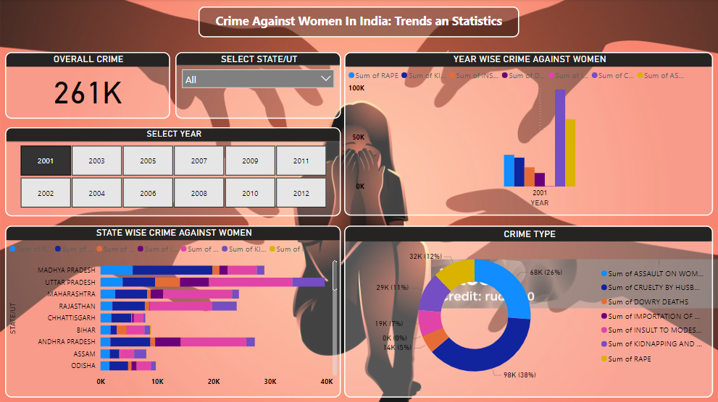

1. **Conclusion: Insights from Analysis**
2. **Crime Trends and Patterns**
   * **High Prevalence Crime Types**: Crimes such as **assault on women** and **cruelty by husbands/relatives** consistently make up a large portion of reported crimes. This highlights the need for targeted interventions and awareness campaigns focusing on these prevalent crime types.
   * **Regional Disparities**: States like **Uttar Pradesh**, **Madhya Pradesh**, and **Maharashtra** show significantly higher crime rates, indicating regional hotspots where greater law enforcement resources and preventive measures should be focused.
   * **Temporal Trends**: A steady increase in crime rates over the past decade suggests that while some progress may have been made, there is a continuing need for systemic reforms, stronger enforcement, and societal awareness to curb these crimes.
3. **Crime Rate and Population Density**
   * **Correlation with Population**: States with higher population densities tend to report higher crime rates, suggesting that urbanization and population growth might contribute to increased crime. This insight could help policymakers plan better resource allocation and target crime reduction efforts in densely populated areas.
   * **Vulnerable Populations**: Specific regions with a higher percentage of marginalized communities report a disproportionate number of crimes. These areas may require tailored social programs and outreach initiatives to reduce vulnerability.
4. **Crime Prevention Strategies**
   * **High Crime Areas**: By identifying high-crime states and districts, resources can be directed to these hotspots for better policing and preventative measures, including community engagement programs and women’s safety initiatives.
   * **Emerging Crime Categories**: Certain emerging crimes, such as **cyber harassment** and **online exploitation**, may require policy attention and tech-based solutions. These areas are not fully captured in historical crime data but are gaining attention due to the rise of digital platforms.
5. **Gender-Based Violence**
   * **Persistent Issues**: High levels of **gender-based violence** such as domestic violence, dowry deaths, and sexual assault highlight the need for continued efforts in law enforcement, victim support, and social reform.
   * **Impact of Laws and Reforms**: Analyzing trends before and after specific legislative changes (e.g., the Nirbhaya Act) may reveal insights into the effectiveness of legal reforms in reducing crime against women.

These insights provide a comprehensive understanding of crime patterns and trends, offering actionable data for policymakers, law enforcement agencies, and NGOs. By focusing efforts on high-crime regions and prevalent crime types, it is possible to reduce violence against women and create a safer society.

1. **Future Scope of the Project**

This project offers significant opportunities for further development, scalability, and integration with broader initiatives aimed at improving women's safety and crime prevention in India. The future scope includes:

1. **Predictive Crime Analytics**
   * Develop machine learning models to forecast future crime trends based on historical data, socio-economic factors, and emerging patterns.
   * Implement predictive tools to identify potential crime hotspots and deploy resources accordingly, allowing law enforcement to proactively address areas at high risk.
2. **Real-time Crime Data Integration**
   * Integrate live data feeds from police stations, law enforcement agencies, and social platforms to monitor crime rates in real-time.
   * Enable real-time alerts for critical issues, such as sudden increases in crime rates or specific types of offenses, allowing for rapid response and intervention.
3. **Advanced Crime Categorization and Analysis**
   * Use natural language processing (NLP) techniques to analyze and classify crime reports, police records, and media coverage for deeper insights into public perceptions of crime and victimization.
   * Implement crime segmentation based on geographical, demographic, and socio-economic data to uncover hidden trends and tailor prevention strategies.
4. **Crime Prevention and Resource Allocation Optimization**
   * Apply predictive analytics to optimize the allocation of law enforcement and public safety resources, ensuring timely intervention in high-crime areas.
   * Develop automated systems for optimizing patrol routes, emergency response teams, and resource distribution to reduce crime and enhance community safety.
5. **State-wise and Regional Performance Benchmarking**
   * Expand the analysis to compare crime rates and law enforcement efficiency across different states and union territories using key performance indicators (KPIs).
   * Establish benchmarks and best practices for high-performing regions to improve overall law enforcement effectiveness and crime prevention strategies.
6. **Expansion Across Crime Categories**
   * Adapt the analytical framework to cover other types of crimes beyond violence against women, such as cybercrime or child trafficking, using similar data-driven approaches.
   * Incorporate competitive analysis with other nations or states to identify best practices in crime reduction and develop comparative strategies.
7. **Predictive and Prescriptive Crime Strategies**
   * Transition from descriptive to prescriptive analytics by developing systems that recommend specific actions based on data insights, such as targeted law enforcement initiatives or public awareness campaigns.
   * Implement AI-driven solutions to suggest optimal strategies for tackling crime, improving policy decisions, and enhancing public safety.

By expanding on this foundation, the project can help law enforcement agencies, policymakers, and social organizations move from reactive approaches to proactive, data-driven strategies, significantly improving women's safety and reducing crime across the country.