WORLD HEALTH REPORT - 2024 DATASET

- Perform the calculation of the standard deviation and mean for Happiness_Score and compare both.
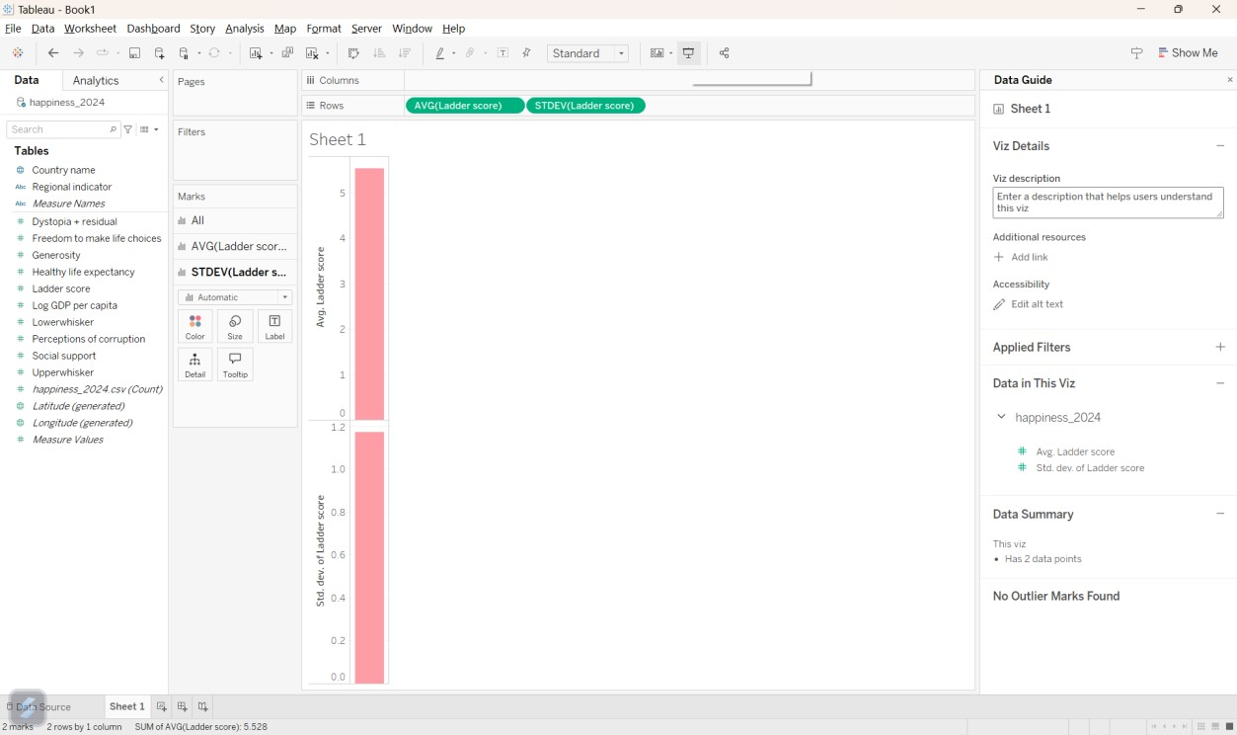

- Create a set for the top 5 Countries where the sum of GDP_per_Capita is greater than or equal to 10.
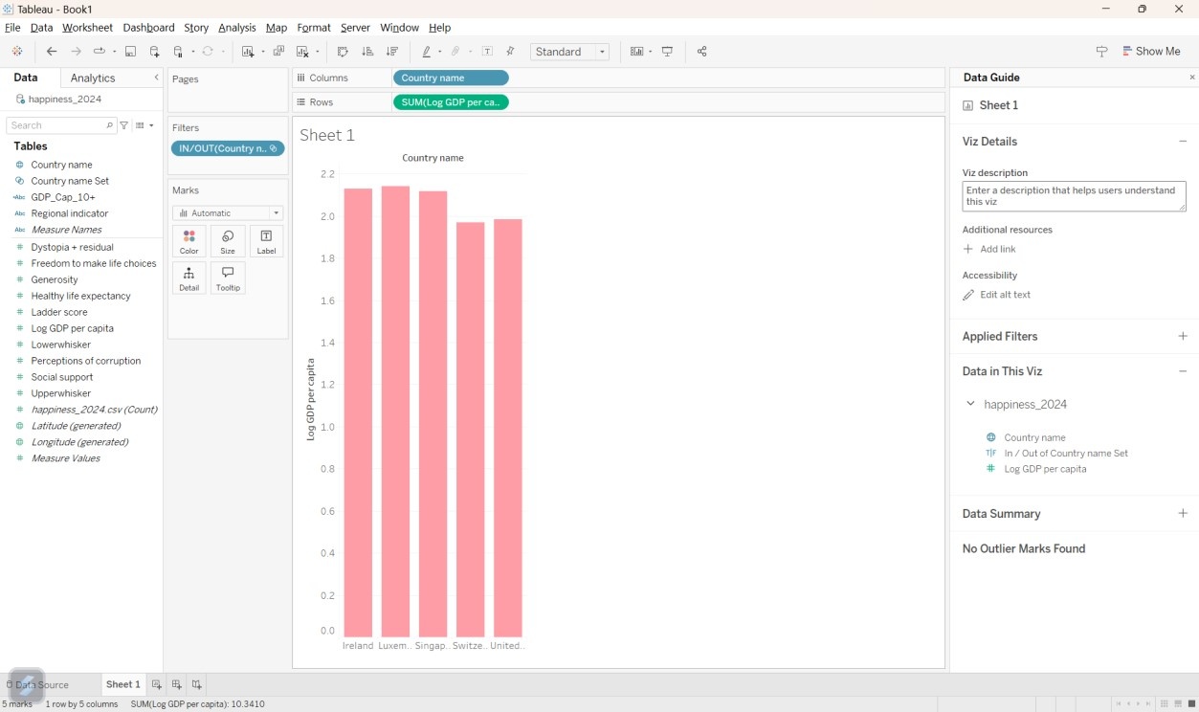

- Create a group for Countries that start with 'C' and show the difference in their Happiness_Score.
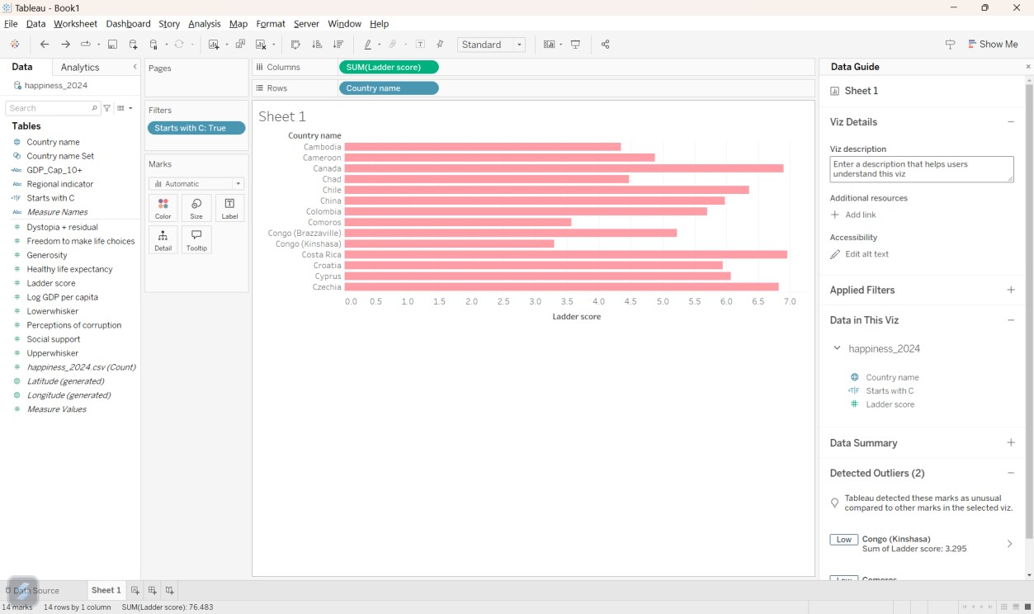

- Create a hierarchy with Region and Country and show the labels only for fields in Region. Show the difference in Happiness_Score using a scatter plot.
