**A PROJECT ON**

**TO SUPPLY LEFTOVER FOOD TO POOR**

*A Project Report Submitted in the partial fulfilment of the*

*requirements for the verification of project*

Submitted by

**AISHWARYA BALA, ASWINI,ARTHI,HARIINI**





**SALESFORCE DEVELOPER**

**MAY 2024 - JUNE 2024**

**DECLARATION**

I, Aishwarya Bala, the sole member responsible for the "To Supply Leftover Food to Poor" project, hereby declare that the project documentation, processes, and implementations described herein are accurate and created in good faith. I affirm that all the details regarding the management of venues, tasks, volunteers, and drop-off points have been thoroughly considered and documented to the best of my knowledge and abilities.

This documentation reflects the intended implementation of the project using Salesforce and is aimed at ensuring a streamlined and efficient system for redistributing leftover food to underprivileged communities. I acknowledge that the success of this project relies on accurate record-keeping, effective coordination, and the collaborative efforts of all involved parties.

I am committed to the ethical and effective execution of this project, and I am dedicated to the continuous improvement of our processes to maximize the positive impact on our target communities.

**Aishwarya Bala**

**Contents**

**Abstract** 4

Creating Developer Account: 9

**Account Activation** 10

Create Drop-Off Point Object 12

Create Task Object: 13

Create Volunteer Object 13

Create Execution Details Object 14

Creating A Custom Tab 14

**Creation Of Relationship Fields In Objects** 15

**Creation Of Fields For The Venue Object:** 18

**Creation Of Fields For The Drop-Off Point Object** 20

**Creation Of Fields For The Task Object:** 24

**Creation Of Fields For The Volunteer Object** 28

Creation Of Fields For The Execution Details Object 32

Create Flow To Create A Record In Venue Object 32

Create A Trigger 35

Profiles: 36

**Creation Of Users:** 36

Creation Of Public Group 1 36

Creation Of Report Types 37

**Creation Of Report On Venue With DropOff With Volunter:** 38

Creation Of Report On Volunteers With Execution Details And Tasks 39

Adding Venue And Drop Off Point Report To The Dashboard 40

Adding Volunteer Task Report To The Dashboard 41

Creation Of Sharing Rules 41

**Abstract**

The "To Supply Leftover Food to Poor" project, facilitated through the Food Connect app on Salesforce, aims to reduce food waste and alleviate hunger. This initiative involves managing venues with surplus food, coordinating tasks and volunteer efforts, and establishing drop-off points for redistribution. Custom objects in Salesforce track venues, tasks, volunteers, and drop-off points, ensuring efficient food collection and distribution. The project fosters better coordination and effective resource allocation, contributing to a more structured and impactful approach to feeding the underprivileged, thereby addressing both food waste and hunger in our communities.

**OBJECTIVE**

The primary goal of the Food Connect project is to establish an efficient and streamlined system for redistributing leftover food to underprivileged communities. By leveraging Salesforce, the project aims to manage venues, tasks, volunteers, and drop-off points effectively, ensuring that surplus food reaches those in need in a timely manner.

**SCOPE:**

This project addresses the dual issues of food waste and hunger by setting up a structured process for food collection and distribution. The key activities include:

1. Identifying venues that generate leftover food.
2. Coordinating tasks and volunteer efforts.
3. Establishing drop-off points for food redistribution.

**INTRODUCTION TO SALESFORCE**

Salesforce is a leading cloud-based Customer Relationship Management (CRM) platform that enables organizations to streamline their business processes and enhance customer interactions. Established in 1999, Salesforce offers a suite of applications for sales, customer service, marketing, and more, designed to help businesses manage relationships with customers, prospects, and partners.

**Key Features of Salesforce:**

1. **Customizable CRM:** Salesforce provides a highly customizable platform that can be tailored to meet the specific needs of any business, regardless of industry.
2. **Cloud-Based:** As a cloud-based service, Salesforce allows users to access their data from anywhere, on any device, ensuring flexibility and mobility.
3. **Integration Capabilities:** Salesforce can be integrated with a wide variety of other systems and applications, allowing for seamless data flow across different platforms.
4. **Automation:** The platform supports advanced automation features, such as workflow rules, process builder, and Salesforce Flow, to automate repetitive tasks and improve efficiency.
5. **Analytics and Reporting:** Salesforce offers robust analytics and reporting tools that provide insights into business performance and help make data-driven decisions.
6. **AppExchange:** This marketplace offers a wide range of third-party applications and integrations that can extend Salesforce’s functionality.

**WHY SALESFORCE FOR THIS APPLICATION?**

1. **Data Management:**
   * **Venues:** Track and store detailed information about venues providing leftover food, including their contact details, capacity, and available food quantity.
   * **Tasks:** Manage tasks related to food collection and distribution, documenting task details, status, due dates, and assigned volunteers.
   * **Volunteers:** Maintain a database of volunteers, including their availability, skills, and contact information.
   * **Drop-Off Points:** Document drop-off points for food redistribution, storing details such as location, capacity, and contact persons.
2. **Automation of Processes:**
   * Automate notifications and reminders for tasks and deadlines.
   * Streamline volunteer assignments and ensure efficient coordination of efforts.
3. **Reporting and Analytics:**
   * Generate reports to monitor food collection and distribution progress.
   * Analyze data to identify trends, improve processes, and make informed decisions.
4. **Collaboration:**
   * Facilitate collaboration among team members through shared records and Chatter, Salesforce’s social collaboration tool.
   * Ensure that all stakeholders have access to up-to-date information.
5. **Compliance and Accountability:**
   * Maintain accurate records for audit and compliance purposes.
   * Ensure accountability through detailed documentation of all activities and processes.

**Key Components**

1. **Venue Management:**
   * Track and manage venues that provide leftover food.
   * Store details such as venue name, address, contact person, phone number, capacity, and available food quantity.
2. **Task Management:**
   * Define and assign tasks related to the collection and distribution of food.
   * Store task details including name, description, due date, status, assigned volunteer, and associated venue.
3. **Volunteer Management:**
   * Maintain a database of volunteers with their names, contact information, availability, and skills.
   * Assign volunteers to specific tasks and venues based on their availability and skill set.
4. **Drop-Off Point Management:**
   * Identify and manage locations where food can be dropped off for redistribution.
   * Store details such as drop-off point name, address, contact person, phone number, capacity, and received food quantity.

**IMPLEMENTATION**

The project will be implemented in Salesforce, with the following steps:

**Salesforce Developer Account Creation:**

### Creating Developer Account:

Creating a developer org in salesforce.

1. Go to <https://developer.salesforce.com/signup>
2. On the sign up form, enter the following details :[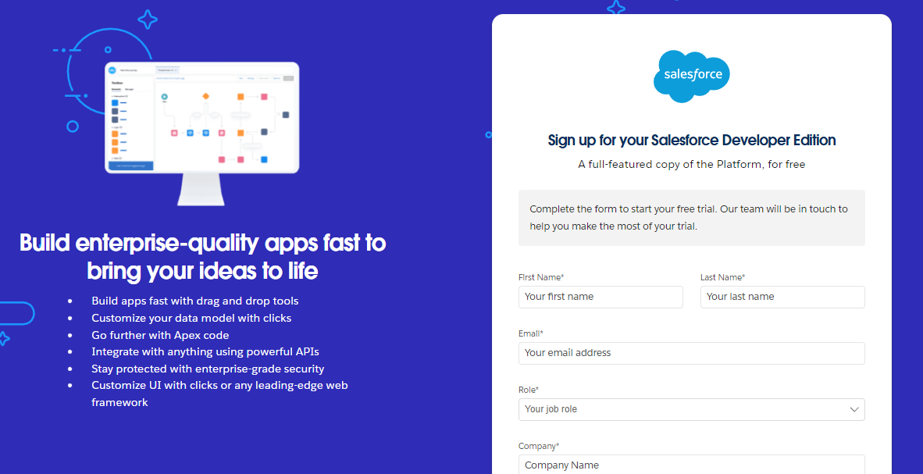](https://developers.salesforce.com/Signup*)
   1. First name & Last name
   2. Email
   3. Role : Developer
   4. Company : College or Company Name
   5. County : India
   6. Postal Code : pin code
   7. Username : should be a combination of your name and company

This need not be an actual email id, you can give anything in the format :

username@organization.com

Click on sign me up after filling these.

**Account Activation**

1. Go to the inbox of the email that you used while signing up. Click on the verify account to activate your account. The email may take 5-10mins.

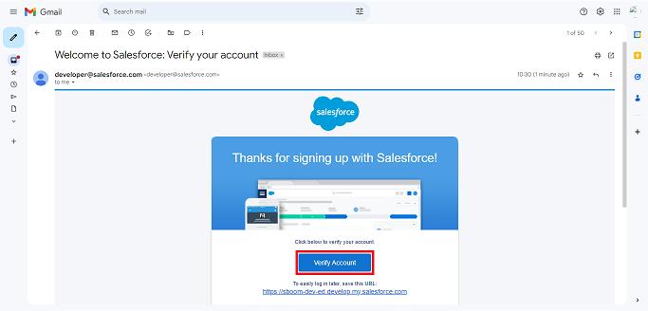

1. 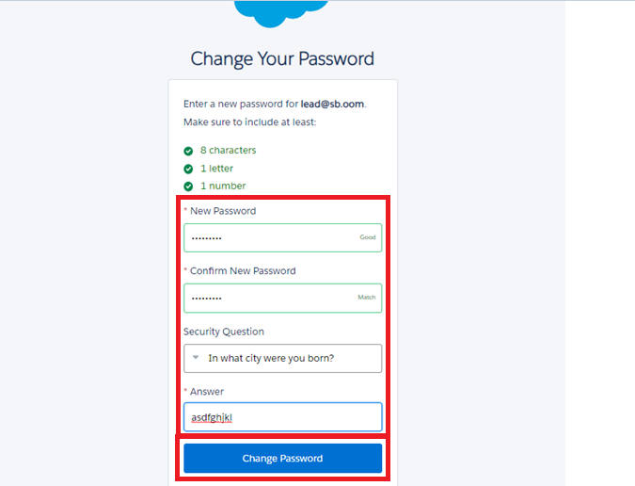Click on Verify Account
2. Give a password and answer a security question and click on change password.

1. Give a password and answer a security question and click on change password.
2. Then you will redirect to your salesforce setup page.

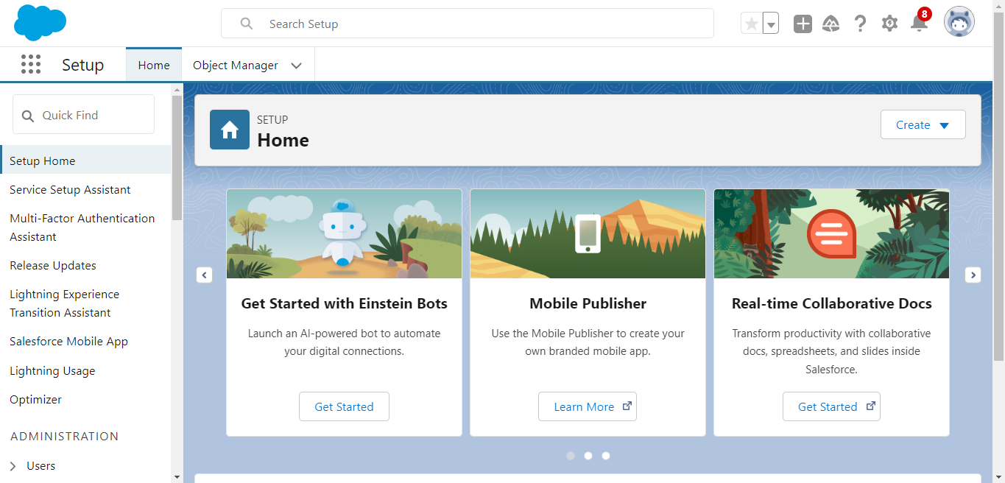

**CREATION OF OBJECTS:**

**Create Venue Object:**

To create an object:

1. From the setup page >> Click on Object Manager >> Click on Create >>Click on Custom Object.
2. Enter the label name >> Venue
3. Plural label name >> Venues
4. Enter Record Name Label and Format

* Record Name >> Venue Name
* Data Type >> Text

1. Click on Allow reports and Track Field History,Allow Activities.
2. Allow search >> Save.

### Create Drop-Off Point Object

To create an object:

1. From the setup page >> Click on Object Manager >> Click on Create >> Click on Custom Object.
2. Enter the label name >> Drop-Off Point
3. Plural label name>> Drop-Off Points
4. Enter Record Name Label and Format

* Record Name >> Drop-Off point Name
* Data Type >> Text

1. Click on Allow reports and Track Field History,Allow Activities
2. Allow search >> Save.

### Create Task Object:

To create an object:

1. From the setup page >> Click on Object Manager >> Click on Create >> Click on Custom Object.
2. Enter the label name>> Task
3. Plural label name>> Tasks
4. Enter Record Name Label and Format

* Record Name >> Task Name
* Data Type >> Text

1. Click on Allow reports and Track Field History,Allow Activities
2. Allow search >> Save.

### Create Volunteer Object

To create an object:

1. From the setup page >> Click on Object Manager>> Click on Create >> Click on Custom Object.
2. Enter the label name>> Volunteer
3. Plural label name>> Volunteers
4. Enter Record Name Label and Format

* Record Name >> Volunteer Name
* Data Type >> Text

1. Click on Allow reports and Track Field History, Allow Activities
2. Allow search >> Save.

### Create Execution Details Object

To create an object:

1. From the setup page >> Click on Object Manager >> Click on Create >> Click on Custom Object.
2. Enter the label name >> Execution Detail
3. Plural label name >> Execution Details
4. Enter Record Name Label and Format

* Record Name >> Execution Detail Name
* Data Type >> Text

1. Click on Allow reports and Track Field History, Allow Activities
2. Allow search >> Save.

### Creating A Custom Tab

To create a Tab:(Venue)

1. Go to setup page >> type Tabs in Quick Find bar >> click on tabs >> New (under custom object tab)
2. Select Object(Venue) >> Select the tab style >> Next (Add to profiles page) keep it as default >> Next (Add to Custom App)  uncheck the include tab
3. Make sure that the Append tab to users' existing personal customizations is checked.
4. Click save 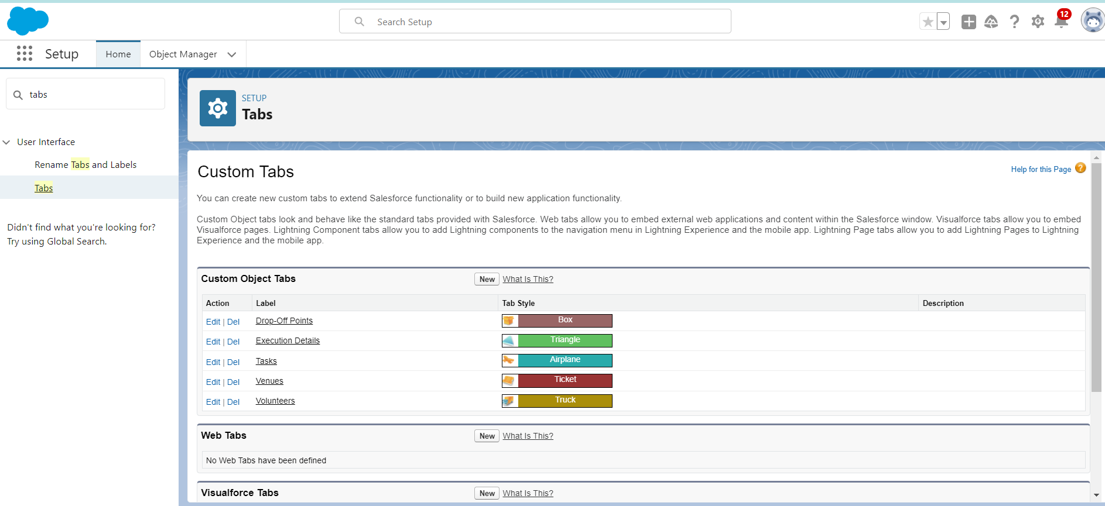

Now create the Tabs for the remaining Objects, they are “Drop-Off Point, Task, Volunteer, Execution Details.

**Creation Of Relationship Fields In Objects**

**Creation of Lookup Relationship Field on Volunteer Object :**

1. Go to setup >> click on Object Manager >> type object name(Volunteer) in the search  bar >> click on the object.
2. Now click on “Fields & Relationships” >> New
3. Select Master Detail relationship
4. Select the related object “Drop-Off point” and click next.
5. Field Name : Drop_Off_point
6. Field label : Auto generated
7. Next >> Next >> Save.

**Creation of Master Detail Relationship Field on Execution Details Object :**

1. Go to setup >> click on Object Manager >> type object name(Execution Details) in the search  bar >> click on the object.
2. Now click on “Fields & Relationships” >> New
3. Select Master Detail relationship
4. Select the related object “Volunteer” and click next.
5. Field Name : Volunteer
6. Field label : Auto generated
7. Next >> Next >> Save.

Creation of Master Detail Relationship Field on Execution Details Object :

1. Go to setup >> click on Object Manager >> type object name(Execution Details) in the search  bar >> click on the object.
2. Now click on “Fields & Relationships” >> New
3. Select Master Detail relationship
4. Select the related object “Task” and click next.
5. Field Name : Task
6. Field label : Auto generated
7. Next >> Next >> Save.

Creation of Lookup Relationship Field on Drop-Off Point Object :

1. Go to setup >> click on Object Manager >> type object name(Task) in the search  bar >> click on the object.
2. Now click on “Fields & Relationships” >> New
3. Select Lookup relationship
4. Select the related object “Drop-Off Point” and click next.
5. Field Name : Venue
6. Field label : Venue__c
7. Next >> Next >> Save.

Creation of Lookup Relationship Field on Task Object :

1. Go to setup>> click on Object Manager >> type object name(Task) in the search  bar >> click on the object.
2. Now click on “Fields & Relationships” >> New
3. Select Lookup relationship
4. Select the related object “Venue” and click next.
5. Field Name : Sponsored By
6. Field label : Auto generated
7. Next >> Next >> Save.

Creation of Lookup Relationship Field on Task Object :

1. Go to setup>> click on Object Manager >> type object name(Task) in the search  bar >> click on the object.
2. Now click on “Fields & Relationships” >> New
3. Select Lookup relationship
4. Select the related object “Drop-Off point” and click next.
5. Field Name : Drop-Off point
6. Field label : Auto generated
7. Next >> Next >> Save.

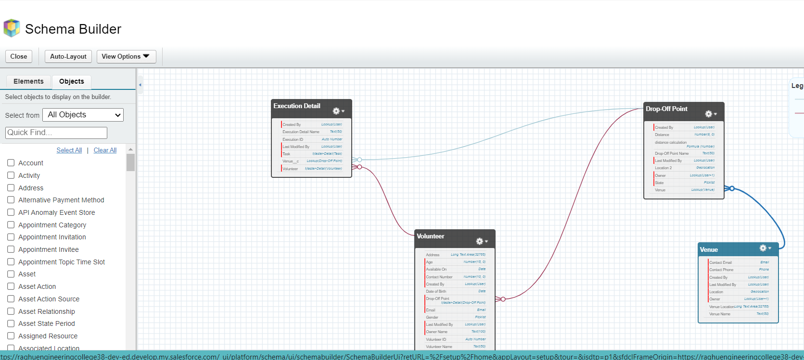

**Creation Of Fields For The Venue Object:**

1. Go to setup>> click on Object Manager >> type object name(Venue) in search bar >> click on the object.
2. Now click on “Fields & Relationships” >> New
3. Select Data type as a “Email” and Click on Next
4. Fill the Above as following:

* Field Label : Contact Email
* Field Name : Contact Email
* Click on required check box
* Click on Next >> Next >> Save and new.

**To create another fields in an object:**

1. Go to setup >> click on Object Manager >> type object name(Venue) in search bar >> click on the object.
2. Now click on “Fields & Relationships” >> New
3. Select Data type as a “Phone” and Click on Next
4. Fill the Above as following:

* Field Label : Contact Phone
* Field Name : Contact Phone
* Click on required check box
* Click on Next >> Next >> Save and new.

**To create another fields in an object:**

1. Go to setup >> click on Object Manager >> type object name(Venue) in search bar >>click on the object.
2. Now click on “Fields & Relationships” >> New
3. Select Data type as a “Geolocation” and Click on Next
4. Fill the Above as following:

* Field Label : Location
* Decimal Places : 4
* Field Name : Location
* Description : Enter the Geolocation of your Venue
* Click on Next >> Next >> Save and new.

To create another fields in an object:

1. Go to setup >> click on Object Manager >> type object name(Venue) in search bar >> click on the object.
2. Now click on “Fields & Relationships” >> New
3. Select Data type as a “Long Text Area” and Click on Next
4. Fill the Above as following:

* Field Label : Venue Location
* Field Name : Venue_Location
* Click on Next >> Next >> Save and new.

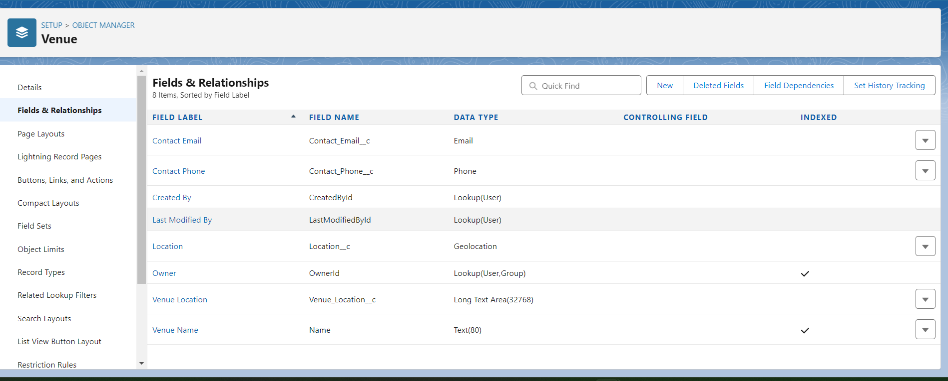

**Creation Of Fields For The Drop-Off Point Object**

1. Go to setup >> click on Object Manager >> type object name(Drop-Off point) in search bar >> click on the object.

2. Now click on “Fields & Relationships” >> New

3. Select Data type as a “Geolocation” and Click on Next

4. Fill the Above as following:

* Field Label : Location 2
* Field Name : gets auto generated
* Description : Enter the Geolocation of the Drop off Point
* Geolocation Options : select Decimal
* Decimal Places : 4
* Click on Next >> Next >> Save and new.

To create another fields in an object:

1. Go to setup >> click on Object Manager >> type object name(Drop-Off point) in search bar >> click on the object.
2. Now click on “Fields & Relationships” >> New
3. Select Data type as a “Formula” and Click on Next
4. Fill the Above as following:

* Field Label : distance calculation
* Field Name : distance_calculation
* Formula Return Type : Number
* Formula Options : DISTANCE( Location_2__c ,  Venue__r.Location__c , 'km')
* Click on Next >> Next >> Save and new

To create another fields in an object:

1. Go to setup >> click on Object Manager >> type object name(Drop-Off point) in search bar >> click on the object.
2. Now click on “Fields & Relationships” >> New
3. Select Data type as a “Picklist” and Click on Next
4. Fill the Above as following:

* Field Label : State
* Field Name : State
* Enter values, with each value separated by a new line :

Andhra Pradesh

Arunachal Pradesh

Assam

Bihar

Chhattisgarh

Goa

Gujarat

Haryana

Himachal Pradesh

Jharkhand

Karnataka

Kerala

Maharashtra

Madhya Pradesh

Manipur

Meghalaya

Mizoram

Nagaland

Odisha

Punjab

Rajasthan

Sikkim

Tamil Nadu

Tripura

Telangana

Uttar Pradesh

Uttarakhand

West Bengal

Andaman & Nicobar (UT)

Chandigarh (UT)

Dadra & Nagar Haveli and Daman & Diu (UT)

Delhi [National Capital Territory (NCT)]

Jammu & Kashmir (UT)

Ladakh (UT)

Lakshadweep (UT)

Puducherry (UT)

* Click on required check box
* Click on Next >> Next >> Save and new.

To create another fields in an object:

1. Go to setup >> click on Object Manager >> type object name(Task) in search bar >> click on the object.
2. Now click on “Fields & Relationships” >> New
3. Select Data type as a “Number” and Click on Next
4. Fill the Above as following:

* Field Label : Distance
* Field Name : Distance
* Length : 14
* Decimal Places : 4
* Click on required check box
* Click on Next >> Next >> Save and new.

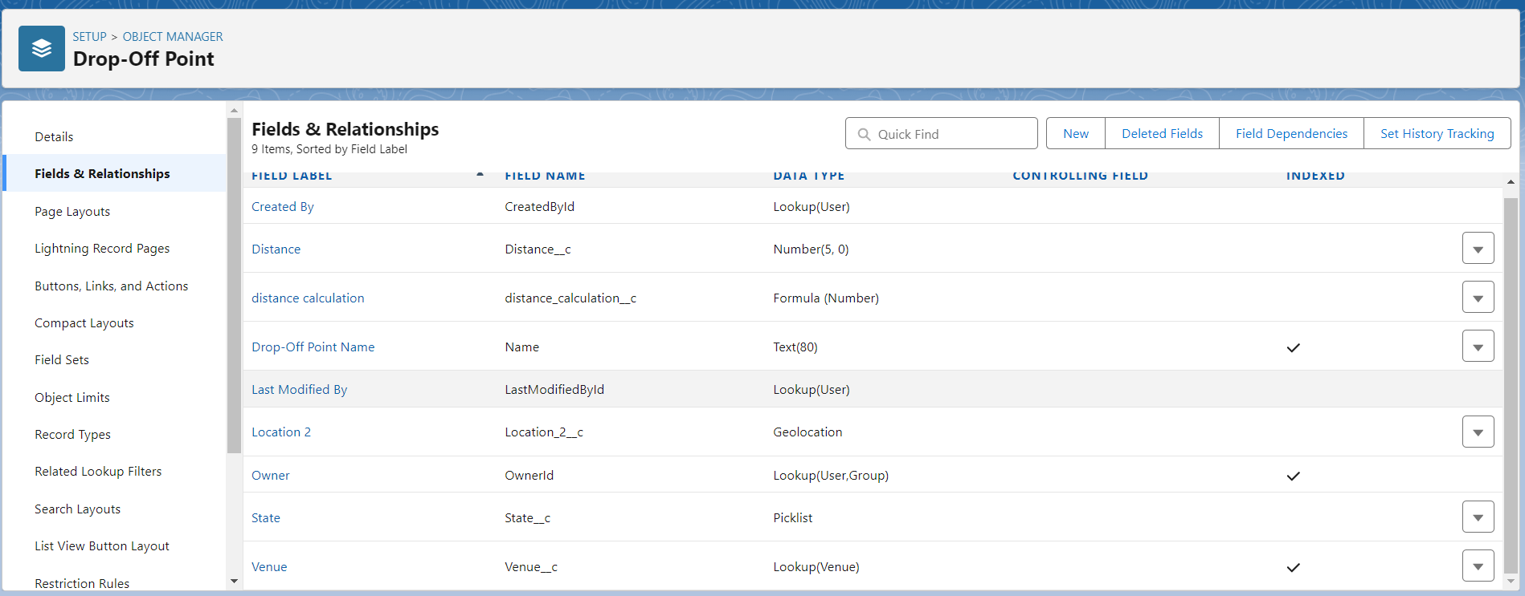

**Creation Of Fields For The Task Object:**

1.Go to setup>> click on Object Manager >> type object name(Task) in search bar >> click on the object.

2. Now click on “Fields & Relationships” >> New

3. Select Data type as a “Auto Number” and Click on Next

4. Fill the Above as following:

* Field Label : Task ID
* Display Format : TASK-{0}
* Starting Number : 1
* Field Name : gets auto generated
* Click on required check box
* Click on Next >> Next >> Save and new.

To create another fields in an object:

1. Go to setup >> click on Object Manager >> type object name(Task) in search bar >> click on the object.
2. Now click on “Fields & Relationships” >> New
3. Select Data type as a “Date” and Click on Next
4. Fill the Above as following:

* Field Label : Date
* Field Name : Date
* Click on required check box
* Click on Next >> Next >> Save and new.

To create another fields in an object:

1. Go to setup >> click on Object Manager >> type object name(Task) in search bar >> click on the object.
2. Now click on “Fields & Relationships” >> New
3. Select Data type as a “Picklist (Multi-Select)” and Click on Next
4. Fill the Above as following:

* Field Label : Food Category
* Field Name : Food Category
* Enter values, with each value separated by a new line :

Veg

Non-Veg

Salad

Snack

* Click on required check box
* Click on Next >> Next >> Save and new.

To create another fields in an object:

1. Go to setup >> click on Object Manager >> type object name(Task) in search bar >> click on the object.
2. Now click on “Fields & Relationships” >> New
3. Select Data type as a “Number” and Click on Next
4. Fill the Above as following:

* Field Label : Number of People Served
* Field Name : Number_of_People_Served
* Click on required check box
* Click on Next >> Next >> Save and new.

To create another fields in an object:

1. Go to setup >> click on Object Manager >> type object name(Task) in search bar >> click on the object.
2. Now click on “Fields & Relationships” >> New
3. Select Data type as a “Text” and Click on Next
4. Fill the Above as following:

* Field Label : Name of the Person
* Field Name : Name_of_the_Person
* Click on Next >> Next >> Save and new.

To create another fields in an object:

1. Go to setup>> click on Object Manager >> type object name(Task) in search bar >> click on the object.
2. Now click on “Fields & Relationships” >> New
3. Select Data type as a “Phone” and Click on Next
4. Fill the Above as following:

* Field Label : Phone
* Field Name : Phone
* Click on Next >> Next>> Save and new.

To create another fields in an object:

1. Go to setup >> click on Object Manager >> type object name(Task) in search bar >> click on the object.
2. Now click on “Fields & Relationships” >> New
3. Select Data type as a “Pick List” and Click on Next
4. Fill the Above as following:

* Field Label : Rating
* Field Name : Rating
* Enter values, with each value separated by a new line :

1

2

3

4

5

* Click on Next >> Next >> Save and new.

To create another fields in an object:

1. Go to setup >> click on Object Manager >> type object name(Task) in search bar >> click on the object.
2. Now click on “Fields & Relationships” >> New
3. Select Data type as a “Long Text Area” and Click on Next
4. Fill the Above as following:

* Field Label : Feedback
* Field Name : Feedback
* Click on Next >> Next >> Save and new.

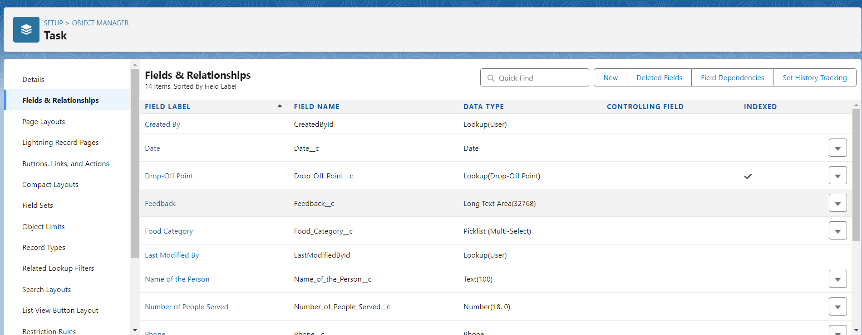

**Creation Of Fields For The Volunteer Object**

1. Go to setup >> click on Object Manager >> type object name(Volunteer) in search bar >> click on the object.

2. Now click on “Fields & Relationships” >> New

3. Select Data type as a “Auto Number” and Click on Next

4. Fill the Above as following:

* Field Label : Volunteer ID
* Field Name : gets auto generated
* Click on required check box
* Click on Next >> Next >> Save and new.
* Click on Next >> Next >> Save and new.

To create another fields in an object:

1. Go to setup >> click on Object Manager >> type object name(Volunteer) in search bar >> click on the object.
2. Now click on “Fields & Relationships” >> New
3. Select Data type as a “Picklist” and Click on Next
4. Fill the Above as following:

* Field Label : Gender
* Field Name : Gender
* Enter values, with each value separated by a new line :

Female

Male

* Click on Next >> Next >> Save and new.

To create another fields in an object:

1. Go to setup >> click on Object Manager >> type object name(Volunteer) in search bar >> click on the object.
2. Now click on “Fields & Relationships” >> New
3. Select Data type as a “Date” and Click on Next
4. Fill the Above as following:

* Field Label : Available On
* Field Name : Available On
* Click on required check box
* Click on Next >> Next >> Save and new.

To create another fields in an object:

1. Go to setup >> click on Object Manager >> type object name(Volunteer) in search bar >> click on the object.
2. Now click on “Fields & Relationships” >> New
3. Select Data type as a “Number” and Click on Next
4. Fill the Above as following:

* Field Label : Age
* Field Name : Age
* Click on required check box
* Click on Next >> Next>> Save and new.

To create another fields in an object:

1. Go to setup >> click on Object Manager >> type object name(Volunteer) in search bar >> click on the object.
2. Now click on “Fields & Relationships” >> New
3. Select Data type as a “Email” and Click on Next
4. Fill the Above as following:

* Field Label : Email
* Field Name : Email
* Click on required check box
* Click on Next>> Next >> Save and new.

To create another fields in an object:

1. Go to setup >> click on Object Manager >> type object name(Volunteer) in search bar >> click on the object.
2. Now click on “Fields & Relationships” >> New
3. Select Data type as a “Number” and Click on Next
4. Fill the Above as following:

* Field Label : Contact Number
* Field Name : Contact_Number
* Click on required check box
* Click on Next >> Next >> Save and new.

To create another fields in an object:

1. Go to setup >> click on Object Manager >> type object name(Volunteer) in search bar >> click on the object.
2. Now click on “Fields & Relationships” >> New
3. Select Data type as a “Text Area (Long)” and Click on Next
4. Fill the Above as following:

* Field Label : Address
* Field Name : Address
* Click on Next >> Next >> Save and new.

To create another fields in an object:

1. Go to setup >> click on Object Manager >> type object name(Volunteer) in search bar >> click on the object.
2. Now click on “Fields & Relationships” >> New
3. Select Data type as a “Date” and Click on Next
4. Fill the Above as following:

* Field Label : Date of Birth
* Field Name : Date_of_Birth
* Click on Next >> Next >> Save and new.

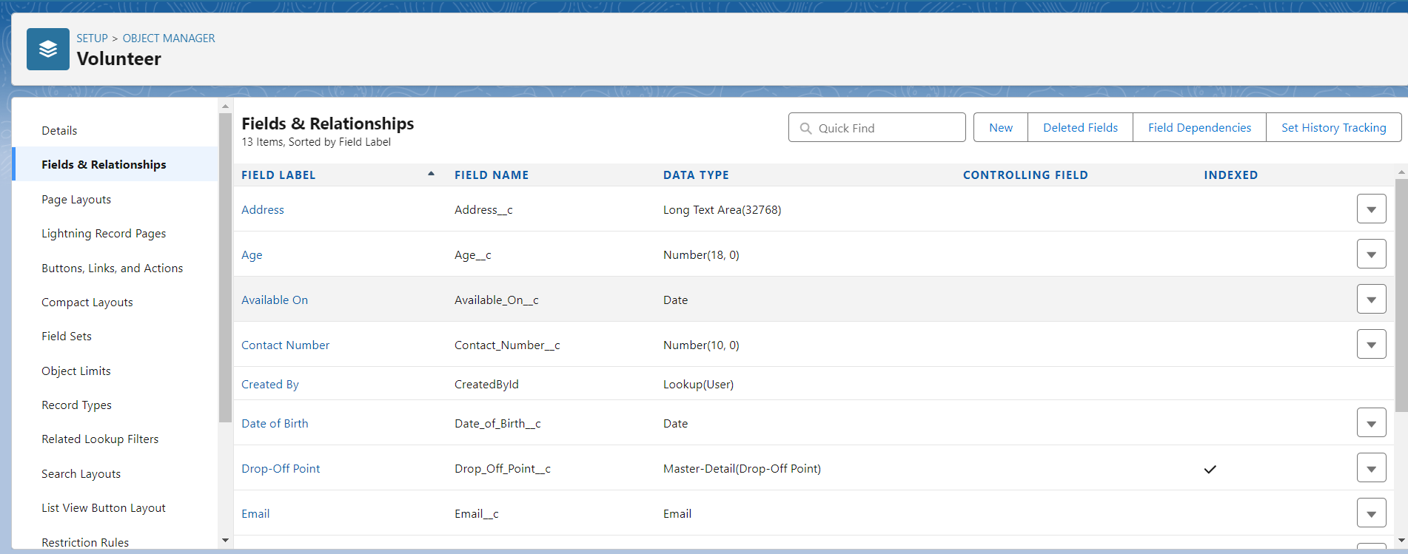

### Creation Of Fields For The Execution Details Object

1.Go to setup >> click on Object Manager >> type object name(Volunteer) in search bar >> click on the object.

2. Now click on “Fields & Relationships” >> New

3. Select Data type as a “Auto Number” and Click on Next

4. Fill the Above as following:

* Field Label : Execution ID
* Field Name : gets auto generated
* Click on required check box
* Click on Next >> Next >> Save and new.

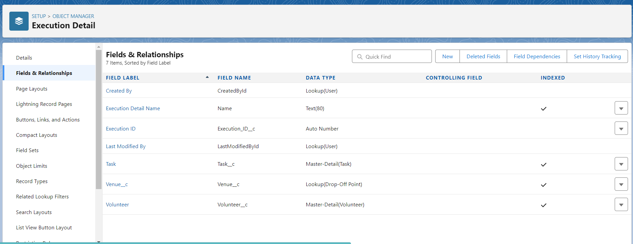

**FLOWS:**

### Create Flow To Create A Record In Venue Object

1. Go to setup >> type Flow in quick find box >> Click on the Flow and Select the New Flow.
2. Select the Screen flow. Click on create.
3. Click on the ‘+’ icon in between start and end, and click on screen element.
4. Under the Screen Properties:

Label : Venue Details

API Name : Venue_Details

1. Now lets add components in this flow. Click on Text Component and name it as:

Label : Venue Name

API Name : Venue_Name

1. Click on Email Component and name it as:

Label : Email

API Name : Contact_Email

1. Click on Phone Component and name it as:

Label : Phone

API Name : Contact_Phone

1. Click on Text Component and name it as:

Label : Venue Location

API Name : Venue_Location

1. Click on Number Component and name it as:

Label : Latitude

API Name : Latitude

1. Click on Number Component and name it as:

Label : longitude

API Name : longitude

1. Next click on Done. This would like below
2. Click on the ‘+’ icon in between Venue details and end, and click on create record element.
3. Now label it as

Label : Create Venue Record

API Name : Create_Venue_Record

How Many Records to Create : One

How to Set the Record Fields : Use separate resources, and literal values

Object : Venue

Set Field Values for the Venue : Click on ‘Add Field’ 5 times

Field : Value = Contact_Email__c : {!Contact_Email.value}

Field : Value = Contact_Phone__c : {!Contact_Phone.value}

Field : Value = Name : {!Venue_Name}

Field : Value = Venue_Location__c : {!location}

Field : Value = Location__Latitude__s : {!latitude}

Field : Value = Location__Longitude__s : {!longitude}

1. This would look like:
2. Click on Save as:

Flow Label : Venue Form

Flow API Name : Venue_Form

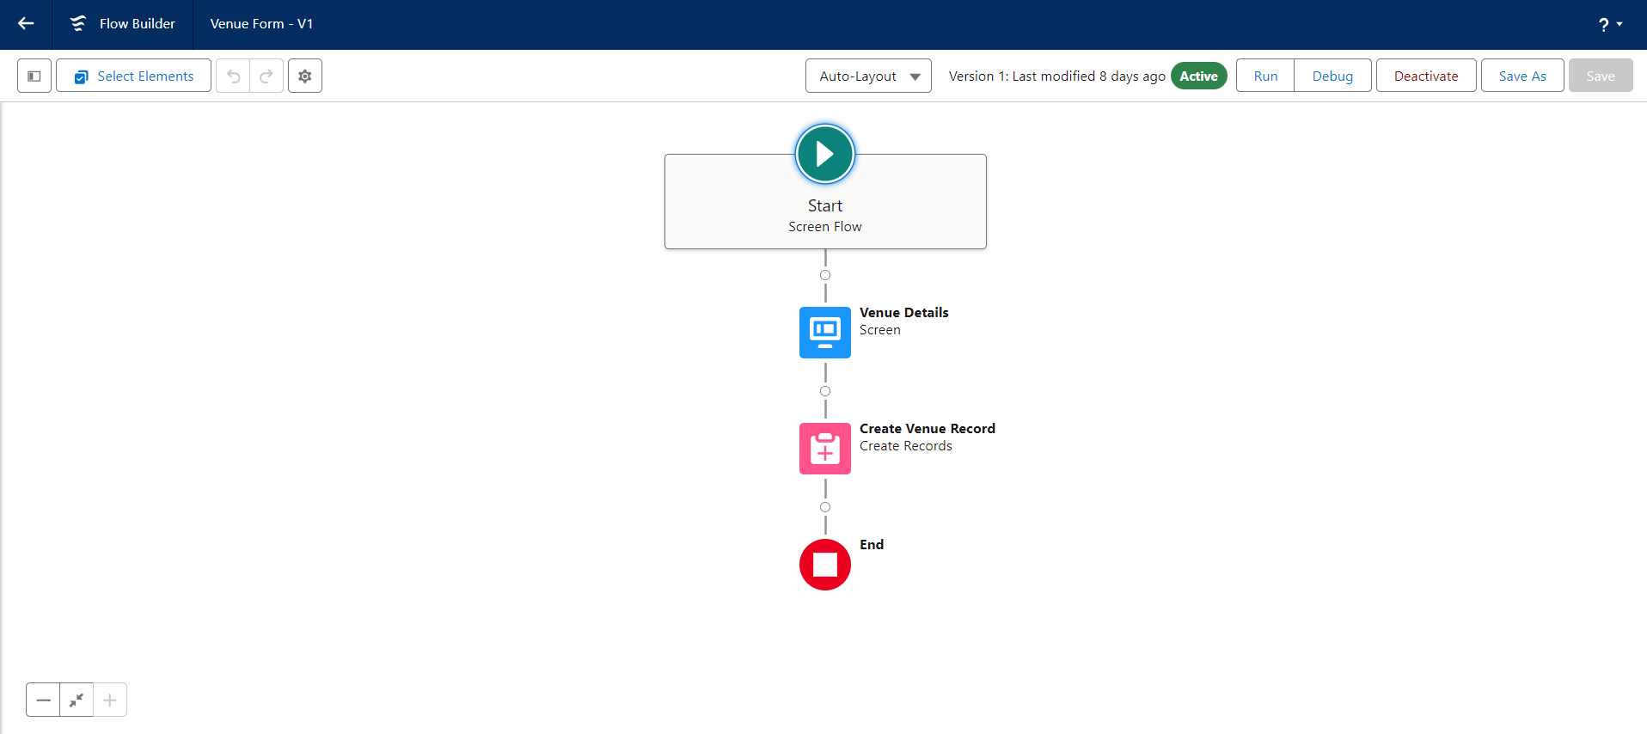

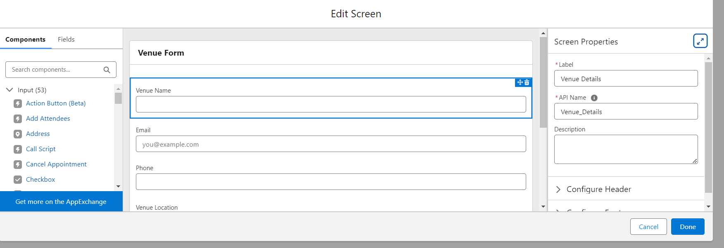

**TRIGGER:**

### Create A Trigger

1. Log into the trailhead account, navigate to the gear icon in the top right corner.
2. Click on developer console and you will be navigated to a new console window.
3. Click on the File menu in the toolbar, and click on new >> Trigger.
4. Enter the trigger name and the object to be triggered.Enter Name : DropOffTriggersObject: Drop-Off Point.Click on Submit.

**TRIGGER CODE:**

**Code:**

trigger DropOffTrigger on Drop_Off_point__c (before insert) {

    for(Drop_Off_point__c Drop : Trigger.new){

        Drop.Distance__c = Drop.distance_calculation__c;

    }

}

### Profiles:

1. Go to setup page >> type Profiles in Quick Find bar >> click on Profiles >> click on ‘S’
2. Click on Clone beside Standard Platform User.
3. Under Clone Profile:

Profile Name : NGOs Profile

Then click on Save

**Creation Of Users:**

In this Project we consider them as NGO’s.

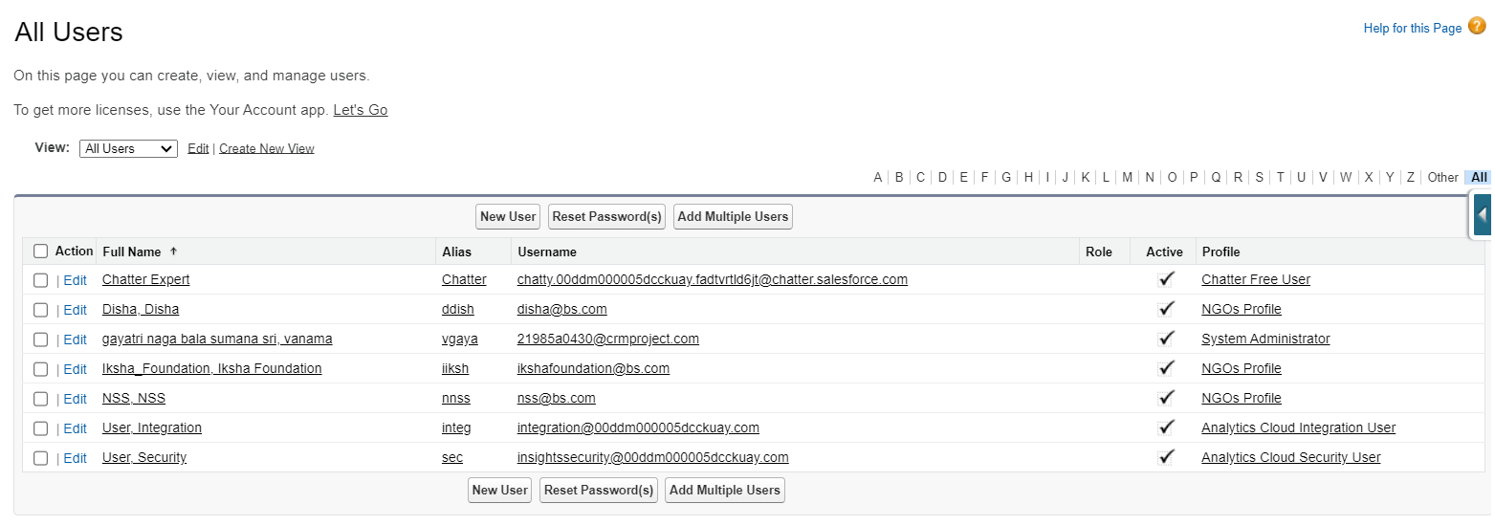

### Creation Of Public Group 1

1. Go to setup page  >>  type Public Groups in Quick Find bar  >>  click on Public Groups >>  click on New.
2. Under Group Information:

Label : Iksha

Group Name : Iksha

Grant Access Using Hierarchies : Check

1. In Search, Select Users.
2. In Selected Members Add Iksha Foundation and System Administrator

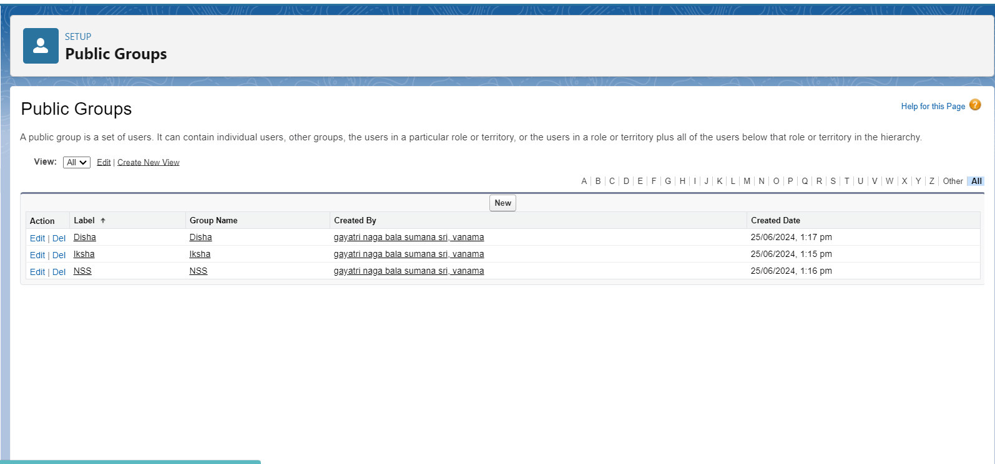

5.create another two public groups as disha and nss.

### Creation Of Report Types

1. Go to setup page  >>  type Report Types in Quick Find bar  >> click on Report Types  >>  click on Continue   >>  Click on New Custom Report Type.
2. In Define the Custom Report Type:

Primary Object : Select Venues

Report Type Label : Venue with DropOff with Volunteer

Report Type Name : Venue_with_DropOff_with_Volunteer

Description : Venue with DropOff with Volunteer

Store in Category : Select Other Reports

Deployment Status : Deployed

1. Click on Next
2. Near Click to relate another Object Select Drop-Off Points.
3. And also select "A" records may or may not have related "B" records.
4. Now again Near Click to relate another Object Select Volunteers.
5. Now click on Save.

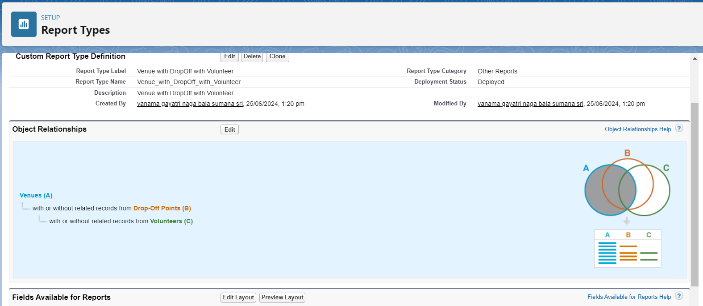

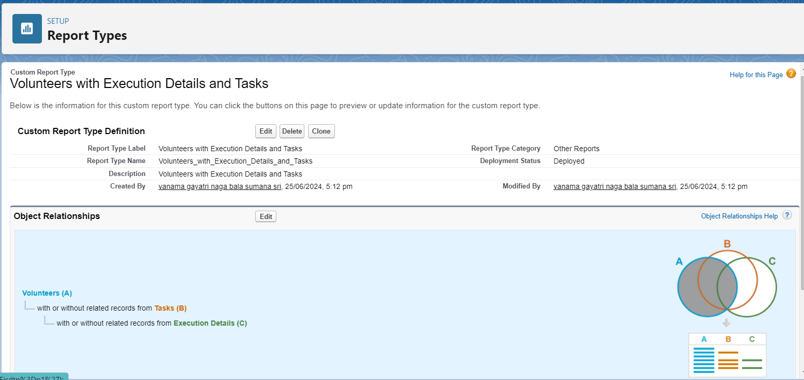

**Creation Of Report On Venue With DropOff With Volunter:**

1. Go to the app(FoodConnect)  >>  click on the reports tab
2. Click on New Folder.

Folder Label : Custom Reports

Folder Unique Name : CustomReports

1. Open Custom Reports and click on New Report
2. Select Report Type : Venue with DropOff with Volunteer
3. Then click on Start Report.
4. In GROUP ROWS : Add Volunteer Name
5. In Columns : Add Venue Name, Drop-Off point Name, Distance.

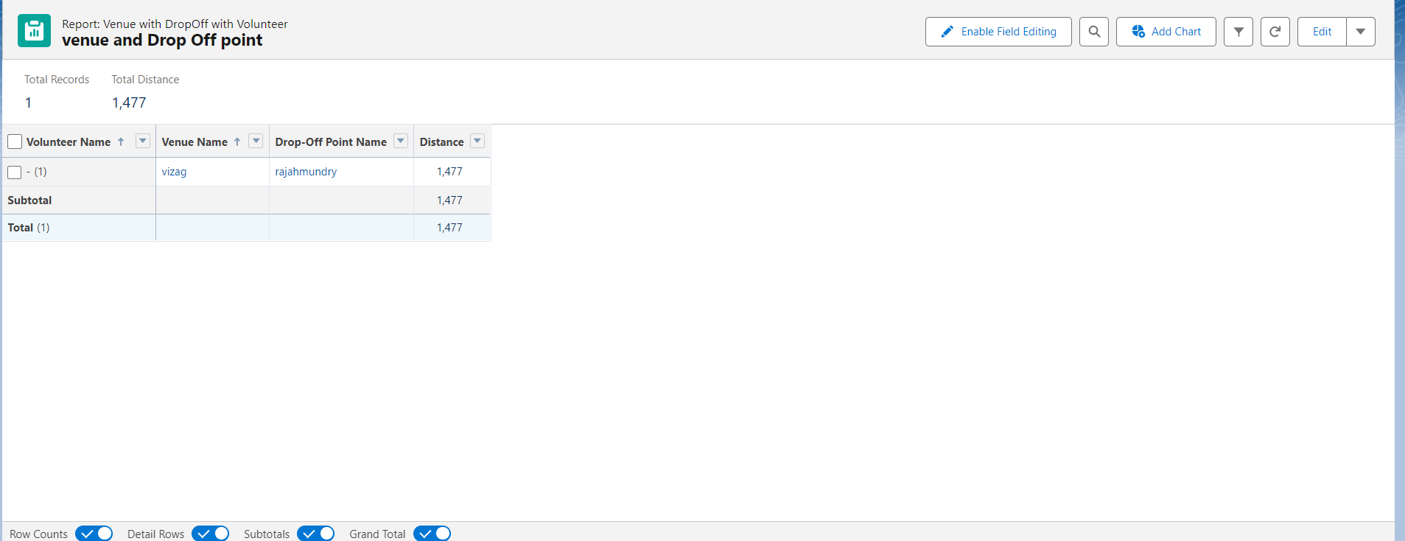

1. Now click on Save & Run.
2. Give Label as :
3. Report Name : venue and Drop Off point
4. Report Unique Name : Auto Populated
5. Click on Select Folder and select Custom Report, then click on Save.

### Creation Of Report On Volunteers With Execution Details And Tasks

1. Go to the app(FoodConnect)  >>  click on the reports tab
2. Click on Custom Reports Folder and click on New Report
3. Select Report Type : Volunteers with Execution Details and Tasks.
4. Then click on Start Report.
5. In GROUP ROWS : Volunteer ID
6. In Columns : Add Volunteer : Volunteer Name, Task : Task Name, Execution Detail : Execution Detail Name, Volunteer: Owner Name, Task: Date, Task : Rating.

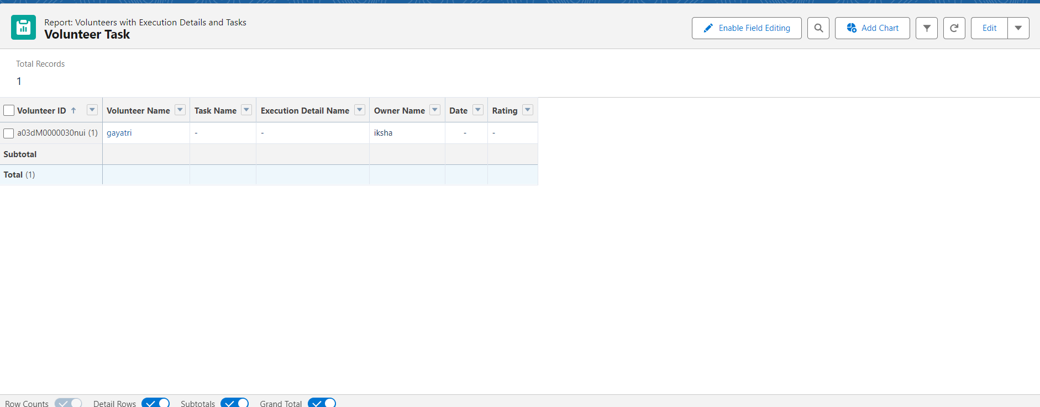

**DASHBOARDS:**

### Adding Venue And Drop Off Point Report To The Dashboard

1. Go to the app(FoodConnect)  >>  click on the Dashboards tab.
2. Click on New Folder.

Folder Label : Custom Dashboards

Folder Unique Name : Auto Populated

1. Open Custom Dashboards and click on New Dashboards
2. Name : Organization Details
3. Click on Widget and select Chart or Table
4. In Select Report : Select venue and Drop Off point Report.
5. Then click on select
6. In Add Component:

Display As : Select Lightning Table

Component Theme : Select Dark (Optional).

Now click on save.

### Adding Volunteer Task Report To The Dashboard

1. Click on Widget and select Chart or Table
2. In Select Report : Select Volunteer Task Report.
3. Then click on select
4. In Add Component:

Display As : Select Line Chart

Component Theme : Select Dark (Optional).

Now click on save.

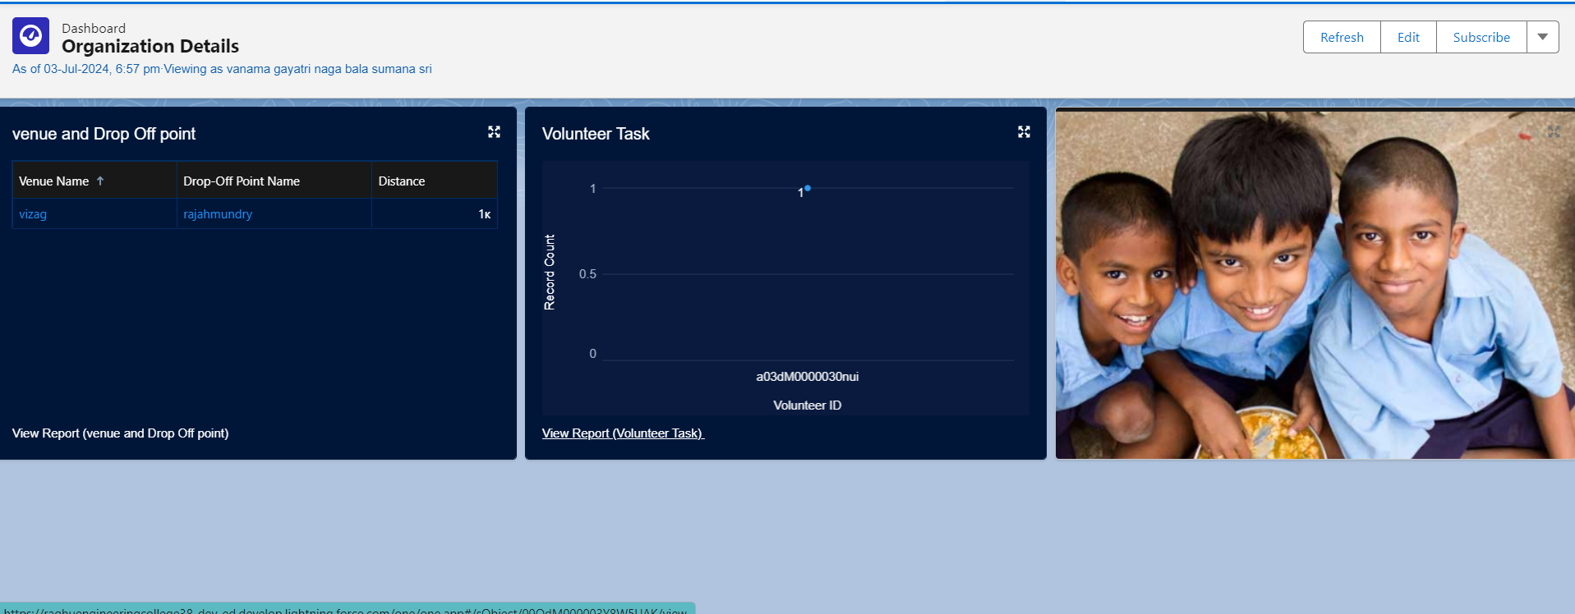

**SHARING RULES:**

### Creation Of Sharing Rules

1. Go to setup  >>  type Sharing Settings in quick find box  >>  Click on the Sharing Settings.
2. Scroll down and find Drop-Off point Sharing Rules.
3. Click on new near Drop-Off point Sharing Rules and Name it as:

Label : Rule 1

Rule Name : Rule_1

1. Select your rule type : Select Based on criteria.
2. Select which records to be shared:

Field : Operator : Value = Distance : less than : 15

1. Select the users to share with : Near Share With

Public Groups : Iksha

1. Click on Save.
2. Click on new near Drop-Off point Sharing Rules and Name it as:

Label : Rule 2

Rule Name : Rule_2

1. Select your rule type : Select Based on criteria.
2. Select which records to be shared:

Field : Operator : Value = Distance : greater than : 15

Field : Operator : Value = Distance : less or equal : 30

1. Select the users to share with : Near Share With

Public Groups : NSS

1. Click on Save.
2. Click on new near Drop-Off point Sharing Rules and Name it as:

Label : Rule 3

Rule Name : Rule_3

1. Select your rule type : Select Based on criteria.
2. Select which records to be shared:

Field : Operator : Value = Distance : greater than : 30

Field : Operator : Value = Distance : less or equal : 50

1. Select the users to share with : Near Share With

Public Groups : Street Cause

1. Click on Save.

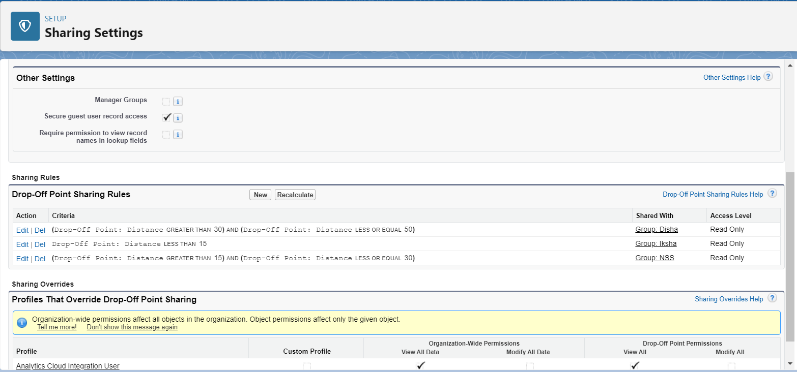

**HOME PAGE:**

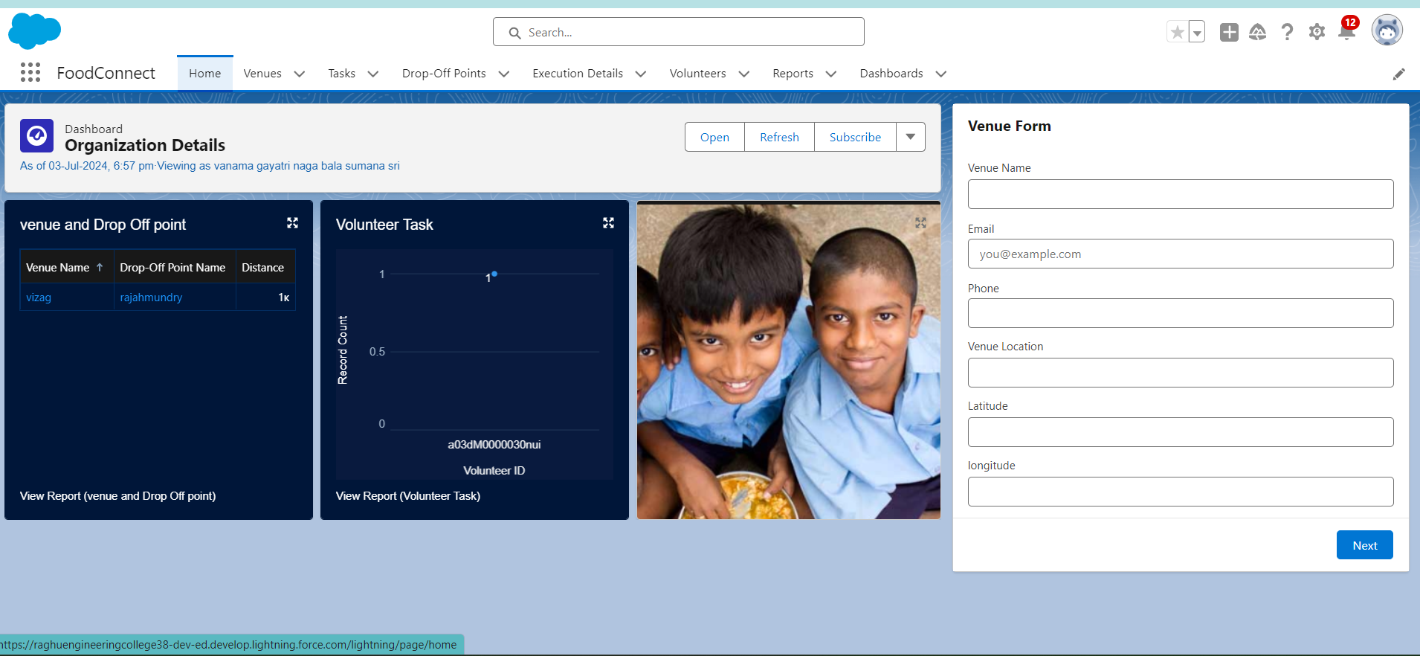

**Impact**

By implementing this project in Salesforce, the organization aims to significantly reduce food waste and alleviate hunger in local communities. The project will enable better coordination between food donors, volunteers, and distribution points, leading to a more efficient and effective food redistribution network. By implementing the Food Connect project in Salesforce, the organization aims to significantly reduce food waste and alleviate hunger in local communities. The project will enable better coordination between food donors, volunteers, and distribution points, ultimately leading to a more efficient and effective food redistribution network.

**Conclusion:**

Food Connect represents a strategic initiative to tackle food insecurity through technology-driven solutions. With Salesforce as the backbone, the project will bring structure and efficiency to the process of collecting and distributing leftover food, fostering a collaborative effort to support those in need. To Supply Leftover Food to Poor" represents a strategic initiative to combat food insecurity through technology-driven solutions. With Salesforce as the backbone, the project will bring structure and efficiency to the process of collecting and distributing leftover food, fostering a collaborative effort to support those in need.