**Neighborhoods in Mumbai**

**Introduction :**

**Problem background :**

Mumbai is the capital city of Indian State of Maharashtra and also the financial capital of India and is one of the most densely populated cities in the world. It lies on the west coast of India and attracts heavy tourism from all over the globe every year. It is one of the major hubs of the world and is extremely diverse with people from various societies residing here. The multi-cultural environment of the city of Mumbai has brought along with it numerous cuisines from all over the world. Mumbai can also be called a foodie's paradise because of its vast variety of foods. Thus, the aim of this project is to study the neighbourhoods in Mumbai to determine possible locations for starting a restaurant. This project can be useful for business owners and entrepreneurs who are looking to invest and open a restaurant in Mumbai. The main objective of this project is to analyze appropriate data and find recommendations for the stakeholders.

**Data :**

To find a solution to the questions and build a recommender model, we need data and lots of data. Data can answer question which are unimaginable and non-answerable by humans because humans do not have the tendency to analyze such large dataset and produce analytics to find a solutions.The data of the neighborhoods in Mumbai was scraped from [https://en.wikipedia.org/wiki/List_of_neighborhoods_in_Mumbai](https://en.wikipedia.org/wiki/List_of_neighbourhoods_in_Mumbai). The data is read into a pandas data frame using the html method. The top 10 rows of the dataframe are shown as below,

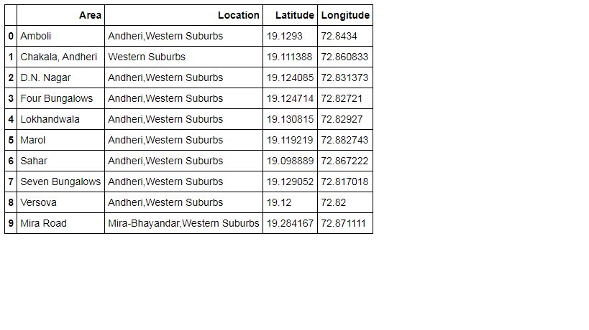

To access location of a restaurant, it’s Latitude and Longitude is to be known so that we can point at its coordinates and create a map displaying all the restaurants with its labels respectively. I have downloaded the commercial property rate data of the neighborhoods as below,

