**Music Band Website**

**Submitted By**: Charushree.S  
**Roll Number**: 2462509  
**College Email ID**: charushree,s@btech.christuniversity.in

**Submitted By**: Lalit kumar  
**Roll Number**: 2462516  
**College Email ID**: lalit.kumar@btech.christuniversity.in

**Submitted By**: Aarvisha yadav  
**Roll Number**: 2462501  
**College Email ID**: aarvisha.yadav@btech.christuniversity.in

**Course**: UI/UX Design Fundamentals  
**Institution**: Christ University  
**Date of Submission**: 11/08/2025

**Abstract:**

This project consists of two HTML5 and CSS3 based responsive websites. The first is a Music Band Website showcasing artist profiles, tour dates, photo gallery, and contact form. The second is an NGO Awareness Website focusing on impact statistics, volunteer engagement, and donation prompts. Both projects were built using semantic HTML5 structure, modern CSS layouts (Flexbox/Grid), and responsive design principles. The goal was to design visually appealing, accessible, and user-friendly websites without using JavaScript. The final outcome demonstrates clean layout structuring, strong visual branding, and ease of navigation.

**Objectives:**

- Structure multi-page and single-page websites using HTML5 semantic tags.  
- Implement CSS styling for engaging visual identity.  
- Utilize Flexbox and Grid for layout organization.  
- Ensure responsiveness and accessibility.  
- Maintain high-contrast, brand-consistent visuals.

**Scope of the Project:**

The project is front-end only, focusing on layout, styling, and user experience. It is designed to work on desktop, tablet, and mobile devices. No JavaScript or backend integration was included. The websites are static but visually appealing and optimized for fast loading.

**Tools & Technologies Used:**

HTML5 - Structure and semantic markup  
CSS3 - Styling, animations, responsive design  
VS Code - Code editor  
Chrome DevTools - Testing & debugging

**HTML Structure Overview:**

Both projects follow semantic HTML5 structure, including header, nav, main, section, and footer. Navigation menus are created with unordered lists. The Music Band site includes hero, about, tour dates, gallery, and contact sections. The NGO site includes impact statistics and a get involved section.

**CSS Styling Strategy:**

External CSS (style.css) was used. Layout is managed using Flexbox and Grid. Media queries enable responsiveness. High contrast color schemes ensure readability. Animations and hover effects enhance interactivity.

**Key Features:**

- Responsive layouts for multiple devices.  
- Fixed/sticky navigation.  
- Photo gallery grid.  
- Impact counters (NGO).  
- Volunteer and contact forms.

Challenges Faced & Solutions

Challenge: Maintaining layout consistency across devices.  
Solution: Used CSS Grid/Flexbox and tested with Chrome DevTools.  
  
Challenge: High-quality imagery without slowing page load.  
Solution: Used optimized image formats and compression.

Outcome

Successfully built two visually appealing and responsive websites using HTML5 and CSS3 only. The project enhanced skills in semantic structuring, responsive layouts, and brand-consistent styling.

Future Enhancements: -Add JavaScript for form validation.  
- Integrate backend for real-time data.  
- Add animations and sliders.

**Sample Code:**

HTML and CSS code for Music band website

<!DOCTYPE html>

<html lang="en">

<head>

<meta charset="UTF-8">

<meta name="viewport" content="width=device-width, initial-scale=1.0">

<title>Neon Echo - Music Band</title>

<link rel="stylesheet" href="style.css">

</head>

<body>

<header>

<div class="logo">Neon Echo</div>

<nav>

<a href="#home">Home</a>

<a href="#about">About</a>

<a href="#tour">Tour</a>

<a href="#albums">Albums</a>

<a href="#gallery">Gallery</a>

<a href="#contact">Contact</a>

</nav>

</header>

<section id="home" class="hero" style="background-image: url('images/hero.jpg');">

<h1>Neon Echo</h1>

<p>Synth-driven alt-rock — New album out now</p>

<a href="#albums" class="btn">Listen Now</a>

</section>

<section id="about">

<h2>About The Band</h2>

<p>

Neon Echo is not just a band — it’s a movement of sound, light, and raw energy. Born in 2018 on the streets of Mumbai, the band brings together five friends who share one dream: to create music that feels like freedom. With every note, they mix the grit of alternative rock with the shimmer of synthwave, building soundscapes that are as electric as city nights. Their debut album “Neon Nights” didn’t just drop into the scene; it lit it up like a flare, sparking conversations among music lovers everywhere. Whether they’re playing to a sold-out stadium or an intimate rooftop crowd, they give it everything they have, every single time. Beyond the music, Neon Echo supports causes they care about — from mental health awareness to environmental projects — using their platform for good. For them, the journey is as important as the destination. Every rehearsal, every gig, every fan interaction adds to the story they’re writing together. And that story is far from over. With new songs in the works, collaborations on the horizon, and tours that promise to reach new cities, Neon Echo is set to shine brighter than ever. This is more than a band. This is Neon Echo — and the echo is only getting louder.

</p>

</p>

</section>

<section id="tour">

<h2>Tour Dates</h2>

<ul>

<li>12 Sep 2025 — Mumbai</li>

<li>28 Sep 2025 — Bangalore</li>

<li>10 Oct 2025 — Pune</li>

</ul>

</section>

<section id="albums">

<h2>Albums</h2>

<div class="album-grid">

<div class="album-card">

<img src="https://images.unsplash.com/photo-1499364615650-ec38552f4f34?auto=format&fit=crop&w=500&q=80" alt="Album 1">

<p>Neon Nights (2024)</p>

</div>

<div class="album-card">

<img src="https://images.unsplash.com/photo-1556286654-391b54ea0d60?auto=format&fit=crop&w=500&q=80" alt="Album 2">

<p>Echoes (2022)</p>

</div>

</div>

</section>

<section id="gallery">

<h2>Gallery</h2>

<div class="gallery-grid">

<img src="https://images.unsplash.com/photo-1487180144351-b8472da7d491?auto=format&fit=crop&w=500&q=80" alt="Gallery Image 2">

<img src="https://images.unsplash.com/photo-1507874457470-272b3c8d8ee2?auto=format&fit=crop&w=500&q=80" alt="Gallery Image 3">

</div>

</section>

<section id="contact">

<h2>Contact / Bookings</h2>

<form>

<input type="text" placeholder="Name">

<input type="email" placeholder="Email">

<textarea placeholder="Message"></textarea>

<button type="submit">Send</button>

</form>

</section>

<footer>

<p>&copy; 2025 Neon Echo. All rights reserved.</p>

</footer>

</body>

</html> /* Reset and base styles */

* {

margin: 0;

padding: 0;

box-sizing: border-box;

font-family: Arial, sans-serif;

}

body {

background: #0a0a0b;

color: #fff;

line-height: 1.6;

}

/* Header and Navigation */

header {

display: flex;

justify-content: space-between;

align-items: center;

padding: 1rem 2rem;

background: #111;

}

header .logo {

font-size: 1.5rem;

color: #00e6ff;

font-weight: bold;

}

header nav {

display: flex;

gap: 1rem;

}

header nav a {

color: #fff;

text-decoration: none;

font-weight: bold;

}

header nav a:hover {

color: #00e6ff;

}

/* Hero Section */

.hero {

height: 60vh;

display: flex;

flex-direction: column;

justify-content: center;

align-items: center;

text-align: center;

background: #222;

padding: 2rem;

}

.hero h1 {

font-size: 3rem;

color: #00e6ff;

margin-bottom: 0.5rem;

}

.hero p {

font-size: 1.2rem;

margin-bottom: 1rem;

}

.btn {

background: #00e6ff;

color: #000;

padding: 0.6rem 1.2rem;

border: none;

border-radius: 5px;

text-decoration: none;

font-weight: bold;

transition: background 0.3s ease;

}

.btn:hover {

background: #00b3cc;

}

/* Section styling */

section {

padding: 2rem;

max-width: 1100px;

margin: auto;

}

/* Tour Dates */

#tour ul {

list-style: none;

padding: 0;

}

#tour li {

background: #1a1a1a;

padding: 0.8rem;

margin: 0.5rem 0;

border-radius: 5px;

}

/* Albums Grid */

.album-grid {

display: grid;

grid-template-columns: repeat(auto-fit, minmax(220px, 1fr));

gap: 1.5rem;

margin-top: 1rem;

}

.album-card {

background: #1a1a1a;

padding: 1rem;

border-radius: 5px;

text-align: center;

}

.album-card img {

width: 100%;

border-radius: 5px;

margin-bottom: 0.5rem;

}

/* Gallery Grid */

.gallery-grid {

display: grid;

grid-template-columns: repeat(auto-fit, minmax(150px, 1fr));

gap: 0.8rem;

margin-top: 1rem;

}

.gallery-grid img {

width: 100%;

border-radius: 5px;

display: block;

}

/* Contact Form */

form {

display: flex;

flex-direction: column;

gap: 0.7rem;

max-width: 400px;

}

form input,

form textarea {

padding: 0.6rem;

border: none;

border-radius: 3px;

background: #1a1a1a;

color: #fff;

}

form button {

background: #00e6ff;

color: #000;

padding: 0.6rem;

border: none;

border-radius: 3px;

font-weight: bold;

cursor: pointer;

}

form button:hover {

background: #00b3cc;

}

/* Footer */

footer {

text-align: center;

padding: 1rem;

background: #111;

margin-top: 2rem;

}

@media (max-width: 600px) {

header {

flex-direction: column;

gap: 0.5rem;

}

.hero h1 {

font-size: 2rem;

}

}

**Screenshots of Music band website:** 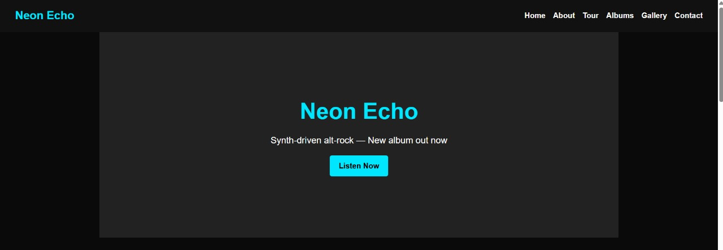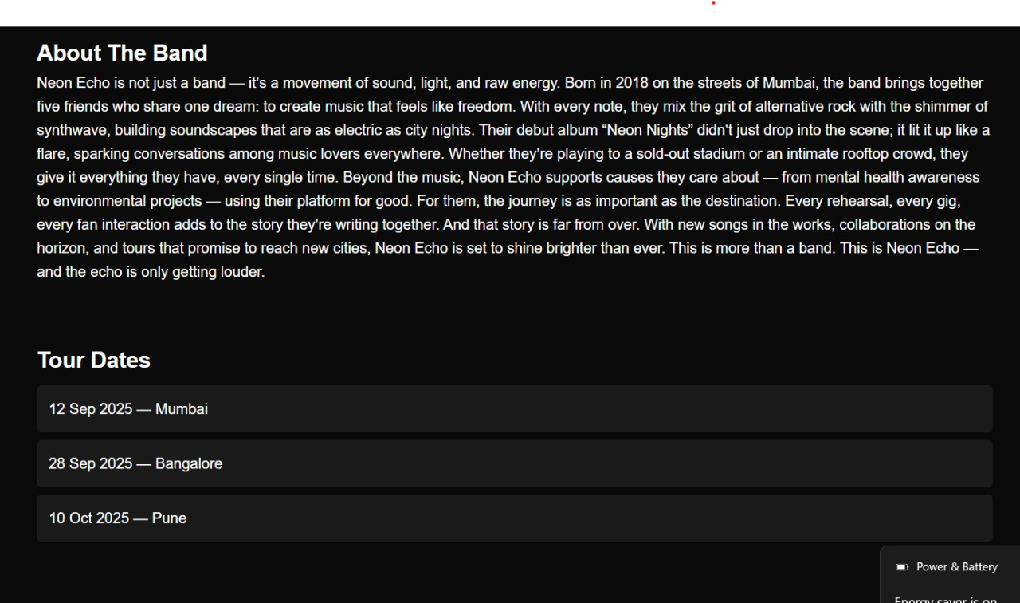

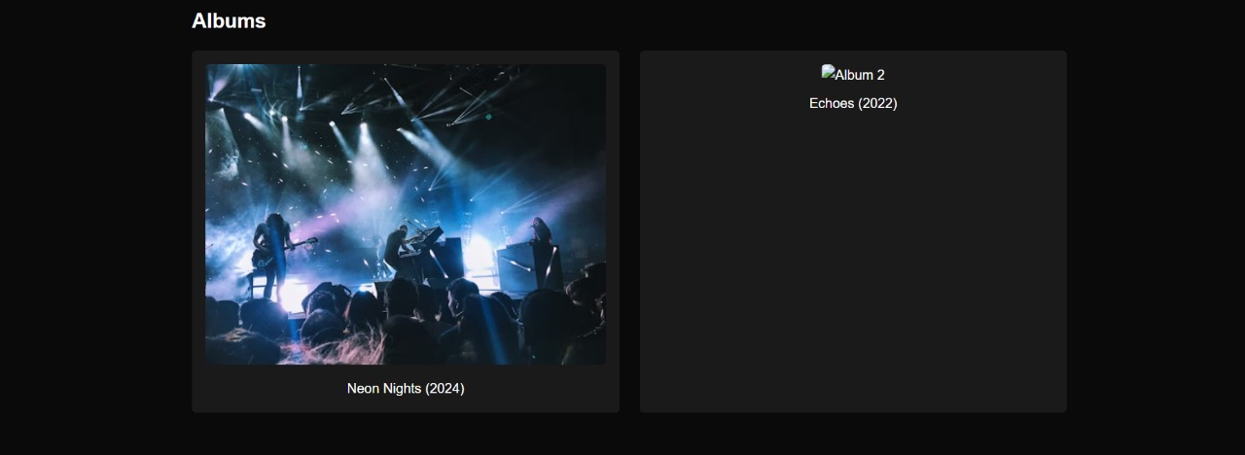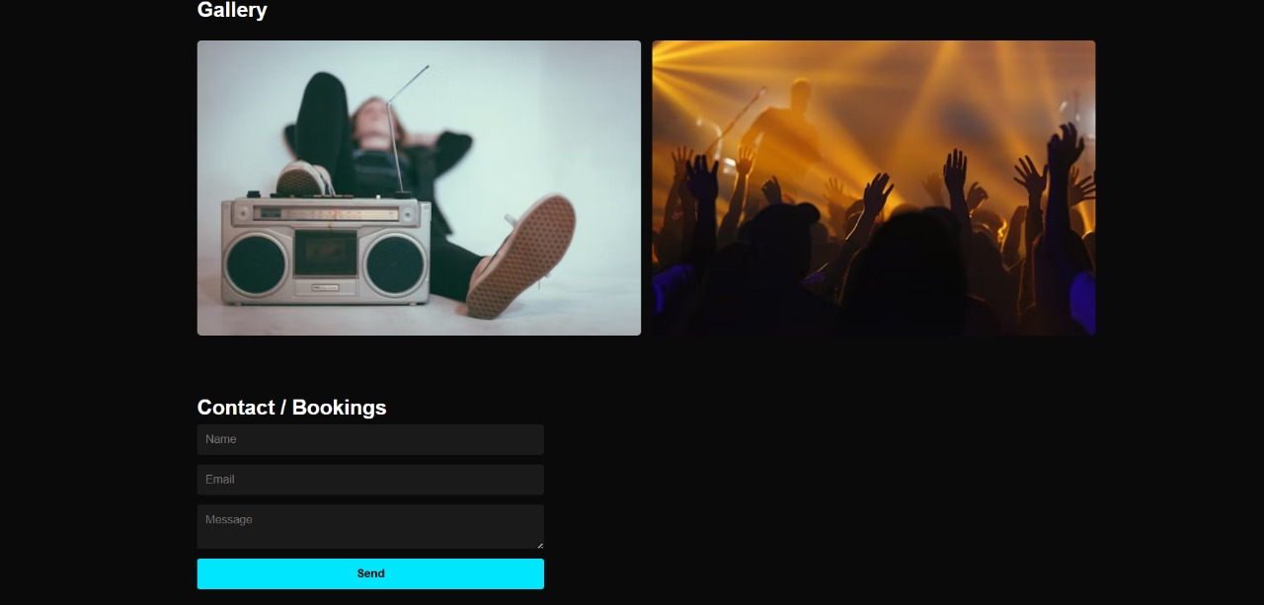

**Conclusion – Music Band Website**  
The *Music Band Website* successfully demonstrates the ability to create a visually appealing, responsive, and user-friendly platform using only HTML5 and CSS3. It effectively showcases the band’s identity, tour dates, albums, and gallery while maintaining smooth navigation and strong visual branding. This project enhanced my skills in semantic HTML structuring, responsive layout design, and creative presentation of entertainment content. The outcome reflects how design can amplify a band’s digital presence, engage fans, and promote events efficiently.