NGO Awareness Website

Submitted By: Charushree.S  
Roll Number: 2462509  
College Email ID: [charushree.s@btech.christuniversity.in](mailto:charushree.s@btech.christuniversity.in)

Submitted By: Lalit kumar  
Roll Number: 2462516  
College Email ID: [lalit.kumar@btech.christuniversity.in](mailto:lalit.kumar@btech.christuniversity.in)

Submitted By: Aarvisha yadav  
Roll Number: 2462501  
College Email ID: aarvisha.yadav@btech.christuniversity.in  
Course: UI/UX Design Fundamentals  
Institution: Christ University  
Date of Submission: 11/08/2025

# Abstract

The NGO Awareness Website focuses on impact statistics, volunteer engagement, and donation prompts. It was built using semantic HTML5 structure, modern CSS layouts (Flexbox/Grid), and responsive design principles. The goal was to design a visually appealing, accessible, and user-friendly website without using JavaScript, demonstrating clean layout structuring, strong visual branding, and ease of navigation.

# Objectives

- Structure multi-page and single-page websites using HTML5 semantic tags.  
- Implement CSS styling for engaging visual identity.  
- Utilize Flexbox and Grid for layout organization.  
- Ensure responsiveness and accessibility.  
- Maintain high-contrast, brand-consistent visuals.

# Scope of the Project

The project is front-end only, focusing on layout, styling, and user experience. It is designed to work on desktop, tablet, and mobile devices. No JavaScript or backend integration was included. The websites are static but visually appealing and optimized for fast loading.

# Tools & Technologies Used

HTML5 - Structure and semantic markup  
CSS3 - Styling, animations, responsive design  
VS Code - Code editor  
Chrome DevTools - Testing & debugging

# HTML Structure Overview

The NGO Awareness Website follows a semantic HTML5 structure, using elements such as header, nav, main, section, and footer to create a clear and accessible layout. The navigation menu is built with an unordered list, allowing visitors to easily move between different parts of the site. The main sections include an Impact section, which displays key statistics like the number of families helped and communities reached, and a GetInvolved section, which encourages users to volunteer or donate. This structure ensures that information is easy to find, improves user experience, and supports accessibility standards.

# CSS Styling Strategy

External CSS (style.css) was used. Layout is managed using Flexbox and Grid. Media queries enable responsiveness. High contrast color schemes ensure readability. Animations and hover effects enhance interactivity.

# Key Features

- Responsive layouts for multiple devices.  
- Fixed/sticky navigation.  
- Photo gallery grid.  
- Impact counters (NGO).  
- Volunteer and contact forms.

# Challenges Faced & Solutions

Challenge: Maintaining layout consistency across devices.  
Solution: Used CSS Grid/Flexbox and tested with Chrome DevTools.  
  
Challenge: High-quality imagery without slowing page load.  
Solution: Used optimized image formats and compression.

# Outcome

Successfully built two visually appealing and responsive websites using HTML5 and CSS3 only. The project enhanced skills in semantic structuring, responsive layouts, and brand-consistent styling.

# Future Enhancements

- Add JavaScript for form validation.  
- Integrate backend for real-time data.  
- Add animations and sliders.

# Sample Code

<!DOCTYPE html>

<html lang="en">

<head>

<meta charset="UTF-8">

<meta name="viewport" content="width=device-width, initial-scale=1.0">

<title>Hope For All Foundation</title>

<link rel="stylesheet" href="index.css">

</head>

<body>

<header>

<nav>

<div class="logo">Hope For All</div>

<ul>

<li><a href="#hero">Home</a></li>

<li><a href="#about">About Us</a></li>

<li><a href="#impact">Impact</a></li>

<li><a href="#getinvolved">Get Involved</a></li>

</ul>

</nav>

</header>

<!-- Hero Section -->

<section id="hero">

<div class="hero-content">

<h1>Together for a Brighter Future</h1>

<p>Helping communities grow, one step at a time.</p>

<a href="#getinvolved" class="btn">Join Us</a>

</div>

</section>

<!-- About Section -->

<section id="about">

<h2>About Hope For All Foundation</h2>

<div class="about-container">

<img src=""C:\Users\Charushree S\OneDrive\Desktop\hero-bg.jpg\istockphoto-508497052-612x612.jpg"" alt="NGO team working">

<div class="about-text">

<p>

Hope For All Foundation is a non-profit organization committed to uplifting underprivileged communities through

education, healthcare, and sustainable development. Since its founding in 2015, our mission has been to create equal

opportunities for all, ensuring that every individual can lead a dignified life.

</p>

<p>

Through dedicated volunteers and donors, we have impacted thousands of lives by organizing medical camps, literacy drives,

and skill development programs. Our belief is simple: together, we can bring lasting change and hope for a better tomorrow.

</p>

</div>

</div>

</section>

<!-- Impact Section -->

<section id="impact">

<h2>Our Impact</h2>

<div class="stats">

<div class="stat-card">

<div class="counter">500+</div>

<p>Families Helped</p>

</div>

<div class="stat-card">

<div class="counter">100+</div>

<p>Volunteers</p>

</div>

<div class="stat-card">

<div class="counter">50+</div>

<p>Communities Reached</p>

</div>

</div>

</section>

<!-- Get Involved Section -->

<section id="getinvolved">

<h2>Get Involved</h2>

<div class="involve-container">

<div class="involve-text">

<h3>Volunteer With Us</h3>

<p>Be part of our mission by lending your time, skills, and passion. Every effort counts towards changing lives.</p>

</div>

<form>

<input type="text" placeholder="Your Name" required>

<input type="email" placeholder="Your Email" required>

<button type="submit">Volunteer</button>

<button type="button" class="donate-btn">Donate</button>

</form>

</div>

</section>

<footer>

<p>&copy; 2025 Hope For All Foundation. All rights reserved.</p>

</footer>

</body>

</html>

SCREENSHOTS FOR NGO AWARENESS WEBSITE

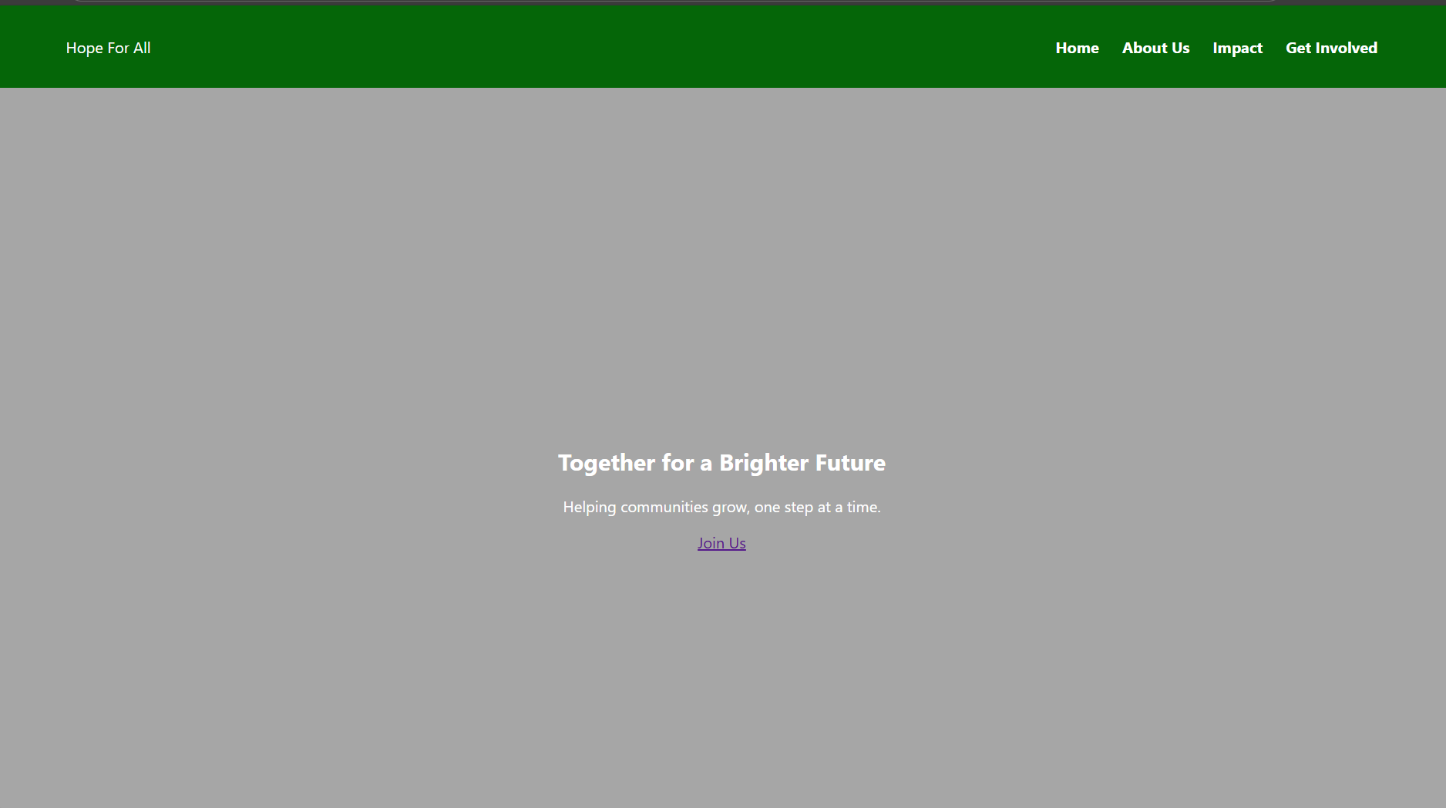

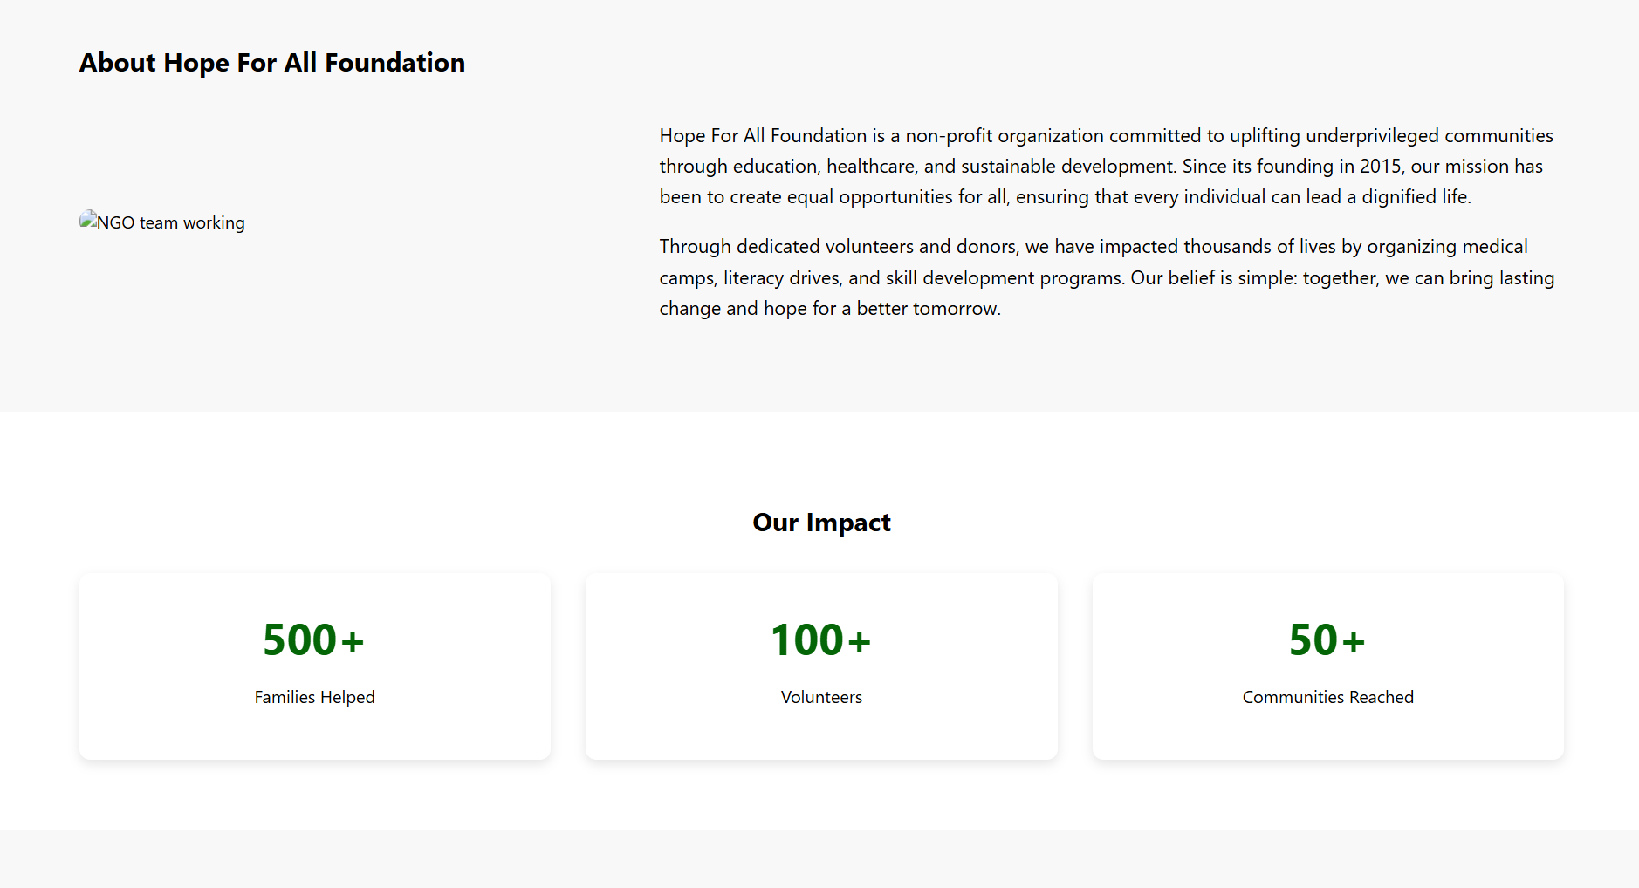



# Conclusion

The Hope For All Foundation NGO Awareness Website exemplifies my capability to develop clean, responsive, and user-friendly web interfaces using HTML5 and CSS3. The website is dedicated to promoting a social cause by effectively presenting the NGO’s mission, significant achievements, and clear avenues for public participation through volunteering and donations.

This project enhanced my proficiency in employing HTML5 semantic tags to ensure structured content, implementing Flexbox and Grid for efficient responsive layouts, and selecting colour schemes, typography, and design elements that align with the organization’s objectives.