1. Create first page of quiz game with New Game button.

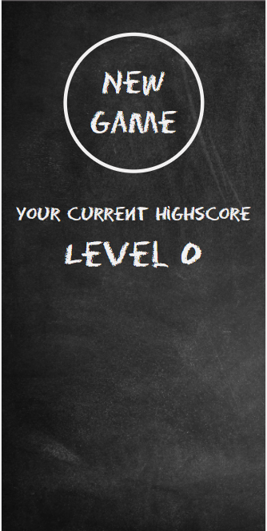

1. After clicking New Game, new page should be shown on the screen with the first question of quiz game.

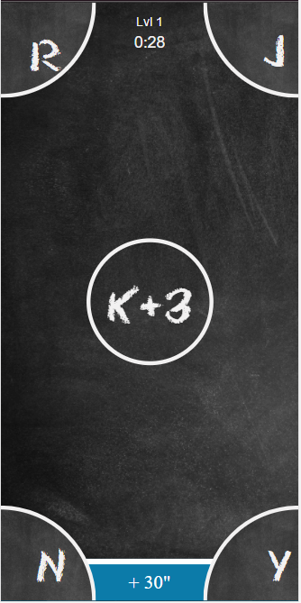

1. The questions will be based on config object

var config = {

DURATION: 30,

TIMER: 5,

ALPHABET: ['A', 'B', 'C', 'D', 'E', 'F', 'G', 'H', 'I', 'J', 'K', 'L', 'M', 'N', 'O', 'P', 'Q', 'R', 'S', 'T', 'U', 'V', 'W', 'X', 'Y', 'Z'],

LEVELS: [

{ id: 1, label: 'Lvl 1', range: [1, 3] },

{ id: 2, label: 'Lvl 2', range: [1, 3] },

{ id: 3, label: 'Lvl 3', range: [1, 3] },

{ id: 4, label: 'Lvl 4', range: [2, 4] },

{ id: 5, label: 'Lvl 5', range: [2, 4] },

{ id: 6, label: 'Lvl 6', range: [2, 4] },

{ id: 7, label: 'Lvl 7', range: [3, 5] },

{ id: 8, label: 'Lvl 8', range: [3, 5] },

{ id: 9, label: 'Lvl 9', range: [3, 5] },

{ id: 10, label: 'Lvl 10', range: [3, 5] },

{ id: 11, label: 'Lvl 11', range: [3, 5] },

{ id: 12, label: 'Lvl 12', range: [4, 6] },

{ id: 13, label: 'Lvl 13', range: [4, 6] },

{ id: 14, label: 'Lvl 14', range: [4, 6] },

{ id: 15, label: 'Lvl 15', range: [4, 6] },

{ id: 16, label: 'Lvl 16', range: [4, 6] },

{ id: 17, label: 'Lvl 17', range: [5, 7] },

{ id: 18, label: 'Lvl 18', range: [5, 7] },

{ id: 19, label: 'Lvl 19', range: [5, 7] },

{ id: 20, label: 'Lvl 20', range: [5, 7] },

]

}

1. Each game should have 30 seconds for answers.
2. The question for each level is any character from the ALPHABET (e.g **K**) + any number from the range for that level (e.g **2 from** **[1,3] range**). So the question for the level will be **K+2.**
3. The level should also show 4 answers, one right answer and 3 wrong random characters from the ALPHABET.
4. If user gives right answer then 5 seconds added to the timer and level is changed.
5. If user gives wrong answer then 5 seconds deducted from the timer. User remains on the same level, but the question should be changed.
6. After time is expired the results page with right answers count should be shown.