**HIVE(DAY-2) ASSIGNMENT**

**Create a database sampledb.  
Create two tables person and employee (create suitable fields for both).**

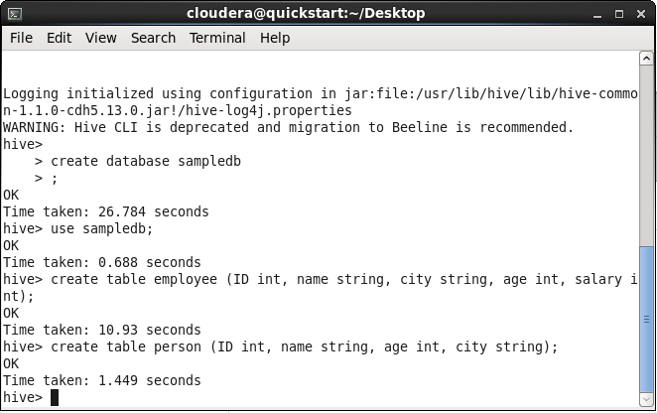

**Create two partitioned tables from employee table dynamically based on any two columns (example :city and salary).**

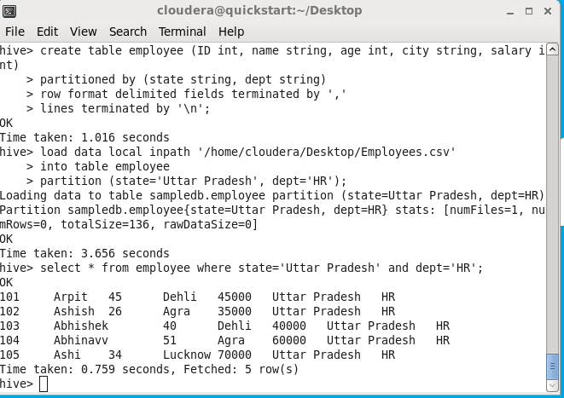

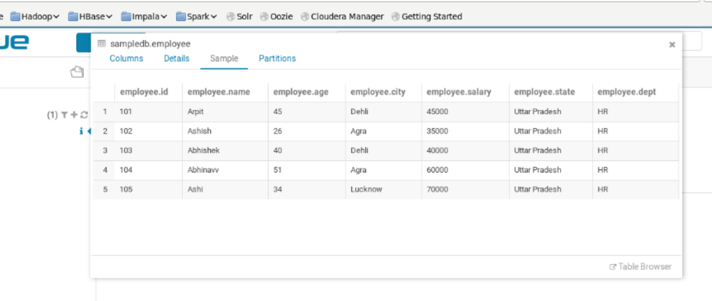

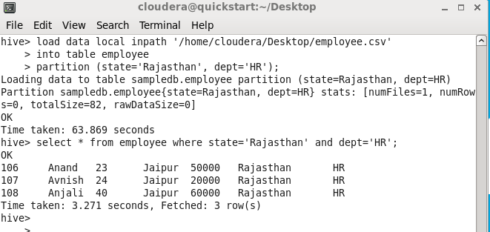

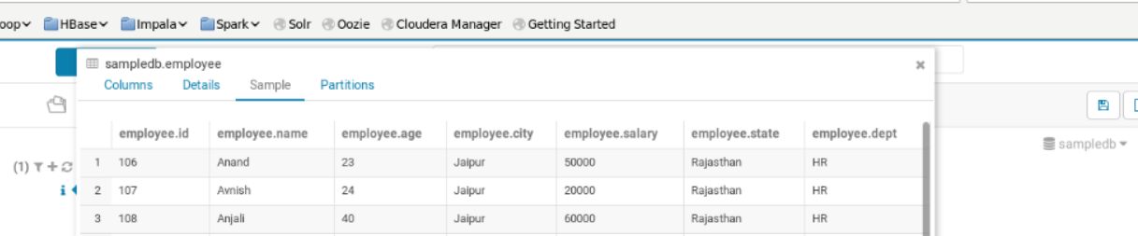

**Create two bucketed tables from person based on any two fields ( example : ID , Age).**

