1. **Create a user in Linux with userid as 10001**

**- Add the user into the secondary group {sales} at time of creating the user**

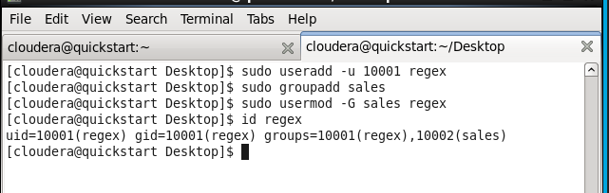

1. **Try to move the file from local environment to any folder into hadoop ecosystem.**



1. **Create an empty file in any location in Hadoop**

-bash-4.1$ hdfs dfs -touchz/user/cloudera/text.txt

1. **Change the permission of the folder & the files & subdirectories present inside the location of Hadoop**

- After that also verify the folder & also the internal files inside the folder

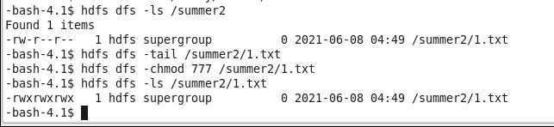

1. **Change the replication factor for any file present in Hadoop to 3**

**- Also change the replication factor for any file while using the {put command} in Hadoop to 3**

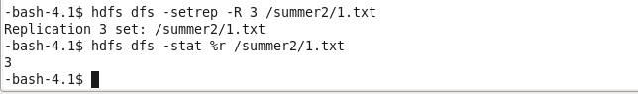

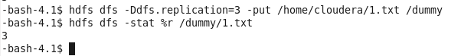

1. **Create any folder in Hadoop**

- **Move the file from local to Hadoop folder**

**- create one more file with data into local Linux**

**- Try to copy the contents of new file from local machine to the Hadoop environment now in the same folder**

