**Architecture- DevOps Project 1**

**Moba (optional):   
https://download.mobatek.net/2412024041614011/MobaXterm_Portable_v24.1.zip  
  
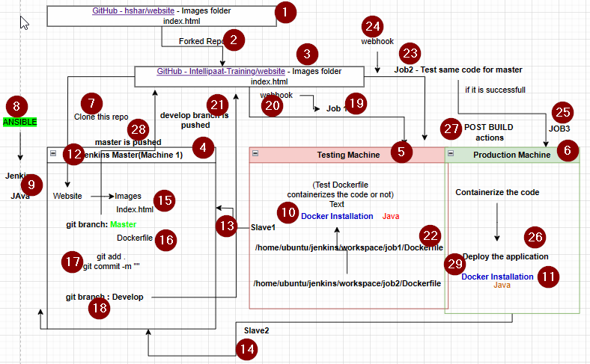**

**Installing Ansible on Machine 1(Jenkins Master)**

sudo apt update

sudo apt install software-properties-common

sudo add-apt-repository --yes --update ppa:ansible/ansible

sudo apt install ansible

**Playbook**---

#Machine1 Installation

- name: Installation of Jenkins and Java on localhost

hosts: localhost

become: true

tasks:

- name: Running Jenkinsmaster_installation script

script: jenkinsmaster_installation.sh

#Machine 2 Installation

- name: Installation of Docker and Java on Testing Machine

hosts: Testing

become: true

tasks:

- name: Running Jenkinsmaster_installation script

script: nodeinstallation_requirement.sh

#Machine3 Installation

- name: Installation of Docker and Java on Production Machine

hosts: Production

become: true

tasks:

- name: Running nodeinstllation_requirements script

script: nodeinstallation_requirement.sh  
  
**Jenkinsmaster_installation.sh**

sudo apt update

sudo apt install openjdk-11-jdk -y

sudo wget -O /usr/share/keyrings/jenkins-keyring.asc \

https://pkg.jenkins.io/debian/jenkins.io-2023.key

echo "deb [signed-by=/usr/share/keyrings/jenkins-keyring.asc]" \

https://pkg.jenkins.io/debian binary/ | sudo tee \

/etc/apt/sources.list.d/jenkins.list > /dev/null

sudo apt-get update

sudo apt-get install jenkins -y  
  
**nodeinstallation_requirement.sh**

sudo apt update

sudo apt install docker.io -y

sudo apt install openjdk-11-jdk -y

**Command History till installation and launching Jenkins**

**sudo apt update**

**2 clear**

**3 git clone https://github.com/Intellipaat-Training/website27april.git**

**4 ls**

**5 cd website27april/**

**6 ls**

**7 cd ...**

**8 cd ..**

**9 clear**

**10 sudo apt install software-properties-common**

**11 sudo add-apt-repository --yes --update ppa:ansible/ansible**

**12 sudo apt install ansible -y**

**13 cd /etc/ansible/**

**14 ls**

**15 cd**

**16 ssh-keygen**

**17 cd .ssh/**

**18 ls**

**19 cat id_rsa.pub**

**20 cd /home/ubuntu/etc/ansible**

**21 cd ..**

**22 cd /etc/ansible/**

**23 ls**

**24 sudo nano hosts**

**25 ansible -m ping Testing**

**26 ansible -m ping all**

**27 sudo nano jenkinsmaster_install.sh**

**28 sudo nano nodeinstallation_requirement.sh**

**29 ls**

**30 sudo nano play.yaml**

**31 cat play.yaml**

**32 ansible-playbook play.yaml --syntax-check**

**33 ansible-playbook play.yaml**

**34 cat clear**

**35 ls**

**36 clear**

**37 ls**

**38 mv jenkinsmaster_install.sh jenkinsmaster_installation.sh**

**39 sudo mv jenkinsmaster_install.sh jenkinsmaster_installation.sh**

**40 ls**

**41 ansible-playbook play.yaml --syntax-check**

**42 ansible-playbook play.yaml**

**43 java --version**

**44 jenkins --version**

**45 cat pla**

**46 cat play.yaml**

**47 cat jenkinsmaster_installation.sh**

**48 ls**

**49 cat nodeinstallation_requirement.sh**

**50 history**

**________________________BREAK___________________________________**

53 sudo cat /var/lib/jenkins/secrets/initialAdminPassword

54 ls

55 cd website27april/

56 ls

57 git status

58 git branch

59 sudo nano Dockerfile

60 git status

61 git add .

62 git status

63 git commit -m "Added Dockerfile"

64 git remote -v

65 git branch develop

66 git branch

67 git checkout develop

68 ls

69 git branch

70 clear

71 ls

72 git push origin develop

73 git checkout master

74 ls

75 cat Dockerfile

76 sudo nano Dockerfile

77 git push origin master

78 ls

79 cat Dockerfile

80 sudo nano Dockerfile

81 git add .

82 git status

83 git commit -m "added updated Dockerfile"

84 git push origin master