HT.NO: 2303A52448
Batch-31
SCHOOL OF COMPUTER SCIENCE AND ARTIFICIAL INTELLIGENCE |  |  |  |  | DEPARTMENT OF COMPUTER SCIENCE ENGINEERING
Program Name: B. Tech |  |  |  | Assignment Type: Lab |  |  | Academic Year:2025-2026
Course Coordinator Name |  |  |  | Dr. Rishabh Mittal
Instructor(s) Name
  Mr. S Naresh Kumar
  Ms. B. Swathi
  Dr. Sasanko Shekhar Gantayat
  Mr. Md Sallauddin
  Dr. Mathivanan
  Mr. Y Srikanth
  Ms. N Shilpa
  Dr. Rishabh Mittal (Coordinator)
  Dr. R. Prashant Kumar
  Mr. Ankushavali MD
  Mr. B Viswanath
  Ms. Sujitha Reddy
  Ms. A. Anitha
  Ms. M.Madhuri
  Ms. Katherashala Swetha
  Ms. Velpula sumalatha
  Mr. Bingi Raju
CourseCode |  |  | 23CS002PC304 | Course Title |  | AI Assisted Coding
Year/Sem |  |  | III/II | Regulation |  | R23
Date and Day  of Assignment |  |  | Week2 – Monday | Time(s) |  | 23CSBTB01 To 23CSBTB52
Duration |  |  | 2 Hours | Applicable to  Batches |  | All batches
Assignment Number: 4.1(Present assignment number)/24(Total number of assignments)
 | Q.No. | Question |  |  |  |  |  | Expected Time  to complete
 | 1 | Lab 4: Advanced Prompt Engineering – Zero-shot, One-shot, and Few-shot Techniques  Lab Objectives:  - To explore and apply different levels of prompt examples in AI-assisted code generation.  - To understand how zero-shot, one-shot, and few-shot prompting affect AI output quality.  - To evaluate the impact of context richness and example quantity on AI performance.  Lab Outcomes (LOs):  After completing this lab, students will be able to:  - Use zero-shot prompting to instruct AI with minimal context.  - Use one-shot prompting with a single example to guide AI code generation.  - Apply few-shot prompting using multiple examples to improve AI responses.  - Compare AI outputs across the three prompting strategies.  Analyze the sample example problem and complete the given problem statement 1,2  Advanced Prompt Engineering – Topic Classification of News Headlines  Sample Example Problem:  Problem Statement 0:  A news aggregation platform wants to automatically categorize headlines into Politics, Sports, Technology, and Entertainment without training a machine learning model.  Tasks to be Completed  - Prepare Sample Data  Collect 10 news headlines, each belonging to one of the four categories.  - Zero-shot Prompting  Write a prompt asking the LLM to classify a headline into a category without examples.  - One-shot Prompting  Add one labeled headline example before classifying a new headline.  - Few-shot Prompting  Use 3–5 labeled headlines in the prompt before requesting classification.  - Evaluation  Compare outputs from all three prompting methods using the same test headlines and document observation  Sample Solution for problem statement 0:  1. Sample News Headlines  2. Zero-shot Prompting  Prompt Used:  Classify the following news headline into one of these categories: Politics, Sports, Technology, Entertainment.  Headline: “India wins the T20 cricket series.”  Output:  Sports  Observation:  The model correctly classified the headline without using any example.  3. One-shot Prompting  Prompt Used:  Example:  Headline: “Government announces new education policy”  Category: Politics  Now classify the following headline into Politics, Sports, Technology, or Entertainment.  Headline: “Tech company launches a new AI-powered smartphone.”  Output:  Technology  Observation:  Providing one example improved clarity and consistency in classification.  4. Few-shot Prompting  Prompt Used:  Example 1:  Headline: “Parliament passes new tax reform bill”  Category: Politics  Example 2:  Headline: “Football club signs a new international player”  Category: Sports  Example 3:  Headline: “Cybersecurity firm reports major data breach”  Category: Technology  Example 4:  Headline: “Upcoming movie breaks box office records”  Category: Entertainment  Now classify the following headline into Politics, Sports, Technology, or Entertainment.  Headline: “Popular actor announces next film project.”  Output:  Entertainment  Observation:  Few-shot prompting produced the most accurate and confident response |  |  |  |  |  | Week2 - Monday
  No. | News Headline | Category
  H1 | Government announces new education policy | Politics
  H2 | Parliament passes new tax reform bill | Politics
  H3 | India wins the T20 cricket series | Sports
  H4 | Football club signs a new international player | Sports
  H5 | Tech company launches a new AI-powered smartphone | Technology
  H6 | Cybersecurity firm reports major data breach | Technology
  H7 | Upcoming movie breaks box office records | Entertainment
  H8 | Popular actor announces next film project | Entertainment
 | Problem Statement1 | Customer Email Classification  A company receives a large number of customer emails every day and wants to automatically classify them into the following categories:  - Billing  - Technical Support  - Feedback  - Others  Instead of training a new machine learning model, the company decides to use prompt engineering techniques with an existing large language model.  Tasks  - Prepare five short sample emails, each belonging to one of the above categories.  - Write a zero-shot prompt to classify a given email into one of the categories without providing any examples.  - Write a one-shot prompt by including one labeled email example and ask the model to classify a new email.  - Write a few-shot prompt by including two or three labeled email examples and ask the model to classify a new email.  - Compare the outputs obtained using zero-shot, one-shot, and few-shot prompting techniques and briefly comment on their effectiveness  Prompt  create data of 5 emails belonging to Biling, Technical Support, Feedback Othes,  write a python program to Classify the emails into one of the categories  Code:  # Sample email data  emails = [  "Subject: Invoice for your recent purchase\nDear Customer, please find attached the invoice for your recent purchase. If you have any questions, feel free to contact our billing department.",  "Subject: Technical Support Needed\nHello, I am experiencing issues with my account login. Can you please assist me in resolving this problem?",  "Subject: Feedback on your service\nI wanted to provide some feedback regarding the excellent service I received from your team last week. Keep up the great work!",  "Subject: Inquiry about product features\nCould you provide more information about the features of your new product? I am considering making a purchase.",  "Subject: Complaint about delayed delivery\nI am writing to express my dissatisfaction with the delayed delivery of my order. Please address this issue promptly."  ]  # Function to classify emails  def classify_email(email):  email_lower = email.lower()  if "invoice" in email_lower or "billing" in email_lower:  return "Billing"  elif "technical support" in email_lower or "issues" in email_lower or "assist" in email_lower:  return "Technical Support"  elif "feedback" in email_lower or "service" in email_lower:  return "Feedback"  else:  return "Others"  # Classify and print the category of each email  for email in emails:  category = classify_email(email)  print(f"Email categorized as: {category}\n")  Output  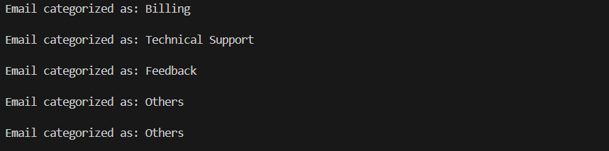
 | Problem Statement 2 | Intent Classification for Chatbot Queries  A company wants to deploy a chatbot to handle customer queries. Each query must be classified into one of the following intents: Account Issue, Order Status, Product Inquiry, or General Question using prompt engineering techniques.  Tasks to be Completed  - Prepare Sample Data  Create 6 short chatbot user queries, each mapped to one of the four intents.  - Zero-shot Prompting  Design a prompt that asks the LLM to classify a user query into the given intent categories without examples.  - One-shot Prompting  Provide one labeled query in the prompt before classifying a new query.  - Few-shot Prompting  Include 3–5 labeled intent examples to guide the LLM before classifying a new query.  - Evaluation  Apply all three techniques to the same set of test queries and document differences in performance.  Prompt  create a ai chatbot to handle customer queries for a retail website,  the chatbot bot should be able to respond to questions about product availability,  order status, Account Issues, product inquiries or general questions.  Code :  # Sample customer queries  queries = [  "Is the new smartphone model available in stock?",  "What is the status of my order #12345?",  "I am having trouble logging into my account. Can you help?",  "Can you provide more details about the features of the laptop?",  "What are your store hours and return policy?"  ]  # Function to classify customer queries  def classify_query(query):  query_lower = query.lower()  if "available" in query_lower or "in stock" in query_lower:  return "Product Availability"  elif "status" in query_lower or "order" in query_lower:  return "Order Status"  elif "trouble logging in" in query_lower or "account" in query_lower:  return "Account Issues"  elif "details" in query_lower or "features" in query_lower:  return "Product Inquiries"  else:  return "General Questions"  # Classify and print the category of each query  for query in queries:  category = classify_query(query)  print(f"Query categorized as: {category}\n")  Output :  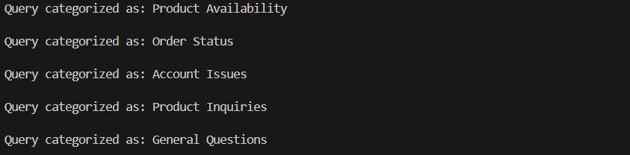
 | Problem Statement 3 | Student Feedback Analysis  A university collects student feedback and wants to categorize comments as Positive, Negative, or Neutral.  Questions:  a) Write a Zero-shot prompt to classify feedback sentiment.  b) Provide a One-shot prompt with one feedback example.  c) Create a Few-shot prompt using multiple labeled feedback samples.  d) Explain how examples improve sentiment classification accuracy.  Prompt  create a feedback analysis system for university feedback recieved from students,  it should be categorized into positive, negative, neutral feedback.  Code  '''create a feedback analysis system for university feedback recieved from students,  it should be categorized into positive, negative, neutral feedback.'''  # Sample feedback data  feedbacks = [  "The course was very informative and the professor was excellent!",  "I found the lectures to be boring and unengaging.",  "The assignments were okay, nothing special.",  "Great learning experience, I enjoyed every part of it.",  "The material was outdated and not relevant to current industry standards.",  "It was an average course, I learned some new things but nothing extraordinary."  ]  # Function to classify feedback  def classify_feedback(feedback):  feedback_lower = feedback.lower()  positive_keywords = ["excellent", "great", "enjoyed", "informative", "good", "fantastic", "amazing"]  negative_keywords = ["boring", "unengaging", "outdated", "dissatisfied", "poor", "bad", "terrible"]  if any(word in feedback_lower for word in positive_keywords):  return "Positive"  elif any(word in feedback_lower for word in negative_keywords):  return "Negative"  else:  return "Neutral"  # Classify and print the category of each feedback  for feedback in feedbacks:  category = classify_feedback(feedback)  print(f"Feedback categorized as: {category}\n")  '''create a feedback analysis system for university feedback recieved from students,  it should be categorized into positive, negative, neutral feedback.  Feedback: “The course content was boring and confusing.”  Sentiment: Negative  '''  feedback = "The course content was boring and confusing."  sentiment = classify_feedback(feedback)  print(f"Feedback: \"{feedback}\"\nSentiment: {sentiment}")  '''create a feedback analysis system for university feedback recieved from students,  it should be categorized into positive, negative, neutral feedback.  Feedback: “I really enjoyed the practical sessions and found them very helpful.”  Sentiment: Positive  Feedback: “The assignments helped me learn a lot.”  Sentiment: Positive  Feedback: “The syllabus was okay, nothing special.”  Sentiment: Neutral  Feedback: “The exams were unfair and too difficult.”  Sentiment: Negative  '''  feedback_list = [  "I really enjoyed the practical sessions and found them very helpful.",  "The assignments helped me learn a lot.",  "The syllabus was okay, nothing special.",  "The exams were unfair and too difficult."  ]  for feedback in feedback_list:  sentiment = classify_feedback(feedback)  print(f"Feedback: \"{feedback}\"\nSentiment: {sentiment}\n")  Output  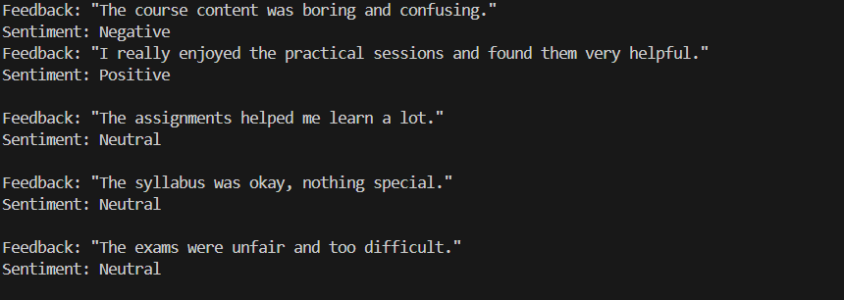
 | Problem Statement 4 | Course Recommendation System  An online learning platform wants to recommend courses by classifying learner queries into Beginner, Intermediate, or Advanced levels.  Questions:  a) Write a Zero-shot prompt to classify learner queries.  b) Create a One-shot prompt with one example query.  c) Develop a Few-shot prompt with multiple labeled queries.  d) Discuss how Few-shot prompting improves recommendation quality.  Prompt  create a online learning platform to recommend courses based on user preferences.  like Display only beginner, intermediate, advanced levels.  Code  '''create a online learning platform to recommend courses based on user preferences.  like Display only beginner, intermediate, advanced levels.'''  # Sample course data  courses = [  {"title": "Python for Beginners", "level": "Beginner"},  {"title": "Data Structures and Algorithms", "level": "Intermediate"},  {"title": "Advanced Machine Learning", "level": "Advanced"},  {"title": "Web Development Basics", "level": "Beginner"},  {"title": "Database Management Systems", "level": "Intermediate"},  {"title": "Deep Learning Techniques", "level": "Advanced"}  ]  # Function to recommend courses based on user preference  def recommend_courses(level):  recommended = [course for course in courses if course["level"].lower() == level.lower()]  return recommended  # Get user preference  user_level = input("Enter your preferred course level (Beginner/Intermediate/Advanced): ")  recommended_courses = recommend_courses(user_level)  # Display recommended courses  if recommended_courses:  print(f"Recommended {user_level} courses:")  for course in recommended_courses:  print(f"- {course['title']}")  else:  print(f"No courses found for the level: {user_level}")  '''create a online learning platform to recommend courses based on user preferences.  like Display only beginner, intermediate, advanced levels.  User Preference: Intermediate  Recommended Intermediate courses:  - Data Structures and Algorithms  - Database Management Systems  '''  user_level = "Intermediate"  recommended_courses = recommend_courses(user_level)  print(f"Recommended {user_level} courses:")  for course in recommended_courses:  print(f"- {course['title']}")  '''create a online learning platform to recommend courses based on user preferences.  like Display only beginner, intermediate, advanced levels.  User Preference: Beginner  Recommended Beginner courses:  - Python for Beginners  - Web Development Basics  '''  user_level = "Beginner"  recommended_courses = recommend_courses(user_level)  print(f"Recommended {user_level} courses:")  for course in recommended_courses:  print(f"- {course['title']}")  Output  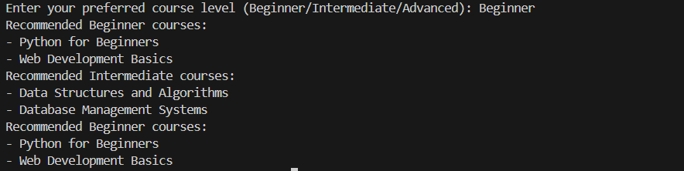
 | Problem Statement 5 | Social Media Post Moderation  A social media platform wants to classify posts into Acceptable, Offensive, or Spam.  Questions:  a) Write a Zero-shot prompt for post moderation.  b) Convert it into a One-shot prompt.  c) Design a Few-shot prompt using multiple examples.  d) Explain the challenges of Zero-shot prompting in content moderation.  Prompt  classify the post posted on social media into acceptable or offensive or spam.  Code  '''classify the post posted on social media into acceptable or offensive or spam.'''  posts = [  "Check out this amazing deal on electronics!",  "You are so stupid and ugly!",  "Win a free iPhone now!!! Click here!",  "Had a great day at the park with friends.",  "This is the worst product I have ever bought.",  "Congratulations! You've been selected for a prize."  ]  # Function to classify posts  def classify_post(post):  post_lower = post.lower()  offensive_keywords = ["stupid", "ugly", "idiot", "hate", "dumb"]  spam_keywords = ["win", "free", "click here", "selected", "prize", "deal"]  if any(word in post_lower for word in offensive_keywords):  return "Offensive"  elif any(word in post_lower for word in spam_keywords):  return "Spam"  else:  return "Acceptable"  # Classify and print the category of each post  for post in posts:  category = classify_post(post)  print(f"Post categorized as: {category}\n")  '''classify the post posted on social media into acceptable or offensive or spam.  Post: “You are an idiot and I hate you.”  Category: Offensive  '''  post = "You are an idiot and I hate you."  category = classify_post(post)  print(f"Post: \"{post}\"\nCategory: {category}")  '''classify the post posted on social media into acceptable or offensive or spam.  Post: “Congratulations! You've won a free vacation.”  Category: Spam  Post: “Had a wonderful time with family.”  Category: Acceptable  Post: “This is a dumb idea.”  Category: Offensive  '''  post_list = [  "Congratulations! You've won a free vacation.",  "Had a wonderful time with family.",  "This is a dumb idea."  ]  for post in post_list:  category = classify_post(post)  print(f"Post: \"{post}\"\nCategory: {category}\n")  Output  