CHAPTER 3
Requirement specification
3.1 Use case
In software and systems engineering, a use case is a list of actions or event steps, typically defining the interactions between a role and a system, to achieve a goal. The actor can be a human or other external system. In systems engineering, use cases are used for representing missions or stakeholder goals [5].
The use case diagram which defines the interactions between external actors and the system under consideration to accomplish a goal. Actors must be able to make decisions, but need not be human: "An actor might be a person, a company or organization, a computer program, or a computer system—hardware, software, or both." Actors are always stakeholders, but not all stakeholders are actors, since they "never interact directly with the system, even though they have the right to care how the system behaves [5].
The use case diagram of our project contains four actors which are teacher, department head, dean and QAMS Head. The use case model gives a bird eye look of the overall project features. As for the actors, the teachers have to login in to the system with correct username and password to get access in the QAMS form. The change password feature will also be available. Teachers can create new record including attendance, exam mark and questions and other student information’s. The teachers have to complete the QAMS form and then send it to the department head for validation. If the department head revert the submission back then the teachers have to correct all the incorrect information and send it to the department head again for further validation.
The Department Head will also have to login to the system with correct username and password to get access in the department head panel and QAMS form to check the information and sent it to the Dean. The change password feature will also be available for the department head. If the Dean revert the submission for incorrect information, the department head will also revert to the teacher for correcting all the incorrect information and finally sent it again to the Dean for validation.
The Dean will also have to go through the login panel with correct username and password to get access to the Dean panel and QAMS form for validate the information and sent it to the QAMS Head. The change password feature will also be available for The Dean. Figure 3.1 demonstrate the use case diagram of our software.

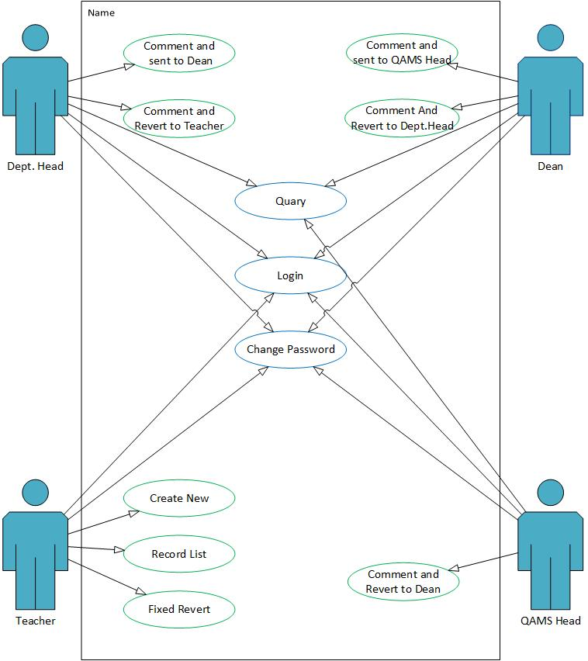

Figure 3.1: Use case model for QAMS Management System
If the QAMS Head find any incorrect information and revert it back to the Dean, the dean have to revert it back to Department Head and then to the teacher for correction and again sent it to the Department Head to Dean to the QAMS Head.
The QAMS Head will also have to go through the login panel with the correct username and password to get access to the QAMS panel and the QAMS form for validate the information. The change password feature will also be available for the QAMS Head. If there is any incorrect information the QAMS Head will revert it to Dean to Department Head to Teacher and the Teacher will correct the information and sent it back to the QAMS Head by following the same process again. If all the information is successfully validate by the QAMS Head then he will sent the document in the server and save it into the database.

3.2 Logical data model
We are proposing a QAMS management system for educational institutions that will benefit the student, teacher and the management authorities of the educational institutes. Our proposed system contains the QAMS form and the validation form to get input from the teacher and to validate the information by the QAMS members including department head, Dean and QAMS head. On the QAMS form the teachers should input the following data- Attendance copy, no of classes taken, assignment, presentation, midterm exam, final exam, course outline covered in classes. The teacher should upload the Attendance copy, final and midterm question copy, course outline in PDF file format.
For the validation part of the system the teacher will submit the QAMS form to the Dept. Head and the Dept. Head will validate all the information and submit the QAMS validation form to the Dean and eventually the document will be submit to the QAMS head by the Dean. The QAMS head validate the information and save it in the database. If the teacher submit any invalid information than he/she must make a resubmission request to the Dept. Head and if the Dept. Head approved the request, the revert option for the submission will be activated again for the teachers to correct the information on the QAMS form and then resubmit the document again.

Our proposed QAMS management system have four module Teacher, Dept. Head, Dean and QAMS Head. The teacher have to fill-up the QAMS form and scanned the attendance sheet and other document and submit on the system. The document will be sent to the Dept. Head for Proper validation and if the content information is false then the Dept. Head will reject the submission and notify the teacher to resubmit the document again. If the Dept. Head validate the document properly then the document will sent to the Dean for more validation. The same process will take effect if any false information occurs otherwise the documentation will be sent to the QAMS Head for final validation. The same process will happen if any false information occurs and if every bit of information is correct and validate properly then the QAMS Head will save the information on the database.
The figure 3.2 is the main working flow diagram for our proposed system
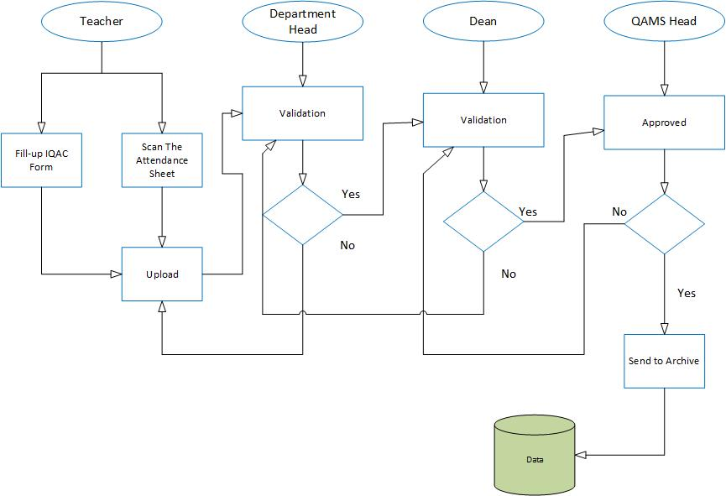
Figure 3.2: Workflow diagram of the proposed system
3.2.1 Teacher’s workflow
Figure 3.3 explain teacher’s workflow where the teachers should have to login correctly to get access to the QAMS form. There is a forget password option in case of the teacher can’t login to the QAMS form. If the teacher submit the form previously then the normal submission menu won’t be available. In that case apply for revert option will be available, to request a resubmission to the Dept. Head. If the teacher submitting the QAMS Form for the first time of the semester, after inputting all the necessary information into the QAMS form, the teacher can submit the document to the Dept. Head. The QAMS form requirements are Course code, Learning feedback system link, no of the classes taken, midterm, final term, assignment, presentation and Course outline, Midterm question, final term question, attendance copy will submitted as PDF file format.
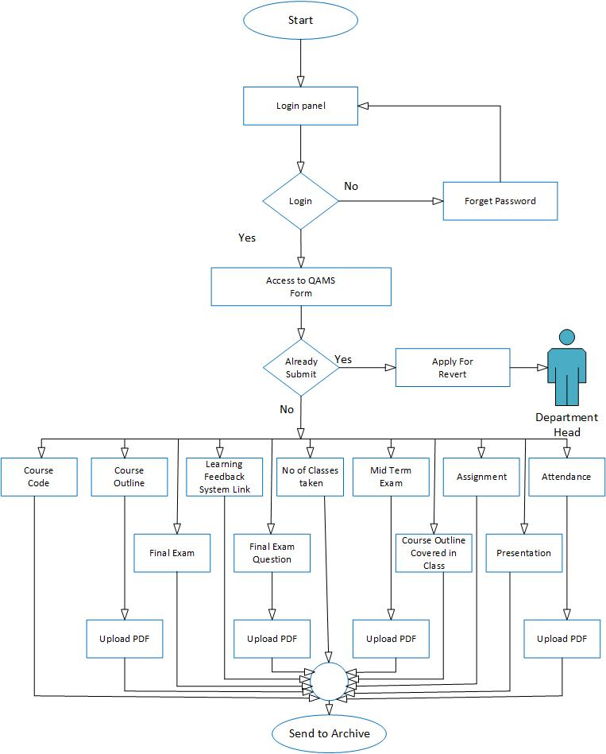

Figure 3.3: Workflow diagram for the teacher’s panel
3.2.2 Department Head workflow
The following figure 3.4 explains the Dept. Head Panel who also have to login through the login panel to access to the QAMS validation form. There is a forget password option for login error. The Dept. Head have to ensure all the information and verify the validation form. If the Dept. Head never submit the QAMS validation form of that semester before, the submission option will be available. Else apply for revert option will be available instead of submission. The Dept. Head have to request a resubmission to the Dean by applying the revert option. If the Dean approve the resubmission request, the submission option will be available again for the Dept. Head to resubmit the QAMS validation form.
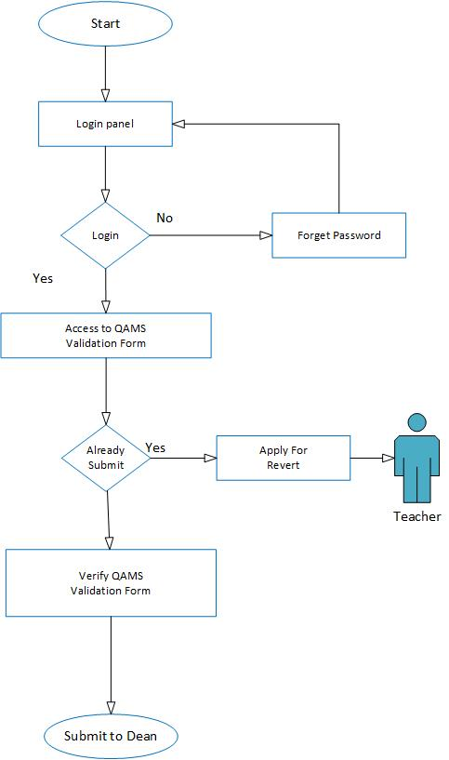

Figure 3.4: Workflow diagram for the Dept. Head panel
3.2.3 Dean workflow
In the following figure 3.5 explain the workflow diagram of the Dean panel, like the previous panels the Dean also have to login through the login panel. In case the password is forgotten, the forgotten password option will be available for creating a new password. After getting access to the QAMS validation form, the Dean will verify the QAMS validation form and submit the document to the QAMS Head. If the Dean never submit the QAMS validation form of that semester before, the submission
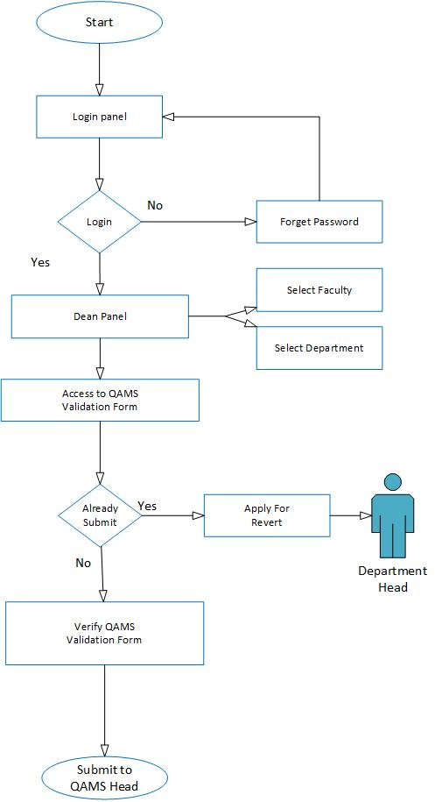

Figure 3.5: Workflow diagram for the Dean panel
option will be available. Else apply for revert option will be available instead of submission. The Dean have to request a resubmission to the QAMS Head by applying the revert option. If the QAMS Head approve the resubmission request, the submission option will be available again for the Dean to resubmit the QAMS validation form.
3.2.4 QAMS Head workflow
In the following Figure 3.6 explain the workflow diagram of the QAMS Head panel, like the previous panels the QAMS Head also have to login through the login panel. In case the password is forgotten, the forgotten password option will be available for creating a new password.
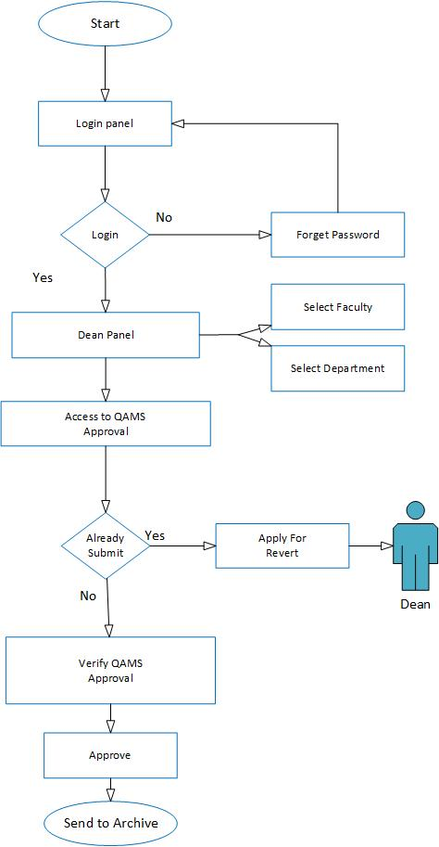
Figure 3.6: Workflow diagram for the QAMS Head panel
Before get access to the QAMS validation form the QAMS Head have to select the specific faculty and department from the drop down menu. After getting access to the QAMS approval, the QAMS Head will verify the QAMS approval. The QAMS Head will approve the document and sent it to the database. There will be not revert option for the QAMS Head because the QAMS Head is the prime authority for QAMS management system. If the Dean apply for a resubmission request, the QAMS can approve the request to resubmission the document again.

3.3 Implementation Requirement
The QAMS has been developed by some professional and resourceful web developing tools & technologies. The development was divided into two parts, front end developing and back end developing. The tools we used for developing the QAMS are the following
- HTML5, CSS3 with Bootstrap framework
- PHP with Codeigniter framework, jQuery
- Apache Server 5
- Database: MySQL
The font end developing required mostly HTML5, CSS3 bootstrap etc. For using HTML5 is the reason that it has constant improving capabilities with better accessibility. But HTML5 is best known for its cross platform capabilities. Compatibility with different platforms is the main attractive feature of this technology. A HTML5 app can work in different operating systems of mobile devices including Android, iOS, Blackberry or Windows Phone. Creating mobile apps using HTML5 is also easy. There are also many HTML5 apps that are easily available and they can be used in any device that supports this technology.
The CSS3 provide the best user friendly interface for any web application or design. The bootstrap framework is filled with simple and attractive design module to use. The using pattern was also very efficient form any other design pattern. The fundamental structure and design plays a vital role of any web based application. The first card of the game has to make the product attractive to the target group of people. Then amaze them by the user friendly backend developing where the application meet all the requirement of the client.
CodeIgniter is one of the most popular PHP frameworks around. It uses the Model-View-Controller Architectural design pattern and it’s considered by lots of PHP developers as one of the best framework solution for small to medium projects. CodeIgniter uses Model-View-Controller pattern which is the most used architectural design pattern in web application. It can also be turned into supporting the more advanced Hierarchical Model View Controller (HMVC) pattern by installing the popular CodeIgniter HMVC Extension. Since performance has been a major concern for each web developer, CodeIgniter is optimized to boost the code performance. Also codeIgniter contains wide variety of helper functions that were created to help for writing cleaner code and save time and effort doing repetitive tasks.
Angular JS makes use of the original MVC (Model-View-Controller) software architectural pattern, but not in the traditional sense. Two-way data binding, which automatically updates the view as soon as any change occurs in the model and vice-versa, is certainly one the most unique and powerful features in Angular JS. Angular takes full advantage of Dependency Injection (DI) to deal with how an application should be wired. That means, it is no longer required to use the un-maintainable main () method in order to execute the code.
We have tested this system in Linux and Windows operating system. We used Apache Web server and NetBeans IDE.
As for our database we use MySQL which is the world most used open source relational database management system that runs as a server providing multi-user access to a number of database. MySQL is a popular choice of database for user in web application, and it is a central component of the widely used LAMP open source web application. For the commercial use, several paid edition are available, and offer additional functionality. MySQL is also in many high-profile large scale worldwide web products [6]. Google has used MySQL in their Adword project [7]. MySQL is also used in world’s biggest networking site Facebook [8].
In this chapter we have discussed about the platform and the technical requirement that we have used in our entire project. Basically we used Codeigniter and Angular JS to develop this project. With the help of Bootstrap framework and CSS we’ve designed and align our website’s Text content and we also connect this project to MySQL database for storing and retrieving data. The overall project is based on PHP, JavaScript, HTML5, CSS3 and MySQL which are very popular platform and efficient for developing web based application.

CHAPTER 4
Design & implementation
4.1 Design of GUI
The design of our software interfaces was based on all the implementation requirements and we also developed the product as much user friendly as possible. As for the software requirement, we developed at least one user panel for the user to communicate with the system. For the security and data protection every single user have to go through the log in panel with the correct user name and password. Every user have their own user panel and some validation panel to validate the inputted data regarding the quality assurance of the educational institute for improving the overall performance. For that in mind we attached every single user interface that we developed with details explanation. So that the user can easily maintain and communicate with the system and properly understand and use all of the available function of this software.

We design the entire software for specifically four user that are the Teachers, Department Head, Dean, and IQAC Head. All the user have their different login panel as for the software functional requirement where different type of data have to be inputted to successfully log on into the system. The Teacher will have access to the teacher panel and the IQACMS form panel log in with correct email address and password. There the teachers will input all the quality assurance data and submit the IQACMS form to the Department Head for further validation. The Department Head will get access to the Head panel by log in to the system and validate all the quality assurance data and submit it to the Dean for more validation. The Dean will also has a Dean panel and a Dean Validation panel to submit all the verified information to the IQAC Head for final validation of the data. The IQAC Head have two user panel like the Dean which is IQAC panel and IQAC validation panel for validate all the student information before saving it on the archive.

The following figures are the snapshot of all the user interface of our developed product with details explanation so that the users can easily understand and use all of the available function and maintain the system properly with maximize output.
4.1.1 Teachers Login Panel
In the following figure 4.1 describe the user interface for teachers login panel. In this panel the teacher have to input the required information to get access into the teacher panel and the IQACMS from. The required information for the teachers to successfully log in into the system are user email and a password. Then the teacher also have to provide dropdown information such as the user type which is teacher, the semester, and for the last dropdown menu is select the year like 2014 or 2015 etc. After providing the correct information the teacher have to click the login button in the bottom down on the interface. If all the information provided by the teacher is correct then the teacher will successfully logged in to the system and get access to the teachers panel and the IQACMS form.

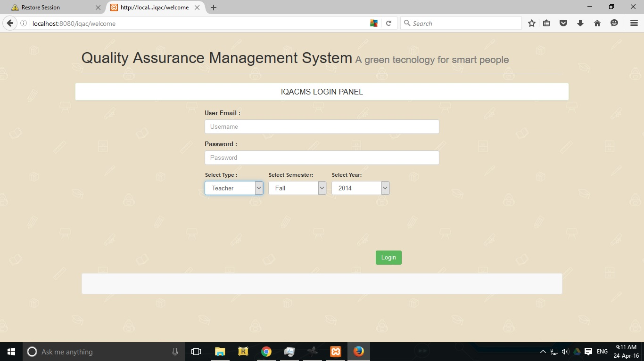
Figure 4.1: UI for Teachers Login Panel

4.1.2 Teachers panel
In the following figures 4.2 describe the user interface for teacher’s panel. Where the teachers panel shows varies information such as Name of the teacher, faculty name, name of the program, semester, year, designation and employee id. Bottom down the menu will display all the course taken by that teacher and the QAMS form submit option will be available here to check the submission. In the bottom right corner is the save button to save all the changes done by the teacher.

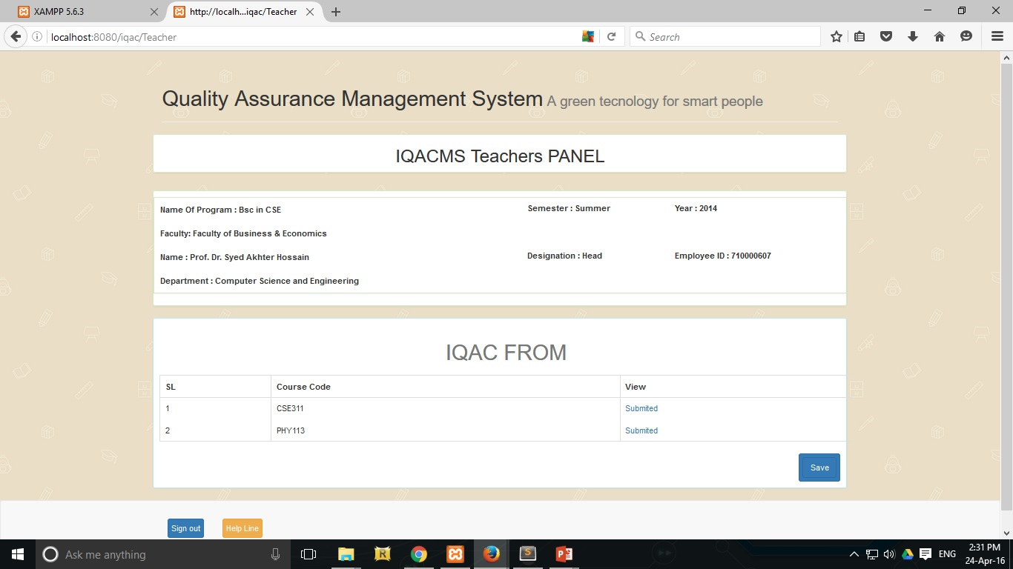
Figure 4.2: UI for Teachers Panel

4.1.3 Teachers QAMS form
In the following figures 4.3 describe the user interface for Teachers QAMS form. Where the teachers will input all the quality assurance data regarding the specific course. The following information will be given automatically on the upper side of the page which are Course name, Section and the rest will be drop down menu and input option for the teacher’s to give the required information for the validation. Such as Zoom Link and Number of class take. For the dropdown menu the options are Number of class test taken, Midterm exam test taken, Final term exam taken, Number of assignment, Number of presentation. The Attendance, Midterm exam question and the Final term exam question will be upload manually by the teachers in PDF format. There is a submit button for submitting all the information that is correct and verified by the teachers. After the teacher submit the form, there is no way to resubmit the same form again unless revert button is activate which will let the teacher’s allow to modify the IQAC form again. There is also three more button to back to the previous page, to sign out from the system and the help line button which describe all the function of that specific page.
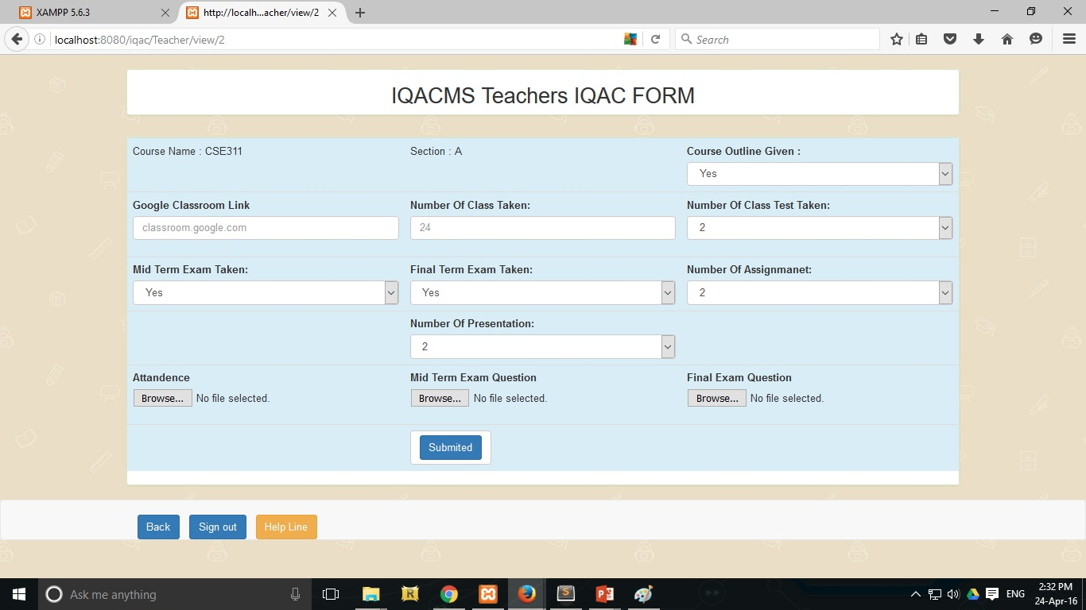
Figure 4.3: UI for Teachers QAMS form

4.1.4 Department Head Login Panel
In the following figure 4.4 describe the user interface for Head Login Panel. In this panel the Department Head have to input the required information to get access into the Department Head panel. The required information for the Department Head to successfully log in into the system are user email and a password. Then the Department Head also have to provide dropdown information such as the user type which is Head, the semester, select the year like 2014 or 2015 and select specific department such as Computer Science & Engineering etc. After providing the correct information the Department Head have to click the login button in the bottom down on the interface. If all the information provided is correct then the Department Head will successfully logged in to the system and get access to the Department Head Panel.

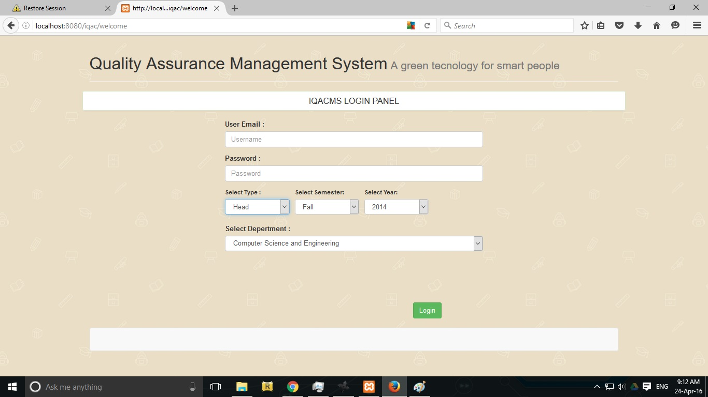
Figure 4.4: UI for Head Login Panel

4.1.5 Department Head Panel
In the following figures 4.5 describe the user interface for Department Head Panel. Where the Department Head Panel shows varies information such as Name of the Department Head, faculty name, name of the program, semester, year, designation and employee id. Bottom down the menu will display the teacher’s name and their submitted IQAC form. There is option available to view every single submission and revert button if the Department Head find any incorrect information in the IQAC form. If the Department Head press the revert button then the specific teacher will be allowed to correct the incorrect information and resubmit the IQAC form again to the Department Head. In the bottom right corner is the save button to save all the changes done by the Department Head. There is also two more button to sign out from the system and the help line button which describe all the function of that specific page.

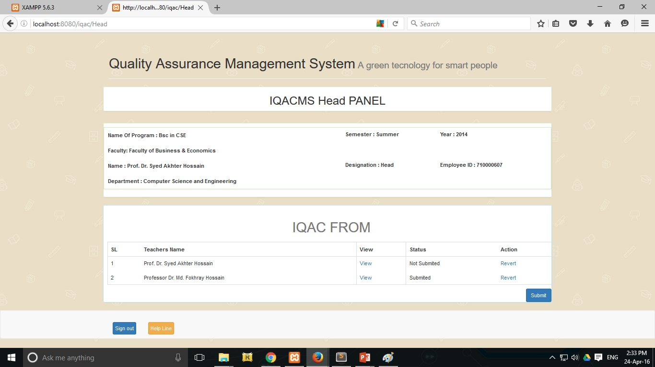
Figure 4.5: UI for Head Panel

4.1.6 Dean Login Panel
In the following figure 4.6 describe the user interface for Dean Login Panel. In this panel the Dean have to input the required information to get access into the Dean panel. The required information for the Dean to successfully log in into the system are user email and a password. Then the Dean also have to provide dropdown information such as the user type which is Dean, the semester, select the year like 2014 or 2015 and select specific faculty such as Faculty of Business & Economics etc. After providing the correct information the Dean have to click the login button in the bottom down on the interface. If all the information provided is correct then the Dean will successfully logged in to the system and get access to the Dean Panel.

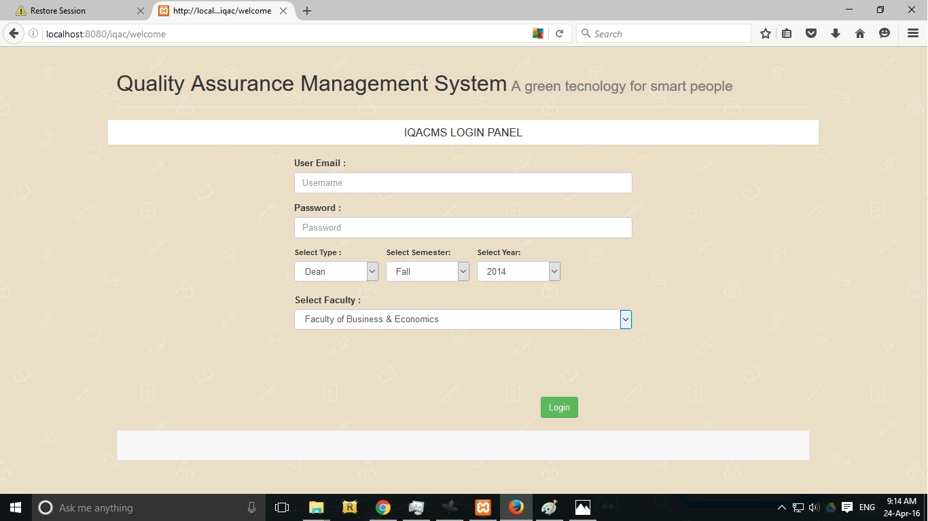
Figure 4.6: UI for Dean Login Panel

4.1.7 Dean Panel
In the following figures 4.7 describe the user interface for Dean Panel. Where the Dean Panel shows varies information such as Name, faculty name, name of the program, semester, year, designation and employee id. Bottom down the menu will display the Department Head names and their submitted IQAC form with submission status. There are option available to view every single submission and revert button if the Dean found any incorrect information in the IQAC form. If the Dean press the revert button then the specific Department Head will be allowed to correct the incorrect information and resubmit the IQAC form again to the Dean for further validation. In the bottom right corner is the save button to save all the changes done by the Dean. There is also two more button to sign out from the system and the help line button which describe all the function of that specific page.

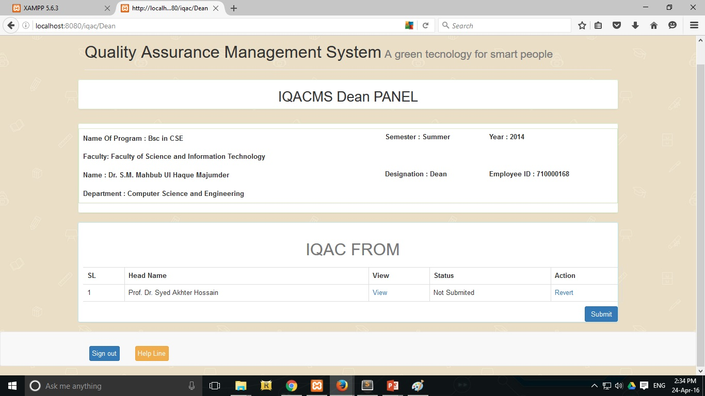
Figure 4.7: UI for Dean Panel

4.1.8 Dean Verification
The following figure 4.8 explain the Dean Verification panel where varies information are given such as Name, faculty name, name of the program, semester, year, designation and employee id. It also contain the IQAC verification form for the Dean to verify all the data and submit it to the IQAC Head for further validation. The IQAC form contain Teachers name, the view option for the review the main IQAC form filled by the teacher’s and the submission status. There is also three more button to back to the previous page, to sign out from the system and the help line button which describe all the function of that specific page.

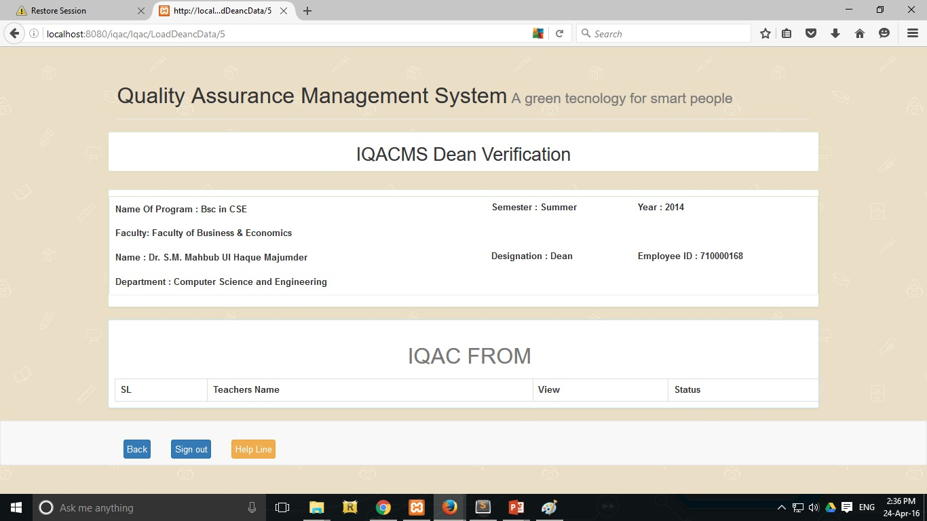
Figure 4.8: UI for Dean Verification

4.1.9 QAMS Head Panel
In the following figures 4.9 describe the user interface for QAMS Head Panel. Where the QAMS Head Panel shows varies information such as Name, faculty name, name of the program, semester, year, designation and employee id. Bottom down the menu will display the Dean names and their submitted IQAC form with submission status. There are option available to view every single submission and revert button if the Dean found any incorrect information in the IQAC form. If the QAMS Head press the revert button then the specific Dean will be allowed to correct the incorrect information and resubmit the IQAC form again to the QAMS Head for further validation. There is also two more button to sign out from the system and the help line button which describe all the function of that specific page.

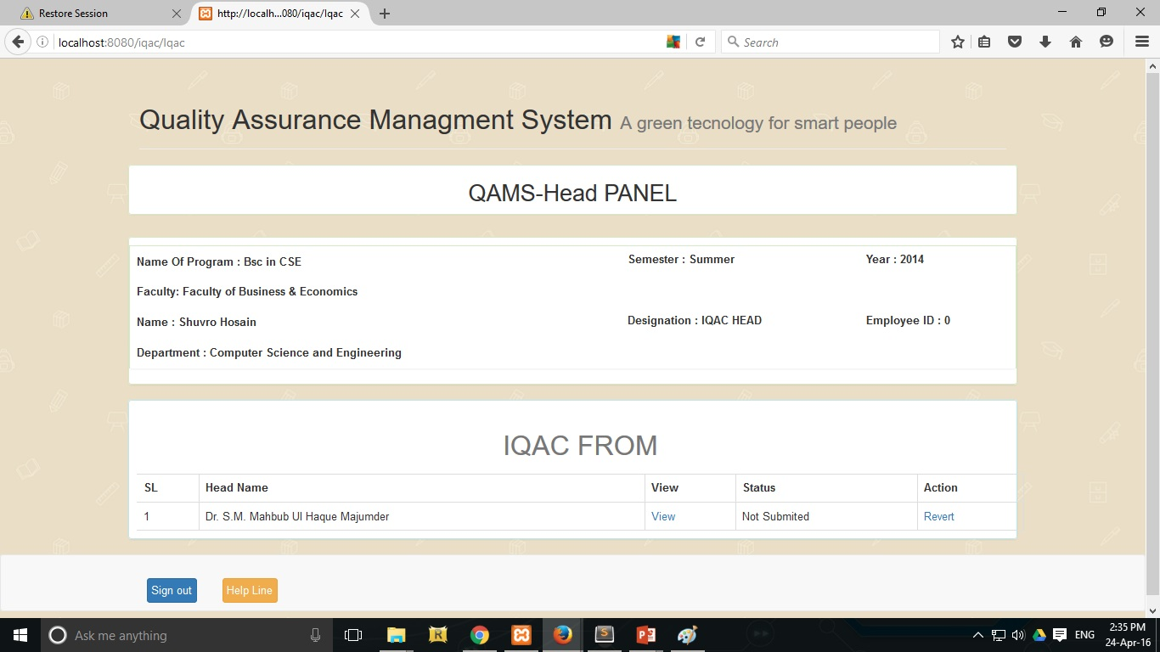
Figure 4.9: UI for QAMS Head Panel

4.1.10 IQAC Head Verification
The following figure 4.10 explain the QAMS Head Verification panel where varies information are given such as Name, faculty name, name of the program, semester, year, designation and employee id. It also contain the IQAC verification form for the QAMS Head to verify all the data. The IQAC form contain Teachers name, the view option for the review the main IQAC form filled by the teacher’s and the submission status. In the bottom right corner is the save button to save the IQAC form into the archive for future scope. There is also three more button to back to the previous page, to sign out from the system and the help line button which describe all the function of that specific page.

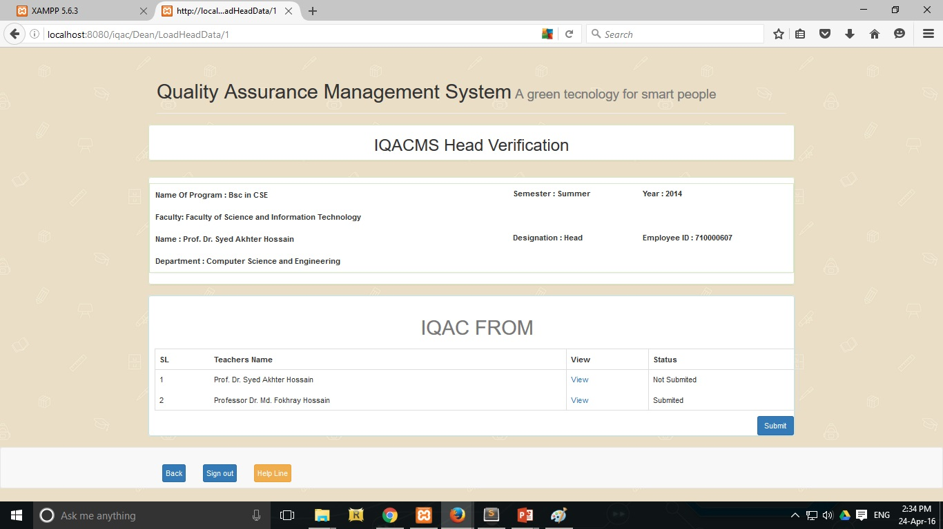
Figure 4.10: UI for IQACMS Head Verification

4.2 Database ERD
In our Database ERD model, there are fourteen tables which are connected each other by their primary keys. Every table has its own attribute. Store table has thirteen attribute, this table mainly store the QAC all data.
In User table we store all user data and all kind of user type store in user type table. Which user which type we only can find out checking UserTypeRelationship table.
Status table control the Teachers submission and the administration table control the Head, Dean and QAC submission. Faculty table store all the faculty details, Department table store department all details.
Figure 4.11 demonstrate the ERD model of our Software database.

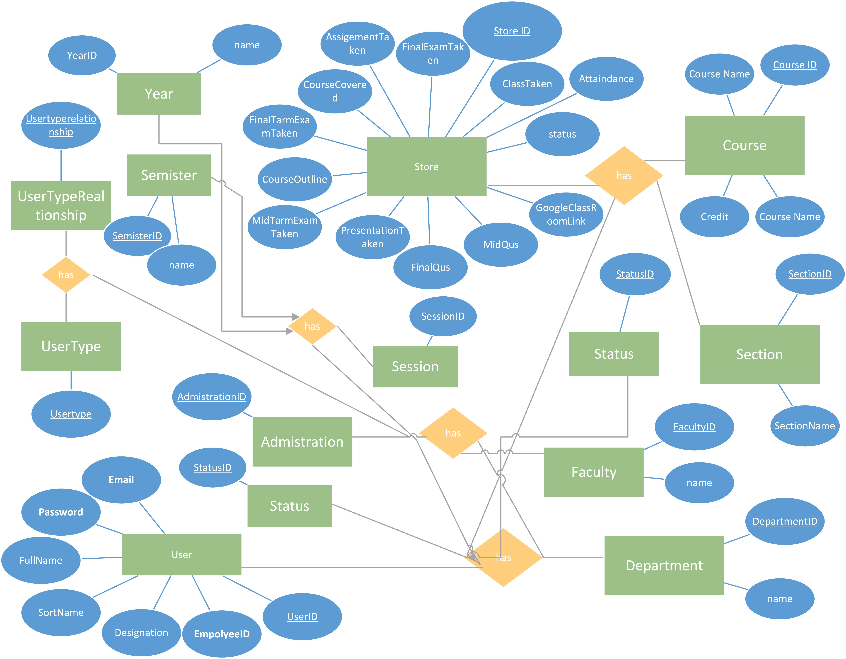
Figure 4.11: Database ERD
4.3 Database Schema
Figure 4.12 explain the connectivity of our product database Schema. The schema model stores data that is retrieved according to commands from the controller. Here we indicate all the models which we use to talk to the tables.
Preload
LoadType(),LoadSemester(),LoadDepertment(),Loadyear(),LoadFaculty().
User
Login_check($username,$password),LoginTypeCheck($userid,$UserTypeId),GetSession($YearId,$SemesterId),VelidationSession($SessionId,$userid),UserDetails($userid),GetFaculty($FacultyId),GetYear($YearId),GetSemester($semester),CheckDepartment($userid,$departmentid),CheckFaculty($userid,$departmentid,$FacultyId),DeanVarification($userid,$DepertmentId,$FacultyId),SubmissionTest($userid,$SessionId,$UsertypeId),HeadScrach($departmentid,$SessionId),DeanScrach($FacultyId,$SessionId),DepertmentDeanList($SessionId),Revert($id,$data),RevartHead($id,$FacultyId,$SessionId,$data),RevartDean($id,$SessionId,$data)
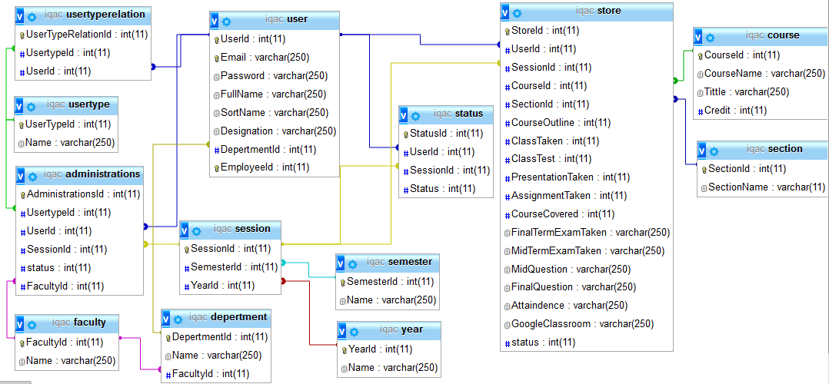
Figure 4.12: Database Schema
Storage
GetTeachersResult($userid,$SessionId),IqacFormDetails($value),_update($id, $data),StatusUpdate($id, $data).
Administrations
HaadSubmittion($userid,$UserTypeId,$SessionId,$data),DeanSubmittion($userid,$UserTypeId,$SessionId,$data),IqacHeadSubmittion($userid,$UserTypeId,$SessionId,$data)
4.4 Functionality testing
Reviewing the testing code is another basic of software engineering that is often overlooked in web development. Testing is an integral part of the system development process. The main standard for software testing is contained in the ANSI/IEEE slandered 829/1983-standard for software testing documentation. Some software testing may be performed by CAST (Computer Aided Software Testing). The Whole application must be tested and result documented. It is not only the software that is evaluated during the system testing process, it is also important to test operating procedure.
4.4.1 Unit Test
Each part of the application is tested to ensure that the detailed design is correctly implemented. It has been carried out to ensure that each part of the system works as per requirement.
4.4.2 System test
System testing has been carried out prior to installation and it is observed that the system works according to requirement and there is no functional errors.
4.4.3 Usability Test
Usability test were carried out by the users. These verify that the system provide the required functionality. Firstly we selected few users to test out system for usability test. By doing the usability test, it is sure that the users do not face any difficult problems while using the application.
4.4.4 Compatibility Testing
Compatibility resting, part of the software nonfunctional test, is testing conducted on the application to evaluate the application’s compatibility with the computing environment
Browser compatibility testing can be more appropriately referred to as user experience testing. This requires that the web alienation are tested on different web browser.
4.5 Discussion summary
The codes are reviewed, whenever they are produced each part of the whole project was tested by the local server. Necessary test were carried out to ensure that the system of the web application are error free and all the operating processor work as per requirement. The stages of testing also correspond to the whole web application development. Problems of illogical data, unclear field, inconsistent movement and performance were detected, tackled and eliminated through different test.

