EECS 497: Human-Centered Software Design and Development
User Requirements Document
This assignment consists of 4 parts:

- Project Context, Expected Deliverables, and Scope
- High-level, Prioritized User Requirements Table with Target Values
- Project Management Strategy and Plan Update
- Primary Persona

Assignment Background & Context
A user requirements document provides an opportunity for your team to discuss strategic options (technical or operational), refine your project scope, develop group-based decisions, and identify the most critical aspects of your project that must be built. Typically a wide variety of users and stakeholders (beyond just the technical, e.g., marketing) contribute to this document. Its primary purpose is to evaluate and discuss strategic options; it is never just a recap of work completed.

Your project is unique. Therefore, the elements that you emphasize in your user requirements document will also be unique; there isn’t a “standard fixed format”. In addition to the topics covered in Rapid Contextual Design, we’ve provided content below to highlight the questions you should ask your team and your potential users. Some elements may not be relevant for your project.

In addition, the time and focus given to included elements will vary between projects. For example, if your project is focused on delivering a refined product using proven technology you might eliminate any consideration of academic literature on cutting edge methodology and instead focus on the needs of the end user group you are targeting, or related success products in the marketplace. If your project objective is to deliver an analytical methodology with radically improved accuracy, you should focus on the current state of cutting edge methodologies with potential to deliver your needs.

Project Context, Expected Deliverables, and Scope
The following should be considered and included when writing this section of your document:

- Project context and user/stakeholder info
  - Brief introduction of your project and its highest level motivation. What high level benefit(s) will your project bring to your users? (e.g., cost reduction, efficiency gain, improved quality, competitive edge, increased reputation, open a new market, a relative priority on a scale of 1-5, etc.)
  - Who are the users and stakeholders that are being considered? (e.g., customers, competitors, user groups, regulatory agencies, etc.)

- Expected deliverables and scope
  - What will be your initial, or most important, deliverable?
  - Do you have any potential stretch goals? These might be dependent on the direction that the project develops.
  - Define the scope of your project. What is “in scope” and what do you consider to be something that your team will be able to create/modify/learn/etc...? What is “out of scope” of the project and, therefore, should not be considered further. In addition, what is “in scope” but of secondary importance to your work (it might be relevant to stretch goals).
  - Provide background context that is most relevant to the expected deliverable. This might include any of the following (some may not apply to your project – this is a general guide):
    - Preliminary studies and/or initial user survey data collected by your team
    - Description of basic technologies or research methods you will employ
    - Algorithms or solution concepts
    - User demographic information (if directly relevant to your project)
    - Brief description of similar solutions or competitive products
    - Relevant academic literature
    - Identifying content experts (e.g. faculty, professionals, etc…) that you plan to engage with in your project

High-level, Prioritized User Requirements Table with Target Values
Requirements are specific, measurable elements that can be evaluated quantitatively and whether a requirement "passes" or "fails" will determine its success. A requirement is typically a target value (with some level of acceptable deviation) and a specific method or standard to evaluate it. Your teams’ understanding of specific, detailed requirements, their target values and evaluation methods or standards will evolve and be refined throughout the project as you become more knowledgeable. With that, you should present as much definition as possible in this section of the document and include the following:

- A Table of Requirements expressed in a solution-independent manner with a hierarchical ranking of importance, and the target value of the requirement. Because your team is still developing an understanding of your project domain, you should expect that these will be refined as the project progresses. Regarding your requirements being solution-independent, this refers to the fact that you haven't yet implemented your project (i.e. you are still in the design phase) and thus your requirements can't/shouldn't depend on a specific implementation. In other words, your requirements should be general enough such that they can be satisfied by a variety of implementations.

While the number of requirements that you generate will vary based on your project’s scope, a minimum of 5 requirements should be included in your table. If you have too few, there isn't much to design for and/or evaluate at the end. If you have too many, you run the risk of not finishing and/or not being able to schedule everything properly. See Appendix A at the end of this document for some example tables (one is software-based and the other hardware-based).

- The Table should include the following information for each requirement (if known):
  - Requirement Name
  - Priority of the requirement to the solution (e.g,. important, nice to have, legal requirement, etc.)
  - Target Value, Specification, Range, or Threshold for the requirement that, if satisfied, will indicate that the corresponding requirement has been satisfied
  - Evaluation Method for measuring requirement. Note that, as was discussed in lecture, these can be either direct or indirect measurements. Direct measurements are usually objective in nature, simple to understand, and easy to replicate. Indirect measurements, on the other hand, are usually subjective, more difficult to measure precisely, and harder to replicate. One type is no better or worse than the other, they just measure different things that are all important to your project.
  - Whether or not the requirement is considered a “not-only-you” requirement (as was discussed in the first few lectures). Note: the examples in Appendix A do not include this information as they came from projects that didn’t consider this a priority.

Project Management Strategy and Plan Update
This section of the document should expand, refine, and update the Initial Project Management Strategy and Plan that you created in your Project Planning Document by addressing the following:

- Describe and provide a justification for any changes that have been made to your project management strategy. For example, changes associated with your:
  - Current team organization
  - Areas of responsibility/roles for each member of the team
  - When/where your team works outside of regular team meetings
  - Communication and accountability strategy
- Include an updated Gantt chart covering the entire project period that should demonstrate:
  - A considered break down of tasks
  - Assignment of responsibilities to subteam or individuals
  - Any logical sequencing and parallel task completion

Note that you will likely be communicating the status and plans of your project via a Gantt chart again in later assignments. Therefore, it is worthwhile to establish a standard structure that can be easily edited to make this easier. Software that is designed to help you manage the process (e.g., Microsoft Project) is strongly suggested.

Primary Persona
The final section of this document is the creation of your primary persona. This persona should be a single page in length and contain key features taken from the material that was discussed in lecture. In particular, be sure to not include any details that would trigger any implicit biases in the viewer of the persona. An example persona can be found in Appendix B at the end of this assignment. Note that, when compared to some of the examples of personas that were presented in lecture, the example in Appendix B is more concise and visual in nature, contains less “content and words”, and is more succinct in its delivery of the persona’s material. Given that a persona is intended to be a focusing device that will be referred back to often by the development team, the example below is considered preferable to those that were discussed (negatively) in lecture.

Grading
Your work will be graded, as a team grade, utilizing the rubric that can be found under the associated Assignment on Canvas

Appendix A: Example User Requirements Tables

Example 1:
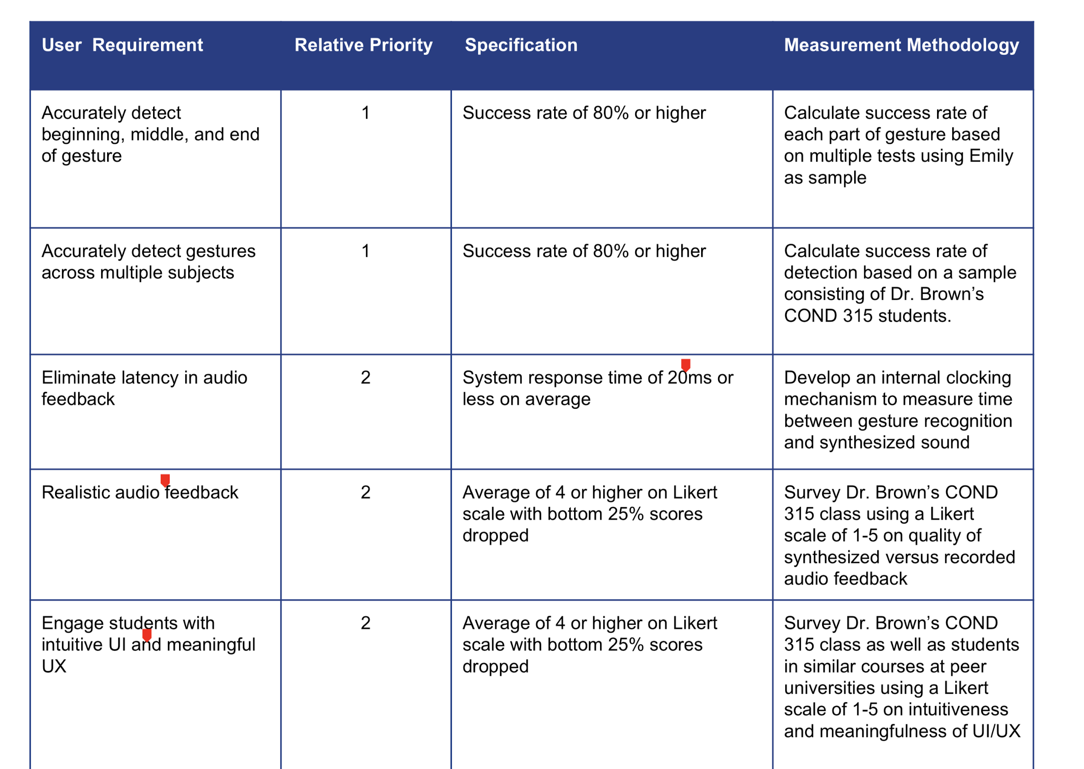

Example 2:
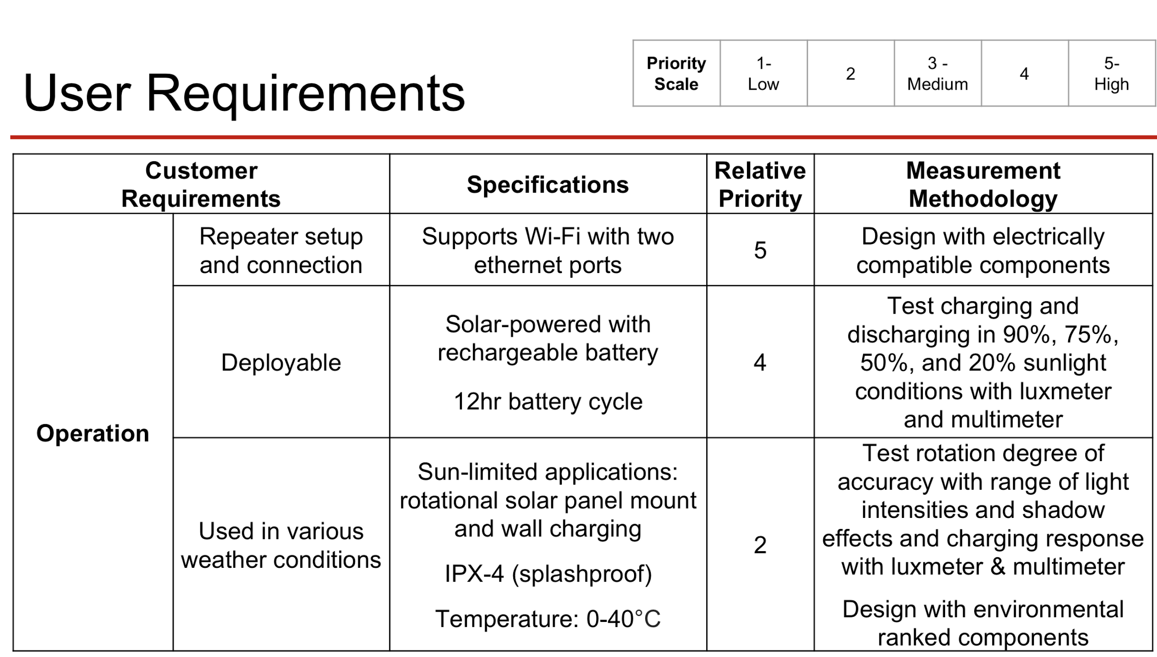
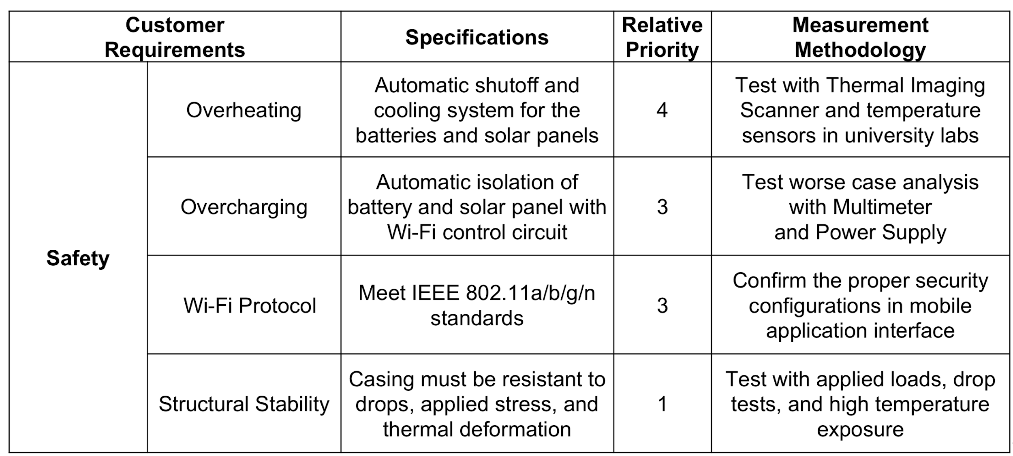
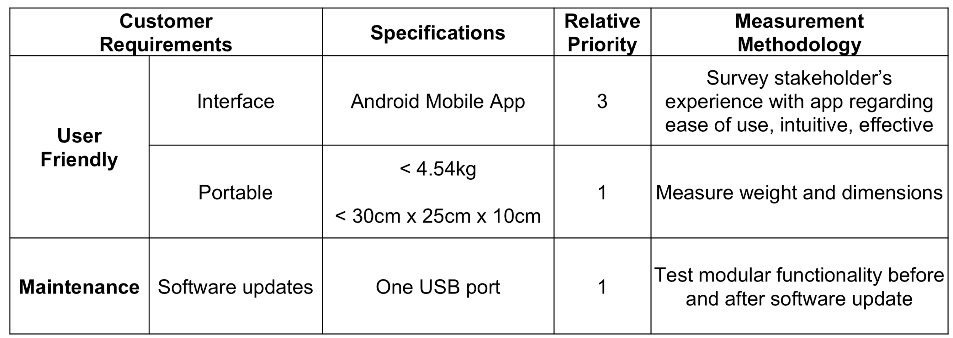
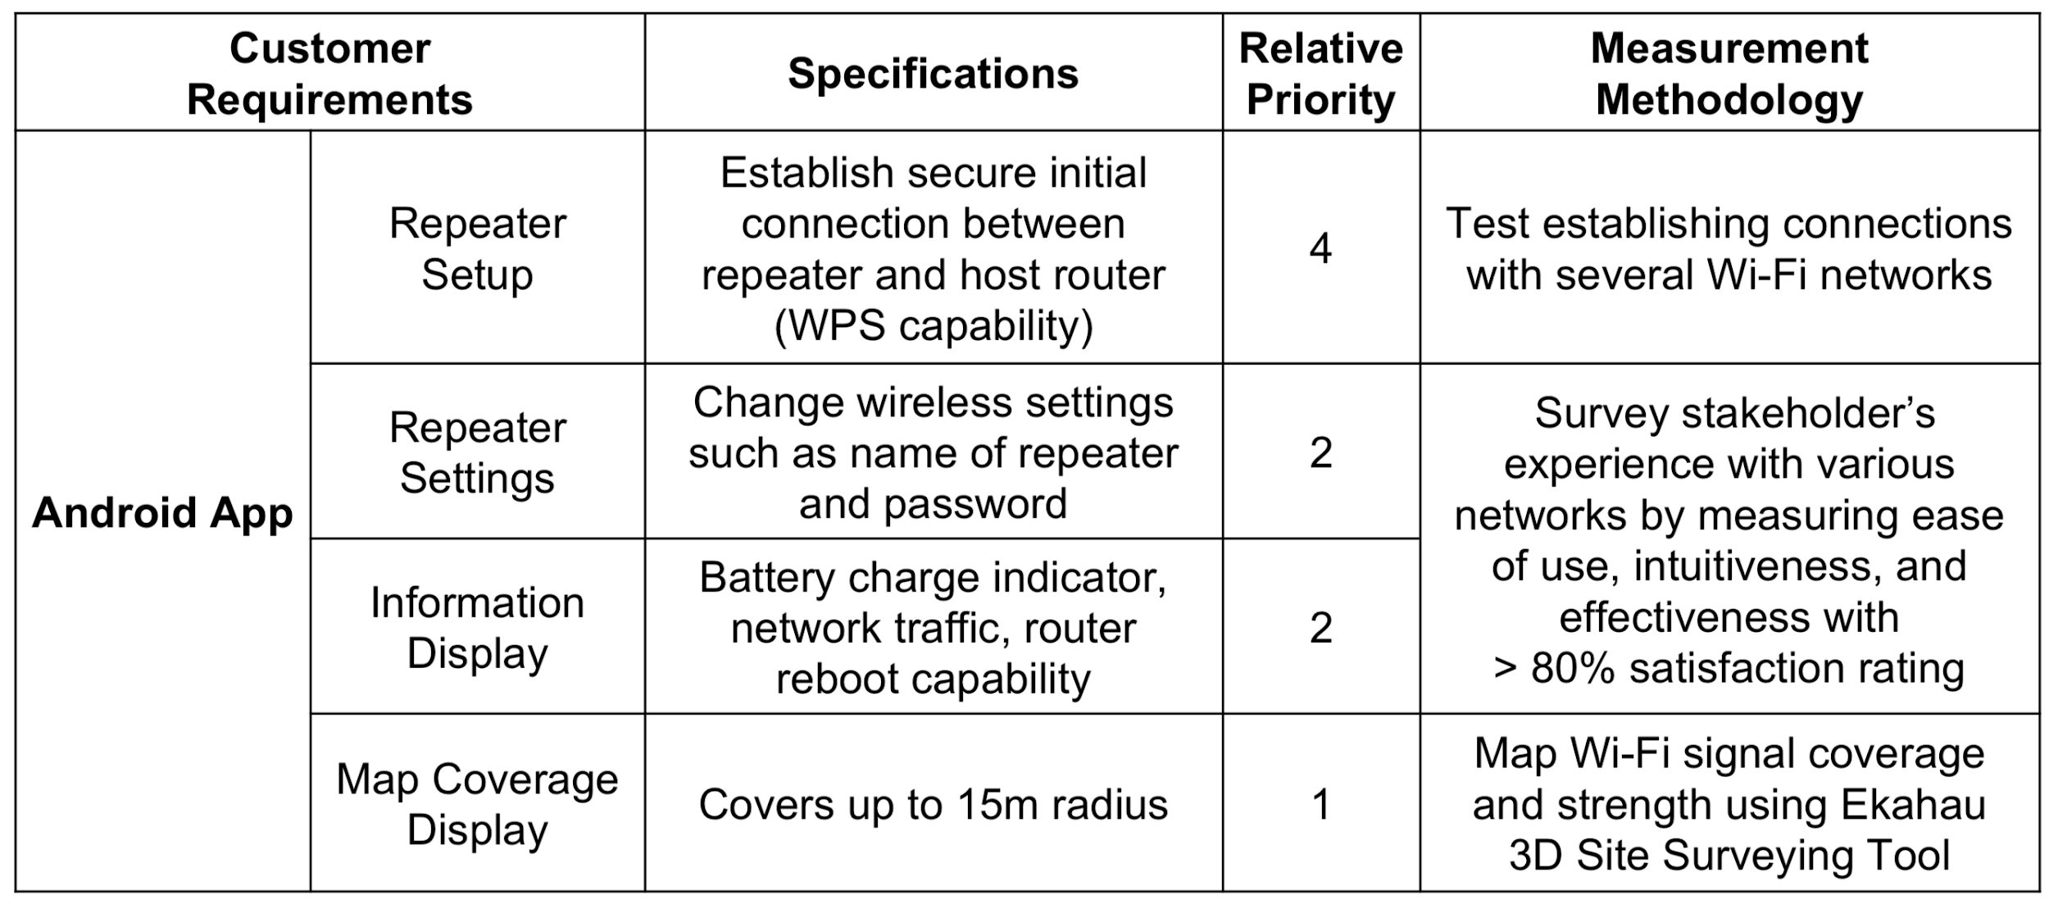

Appendix B: Example Persona

More details on this can be found at: https://dscout.com/people-nerds/transition-personas

