Live Support Desk and Messaging Flowchart
System: ADC Gadgets | Portal: Admin Portal (Management Side) | Page File: src/admin/communication.html
FUNCTIONAL SUMMARY & SCOPE:
Unified inbox for staff to review incoming customer inquiries and reply in real time.
Note: In accordance with system directives, there are no online loan requests. Admin provisions user accounts directly from face-to-face agreements.

1. Flowchart Diagram (Paper-Ready Visual)
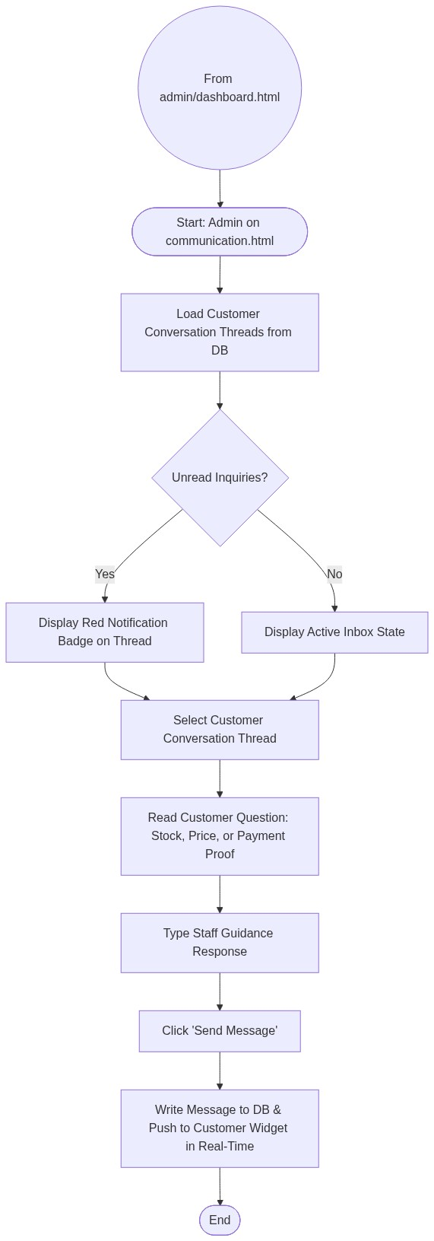

2. Page Connectors (Navigation Relationships)
Connector Symbol | Connector Type | Target Page & Explanation
((From admin/dashboard.html)) | Incoming Connector | Arrives from dashboard menu.

3. Step-by-Step Process & Logic Table
Flowchart Step / Node | Flowchart Shape | Logic & Action Description
Start | Terminal | Admin opens communication.html.
Check Unread | Decision | Identifies threads with pending customer messages.
Read Message | Process | Admin reviews customer inquiry.
Send Reply | Process | Sends advice, payment instructions, or stock availability.
Push to DB | Database Write | Real-time sync to customer's live chat session.
End | Terminal | Terminates current page flow.

