Admin Executive Dashboard Flowchart
System: ADC Gadgets | Portal: Admin Portal (Management Side) | Page File: src/admin/dashboard.html
FUNCTIONAL SUMMARY & SCOPE:
Executive command center summarizing operational KPIs and providing routing to all management modules.
Note: In accordance with system directives, there are no online loan requests. Admin provisions user accounts directly from face-to-face agreements.

1. Flowchart Diagram (Paper-Ready Visual)
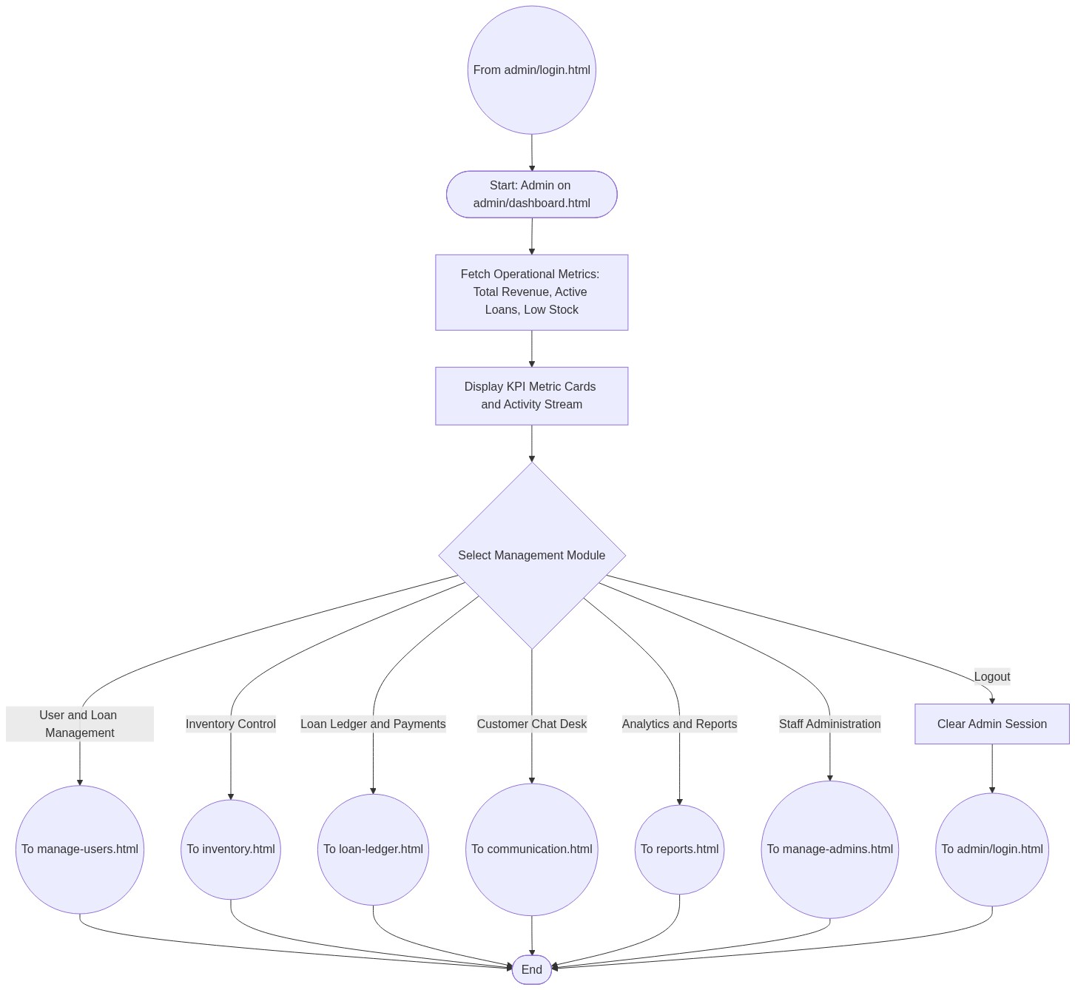

2. Page Connectors (Navigation Relationships)
Connector Symbol | Connector Type | Target Page & Explanation
((From admin/login.html)) | Incoming Connector | Arrives after successful admin login.
((To manage-users.html)) | Outgoing Connector | Transfers to Customer and Loan provisioning.
((To inventory.html)) | Outgoing Connector | Transfers to Device Inventory management.
((To loan-ledger.html)) | Outgoing Connector | Transfers to Payment Ledger and Collections.
((To communication.html)) | Outgoing Connector | Transfers to Live Customer Support desk.
((To reports.html)) | Outgoing Connector | Transfers to Financial and Business Reports.
((To manage-admins.html)) | Outgoing Connector | Transfers to Admin Staff management.

3. Step-by-Step Process & Logic Table
Flowchart Step / Node | Flowchart Shape | Logic & Action Description
Start | Terminal | Admin opens dashboard.
Fetch KPIs | Process | Aggregates revenue, active loans, and inventory counts.
Select Module | Decision | Admin selects administrative feature to manage.
Module Connectors | Connector | Transfers flow to specific administrative page.
End | Terminal | Terminates current page flow.

