Inventory Control and AppleDB Integration Flowchart
System: ADC Gadgets | Portal: Admin Portal (Management Side) | Page File: src/admin/inventory.html
FUNCTIONAL SUMMARY & SCOPE:
Manages device catalog, utilizing AppleDB search to auto-populate hardware specs and official studio renders, and manages stock levels.
Note: In accordance with system directives, there are no online loan requests. Admin provisions user accounts directly from face-to-face agreements.

1. Flowchart Diagram (Paper-Ready Visual)
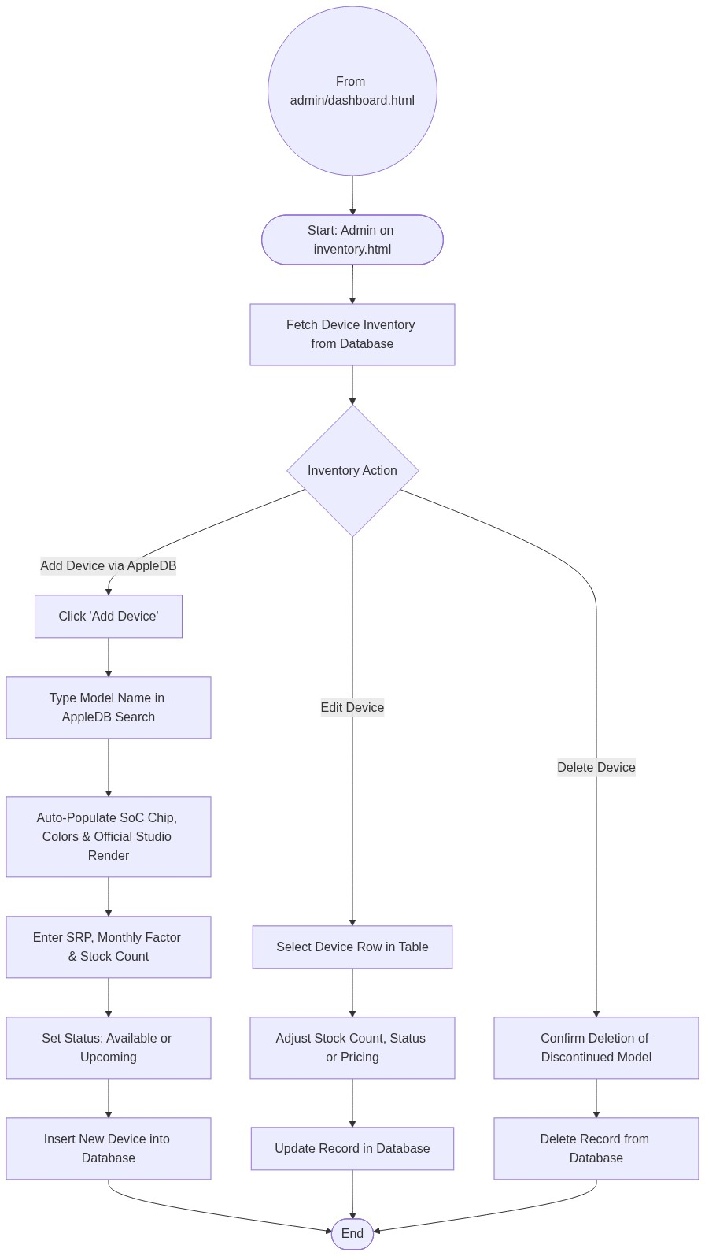

2. Page Connectors (Navigation Relationships)
Connector Symbol | Connector Type | Target Page & Explanation
((From admin/dashboard.html)) | Incoming Connector | Arrives from dashboard menu.

3. Step-by-Step Process & Logic Table
Flowchart Step / Node | Flowchart Shape | Logic & Action Description
Start | Terminal | Admin opens inventory.html.
Inventory Action | Decision | Chooses Add Device, Edit Stock, or Delete Model.
AppleDB Auto-Fill | External Integration | Queries AppleDB API for verified specs and studio renders.
Set Stock and Status | Input | Sets inventory units and marks Available or Upcoming.
Database Write | Database Write | Commits device changes to PostgreSQL table.
End | Terminal | Terminates current page flow.

