Loan Ledger and Collections Flowchart
System: ADC Gadgets | Portal: Admin Portal (Management Side) | Page File: src/admin/loan-ledger.html
FUNCTIONAL SUMMARY & SCOPE:
Records customer monthly installment payments (Cash, GCash, Bank Transfer) and automatically computes remaining balance and due dates.
Note: In accordance with system directives, there are no online loan requests. Admin provisions user accounts directly from face-to-face agreements.

1. Flowchart Diagram (Paper-Ready Visual)
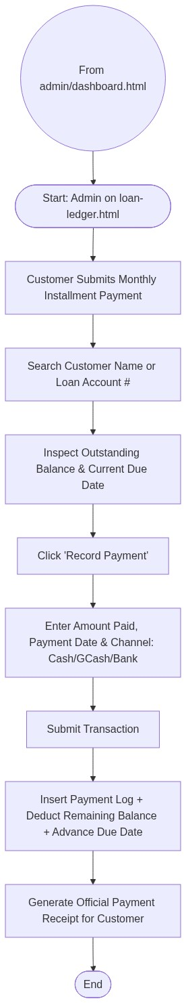

2. Page Connectors (Navigation Relationships)
Connector Symbol | Connector Type | Target Page & Explanation
((From admin/dashboard.html)) | Incoming Connector | Arrives from dashboard menu.

3. Step-by-Step Process & Logic Table
Flowchart Step / Node | Flowchart Shape | Logic & Action Description
Start | Terminal | Admin opens loan-ledger.html.
Payment Notice | External Trigger | Customer pays installment at store or sends transfer slip.
Search Account | Input | Admin locates active loan record in ledger.
Record Payment | Input | Enters amount paid, timestamp, and payment method.
Update Database | Database Write | Deducts payment from balance and rolls forward due date.
Issue Receipt | Output | Generates official receipt for the borrower.
End | Terminal | Terminates current page flow.

