Administrator Authentication Flowchart
System: ADC Gadgets | Portal: Admin Portal (Management Side) | Page File: src/admin/login.html
FUNCTIONAL SUMMARY & SCOPE:
Authenticates administrative personnel and establishes authorized session before granting dashboard access.
Note: In accordance with system directives, there are no online loan requests. Admin provisions user accounts directly from face-to-face agreements.

1. Flowchart Diagram (Paper-Ready Visual)
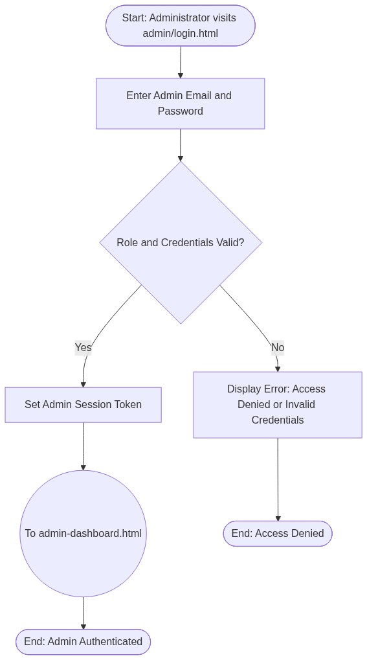

2. Page Connectors (Navigation Relationships)
Connector Symbol | Connector Type | Target Page & Explanation
((To admin-dashboard.html)) | Outgoing Connector | Navigates to Executive Dashboard upon successful authentication.

3. Step-by-Step Process & Logic Table
Flowchart Step / Node | Flowchart Shape | Logic & Action Description
Start | Terminal | Admin opens admin/login.html.
Enter Admin Credentials | Input | Enters administrative email and password.
Verify Role and Hash | Decision | Verifies credentials against admin accounts in database.
Issue Token | Process | Stores admin session token.
To admin-dashboard.html | Connector | Transfers flow to Admin Command Center.
End | Terminal | Terminates current page flow.

