Staff and Admin Access Control Flowchart
System: ADC Gadgets | Portal: Admin Portal (Management Side) | Page File: src/admin/manage-admins.html
FUNCTIONAL SUMMARY & SCOPE:
Security administration module to create, manage, and revoke internal staff credentials.
Note: In accordance with system directives, there are no online loan requests. Admin provisions user accounts directly from face-to-face agreements.

1. Flowchart Diagram (Paper-Ready Visual)
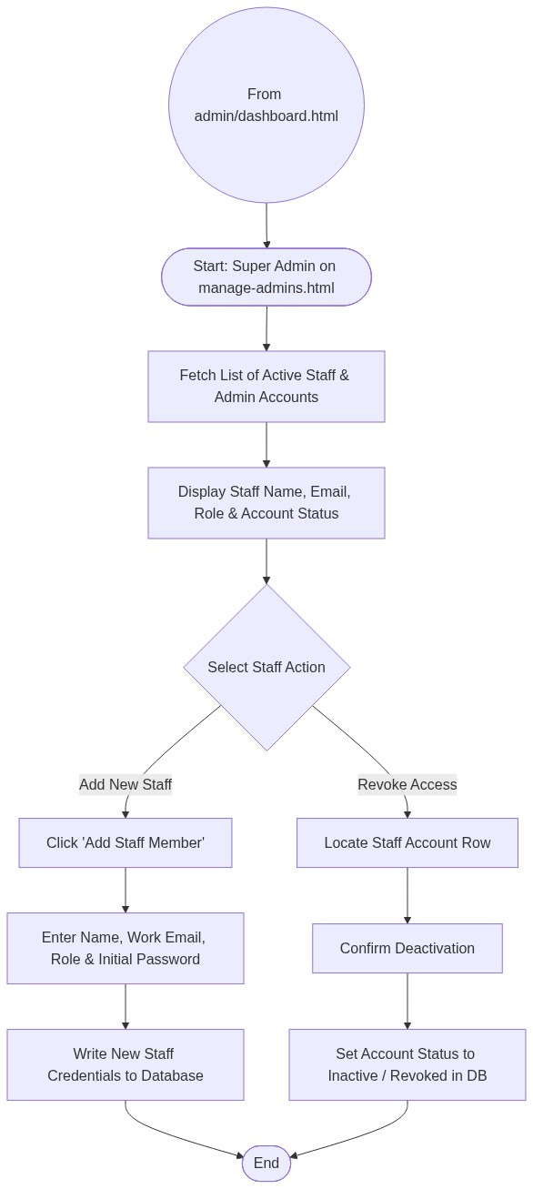

2. Page Connectors (Navigation Relationships)
Connector Symbol | Connector Type | Target Page & Explanation
((From admin/dashboard.html)) | Incoming Connector | Arrives from dashboard menu.

3. Step-by-Step Process & Logic Table
Flowchart Step / Node | Flowchart Shape | Logic & Action Description
Start | Terminal | Super Admin opens manage-admins.html.
Staff Action | Decision | Chooses to provision new staff or revoke existing access.
Input Staff Data | Input | Enters work email, security role, and password.
Save to Database | Database Write | Creates staff record in admin_users table.
Revoke Access | Process | Deactivates staff credentials to prevent system access.
End | Terminal | Terminates current page flow.

