Customer Account and Direct Loan Assignment Flowchart
System: ADC Gadgets | Portal: Admin Portal (Management Side) | Page File: src/admin/manage-users.html & user-loan.html
FUNCTIONAL SUMMARY & SCOPE:
Core administrative workflow: provisions customer accounts and registers verified face-to-face loan agreements onto the system.
Note: In accordance with system directives, there are no online loan requests. Admin provisions user accounts directly from face-to-face agreements.

1. Flowchart Diagram (Paper-Ready Visual)
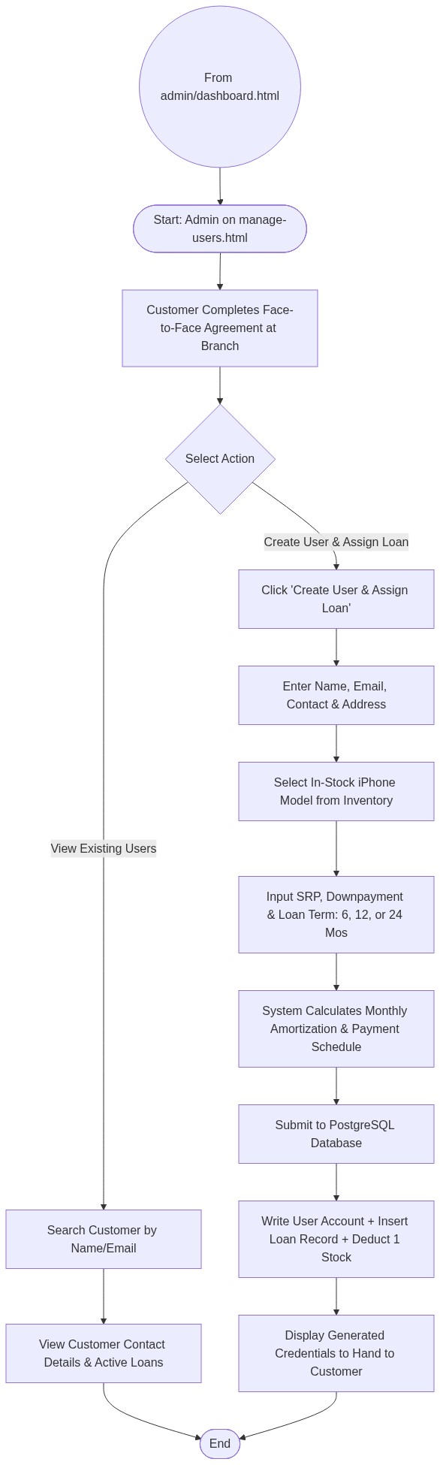

2. Page Connectors (Navigation Relationships)
Connector Symbol | Connector Type | Target Page & Explanation
((From admin/dashboard.html)) | Incoming Connector | Arrives from dashboard menu.

3. Step-by-Step Process & Logic Table
Flowchart Step / Node | Flowchart Shape | Logic & Action Description
Start | Terminal | Admin opens customer provisioning module.
Face-to-Face Agreement | External Trigger | Customer physically completes agreement at store.
Input Profile | Input | Admin enters customer demographic details.
Select Device and Terms | Process | Admin picks in-stock device and defines term length.
System Calculation | Process | Automated amortization calculation based on term.
Write Database | Database Write | Creates user record, inserts loan contract, decrements stock.
Issue Credentials | Output | Admin gives login credentials to customer for account tracking.
End | Terminal | Terminates current page flow.

