Business Reports and Analytics Flowchart
System: ADC Gadgets | Portal: Admin Portal (Management Side) | Page File: src/admin/reports.html
FUNCTIONAL SUMMARY & SCOPE:
Compiles financial analytics, collection efficiency, loan disbursement volume, and inventory velocity for administrative reporting.
Note: In accordance with system directives, there are no online loan requests. Admin provisions user accounts directly from face-to-face agreements.

1. Flowchart Diagram (Paper-Ready Visual)
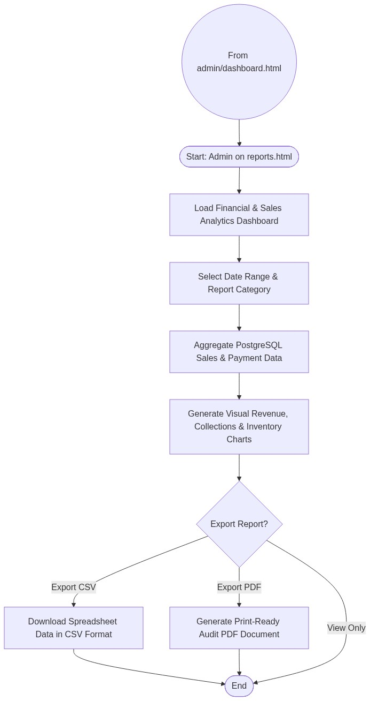

2. Page Connectors (Navigation Relationships)
Connector Symbol | Connector Type | Target Page & Explanation
((From admin/dashboard.html)) | Incoming Connector | Arrives from dashboard menu.

3. Step-by-Step Process & Logic Table
Flowchart Step / Node | Flowchart Shape | Logic & Action Description
Start | Terminal | Admin opens reports.html.
Select Filters | Input | Chooses date range (daily, weekly, monthly) and category.
Aggregate DB Data | Process | Queries database for financial summaries.
Render Charts | Output | Displays visual metrics and summary tables.
Export Choice | Decision | Optionally downloads CSV or PDF for bookkeeping.
End | Terminal | Terminates current page flow.

