Customer Account and Loan Ledger Flowchart
System: ADC Gadgets | Portal: User Portal (Customer Side) | Page File: src/user/account.html
FUNCTIONAL SUMMARY & SCOPE:
Customer personal portal to monitor assigned active device loans (provisioned face-to-face by admin), remaining balance, and amortization history.
Note: In accordance with system directives, there are no online loan requests. Admin provisions user accounts directly from face-to-face agreements.

1. Flowchart Diagram (Paper-Ready Visual)
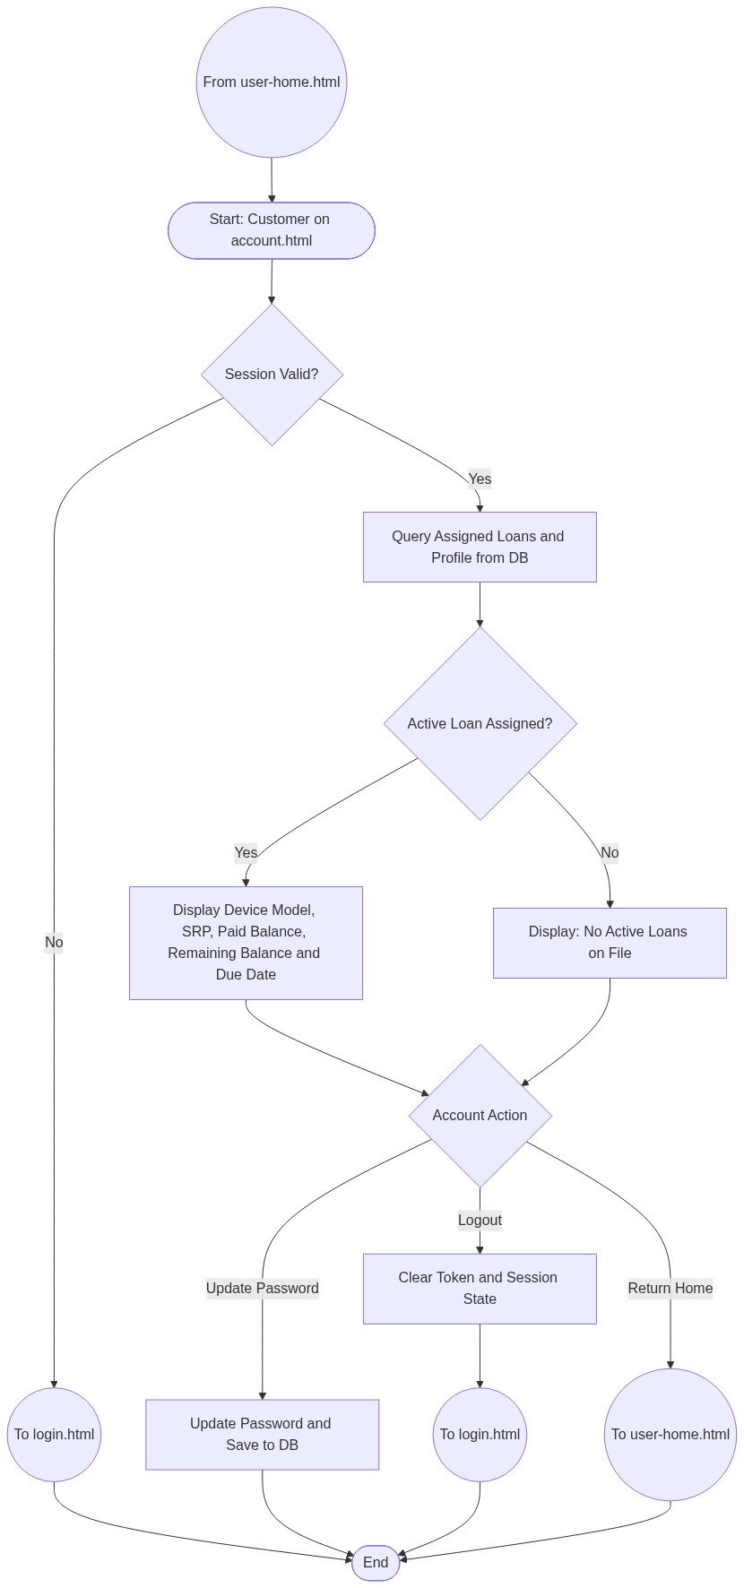

2. Page Connectors (Navigation Relationships)
Connector Symbol | Connector Type | Target Page & Explanation
((From user-home.html)) | Incoming Connector | Arrives from homepage navigation.
((To login.html)) | Outgoing Connector | Redirects to login if session expires or user logs out.
((To user-home.html)) | Outgoing Connector | Returns customer to store homepage.

3. Step-by-Step Process & Logic Table
Flowchart Step / Node | Flowchart Shape | Logic & Action Description
Start | Terminal | Loads account.html dashboard.
Check Session | Decision | Validates browser authentication token.
Query Assigned Loans | Process | Fetches active loans created by admin during face-to-face agreement.
Render Ledger | Process | Displays remaining balance, monthly amortization, and schedule.
Logout / Exit | Connector | Transfers flow to login.html or user-home.html.
End | Terminal | Terminates current page flow.

