Device Catalog and Specification Viewer Flowchart
System: ADC Gadgets | Portal: User Portal (Customer Side) | Page File: src/user/devices.html
FUNCTIONAL SUMMARY & SCOPE:
Allows customers to filter available vs. upcoming iPhones, search by model name, and inspect authentic AppleDB studio renders and specs.
Note: In accordance with system directives, there are no online loan requests. Admin provisions user accounts directly from face-to-face agreements.

1. Flowchart Diagram (Paper-Ready Visual)
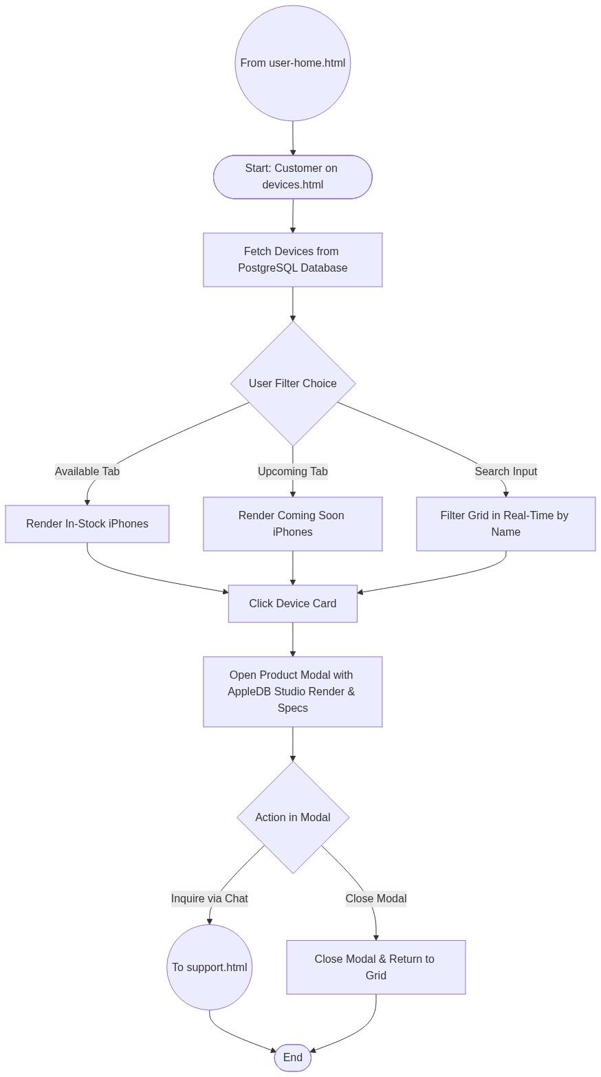

2. Page Connectors (Navigation Relationships)
Connector Symbol | Connector Type | Target Page & Explanation
((From user-home.html)) | Incoming Connector | User enters catalog from homepage navigation.
((To support.html)) | Outgoing Connector | Transfers user to live support chat to inquire about device purchase.

3. Step-by-Step Process & Logic Table
Flowchart Step / Node | Flowchart Shape | Logic & Action Description
Start | Terminal | Initializes devices.html catalog page.
Fetch Devices | Process | Queries database for all iPhone records and AppleDB keys.
Filter Choice | Decision | Customer toggles between Available / Upcoming tabs or searches.
Click Device Card | Process | Launches specification modal for chosen model.
Inspect AppleDB Specs | Process | Displays official studio render, chip, display, camera, and SRP.
To support.html | Connector | Directs customer to live chat for store purchase inquiries.
End | Terminal | Terminates current page flow.

