Customer Homepage and Discovery Flowchart
System: ADC Gadgets | Portal: User Portal (Customer Side) | Page File: src/user/user-home.html
FUNCTIONAL SUMMARY & SCOPE:
Main dashboard for customers to view active store announcements, explore featured devices, and navigate to catalog, account, or support.
Note: In accordance with system directives, there are no online loan requests. Admin provisions user accounts directly from face-to-face agreements.

1. Flowchart Diagram (Paper-Ready Visual)
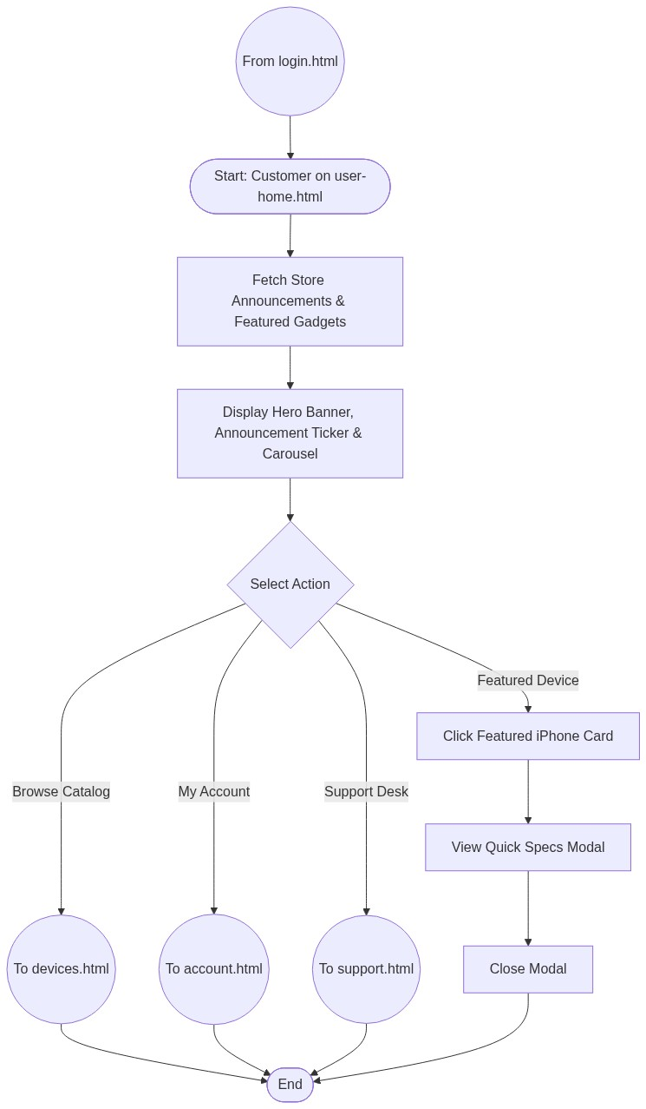

2. Page Connectors (Navigation Relationships)
Connector Symbol | Connector Type | Target Page & Explanation
((From login.html)) | Incoming Connector | Customer arrives after successful login.
((To devices.html)) | Outgoing Connector | Navigates to full device catalog.
((To account.html)) | Outgoing Connector | Navigates to customer account and loan balance tracker.
((To support.html)) | Outgoing Connector | Navigates to store FAQ and live chat widget.

3. Step-by-Step Process & Logic Table
Flowchart Step / Node | Flowchart Shape | Logic & Action Description
Start | Terminal | Loads user-home.html dashboard.
Fetch Store Data | Process | Queries PostgreSQL for active announcements and featured gadgets.
Select Action | Decision | User chooses navigation branch.
To devices.html | Connector | Transfers flow to device browsing.
To account.html | Connector | Transfers flow to personal account ledger.
To support.html | Connector | Transfers flow to live support desk.
End | Terminal | Terminates current page flow.

