User Login and Authentication Flowchart
System: ADC Gadgets | Portal: User Portal (Customer Side) | Page File: src/user/login.html
FUNCTIONAL SUMMARY & SCOPE:
Handles customer authentication, session token generation, error feedback, and password recovery redirection.
Note: In accordance with system directives, there are no online loan requests. Admin provisions user accounts directly from face-to-face agreements.

1. Flowchart Diagram (Paper-Ready Visual)
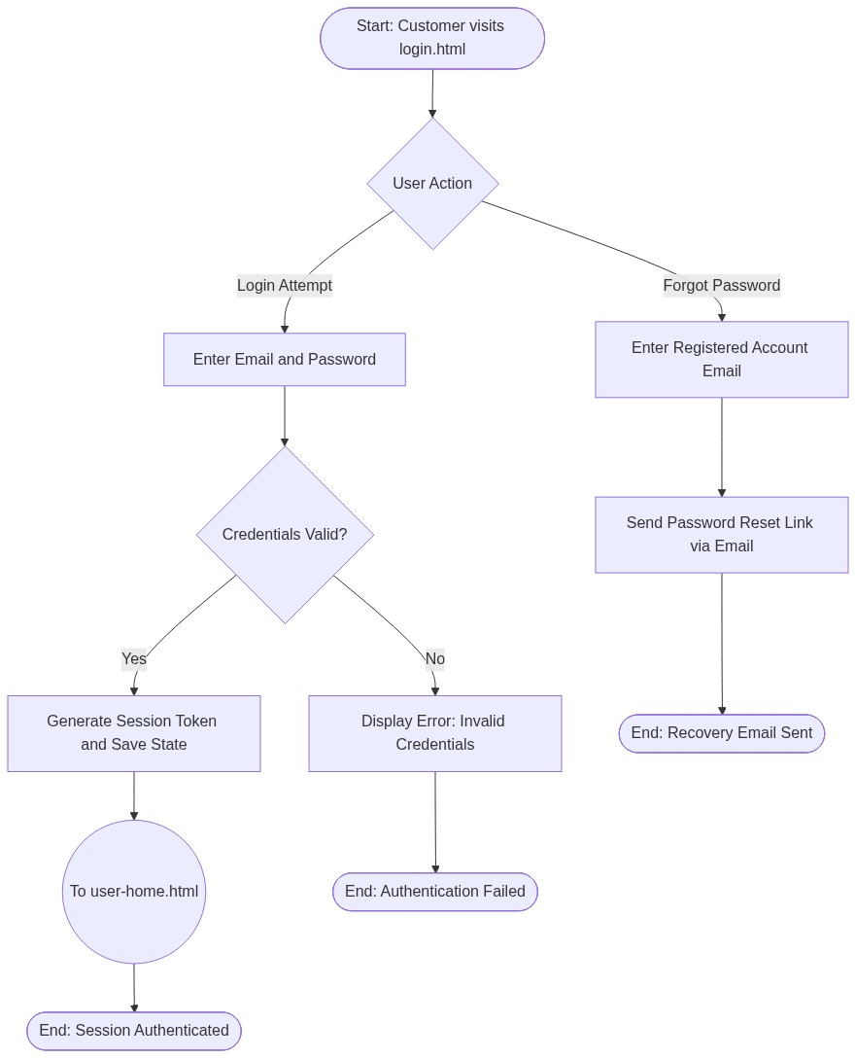

2. Page Connectors (Navigation Relationships)
Connector Symbol | Connector Type | Target Page & Explanation
((To user-home.html)) | Outgoing Connector | Navigates to Customer Homepage upon successful credential verification.

3. Step-by-Step Process & Logic Table
Flowchart Step / Node | Flowchart Shape | Logic & Action Description
Start | Terminal | Customer navigates to login.html directly or via redirection.
User Action | Decision | Customer selects either standard login or password recovery.
Enter Credentials | Input / Process | Customer inputs registered email and password.
Credentials Valid? | Decision | Backend verifies bcrypt hash in PostgreSQL users table.
Generate Session Token | Process | Issues secure session token stored in browser localStorage.
To user-home.html | Connector | Transfers execution flow to customer homepage (user-home.html).
Forgot Password Flow | Alternate Path | Sends secure password reset link to user's registered email.
End | Terminal | Terminates current page flow.

