Customer Support and Live Chat Flowchart
System: ADC Gadgets | Portal: User Portal (Customer Side) | Page File: src/user/support.html
FUNCTIONAL SUMMARY & SCOPE:
Provides store FAQs (branch locations, payment channels, warranty) and real-time live messaging with ADC Gadgets staff.
Note: In accordance with system directives, there are no online loan requests. Admin provisions user accounts directly from face-to-face agreements.

1. Flowchart Diagram (Paper-Ready Visual)
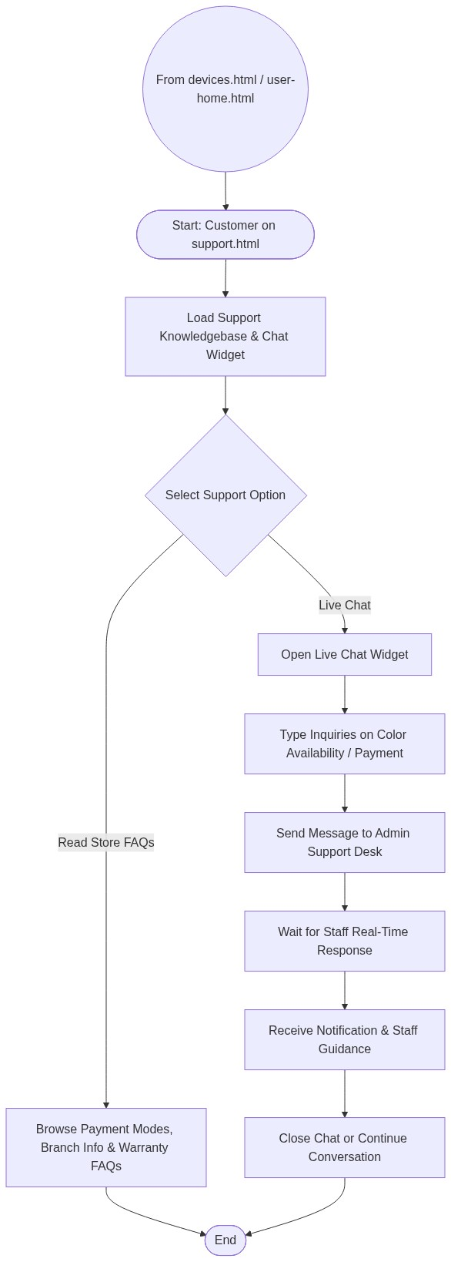

2. Page Connectors (Navigation Relationships)
Connector Symbol | Connector Type | Target Page & Explanation
((From devices.html or user-home.html)) | Incoming Connector | Arrives from catalog inquiry or navbar.

3. Step-by-Step Process & Logic Table
Flowchart Step / Node | Flowchart Shape | Logic & Action Description
Start | Terminal | Customer opens support.html or launches floating chat widget.
Support Choice | Decision | Chooses self-service FAQs or live messaging.
Send Message | Process | Transmits inquiry to Express server / database.
Receive Reply | Process | Staff reply delivered via real-time WebSocket / polling.
End | Terminal | Terminates current page flow.

