Table 1: Escalation Preference and Mediators with Dispositional Controls

|  |  |  |  |  |
| --- | --- | --- | --- | --- |
|  | (1) | (2) | (3) | (4) |
|  | Escalation | Reputation | Certainty | Insulting |
| Denial | -13.840*** | -11.069*** | -3.047*** | -0.506*** |
|  | (1.307) | (1.669) | (0.184) | (0.119) |
|  |  |  |  |  |
| Military Assertiveness | 4.467***  (0.400) | 5.265***  (0.510) | 0.323***  (0.047) | 0.343***  (0.038) |
|  |  |  |  |  |
| National Chauvinism | 4.303***  (1.524) | -2.249  (1.950) | -0.007  (0.172) | 0.480***  (0.143) |
|  |  |  |  |  |
| Trust in Gov. | 0.901 | 0.470 | 0.115 | 0.276*** |
|  | (0.833) | (1.065) | (0.096) | (0.077) |
|  |  |  |  |  |
| Trust in News | 1.489* | 0.012 | 0.193** | -0.114 |
|  | (0.764) | (0.977) | (0.088) | (0.070) |
|  |  |  |  |  |
| International Trust | -0.882  (0.683) | -3.869***  (0.872) | -0.178**  (0.078) | -0.188***  (0.064) |
|  |  |  |  |  |
| Military Service | 4.144**  (2.058) | 4.187  (2.643) | 0.398  (0.247) | 0.246  (0.192) |
|  |  |  |  |  |
| Reads News | 2.000*** | 0.633 | -0.020 | 0.127*** |
|  | (0.519) | (0.663) | (0.059) | (0.047) |
| *N* | 924 | 927 | 932 | 932 |

Standard errors in parentheses

* *p* < .10, ** *p* < .05, *** *p* < .01

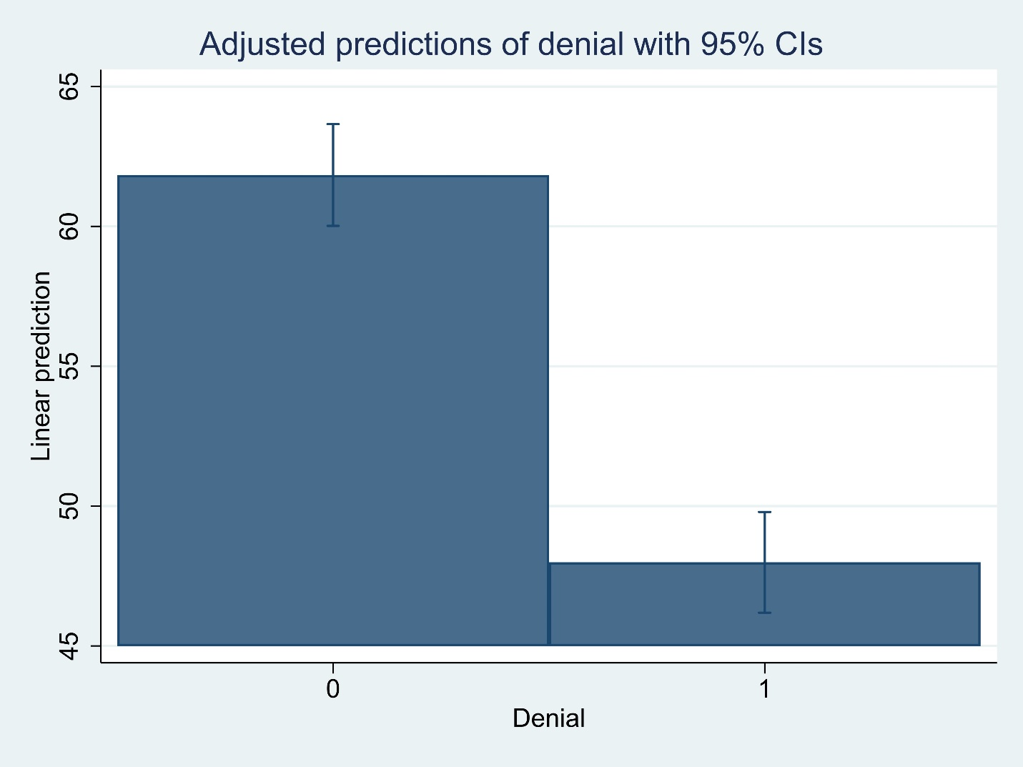



Table A1: Escalation Preference and Mediators with No Controls

|  |  |  |  |  |
| --- | --- | --- | --- | --- |
|  | (1) | (2) | (3) | (4) |
|  | Escalation | Reputation | Certainty | Insulting |
| Denial | -14.748*** | -12.088*** | -2.827*** | -0.525*** |
|  | (1.472) | (1.787) | (0.171) | (0.116) |
| *N* | 946 | 949 | 954 | 954 |

Standard errors in parentheses

* *p* < .10, ** *p* < .05, *** *p* < .01

Table A2: Escalation Preference and Mediators with Demographic Controls

|  |  |  |  |  |
| --- | --- | --- | --- | --- |
|  | (1) | (2) | (3) | (4) |
|  | Escalation | Reputation | Certainty | Insulting |
| Denial | -15.311*** | -12.466*** | -2.987*** | -0.606*** |
|  | (1.375) | (1.750) | (0.178) | (0.118) |
|  |  |  |  |  |
| Age | 0.340*** | 0.285*** | 0.016*** | 0.030*** |
|  | (0.043) | (0.054) | (0.005) | (0.004) |
|  |  |  |  |  |
| Male | 9.543*** | 2.922* | 0.150 | 0.296** |
|  | (1.391) | (1.770) | (0.146) | (0.118) |
|  |  |  |  |  |
| Household Income | 0.216*  (0.115) | -0.014  (0.146) | 0.013  (0.012) | 0.018*  (0.010) |
|  |  |  |  |  |
| White | 0.495 | 0.893 | -0.006 | 0.284** |
|  | (1.603) | (2.030) | (0.166) | (0.135) |
|  |  |  |  |  |
| Education | -0.397 | -0.933* | -0.122*** | -0.083** |
|  | (0.422) | (0.537) | (0.045) | (0.036) |
|  |  |  |  |  |
| Republican | 7.621*** | 5.942** | 0.621*** | 0.533*** |
|  | (2.006) | (2.560) | (0.206) | (0.169) |
|  |  |  |  |  |
| Democrat | 3.101* | -2.425 | 0.511*** | 0.278* |
|  | (1.881) | (2.398) | (0.192) | (0.158) |
| *N* | 936 | 939 | 944 | 944 |

Standard errors in parentheses

* *p* < .10, ** *p* < .05, *** *p* < .01

Table A3: Escalation Preference and Mediators with Military Assertiveness Interaction

|  |  |  |  |  |
| --- | --- | --- | --- | --- |
|  | (1) | (2) | (3) | (4) |
|  | Escalation | Reputation | Certainty | Insulting |
| Denial | -13.842*** | -11.070*** | -3.069*** | -0.506*** |
|  | (1.307) | (1.670) | (0.186) | (0.119) |
|  |  |  |  |  |
| Military Assertiveness | 4.244***  (0.535) | 5.211***  (0.680) | 0.261***  (0.061) | 0.331***  (0.051) |
|  |  |  |  |  |
| Denial X Military Assertiveness | 0.436  (0.694) | 0.107  (0.885) | 0.123  (0.081) | 0.024  (0.065) |
|  |  |  |  |  |
| National Chauvinism | 4.357*** | -2.236 | 0.008 | 0.483*** |
|  | (1.526) | (1.954) | (0.171) | (0.143) |
|  |  |  |  |  |
| Trust in Gov. | 0.903 | 0.470 | 0.115 | 0.276*** |
|  | (0.833) | (1.066) | (0.095) | (0.077) |
|  |  |  |  |  |
| Trust in News | 1.496* | 0.013 | 0.194** | -0.114 |
|  | (0.765) | (0.978) | (0.088) | (0.070) |
|  |  |  |  |  |
| International Trust | -0.889 | -3.870*** | -0.177** | -0.188*** |
|  | (0.684) | (0.873) | (0.078) | (0.064) |
|  |  |  |  |  |
| Military Service | 4.140** | 4.187 | 0.396 | 0.245 |
|  | (2.059) | (2.644) | (0.245) | (0.192) |
|  |  |  |  |  |
| Reads News | 1.989*** | 0.630 | -0.023 | 0.127*** |
|  | (0.519) | (0.663) | (0.059) | (0.047) |
| *N* | 924 | 927 | 932 | 932 |

Standard errors in parentheses

* *p* < .10, ** *p* < .05, *** *p* < .01

