SAN DIEGO SERVICE OPERATIONS
MASTER CASE STUDY
Business Analysis Case Study
From operational analytics to an end-to-end BA portfolio engagement
Portfolio disclosure. This is a simulated business-analysis engagement built from public City of San Diego Get It Done data and a completed Power BI analytics project. It does not represent City employment, internal-system access, stakeholder interviews, approved requirements, or formal City acceptance.

Prepared by Chase Brangham
October 27, 2026

Executive Summary

Business problem. Get It Done service operations generate a large volume of public service-request records across multiple service categories and council districts. The business need is not simply “a dashboard”; it is a consistent way to understand backlog size, aging, workload concentration, throughput, duplicate reporting, referral activity, and where additional operational investigation may be warranted.
Approach. The companion Power BI analytics project was completed first. This case study retrospectively applies Business Analyst practices around that implemented solution: stakeholder analysis, current-state modeling, gap analysis, requirements, user stories, prioritization, KPI governance, business/data rules, traceability, UAT design, solution verification, RAID, implementation planning, and reflection.
800K | 86K | 75.1% | 367 | 13.1% | 6.0%
Total Requests | Open Backlog | 90+ Day Backlog Rate | Median Open Case Age | Duplicate Rate | Referral Rate
Snapshot metrics from the completed companion analytics project. They are descriptive findings from the analyzed data, not City performance targets.
Primary conclusion. The portfolio evidence supports an analytics-enabled monitoring and prioritization solution, but it does not support causal claims about staffing, service quality, or why specific districts/categories have larger backlogs. Those questions require internal operational data and stakeholder/process-owner validation.
1. Business Context & Problem Definition

1.1 Business context
The City of San Diego Get It Done program receives and routes reports for non-emergency problems. The public dataset includes request attributes and status information, but it explicitly does not include details of the work performed to fix a problem or a definitive physical work-completion timestamp. That evidence boundary shapes the entire case study.

1.2 Problem statement
Operational reviewers need to understand where unresolved requests are accumulating, how old the open workload is, which service categories or geographic areas are most concentrated, and whether observed intake and dispositions are moving in balance. Without a consolidated and governed analytical view, identifying priorities and communicating trends becomes more difficult.

1.3 Scope boundaries
- In scope: public Get It Done data used in the companion analytics project; backlog/aging; service category; council district; intake/disposition trends; duplicate/referral patterns; BA documentation and traceability.
- Out of scope: internal City staffing, budgets, detailed work-order procedures, production implementation, approved SLAs, physical resolution verification, or claims of causal root cause.
- The 90-day aging threshold is an analytical monitoring threshold used by the portfolio, not an asserted City-wide SLA.
2. BA Approach & Deliverable Strategy

The case study uses a two-layer structure. The recruiter-facing layer explains the business story from problem to recommendation. The artifact layer provides the detailed work products a BA would use to support the story.
Stage | BA Work | Purpose
1 | Problem & Scope | Define the business problem before proposing the solution.
2 | Stakeholders | Identify who needs what information and how they would be engaged.
3 | Current State | Model the public request lifecycle and document observed operational signals.
4 | Gap Analysis | Translate observed conditions into needs/capabilities.
5 | Requirements | Define business, functional, and non-functional requirements.
6 | Agile Translation | Express selected requirements as user stories and acceptance criteria.
7 | Governance | Define KPIs, fields, business rules, data rules, and priorities.
8 | Future State | Show the proposed analytics-supported monitoring layer.
9 | Traceability & Testing | Link requirements to capabilities, verification, and planned UAT.
10 | Implementation & Reflection | Plan adoption/change and identify what would differ in a live engagement.
Because the dashboard existed before this BA extension, requirements are explicitly labeled Reconstructed or Proposed rather than presented as stakeholder-approved pre-build requirements.

3. Current-State Analysis

3.1 Current-State Process Map
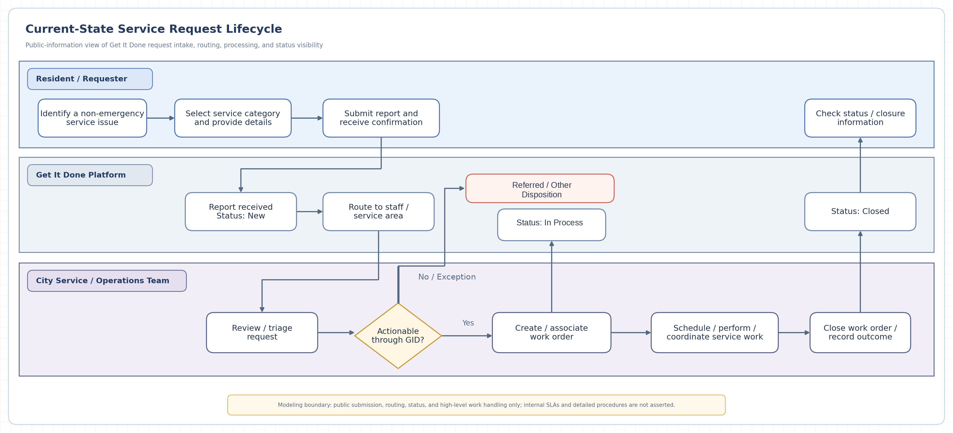
The process map is intentionally high-level and public-information-based. Internal departmental work-order procedures and SLAs are not asserted.

3.2 Observed operational signals
- Approximately 86K requests remain open in the analyzed snapshot; about 65K are aged 90+ days, producing a 75.1% 90+ day backlog rate.
- Median open-request age is approximately 367 days.
- Sidewalk Repair Issues and Street Light Maintenance each contribute about 14.8K open requests; ROW Maintenance contributes about 10.6K.
- Council District 3 has the largest observed open backlog at roughly 19.2K requests.
- Duplicate reporting is approximately 13.1% overall; Street Light Maintenance is about 41.3% and Encampment about 28.6% among high-volume categories.
- Referral activity is approximately 6.0%. The public documentation states referred reports can leave Get It Done visibility.
- Monthly intake often exceeds monthly dispositions, while some periods show the reverse, making Net Request Flow useful for directional monitoring.

3.3 Gap analysis
Current-State Gap | Desired Capability | Traceability
Fragmented analytical sources | Consolidated reporting model | FR-01
Aging severity not obvious from total volume | Aging KPIs and age buckets | BR-02 / FR-03
Category/geographic concentrations require grouping | Service type and district comparisons | BR-03 / BR-04
Static backlog does not show direction | Requests vs dispositions + Net Flow | BR-05
Duplicate/referral semantics complicate interpretation | Duplicate/Referral KPIs + definitions | BR-09
Metric assumptions can be misread | KPI dictionary and business rules | BR-08
Internal work process unavailable publicly | Internal elicitation/process discovery | Future live engagement

3.4 Root-cause hypotheses
The current data supports prioritization questions, not final causal answers. Examples of hypotheses requiring validation include whether severe aging reflects long-cycle infrastructure processes, whether visible unresolved conditions contribute to repeat reporting, and whether district backlog differences reflect service mix or asset density. Artifact 12 records the evidence required to test each hypothesis.
4. Stakeholder Analysis

The portfolio uses proposed stakeholder groups to demonstrate method without claiming direct City interviews. Key groups include operations leadership, department/program managers, operations/data analysts, council district staff, intake/routing staff, service-delivery teams, IT/data support, and residents/requesters.
Stakeholder Group | Primary Information Need | Power / Interest | Engagement
Operations leadership | Backlog severity, trend direction, priorities | High / High | Manage closely
Department/program managers | Service-specific workload and aging | High / High | Manage closely
Operations/data analysts | Metric logic, drill-down, data quality | Medium / High | Collaborate frequently
Council district staff | Geographic concentration/context | Medium / High | Keep informed / validate
IT/data support | Refresh, model, source integrity | High / Medium | Keep satisfied / engage on changes
Residents/requesters | Status clarity and service experience | Low formal power / High interest | Inform / research where appropriate
In a live engagement, stakeholder identification would be validated first, followed by interviews/workshops to confirm decision rights, process ownership, service-specific targets, metric definitions, and reporting cadence.

5. Requirements, Stories & Prioritization

5.1 Business requirements
ID | Business Requirement | Priority
BR-01 | Consolidated operational view | Must
BR-02 | Aged backlog visibility | Must
BR-03 | Council district comparison | Must
BR-04 | Service-category comparison | Must
BR-05 | Intake vs disposition monitoring | Must
BR-06 | Interactive segmentation | Should
BR-07 | Investigation without unsupported causal claims | Should
BR-08 | Metric definitions, assumptions, limitations | Must
BR-09 | Duplicate and referral monitoring | Should

5.2 Prioritization method
Artifact 15 supplements MoSCoW with a weighted score across business value, decision criticality, risk/integrity, dependency/enablement, and inverse effort. The purpose is not to override stakeholder judgment; it is to make priority reasoning explicit and challengeable.

5.3 Agile translation
Eleven user stories translate the requirements into implementable work. Acceptance criteria are written in Given/When/Then style and map forward to UAT or documentation checks. Example: BR-02 → FR-03 → US-02 → Backlog ≥90 Days KPI → UAT-02.
6. KPI, Data & Business-Rule Governance

6.1 KPI dictionary
Metric | Business Meaning | Governance Caveat
Total Requests | Overall modeled request volume | Includes duplicate submissions unless filtered.
Open Backlog | Active/open request count | Public status is not detailed work-order stage.
90+ Day Backlog / Rate | Long-open workload count/share | 90 days is an analytical threshold, not an SLA.
Median Open Case Age | Typical age of active requests | Must be tied to snapshot/refresh date.
Requests Received | Requests by date_requested | Intake measure.
Requests Dispositioned | Inactive records by date_closed | Closed/Referred does not prove physical completion.
Net Request Flow | Received − Dispositioned | Directional flow, not a full productivity measure.
Duplicate Rate | Duplicates / Total Requests | Interpretation requires process/customer context.
Referral Rate | Referred / Total Requests | Workflow exit; downstream resolution may be invisible.

6.2 Data quality lesson from implementation
During the original analytics build, approximately 800 records initially produced date-conversion errors. Investigation showed the dates were not the root problem: quoted multiline text in free-text fields caused CSV parsing to shift values across columns. The ingestion logic was corrected rather than dropping those records downstream. Artifact 14 converts that lesson into repeatable data-quality rules for refresh, status-domain checks, source row counts, parent-ID logic, and metric reconciliation.

6.3 Key interpretation rules
- New and In Process are treated as active/open; Closed and Referred as inactive/workflow-exit for this case study.
- Referred is not presented as confirmed physical resolution.
- Duplicate identification uses the documented parent-request relationship.
- District volume is descriptive unless normalized/contextualized.
- Recommendations from public data are framed as investigation priorities rather than causal conclusions.

7. Proposed Future State

The proposed future state does not automate operational decisions. It creates a governed monitoring layer that refreshes standardized reporting data, surfaces backlog/aging/category/district/throughput patterns, flags conditions for management review, and records whether further analysis or operational action is needed.
The analytics monitoring layer is a portfolio design concept around the completed Power BI solution, not a claim about the City’s current internal workflow.
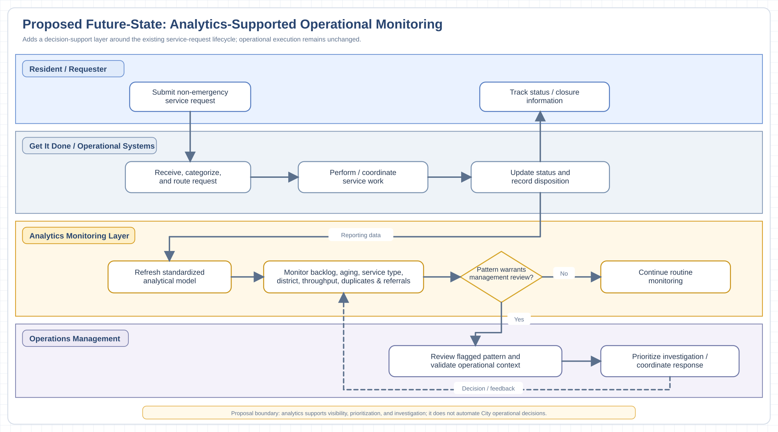

8. Implemented Solution Evidence

The implemented analytical solution is the public companion repository: github.com/ChaseBrangham/san-diego-service-operations

8.1 Executive Overview
The first Power BI page provides leadership-level visibility into Total Requests, Open Backlog, 30+ and 90+ day backlog, median open age, service-type backlog, service-type aging rates, and monthly Requests Received vs. Requests Dispositioned.
View actual dashboard screenshot: Executive Overview

8.2 Backlog & Process Analysis
The second Power BI page provides age-bucket distribution, monthly Net Request Flow, council-district backlog, Duplicate Rate, Referral Rate, and duplicate concentration among high-volume services.
View actual dashboard screenshot: Backlog & Process Analysis
9. Traceability, Verification & UAT

9.1 End-to-end traceability
Business Req | Functional Req | Story | Solution Evidence | Validation
BR-02 | FR-03 | US-02 | Backlog ≥90 Days KPI | UAT-02
BR-03 | FR-04 | US-03 | Council District backlog visual | UAT-03
BR-05 | FR-06 / FR-07 | US-05 / US-06 | Monthly trend + Net Request Flow | UAT-05 / UAT-06
BR-09 | FR-13 / FR-14 | US-11 | Duplicate + Referral metrics | UAT-13 / UAT-14

9.2 Analyst verification
Artifact 17 separates portfolio evidence checks from formal UAT. Visible dashboard capabilities and documented implementation details can be verified from the public companion repository. Filter-interaction behavior and row-level numerical reconciliation are not treated as fully verified unless the PBIX/source model is opened and tested.

9.3 UAT posture
Fourteen business-facing UAT scenarios are defined, but they remain Planned. This is deliberate: a portfolio exercise without representative City users should not claim business acceptance. In a real engagement, UAT would include named testers, execution evidence, defect handling, retest, and formal sign-off/acceptance criteria.

10. Risks, Assumptions, Issues & Dependencies

Level | Risk / Dependency | Response
Critical | Public request data may be mistaken for completed maintenance work. | Use request/disposition terminology and explicit limitations.
Critical | Detailed internal work process is unavailable. | Bound process model to public lifecycle; require internal discovery.
High | District backlog may be misread as performance. | Require normalization/context before ranking.
High | 90-day threshold may be misread as SLA. | Label as analytical threshold; validate by service.
High | Source-schema/CSV parsing changes may corrupt refresh. | Run repeatable data-quality checks and reconciliation.
Dependency | Root-cause interventions require internal process/context data. | Treat recommendations as investigation priorities until validated.

11. Recommendations & Next Steps

- Prioritize deeper operational review where high volume and severe aging overlap, particularly Sidewalk Repair, Street Light Maintenance, ROW Maintenance, and Pavement Maintenance.
- Investigate Street Light duplicate reporting as a business/process question. The observed concentration is a signal, not proof of its cause.
- Review District 3 backlog with population, service mix, asset inventory, and jurisdiction context before drawing performance conclusions.
- Monitor Requests Received vs. Requests Dispositioned and Net Request Flow over time to identify persistent workload pressure or easing.
- Treat referral as a distinct workflow outcome and, if operationally useful, standardize referral destinations for analysis.
- In a live project, validate stakeholders, service-specific metrics/targets, business rules, and detailed process maps before proposing production process changes.
12. Reflection: What This Case Study Adds

The original project proved that I could build an analytical solution. The BA extension changes the emphasis from “what does the dashboard show?” to “why does this capability exist, whose decision does it support, how is it defined, what assumptions does it depend on, and how would we know it is acceptable?”
The biggest limitation is also an important lesson: a strong BA does not fill evidence gaps with confident-sounding assumptions. Public data can show patterns, but a real engagement would require stakeholder elicitation, internal process discovery, service-level definitions, data ownership, and UAT before operational changes were approved.
If this were a live project, I would move requirements and metric governance earlier in the lifecycle, define acceptance criteria before the build, and involve process/data owners in validating status semantics and service-specific thresholds. That would reduce rework and make the final analytical solution easier to defend and maintain.

Appendix — Artifact Library

# | Artifact | Folder
01 | Project Overview & Scope | docs/
02 | Stakeholder Analysis | stakeholders/
03 | As-Is Process Map | process-maps/
04 | To-Be Process Map | process-maps/
05 | Requirements Catalog | requirements/
06 | User Stories & Acceptance Criteria | requirements/
07 | Requirements Traceability Matrix | traceability/
08 | UAT Plan & Test Cases | testing/
09 | Solution Evaluation & Recommendations | evaluation/
10 | Decision & Assumption Log | project-management/
11 | Jira-ready Backlog Import | jira/
12 | Current-State & Gap Analysis | process-analysis/
13 | KPI & Data Dictionary | requirements/
14 | Business Rules & Data Requirements | requirements/
15 | Requirements Prioritization | requirements/
16 | RAID Log | project-management/
17 | Solution Verification | testing/
18 | Implementation & Change Considerations | implementation/
19 | Project Reflection | reflection/

Public source references
- City of San Diego Get It Done Reports dataset
- Tips for working with Get It Done data
- Get It Done status FAQ
- Companion analytics repository

