Germany 2014
World Cup Tactical Analysis
  - How a complete team adapted its way to the title
Detailed English edition • Formations • Player roles • Match sequences • Content script

The central argument
Germany won the 2014 World Cup because its players offered different solutions within a coherent team. They could circulate possession, attack quickly after a regain, threaten from set pieces and defend a narrow lead. Joachim Löw also changed the balance of the side during the tournament. The most useful meaning of a “perfect team” here is a team with enough complementary qualities to solve different problems.
This report follows the same detailed tactical format as the Spain document. It explains the actual starting arrangements, the problems opponents created and the adjustments that mattered. Each match example separates the recorded event from the tactical interpretation. The diagrams can support an article, presentation or narrated football video.
Stage and date | Result | What the match tests
Group • 16 June | Germany 4–0 Portugal | Movement, finishing and set pieces
Group • 21 June | Germany 2–2 Ghana | Recovery after losing control
Group • 26 June | USA 0–1 Germany | Patience against an organised block
Last 16 • 30 June | Germany 2–1 Algeria aet | Space behind the defence
Quarter-final • 4 July | France 0–1 Germany | A revised balance and a narrow lead
Semi-final • 8 July | Brazil 1–7 Germany | Collective execution against disorder
Final • 13 July | Germany 1–0 Argentina aet | Reorganisation and decisive substitutes
Tournament total: 18 goals scored, 4 conceded, 6 wins and 1 draw, counting extra-time victories as wins. Four clean sheets. Totals are calculated from the seven match results. [S1–S7]

01 The opening plan against Portugal
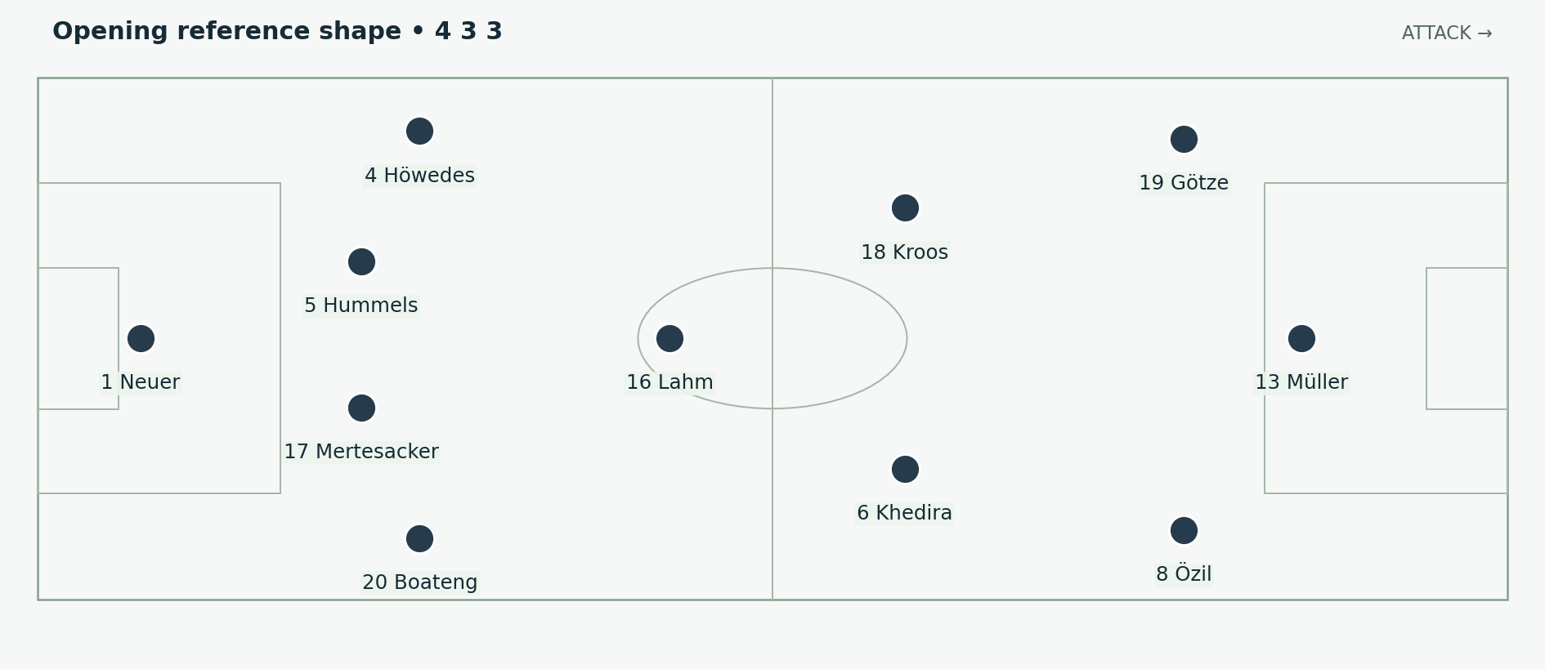
Figure 1. The opening XI with Lahm as the deepest midfielder. Germany attack to the right; the near touchline is Germany’s right flank. Positions and arrows are explanatory schematics, not tracking data.
The starting arrangement placed Philipp Lahm in front of the central defenders, with Toni Kroos and Sami Khedira higher. Jérôme Boateng began at right-back. Benedikt Höwedes played on the left of the defence. Thomas Müller led a mobile front line, with Mesut Özil and Mario Götze starting from wider zones. These are reference positions: the forwards exchanged spaces rather than remaining on three fixed vertical tracks. [S1; S8]

Why this could work
Lahm offered a short outlet when a defender received under pressure. Kroos could receive to the left of the first pressing line; Khedira could advance beyond it. A midfielder did not need to carry the ball through every line himself. The next player’s position could turn a short pass into forward progress. Müller’s movement then gave the passer a changing target between or outside the centre-backs.
This structure also carried a trade-off. With central defenders in both full-back positions, width was less naturally supplied by repeated overlapping runs. When the wide forwards moved inside, the team needed a carefully timed supporting movement outside them. Otherwise possession could gather centrally without stretching the opposition.

What the opening result establishes
Germany were already 2–0 ahead before Pepe was sent off. Müller converted a penalty won by Götze and Hummels headed in a Kroos corner; Müller eventually completed a hat-trick. The dismissal helped make the final margin possible, so the 4–0 should be read with its game context. It demonstrated several scoring routes, not immunity to future problems. [S1]

02 Ghana and the limits of the first balance
The second group match exposed a different problem. Ghana could hurry Germany’s midfield and attack the space that appeared after a turnover. Germany led, then fell behind, and had to recover. A side can possess technically excellent midfielders yet still struggle if the next pass arrives under pressure and the receiving player has no safe forward angle.
Recorded sequence | Tactical significance
Götze scores from Müller’s delivery | A nominal central attacker can become the provider from a wider position.
Ayew equalises from Afful’s cross | Germany must defend the delivery and the receiver; central possession alone does not solve either task.
Muntari intercepts Lahm’s pass and releases Gyan | A central turnover can remove the protection in front of the back line in a single action.
Klose finishes after Höwedes redirects a Kroos corner | A substitute and a dead-ball routine provide a route back when open play is difficult.
These match events are recorded in UEFA’s contemporary report. The explanations in the right column are tactical interpretation. The game finished 2–2. [S2]

The lesson for the midfield
A holding midfielder is effective partly because teammates give him alternatives. If the nearest options are covered, playing into his feet may simply transfer pressure from the centre-back to a more dangerous central zone. The passer, receiver and players beyond the ball must coordinate. The interception before Ghana’s second goal is a useful teaching clip because it shows the cost of losing possession before the team can restore defensive distances.

Why Klose mattered before he became a starter
Klose supplied a different type of occupation of the penalty area. A defender had to account for someone who would continue toward the goal even when the ball was elsewhere. That makes the next cross, knockdown or loose ball more dangerous. His value was not limited to aerial contests: timing, anticipation and the willingness to attack a small finishing space were central.
For a video, pause the equalising corner after the first contact. The important question is who has already committed to the second contact. This is a concrete way to explain the bench’s tactical value without reducing the story to experience or mentality alone.

03 The USA match and patient pressure
Germany’s last group game finished 1–0 in rain-soaked Recife. Löw brought Klose on for Lukas Podolski at half-time. The winner came when Tim Howard saved Mertesacker’s header and Müller struck the rebound from outside the crowded central finishing zone. Germany finished the group with seven points. [S3]
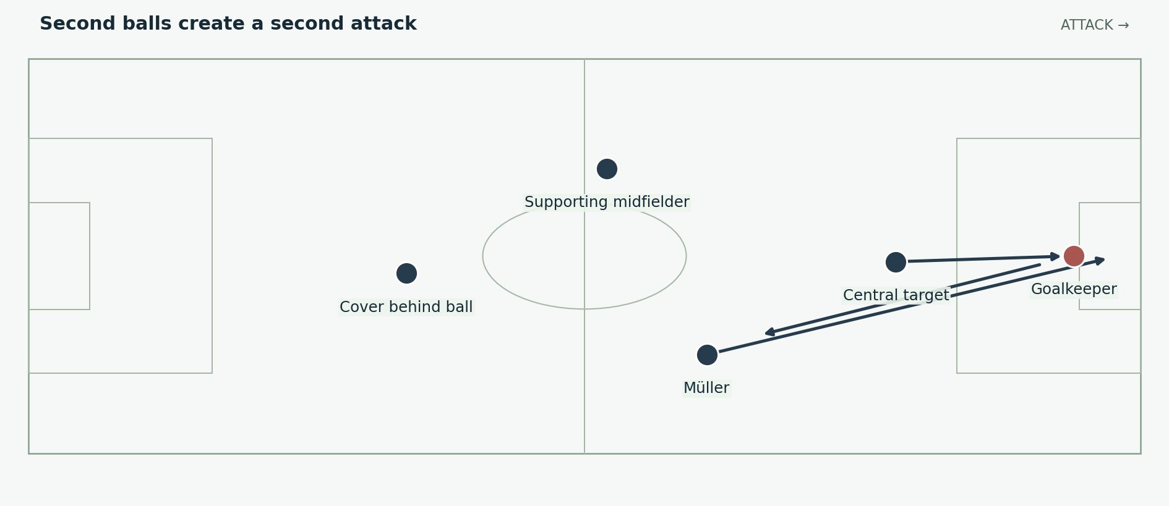
Figure 2. A generalised second-ball pattern inspired by the USA winner. It illustrates the relationship between the first attempt and the player waiting outside the crowd. Positions and arrows are explanatory schematics, not tracking data.

The detail beyond the first cross
An attack does not end when the initial header is saved or cleared. The team’s arrangement outside the penalty area determines whether the clearance becomes an opposition counterattack, a neutral loose ball or a second scoring opportunity. A player positioned just beyond the main contest may have a cleaner view and a more controlled strike than the original target.
There is a balance to maintain. Too many players attacking the first delivery leave nobody for the rebound and nobody to delay the counterattack. Too few inside the area let defenders clear comfortably. Germany’s options across the tournament allowed both an initial penalty-area target and a dangerous player arriving or waiting behind that target.

How to explain this match on screen
Show the initial aerial contest, then widen the picture before following the ball. Mark Müller’s separation from the defensive cluster. The teaching point is the organisation of the second action. A highlights edit that begins only at the final shot misses why the shooter has room to set himself.

04 Algeria exposes the space behind
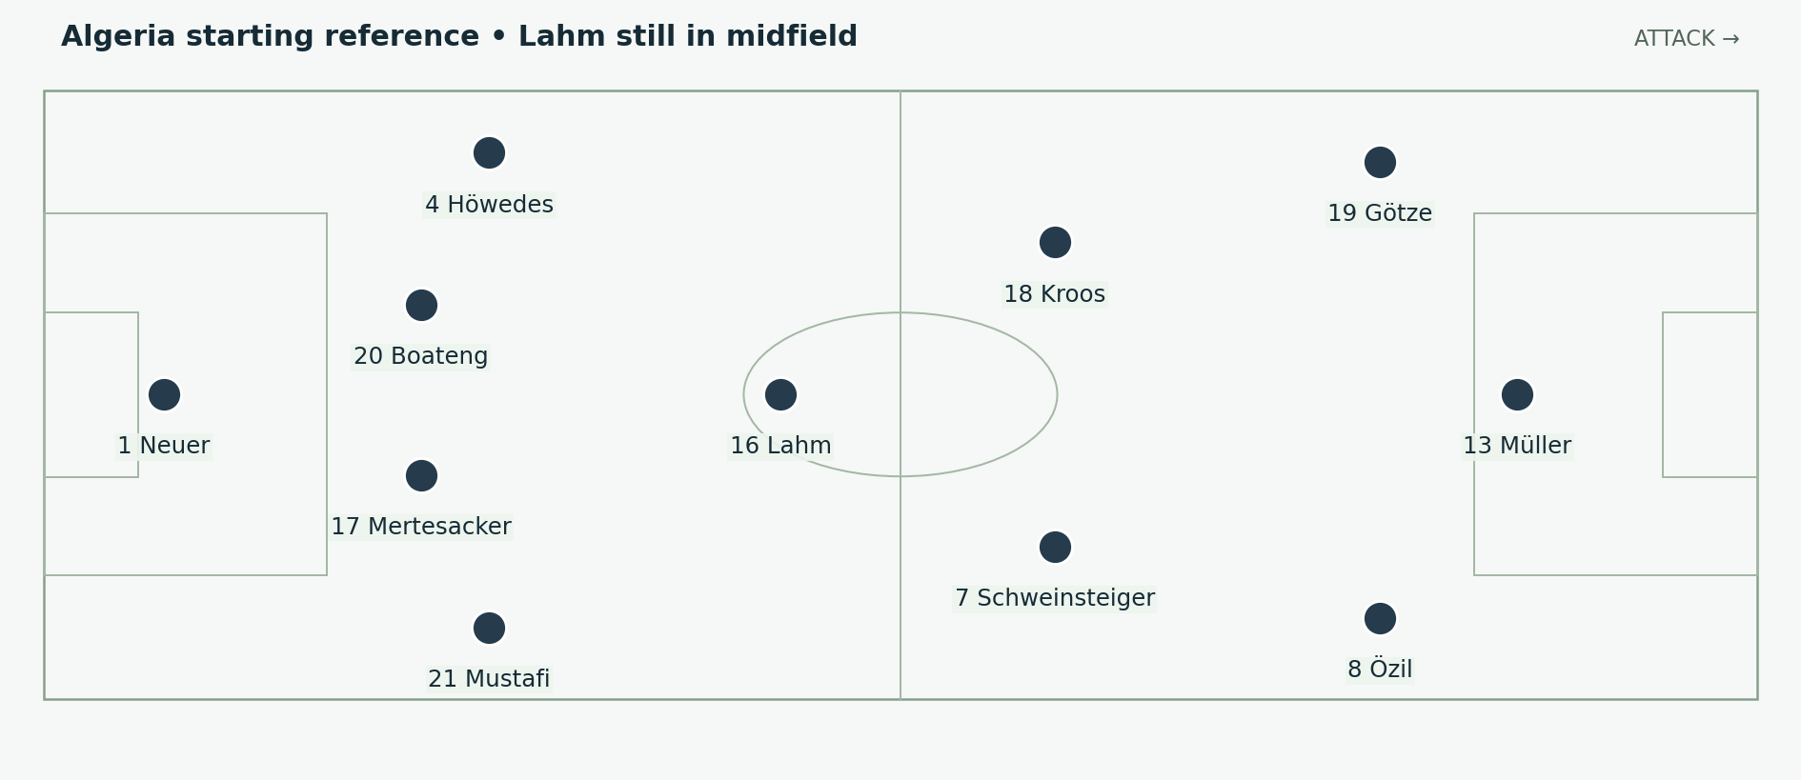
Figure 3. Hummels was unavailable; Boateng moved centrally and Mustafi started at right-back. The XI is checked against the DFB match record. Positions and arrows are explanatory schematics, not tracking data.
Algeria forced Germany into extra time. Hummels missed the match through illness, and the revised defence had to deal with Slimani and runs into the channels. Neuer repeatedly had to act beyond his penalty area. Germany’s possession did not prevent Algeria from producing dangerous forward attacks. [S4; S9]

Why the high line became vulnerable
A high defensive line is safest when the opponent cannot comfortably look up and choose a pass. If pressure on the ball is late, the same line leaves a large running space behind it. The defenders must then turn toward their own goal while the attacker is already accelerating. The weakness is a relationship between pressure and depth; it cannot be explained by drawing the back four high on a tactics board alone.
The team also needs to protect the channel outside a centre-back. A striker can start centrally, bend his run away from the defender and reach a diagonal pass without having to win a stationary duel. That movement tests communication between the full-back, centre-back and goalkeeper.

The changes within the game
Schürrle replaced Götze at half-time. Khedira replaced the injured Mustafi in the 70th minute, allowing Lahm to move to right-back. Schürrle opened the scoring early in extra time; Özil added a second before Djabou’s late reply. The right-back change therefore began during this match, before it became the starting arrangement against France. [S9]

05 Neuer changes the defensive equation
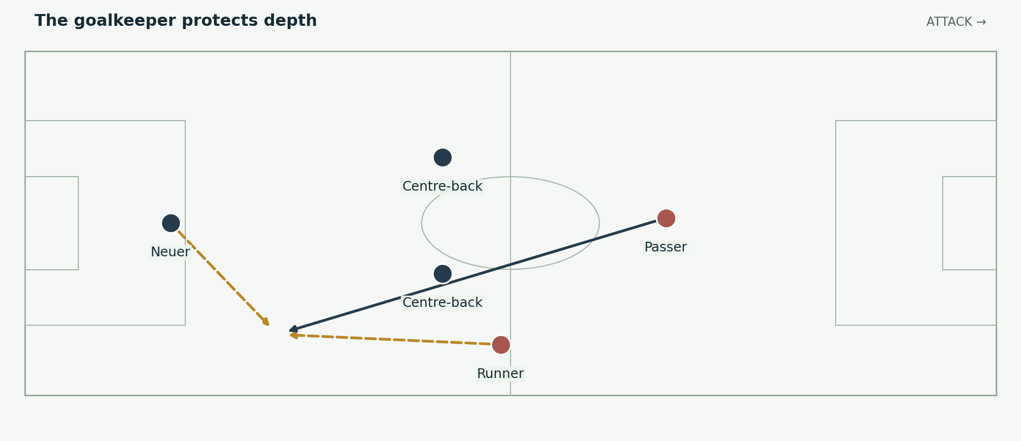
Figure 4. An Algeria-inspired explanation of covering a through ball. The opponent attacks left in this defensive example; Germany’s own attacking direction remains right. Positions and arrows are explanatory schematics, not tracking data.
Neuer’s starting position changed who could reach a ball behind the defence first. A conventional goalkeeper might wait closer to goal and face the eventual shot. Neuer could sometimes end the attack before the forward established control. His intervention moved the decisive contest away from the six-yard box and into the space behind his defenders. [S4]

The decision has three inputs
Read | What it changes
Pressure on the passer | A passer with time can disguise the ball or lift it over an advancing goalkeeper.
Weight and direction of the pass | A ball running away from the attacker offers a different interception opportunity from a pass placed directly into his stride.
The defender’s recovery route | If the defender can delay or steer the forward, the goalkeeper may have time to judge rather than charge immediately.
This role requires more than speed. The goalkeeper must choose whether to clear, head, tackle or hold position. The correct action depends on the ball’s height, the opponent’s distance and the location of teammates who could receive a safer pass. Coming out is not automatically the brave or intelligent option; arriving first is the requirement.

Why this belongs in the complete team argument
Neuer enlarged the range of defensive situations Germany could survive. That capacity let the outfield team continue operating with ambitious positions, but it did not make every exposure desirable. In a rigorous explanation, his interventions are both evidence of individual excellence and evidence that the line ahead of him had been penetrated. Both things can be true in the same sequence.

06 The decisive redistribution of roles
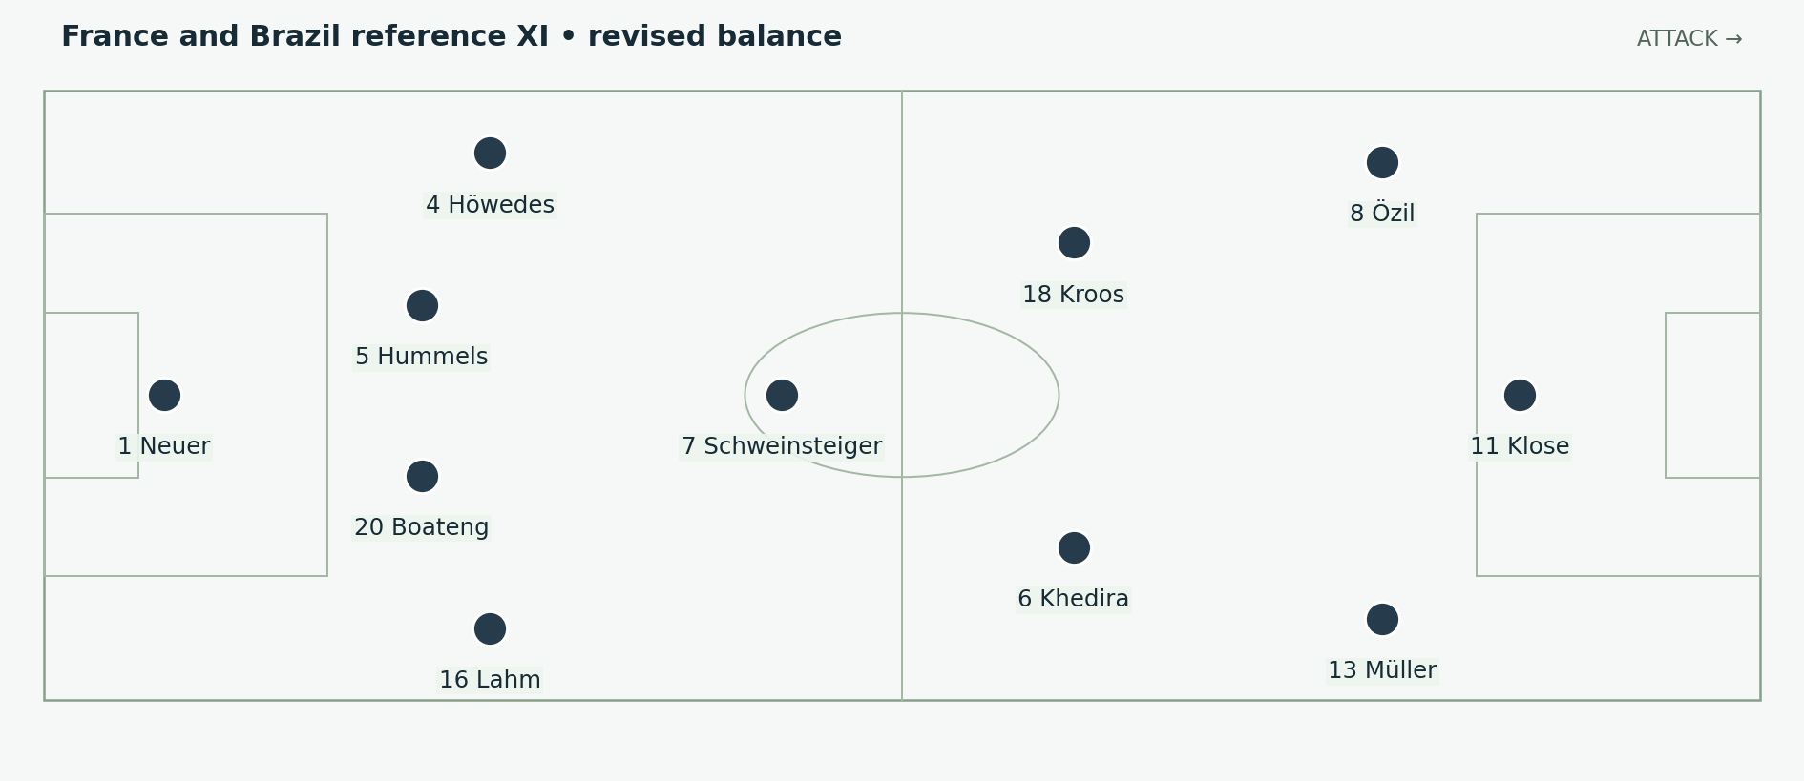
Figure 5. Lahm at right-back, Boateng and Hummels centrally, Schweinsteiger deepest, Khedira and Kroos ahead, with Klose leading the attack. Positions and arrows are explanatory schematics, not tracking data.
Against France, Löw started Lahm at right-back and Klose at centre-forward. Hummels returned, with Boateng beside him and Mertesacker on the bench. Schweinsteiger provided the deepest midfield reference, while Khedira and Kroos could work ahead of him. Germany retained this starting personnel against Brazil. [S5; S6; S8]

One move changes several connections
Putting Lahm outside the midfield did not simply remove a good passer from the centre. It added a reliable receiver on the right touchline and placed Boateng in a central defensive role. It also clarified the central division of labour: Schweinsteiger could connect and protect, Kroos could organise progression, and Khedira could support higher actions.
Klose’s presence gave Müller permission to begin from the right and arrive in the centre selectively. Müller no longer had to be the first central reference on every attack. Özil could seek spaces from the left without the team depending on him to remain a touchline winger throughout the move.

Use formation labels carefully
The shape can be described as a 4–3–3, with a 4–1–4–1 appearance when the wide forwards recover. Those labels describe useful reference points, not a permanent diagram. The clearer explanation is to name who holds the centre, who supplies width and who enters the penalty area. Germany’s improvement came from the relationships between those tasks.

07 The midfield triangle and its division of labour
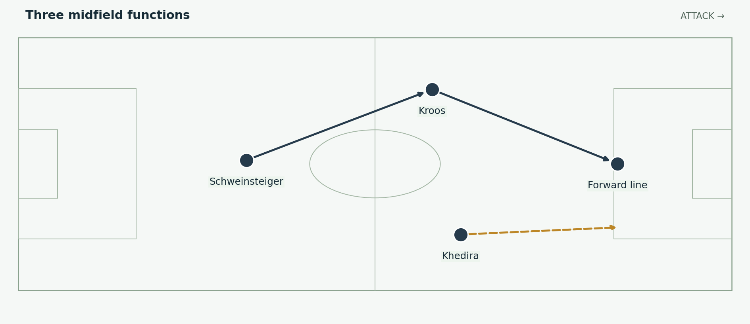
Figure 6. Kroos progresses, Khedira advances and Schweinsteiger supports behind them. These are tendencies, not restrictions on where each player may move. Positions and arrows are explanatory schematics, not tracking data.
Player | Main contribution | What a teammate gains
Schweinsteiger | A central outlet and protection behind attacks | The advanced midfielders can receive with support behind them.
Kroos | Passing range, circulation and set-piece delivery | The forwards receive earlier or from a better angle.
Khedira | Forward running, pressing support and combinations | The right-side attack gains a third participant.
The triangle mattered because its members did not all seek the same pass in the same space. If Kroos dropped to help build, Khedira could remain available beyond the opposing midfield. If Khedira joined an attack, Schweinsteiger could stay connected to the defenders. The ball carrier then had both an ambitious option and a route to retain possession.
A useful analysis watches the player who does not receive. A supporting midfielder may draw a marker away, stand close enough to discourage pressure or remain behind the ball to meet a clearance. None of these contributions requires a touch, but each can improve the next player’s decision.

The caution
These roles were adaptable. Schweinsteiger could advance, Kroos could recover deep, and Khedira could hold when the situation demanded it. Presenting them as three permanent lanes would hide the coordination. The diagram is a way to explain the balance, not a claim that every attack reproduced identical positions.

08 Lahm and the right side combinations
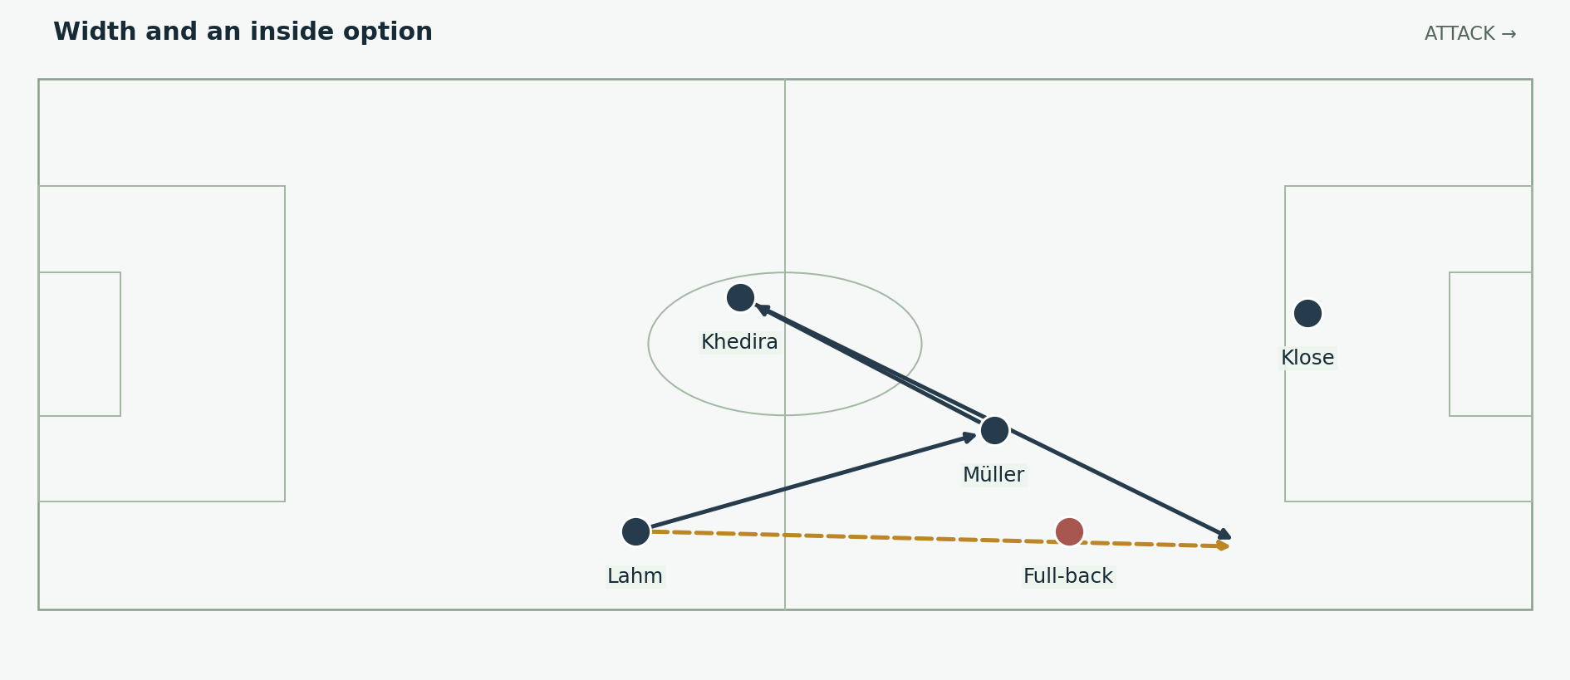
Figure 7. A possible third-player combination. The player who begins the move can become the runner beyond it. This is a mechanism diagram, not a reconstruction of a specific goal. Positions and arrows are explanatory schematics, not tracking data.
Lahm gave the right flank a player comfortable receiving near the touchline and deciding whether to play inside, continue forward or recycle. Müller’s movement could take him away from that touchline, and Khedira could provide another passing angle. Together they made it harder for one defender to close the ball without opening something nearby.

The dilemma for the opposing full-back
If the full-back followed Müller inside, Lahm could advance outside. If he stayed wide, Müller might receive between the full-back and centre-back. A midfielder could help, but that defender then left a different passing lane or a different German midfielder. The advantage depends on timing: moving too early allows the defence to hand over marks and restore its shape.
The receiver’s body position matters as much as the triangle’s geometry. A player who can see both the centre and the touchline can release the runner quickly. A player facing only his own goal may need a supporting pass before Germany can advance. This is why small changes of angle can be more useful than a spectacular dribble.

The concrete match anchor
Against Brazil, Lahm supplied the cutback for Schürrle’s first goal. That is a clear example of a right-back arriving in a position to serve a central finisher. It should not be presented as proof that every preceding German goal used the same route. [S6]

09 Müller Klose and Özil fit together
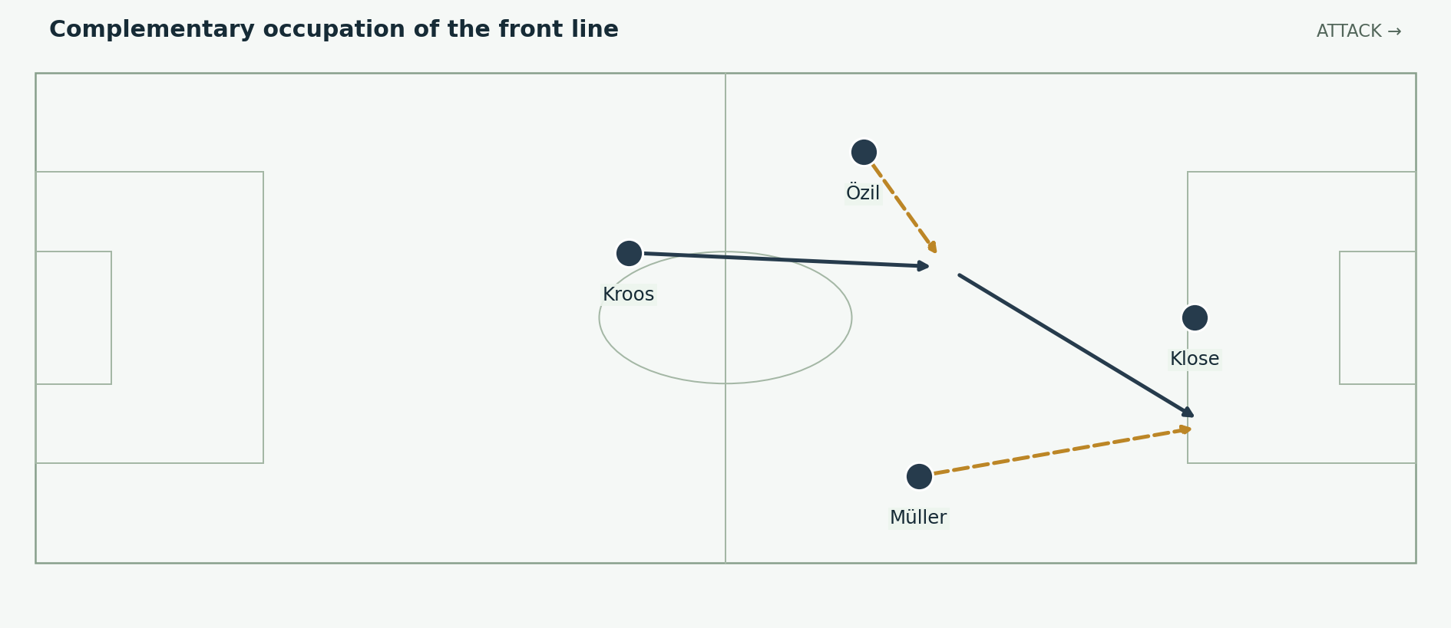
Figure 8. Özil can connect inside, Klose occupies the central defenders and Müller attacks a neighbouring space. The routes illustrate complementary movement. Positions and arrows are explanatory schematics, not tracking data.

Müller finds the unclaimed space
Müller’s contribution is best explained through the defender’s choices. When the defender watches the ball, Müller can move outside his field of vision. When the defender follows him, a teammate may gain room. His starting position on the right is therefore a launch point. His finishing position can be central, at the far side of the box or outside it for a rebound.

Klose gives the attack a central reference
Klose could occupy a centre-back, offer a short connection and continue into a finishing position. His movement gave Germany a presence near goal without requiring every pass to be played directly to him. A striker who holds a defender’s attention can help create a passing lane for another forward even when he never touches the ball.

Özil connects the move
Özil’s value lay partly in receiving at an angle where he could see the next pass. Starting from the left did not require him to behave as an orthodox winger. He could drift into a pocket, combine and release a runner. That freedom worked best when another player preserved the team’s width or occupied the defenders ahead of him.
The practical point for narration is to explain a chain of decisions: who attracts the defender, who receives between lines and who attacks the gap. Listing three talented names does not explain why they are more effective together. Their different movements supply the explanation.

10 Possession that can change speed
Germany’s attacking quality came from having more than one useful tempo. A short pass could draw an opponent forward. A switch could find the other side. A vertical pass or a run after a regain could exploit an opponent before its lines were restored. The same team could use all three within one match.
Situation | Useful response | What makes it possible
Opponent stays compact | Circulate, change angle, then play through or around | Receivers at different heights rather than a flat midfield line.
Opponent presses one side | Find the free player or change sides | A safe supporting option behind the immediate pressure.
Ball won with defenders displaced | Play forward and support at speed | A runner and a passer recognising the same opening.
Forward route closes | Retain the ball and rebuild the attack | Players behind the ball remain connected.

The first forward pass is not always the best pass
A rushed pass can waste the space a regain has created. Sometimes the first action should secure the ball and the second should penetrate. The important measure is whether Germany can attack before the opponent reorganises, not whether every touch points toward goal. A short combination can be the fastest route through a defence when it removes the nearest challenger.

Pressure after losing possession
Nearby players can close the receiver and his nearest outlets while the rest of the team prepares for the next pass. The aim is either to recover the ball or to make the opponent’s escape slower and less accurate. If the first pressure fails, chasing individually may open more space. Players must recognise when to abandon the immediate recovery attempt and restore a defensive block.
Kroos’s regain and exchange with Khedira for the fourth goal against Brazil is a concrete sequence to study. The general lesson is the connection between recovering the ball and using it immediately. The broader interpretation here is analytical; it is not a claim to have measured Germany’s pressing frequency. [S6; S11]

A later assessment from Löw
Looking back in 2018, Löw described the 2014 approach as a “golden middle way” between earlier counterattacking and a stronger emphasis on possession. That retrospective description fits the variety of attacking situations in this report. It should be identified as a later reflection, rather than presented as a quotation made during the tournament. [S10]

11 The defensive balance behind attacks
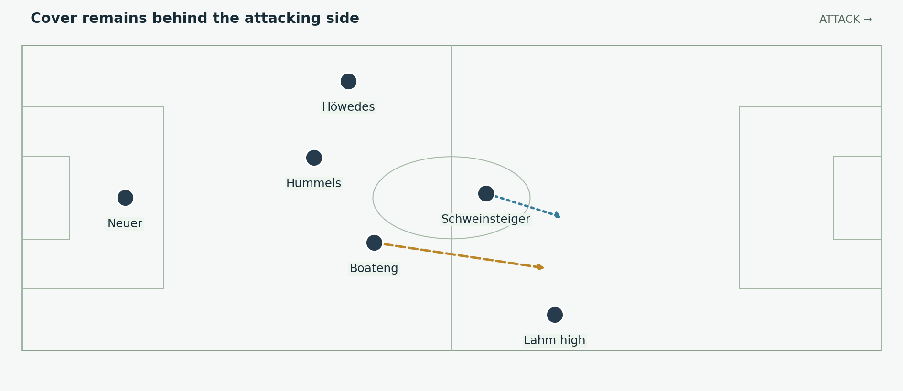
Figure 9. When Lahm advances, the remaining defenders and holding midfielder must manage the space behind him. Höwedes can provide a more conservative balance on the other side. Positions and arrows are explanatory schematics, not tracking data.
“Rest defence” means the positions a team keeps while it attacks so that it can respond if possession is lost. For this Germany side, the concept helps explain why an adventurous right-back could coexist with a more restrained left-back. The two sides did not need to perform identical movements to produce a balanced team.

Höwedes and asymmetry
Höwedes offered a defender’s security on the left. Remaining connected to the centre-backs could make it easier to protect the far side when the attack developed on the right. That did not prohibit him from advancing or joining set pieces: his header against the post in the final is an obvious reminder that a defensive reference role still includes attacking actions. [S7]

Boateng and Hummels
The central pair had to decide who challenged and who covered. If both attacked the same forward ball, the next pass could remove both. If neither stepped forward, the opponent could turn and carry. Good spacing gives the first defender permission to engage because the second is placed to respond if the duel is lost.
Neuer’s position adds another layer, but the layers must agree. A goalkeeper moving out while a defender drops toward the same ball can produce confusion. A defender who holds his line when the goalkeeper expects a recovery run creates a different problem. The mechanism is coordinated coverage, not four excellent players acting independently.
The final shows the limits: Argentina still found threatening moments. Defensive quality should be assessed through the problems Germany resolved and the chances it conceded, rather than inferred solely from the clean sheet.

12 France and the value of a narrow win
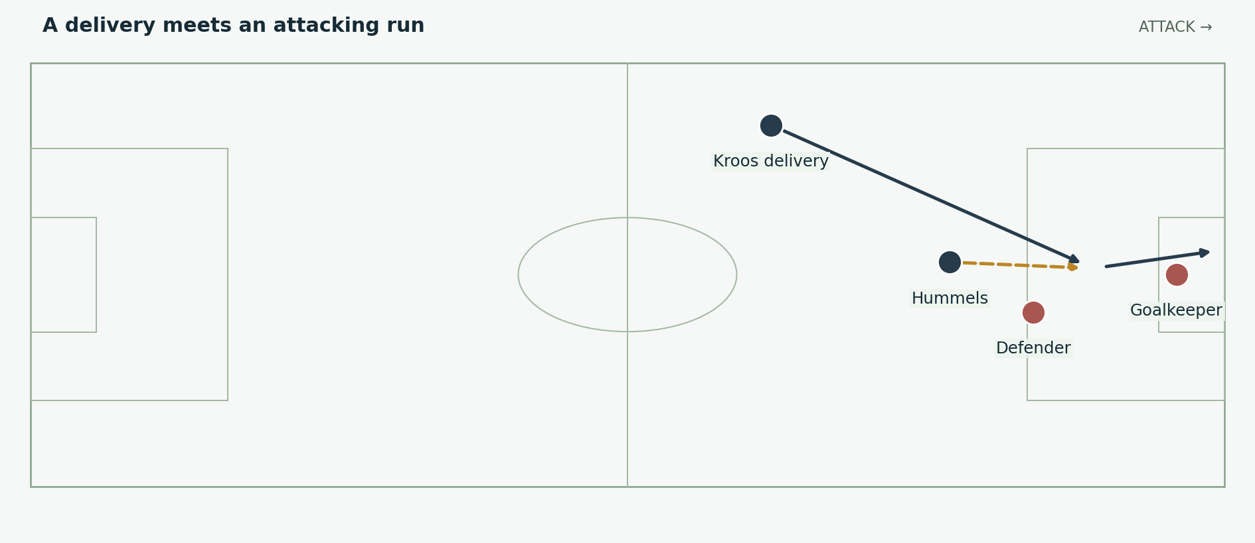
Figure 10. The quarter-final winner in simplified form: an inswinging delivery, Hummels attacking the contact and a header toward goal. Exact locations are illustrative. Positions and arrows are explanatory schematics, not tracking data.
Hummels headed in Kroos’s early free-kick against France, beating Varane to the decisive contact. Germany then protected the lead, while Neuer still had important saves to make, including a late stop from Benzema. The 1–0 demonstrated a different route to victory from the opening 4–0 or the coming semi-final. [S5]

A set piece changes the entire match
An early lead alters the value of risk. Germany no longer needs to create a large number of open-play chances to stay on course. France has to find a goal, and the spaces available later in the game can change as it commits players forward. A successful dead-ball action therefore has consequences far beyond its few seconds of execution.
The attacking header requires several things to meet: a delivery in the right corridor, a run that reaches the ball before the defender and a body position that redirects it toward a difficult area for the goalkeeper. Simply calling the goal “height advantage” leaves out the timing and quality of service.

Control includes defending the dangerous moment
A one-goal victory need not mean the opponent was harmless. France threatened, and Germany had to defend individual situations properly. The stronger argument is that Germany could continue competing effectively when a match demanded concentration, recoveries and saves rather than a stream of scoring chances.
For production, pair the goal with one late defensive action. That combination shows how a lead is obtained and then preserved. It makes the quarter-final an essential chapter in the explanation of the champions, rather than a brief bridge to the 7–1.

13 Brazil and the conditions of the 7 to 1
Brazil entered the semi-final without the injured Neymar and suspended Thiago Silva. Germany punished the hosts with five goals before the half-hour and eventually won 7–1. The result combined German execution with extraordinary Brazilian defensive disorder. The opponent’s circumstances belong in the explanation. [S6]
Minute | Scorer | Sequence to identify
11 | Müller | Kroos corner; unmarked finish.
23 | Klose | Central combination; finishes the rebound.
24 | Kroos | Right-side attack reaches the edge of the area.
26 | Kroos | Regain from Fernandinho; exchange with Khedira.
29 | Khedira | Combination with Özil; controlled finish.
69 | Schürrle | Lahm cutback from the right.
79 | Schürrle | Müller’s pass; control and forceful finish.
90 | Oscar | Brazil’s late consolation.
Event descriptions summarise the match record and contemporary report. The analysis below concerns the decisions those sequences reveal. [S6; S11]

Why the collapse accelerated
When players react to conceding by pressing separately, the first challenger may leave a passing lane behind him. If the next player then abandons his position to repair the problem, the space moves rather than disappears. A composed attacking team can exploit this by passing to the next free player instead of trying to beat every defender individually.
The key German quality was the repeated choice of a teammate in a better position. Around the box, one additional pass can make the goalkeeper move and remove a recovering defender from the shooting line. That pass also requires the supporting player to have continued his run rather than stopped to watch the initial attack.

What the score cannot tell you alone
The goals came through different routes, including a corner, combinations, a regain and wide service. Calling the entire performance counterattacking hides that variety. Brazil also created second-half chances that Neuer saved. The scale of the win should not erase either the range of attacking methods or the remaining defensive work. [S6]

14 The fourth goal as a team in miniature
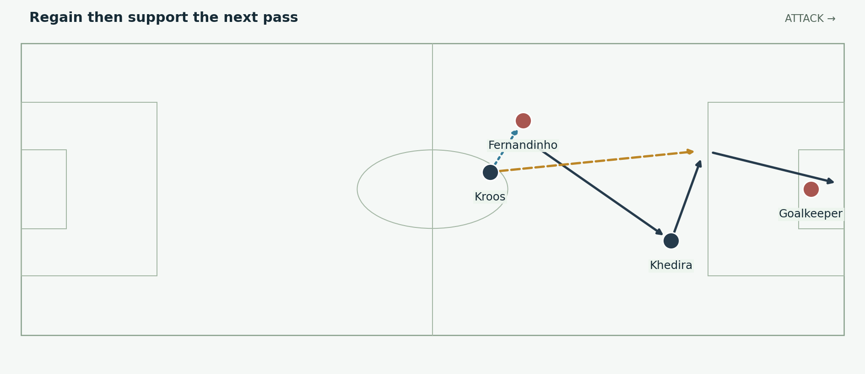
Figure 11. A simplified explanation of Kroos’s second goal against Brazil. The sequence combines a regain, an exchange with Khedira and Kroos continuing into the finishing space. Positions and arrows are explanatory schematics, not tracking data.
Kroos dispossessed Fernandinho, passed to Khedira and received the ball back to finish. The decisive idea is that the player who won possession did not consider his contribution complete after the first pass. He continued into space where the return ball could remove the goalkeeper from the immediate contest. [S11]

Why the return pass matters
After a turnover, the defending team is often looking toward the new ball carrier. A runner behind or beside that attention can gain a small but decisive advantage. The return pass exploits this change of focus. Its value comes from the relationship between the passer’s angle, the runner’s timing and the goalkeeper’s position.
Khedira’s decision is as important as Kroos’s finish. A shot might still have produced a goal, but the return pass created a simpler opportunity for a teammate. This is a useful example of collective attacking judgement: selecting the action that improves the team’s chance rather than the action that gives the current carrier the final touch.

A three pause breakdown
First, pause before the regain and identify Fernandinho’s available support. Second, pause when Khedira receives and mark the defender and goalkeeper he draws. Third, pause before the return and reveal Kroos’s continued movement. The viewer can then see a chain of decisions instead of an unexplained two-pass highlight.
Do not extend this one clip into a claim that Germany always pressed successfully. It is a clear, successful example of how pressure, anticipation and support can become one attacking sequence.

15 The final began with a different midfield
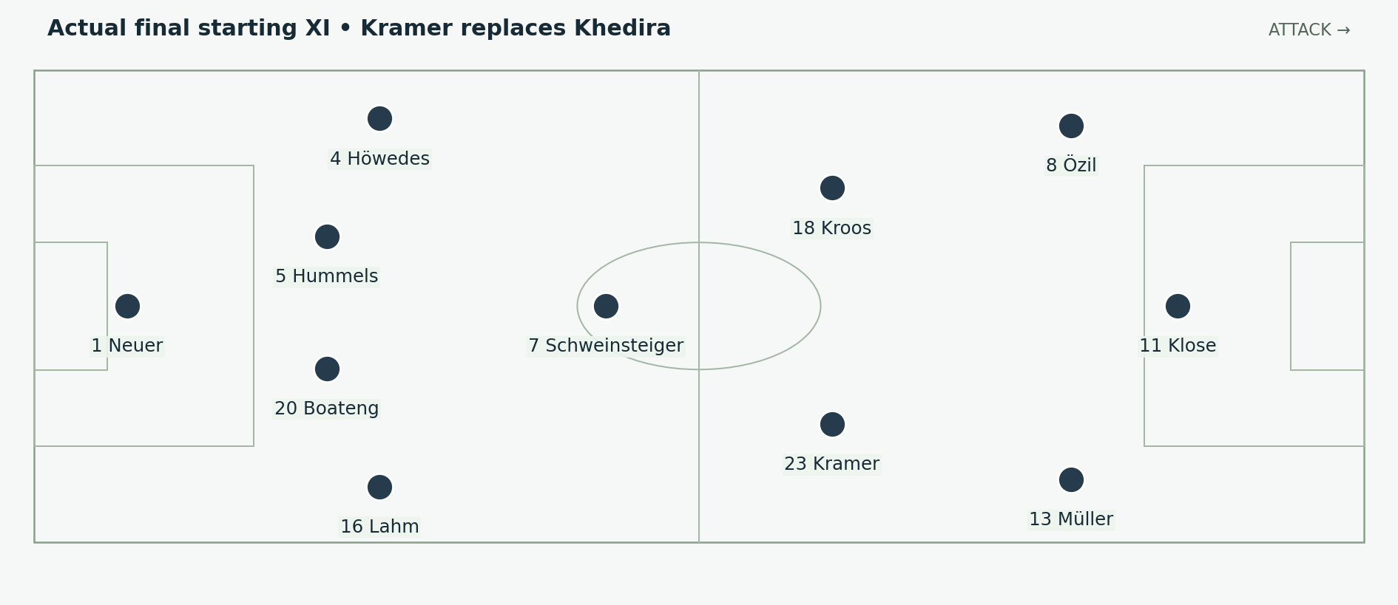
Figure 12. Khedira was injured in the warm-up. Kramer started in midfield; a diagram showing Khedira as a starter in the final would be incorrect. Positions and arrows are explanatory schematics, not tracking data.
Germany intended to keep the semi-final lineup, but Khedira’s warm-up injury forced a late change. Kramer started and later left the match after a head injury. Argentina created serious threats, including Higuaín’s opportunity after a misplaced Kroos back-header. The final was a competitive, narrow match. [S7; S12]

What the late change demands
A midfield replacement affects the surrounding players as well as the substitute. Teammates must recognise different movement cues and make their support positions clear. The team benefits if its basic tasks are understood independently of one individual: someone offers behind the ball, someone connects higher, and someone covers when another player advances.

Argentina tested the defensive channels
A forward does not need long spells of possession to threaten. Space beside a centre-back can become dangerous with one accurate release and a well-timed run. Germany had to judge when to engage the receiver and when to protect the route toward goal. That is why a clean sheet should not be confused with an absence of danger.
For narration, establish the disrupted lineup before discussing the eventual winning substitutes. Otherwise the audience may assume Löw was able to use an untouched ideal team for 120 minutes. The final is stronger evidence of adaptability precisely because the original plan could not remain intact.

A fair description of the contest
Höwedes struck the post before half-time, while Argentina also had openings. The winner did not emerge from a match in which only one side could score. The useful question is how Germany remained capable of creating a decisive moment after repeated changes and a long period without a goal. [S7]

16 Reorganisation after Kramer left
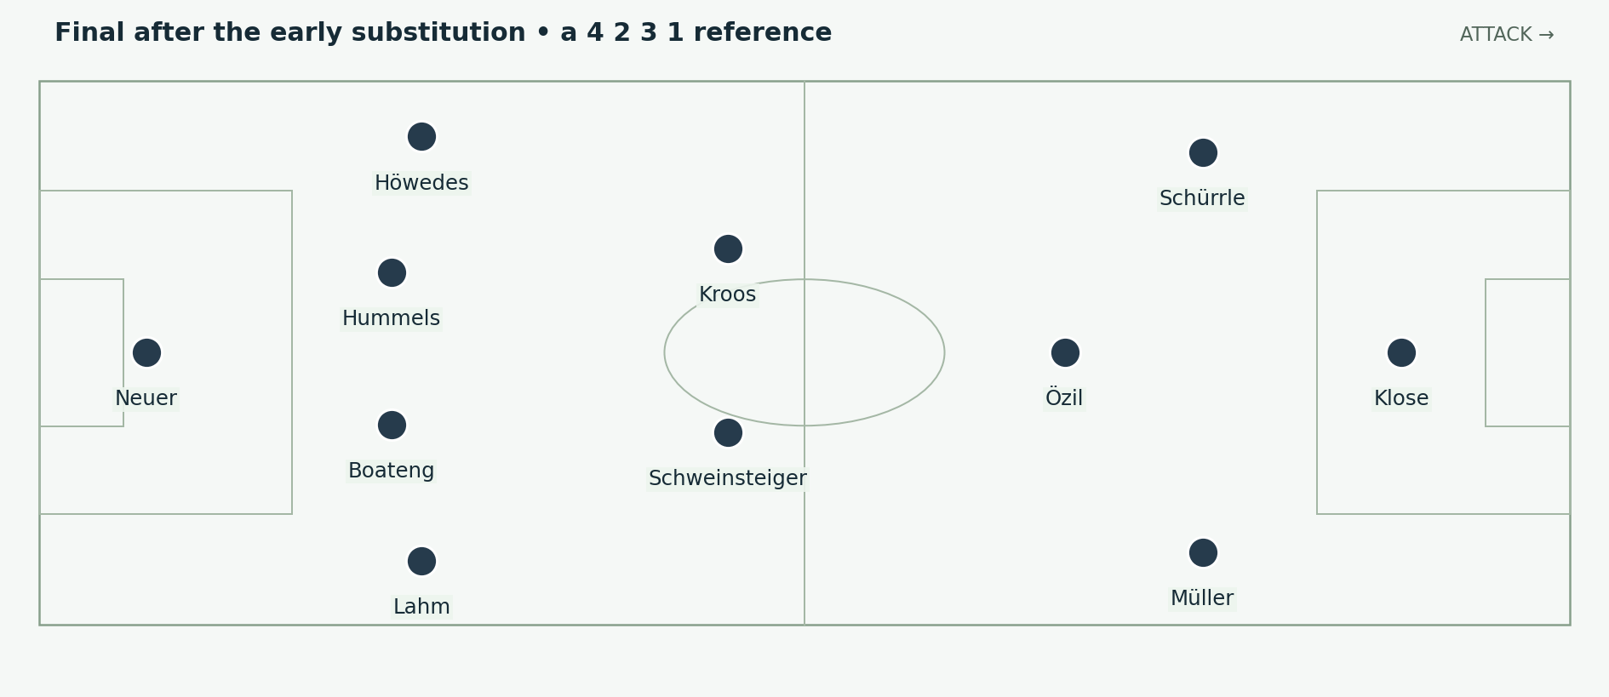
Figure 13. Schürrle replaced Kramer around the half-hour. This functional reference shows Kroos deeper, Özil inside and Schürrle providing the left attacking threat; actual positions remained fluid. Positions and arrows are explanatory schematics, not tracking data.
Schürrle’s introduction added a forward rather than replacing Kramer with another like-for-like midfielder. The resulting arrangement can usefully be read as a 4–2–3–1: Schweinsteiger and Kroos forming the deeper pair, Özil connecting centrally, and Schürrle and Müller working around Klose. This is a tactical interpretation of the changed roles, not a claim that the team held a rigid shape on every phase. [S7; S12]

What Germany gained
Schürrle could run directly into space on the left and carry the attack toward the penalty area. Özil had more opportunity to receive inside. Klose still supplied a central reference, and Müller could continue arriving from the right. The change preserved several ways of reaching the box even though the original midfield trio was gone.

What had to be protected
With fewer players assigned to the central midfield line, the distances around Kroos and Schweinsteiger became especially important. If both were drawn toward the same side, the next pass could expose the central route. The wide players’ recovery and the defenders’ decisions about stepping forward therefore remained part of the attacking change.
This is the right place to explain tactical flexibility concretely. Name the outgoing role, the incoming role and the work redistributed to the players who stay on. “Löw changed the system” is less informative than showing which player now receives deeper and which player now attacks the left channel.

17 Schürrle and Götze decide the title
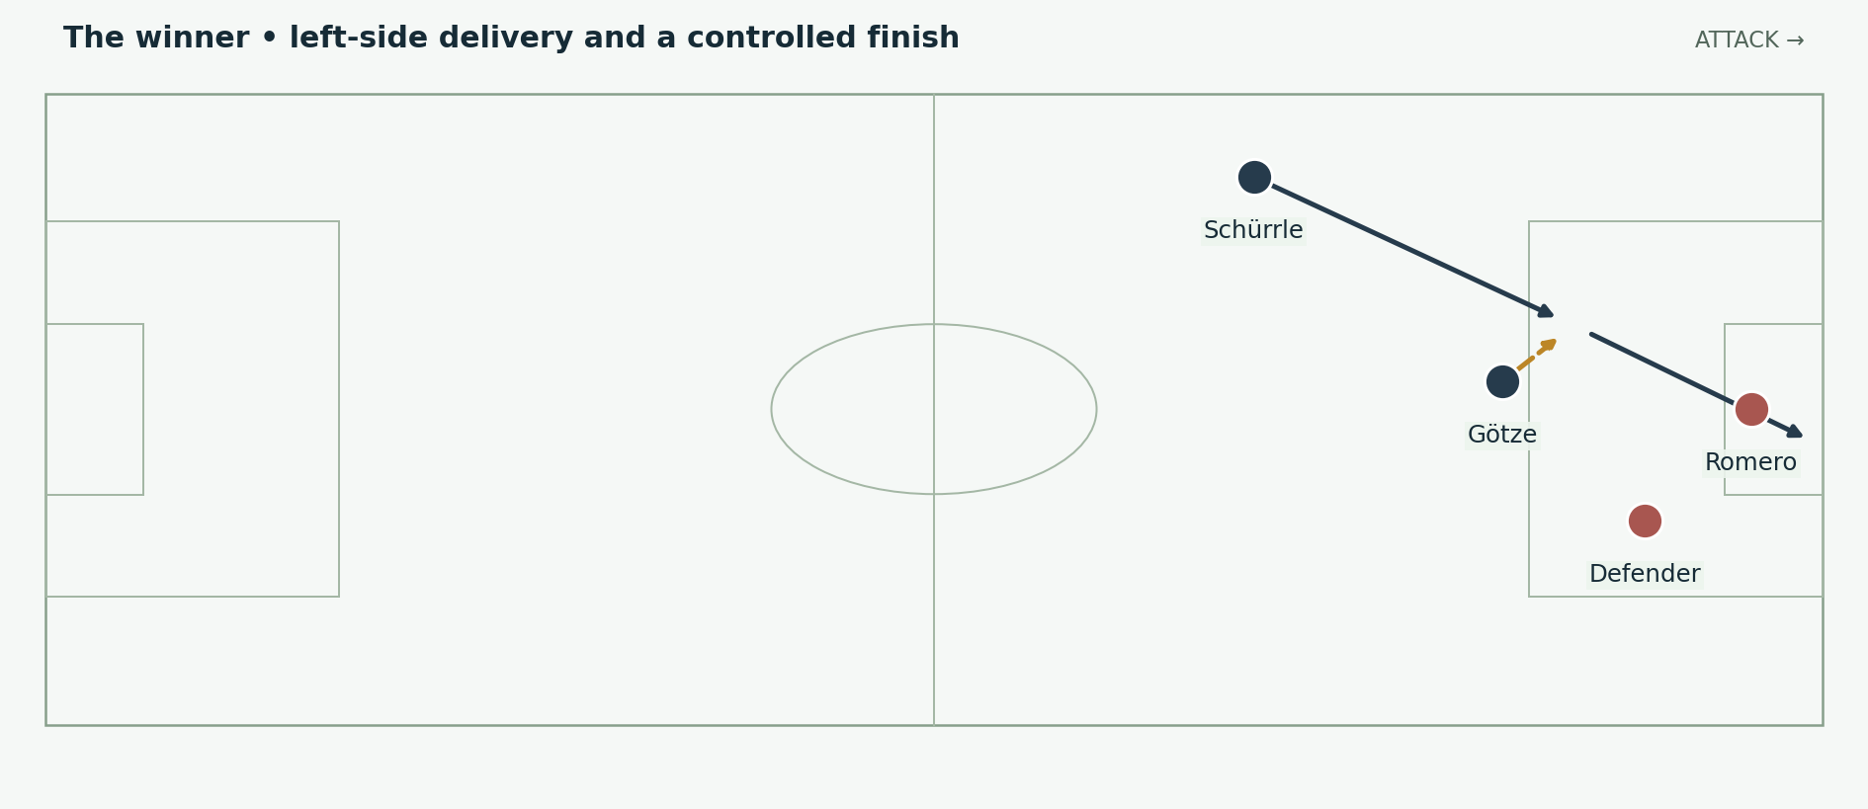
Figure 14. The 113th-minute winner in schematic form. Schürrle crosses from the left; Götze controls with his chest and finishes with his left foot. Positions and arrows are explanatory schematics, not tracking data.
Götze replaced Klose near the end of normal time. In the 113th minute, Schürrle delivered from the left and Götze controlled the ball on his chest before volleying past Romero. Two substitutes supplied the decisive combination. [S7; S12; S13]

The first touch creates the finish
A cross is only a chance if the receiver can turn its flight into a playable next action. Götze’s chest control let him bring the ball into a finishing path without waiting for it to drop freely. The subsequent left-foot strike followed before the defending team could fully reset. The technical actions belong together: the quality of the finish begins with the quality of the control.

Fresh players change the type of threat
The substitution did more than add energy. Götze offered a different receiving and finishing profile from Klose, while Schürrle had already provided direct running from the left. Their combination illustrates why squad depth should be described through usable differences. A bench is valuable when the coach can change how the attack works, not merely replace tired legs.

The sequence to show
Begin the clip early enough to include Schürrle’s approach and the defender’s orientation. Pause before the cross, then before Götze’s control. Keep the receiving body position visible rather than zooming immediately to the ball. End with the finish at normal speed so the audience understands how little time separates the three actions.
This decisive moment completes the argument without making the rest of the final disappear. Argentina had made the match difficult; Germany’s depth and execution supplied the action that separated the teams.

18 What made this team so complete
Quality | Concrete evidence | Careful conclusion
Several routes to goal | Corners, a free-kick, rebounds, combinations and wide service across the seven matches | Germany did not depend on a single finishing pattern.
Flexible roles | Lahm shifts to right-back; Müller works around Klose | Changing one position could improve several connections.
Recovery under pressure | Ghana draw and extra-time win against Algeria | The team could respond after its first plan was challenged.
Defending a small advantage | France quarter-final | Progress did not require a spectacular attacking score.
Goalkeeper range | Neuer against Algeria and in the later rounds | Coverage behind the defence complemented shot-stopping.
Different substitutes | Klose against Ghana; Schürrle against Algeria; Götze in the final | The bench changed the available attacking solutions.

A useful comparison with the Spain report
The comparison should focus on the relationship between a team’s preferred style and the problems it faces. Possession is valuable when the positions around the ball create useful next actions and protect against the loss of it. Germany’s campaign supplies examples of adjusting those relationships during a tournament. It would be too simple to turn the comparison into a claim that possession football failed or direct football alone succeeded.
Germany could slow a match down, accelerate through a gap or obtain a decisive advantage from a dead ball. Its strongest arrangement also combined different player profiles rather than asking every player to solve the same problem. These are the reasons to call the team complete.

What the word perfect should mean in the final script
Use “perfect team” as an opening question, then answer it through balance and adaptation. The factual record includes conceded goals, emergency defending, injuries and difficult extra-time games. Those episodes make the achievement more informative. The team’s quality lay partly in finding a way through them.
The central conclusion is that Germany had a coherent identity with room for correction. The players understood enough of the shared structure to keep competing when personnel and roles changed. That is a stronger explanation of the title than treating the starting eleven as an untouchable formula.

19 Narration and editing guide
Suggested length: approximately 10–12 minutes. The timings below are an editorial plan, not historical match timings. Use the figures in this report as explanatory overlays; obtain any match footage separately and check its usage rights.
Segment | Visual focus | Narration purpose
0:00–0:50 | Trophy, then Ghana and Algeria difficulty | Ask how a team becomes complete without being flawless.
0:50–2:00 | Opening XI; Lahm in midfield | Explain the first plan and its trade-offs.
2:00–3:20 | Algeria through balls; Neuer coverage | Show the relationship between pressure, the line and the goalkeeper.
3:20–4:50 | Revised XI; right-side triangle | Explain Lahm, Schweinsteiger, Khedira and Müller together.
4:50–5:50 | France free-kick and late defence | Show the value of a narrow, controlled result.
5:50–7:20 | Brazil goal routes; fourth-goal sequence | Explain collective decisions and the opponent’s collapse.
7:20–9:10 | Kramer starting; final reorganisation | Show why the final tested adaptability.
9:10–10:30 | Schürrle to Götze; role summary | Connect the winning action to squad depth and complementary skills.

Suggested opening narration
“When people remember Germany in 2014, they often begin with seven goals against Brazil. But that score alone does not explain the champions. Ghana had pushed them behind. Algeria had forced their goalkeeper to defend far outside his box. And in the final, an injury changed the starting midfield before the match had even begun. Germany’s strength was the range of answers it could find.”

Suggested closing narration
“The winning goal brought two substitutes together, but it also completed the tournament’s larger story. Germany could change a role without losing its purpose. It could win through a set piece, a quick combination, a save or one precise touch in extra time. This was a complete team because different players could solve different problems, and because the team could adjust when its first answer was not enough.”

Accuracy checks before publication
Show Kramer in the final’s starting XI. Place Lahm’s in-game move to right-back against Algeria before his start there against France. Separate a schematic pattern from a measured reconstruction. Include Portugal’s red card and Brazil’s absences. Preserve Argentina’s chances when explaining the final. These details keep the analysis specific and credible.

20 Sources and evidence notes
Match results, personnel changes and selected events are grounded in the sources below. Explanations of spacing, complementary roles and decision-making are the report’s tactical interpretation. All pitch illustrations are original teaching schematics; no positional tracking measurements are asserted. Accessed 3 October 2026.
[S1] UEFA • Germany poacher Müller makes Portugal pay • 16 June 2014
[S2] UEFA • Klose equals record as Germany draw with Ghana • 21 June 2014
[S3] UEFA • Müller strike seals top spot for Germany • 26 June 2014
[S4] UEFA • Germany survive Algeria scare to reach last eight • 30 June 2014
[S5] UEFA • Hummels heads Germany past France • 4 July 2014
[S6] UEFA • Klose breaks record for seven-goal Germany • 8 July 2014
[S7] UEFA • Götze goal wins Germany the World Cup • 13 July 2014
[S8] FIFA • Germany and their towering defence • personnel and positional context
[S9] DFB Data Center • Germany 2–1 Algeria • lineup and substitutions
[S10] FIFA • Reflective Löw plots Germany’s path forward • retrospective assessment
[S11] FIFA • Toni Kroos and the fastest World Cup brace • goal sequence
[S12] DFB Data Center • Germany 1–0 Argentina • final match record
[S13] FIFA • Mario Götze’s 2014 final goal • winning action
Timing note: match reports sometimes express an elapsed minute differently from the standard event label. The winner is shown as 113′; the early final substitution is described as around the half-hour. Formation labels describe reference roles rather than exact average positions.

