Italy 2006
World Cup Tactical Analysis
  - Defensive security and attacking variety in a complete team
Detailed English edition • Formations • Player roles • Match sequences • Content script

The central argument
Italy won through complementary skills rather than a single attacking system. Marcello Lippi built around Buffon and Cannavaro, gave Pirlo protection and passing options, used Totti to connect the attack and allowed the full-backs to become decisive. The team could protect the penalty area, play through midfield, attack directly and obtain goals from dead balls. It also changed personnel and attacking arrangements during the competition.
A useful analysis of this “perfect team” explains how the parts fit together. It also includes the difficult moments: disciplinary problems against the USA, a long spell with ten men against Australia, an injured Nesta and a final settled by penalties. Those challenges reveal the team’s range of solutions.
Stage and date | Result | Main tactical test
Group • 12 June | Italy 2–0 Ghana | Narrow midfield and two strikers
Group • 17 June | Italy 1–1 USA | Discipline and an unsettled game
Group • 22 June | Czech Republic 0–2 Italy | A replacement defender and bench goals
Last 16 • 26 June | Italy 1–0 Australia | Ten-man defence and a late attack
Quarter-final • 30 June | Italy 3–0 Ukraine | Full-back involvement and box finishing
Semi-final • 4 July | Germany 0–2 Italy aet | Patience and attacking extra time
Final • 9 July | Italy 1–1 France aet | Set pieces, resistance and a shoot-out
Italy won the final shoot-out 5–3. Tournament totals: 12 goals scored, 2 conceded and 5 clean sheets. Shoot-out kicks are excluded. Ten different players scored. [I1; I2; I3]

01 The first plan against Ghana
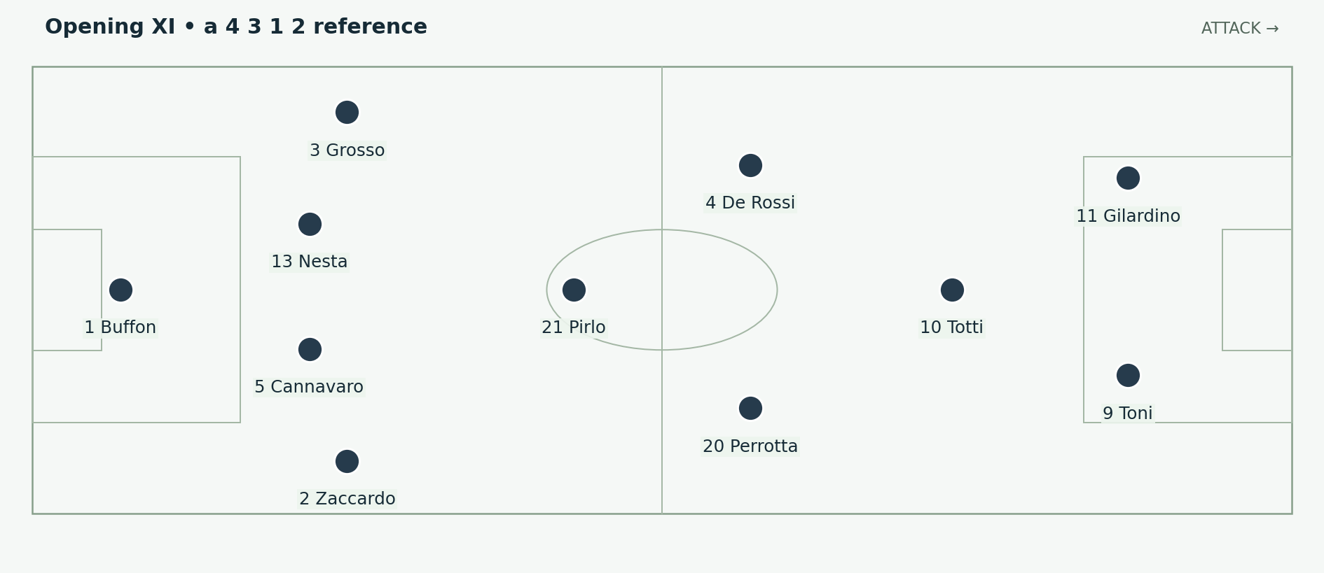
Figure 1. Two strikers ahead of Totti, with Pirlo as the deepest midfield reference. Italy attack to the right; the lower touchline is their right side. Positions and arrows are explanatory schematics, not tracking data.
Lippi opened with Toni and Gilardino together, Totti behind them, and a narrow midfield containing Pirlo, Perrotta and De Rossi. Zaccardo began at right-back, Nesta and Cannavaro centrally, and Grosso at left-back. The starting XI and 4–3–1–2 designation are recorded in the contemporary match sheet. Italy won through Pirlo and substitute Iaquinta. [I4]

Why a narrow midfield can help
The midfielders could support one another at short distances. A defender passing into Pirlo did not leave him isolated with only a long ball available. Totti supplied a receiver further forward, while two strikers occupied the centre-backs. The first pass could therefore lead toward a combination rather than requiring the striker to beat a defender alone.
The cost was width. With no permanent winger on either side, the full-backs had to judge when to advance, and the midfielders had to recognise when to support outside. If both sides pushed up at once and a central pass failed, the team could expose the channels around its centre-backs.

What to show in a tactics image
Draw the centre-forward pair first, then Totti’s position between the opposing midfield and defence. Finally reveal the full-back lanes. This makes the attack’s central density and its dependence on wider support visible in one picture. The formation number alone cannot explain that trade-off.

02 The route to the later reference team
Italy did not use the final’s lineup unchanged throughout the tournament. The opening midfield was disrupted by De Rossi’s dismissal against the USA. Nesta was injured against the Czech Republic, and Materazzi became an important replacement. Zambrotta supplied a different right-back profile from Zaccardo. [I5; I6]
Change | Effect on the team
Gattuso becomes a central reference | More defensive work and pressure around Pirlo.
Camoranesi provides a right-sided role | An outside receiver and connection with Zambrotta.
Perrotta works from the left and inside | A supporting runner rather than a winger who must remain on the line.
Materazzi replaces injured Nesta | The central defence keeps aerial strength and gains an important set-piece scorer.
Toni becomes the main central target in the later rounds | Totti can connect underneath; the wide and midfield players support around one striker.

A connected redistribution
These changes did not remove the team’s basic ideas. Pirlo still needed a nearby outlet and defensive cover. Totti still needed someone ahead of him to occupy defenders. The full-backs still needed teammates who could cover the spaces they left. The identities changed, but the tasks remained understandable.
That continuity is the practical meaning of a complete squad. A replacement is useful when the surrounding players can adapt their distances and passing choices to him. It is not enough to say the bench was strong; the analysis should show which particular task the incoming player made possible.

Do not reduce the campaign to the injury
Materazzi was a major contributor, but Nesta’s absence did not alone create Italy’s later shape. Lippi was also choosing how many forwards to use and where to place his midfield support. The development was a series of choices under changing conditions, rather than one automatic transformation.

03 The semi final and final starting structure
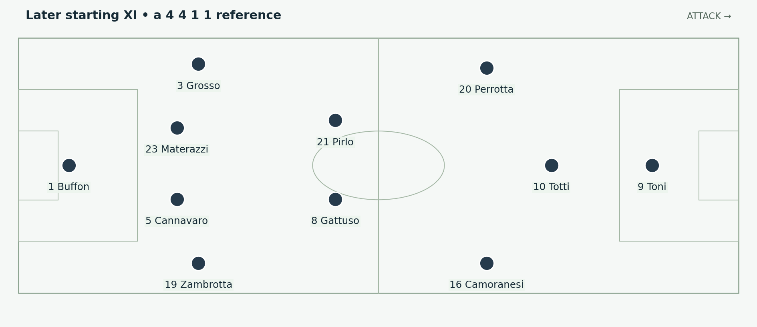
Figure 2. The starting personnel used against Germany and France. Totti plays beneath Toni; Perrotta’s left-sided role often becomes an inside supporting run. Positions and arrows are explanatory schematics, not tracking data.
The later starting structure can be shown as 4–4–1–1, or as 4–2–3–1 when Perrotta and Camoranesi stand higher around Totti. Buffon; Zambrotta, Cannavaro, Materazzi, Grosso; Camoranesi, Gattuso, Pirlo, Perrotta; Totti; Toni is the useful personnel reference. The semi-final and final records confirm these starters. [I7; I8]

What the shape gives Pirlo
Gattuso can work close enough to contest a loose ball or challenge an opponent who receives behind the first pressure. Camoranesi and Perrotta offer routes around central congestion. Totti offers a connection ahead. Pirlo consequently has choices at several distances: retain, progress, switch sides or find the central target more directly.

What the shape gives the defenders
A midfield line can close the space in front of the back four. The centre-backs then have less reason to follow an opponent far away from the penalty area. This helps preserve a covering defender when the first one challenges. The compact arrangement also lets the wide midfielder assist his full-back before a cross is delivered.
The diagram shows starting relationships, not every phase. Perrotta could arrive beyond Totti, Grosso could move higher than the midfield line, and a striker could drop to connect. The most informative explanation follows the exchange of tasks when those movements occur.

04 Pirlo makes deep possession useful
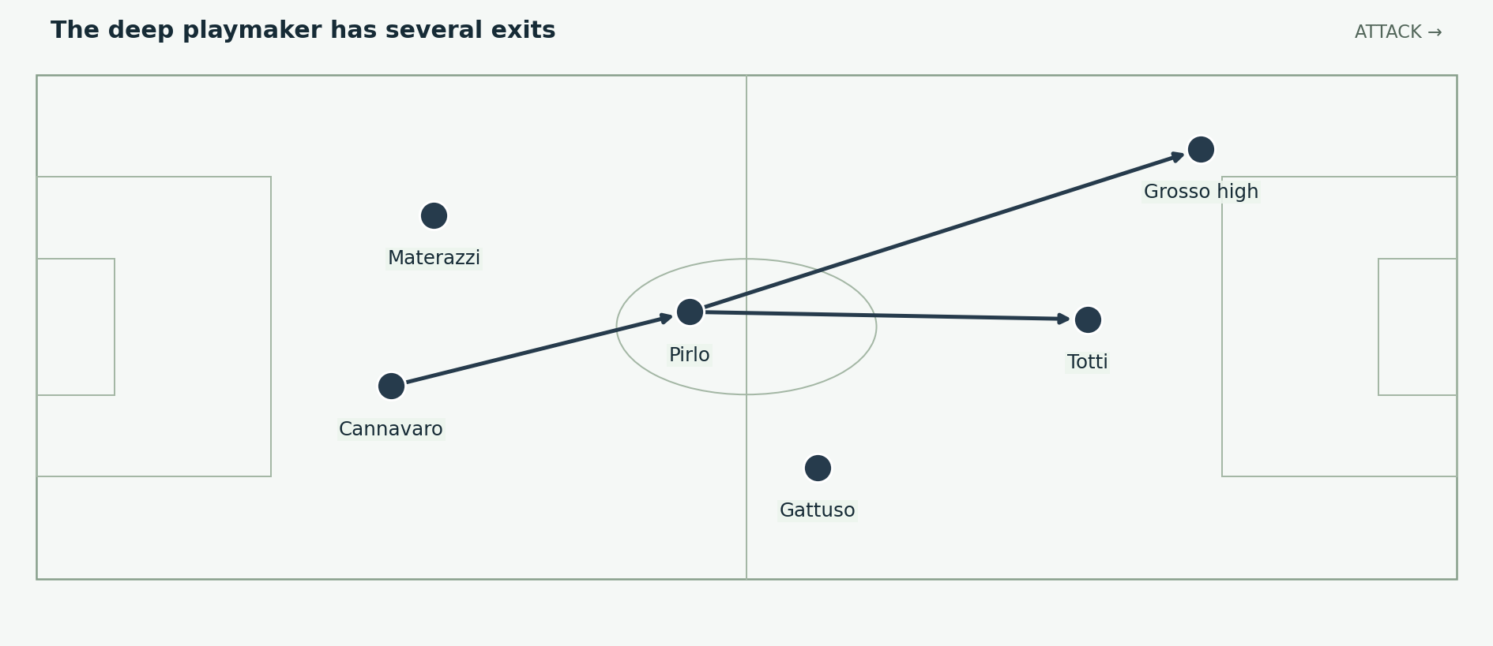
Figure 3. Pirlo can connect centrally or find a wide runner. Gattuso’s nearby position helps protect the move if possession changes. Positions and arrows are explanatory schematics, not tracking data.
Pirlo’s deeper position let him see more of the field before delivering the next pass. A short forward pass could find Totti; a longer diagonal could reach a full-back; a direct ball could ask the centre-forward to compete. The advantage was the choice of route and the timing of the release, rather than long passing for its own sake.

Receiving before deciding
A midfielder must scan before the ball arrives. If he first discovers the pressure after taking his touch, he may lose the angle for the intended forward pass. By adjusting his body and his distance from the defender, the receiver can make one touch carry the ball away from the challenger and toward the next action.
The supporting players also have a role. A midfielder who stands directly behind an opponent may be technically available but practically impossible to find. Moving a few metres to create a visible lane changes the quality of the choice Pirlo has. A full-back remaining wide can stretch that lane even without receiving.

Why the passer needs protection
Deep creativity carries a particular risk: a turnover happens close to the defence and with teammates potentially moving forward. Italy’s supporting midfield and central defenders therefore form part of the playmaking system. Their positioning allows Pirlo to attempt ambitious passes without leaving every failure to be solved by an emergency tackle.

05 Gattuso protects more than one player
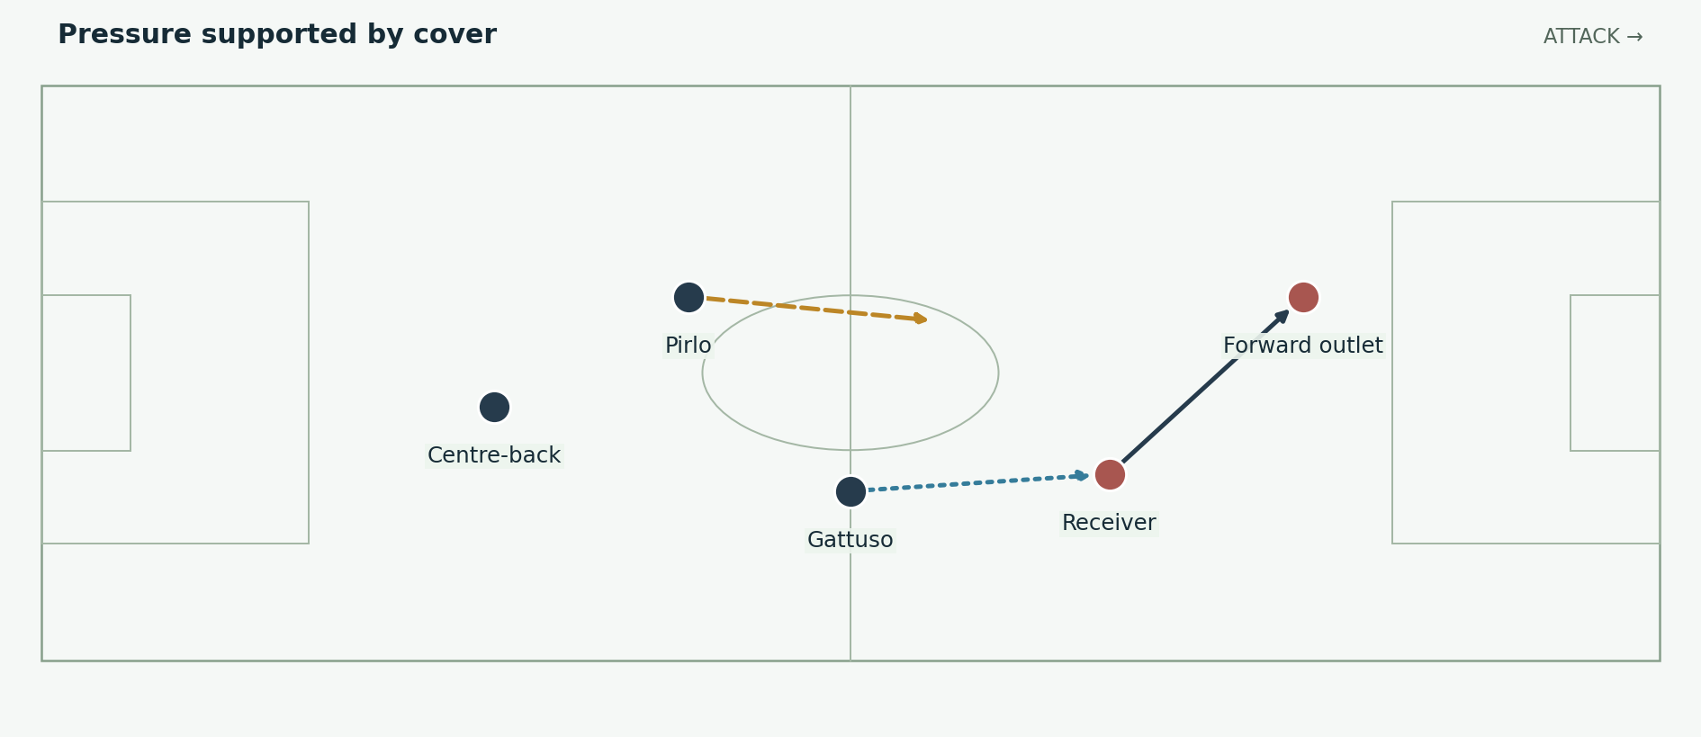
Figure 4. The first challenger pressures the receiver while teammates protect the next pass. A press becomes useful when its cover is coordinated. Positions and arrows are explanatory schematics, not tracking data.
Gattuso’s work helped Pirlo, but describing him only as Pirlo’s bodyguard understates the role. He could contest the ball, narrow a passing lane and support a full-back. The important question is what the challenge allows teammates to do: hold a useful position, prepare for the next ball or recover behind the attack.

Challenge and cover are different tasks
If two midfielders attack the same receiver, a simple pass may eliminate both. If neither challenges, the receiver can turn and carry. A coordinated pair divides those tasks. One reduces the carrier’s time; the other protects the route the carrier is most likely to use. The defender behind them also needs to read whether he should step up or remain as cover.
Successful defensive work is not measured solely by the number of tackles. A receiver forced to pass backwards may end the threat without any contact. A passing lane removed by positioning can make the next challenge easier for a teammate. The visible duel is often the final action of a wider defensive arrangement.

The trade off
An aggressive midfielder can be pulled away from his reference space. The nearest teammates must judge when to cover that space and when to ask him to return. Italy’s balance depended on that judgement. Individual intensity helped because it was connected to a compact structure, not because every player chased every ball.

06 Totti links the passer and the target
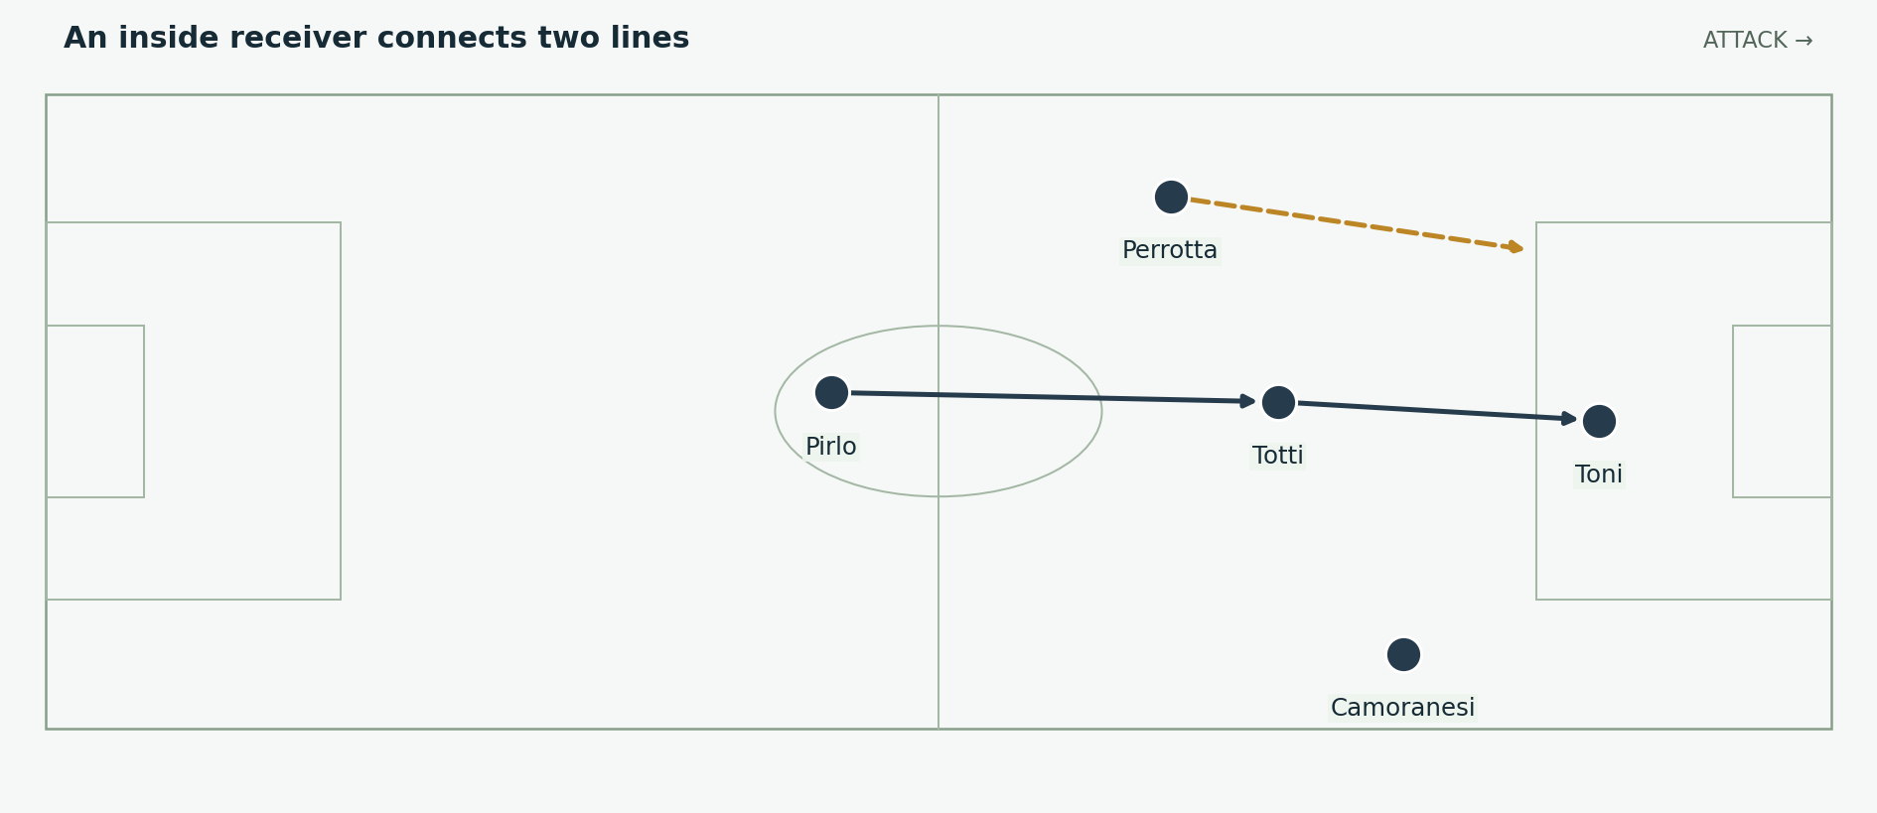
Figure 5. Totti can connect a deeper pass to Toni while Perrotta supplies a run from midfield. The supporting movement keeps the receiver from becoming a dead end. Positions and arrows are explanatory schematics, not tracking data.
Totti offered Italy a receiver between lines who could turn, release a runner or serve the centre-forward. He did not need to dominate every possession to be useful. One accurate pass in the final third can turn a period of circulation into a direct threat, particularly when the runner has already begun moving.

Two levels of creativity
Pirlo’s position let him organise the approach from deeper areas. Totti worked closer to the defenders who protected the penalty box. A pass from the first creator to the second could bypass an opposing midfield line and leave the next decision to a player already near the dangerous space.
The striker made that arrangement practical. If Toni pinned a centre-back or offered a target for a direct ball, Totti had a reference beyond him. If the defender followed Totti away from the back line, the forward could benefit from the resulting gap. If the defender held, Totti could receive with more time.

The relationship to the bench
Totti was not the only way Italy could connect the attack. Del Piero could operate in a creative forward role, and a quicker runner such as Iaquinta could change the next pass into a release behind the defence. The substitutions were meaningful because they changed the receiving and running profiles around the same central idea.

07 Perrotta and Camoranesi balance the flanks
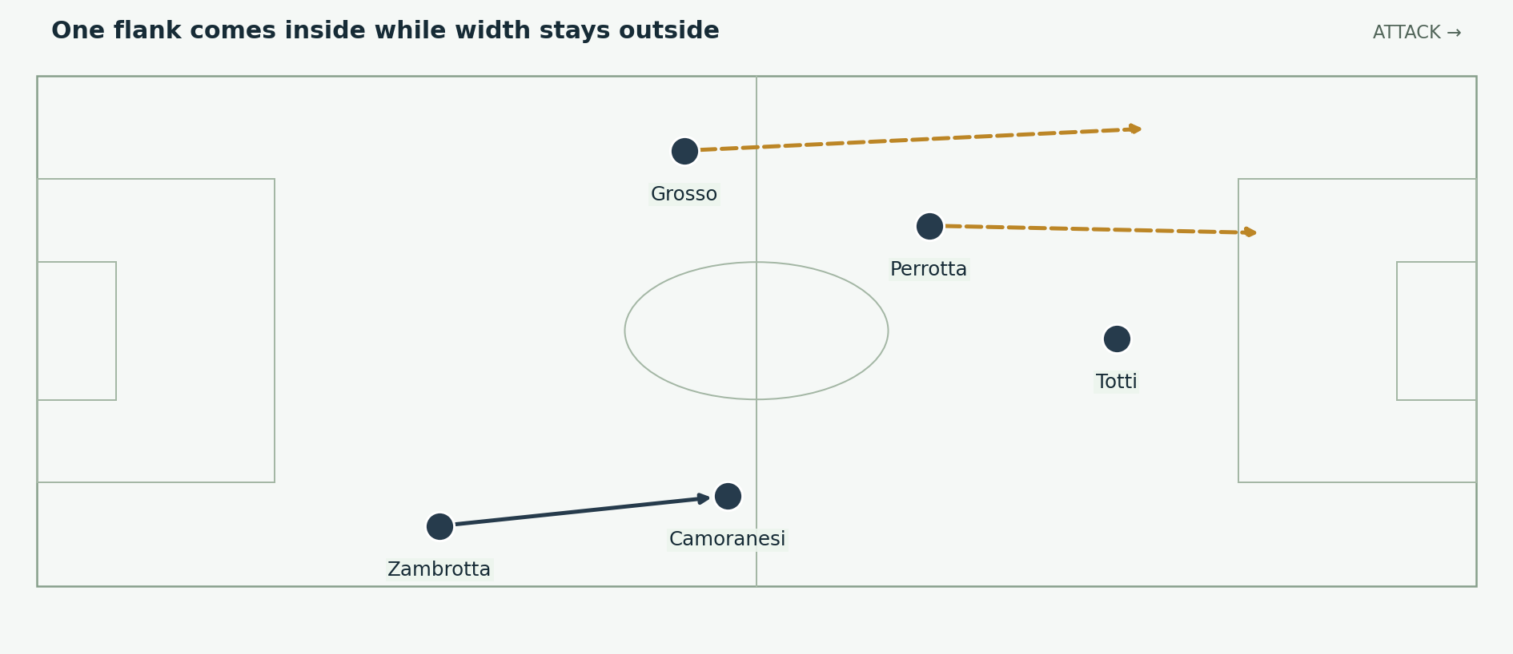
Figure 6. Perrotta’s inward run can coexist with Grosso’s outside advance. Camoranesi supplies a different starting relationship on the right. Positions and arrows are explanatory schematics, not tracking data.
Perrotta’s value was his ability to support the centre while still helping the left side defensively. A midfielder beginning left of Pirlo could move into a central receiving or finishing space, giving the attack another runner without selecting a second permanent striker. Grosso could then provide the outside route.
Camoranesi offered an outside reference on the right and could combine with Zambrotta. The two flanks therefore did not need to behave identically. One side might progress through an overlap, the other through an inside combination. This asymmetry gave opponents more than one type of movement to organise against.

The defensive obligation remains
When the left-sided midfielder moves inside, the team must still control the opponent’s wide outlet if possession changes. He may recover outward, the nearest central midfielder may delay the carrier, or the full-back may hold a safer position. The correct response depends on where the ball is lost.
For a video, follow Perrotta before the pass is played. His movement can make Totti’s option useful or create a lane for Grosso. Tracking only the player in possession misses how an apparently simple pass becomes possible. The same method helps explain Camoranesi’s support of the right-side attack.

08 Grosso and Zambrotta are attacking solutions
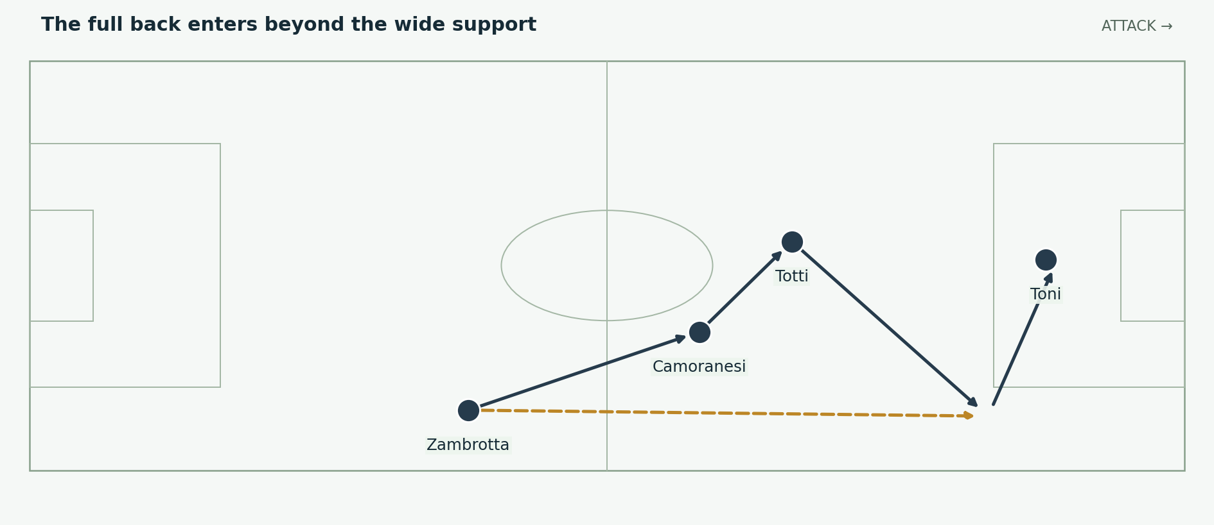
Figure 7. A generalised overlap and delivery pattern. Full-back movement turns a central combination into a route toward the penalty area. Positions and arrows are explanatory schematics, not tracking data.
The full-backs added width to a team containing several players naturally drawn toward the centre. A run outside the ball could force the opponent’s wide defender to choose between closing the inside receiver and protecting the touchline. Either choice could improve the next pass if Italy timed the supporting movement correctly.

A run is valuable before the runner receives
If a defender follows the overlap, the player inside may gain space to turn or shoot. If the defender remains inside, the runner may receive in a position to cross. The attacking benefit is the dilemma, rather than a guarantee that every overlap ends with a delivery.
The Ukraine quarter-final gives a concrete anchor. Zambrotta opened the scoring, later contributed a vital defensive block and supplied Toni’s second goal. Those actions connect the defender’s attacking contribution to his responsibility when the opponent threatens. [I9]

Protect the opposite side
Advancing both full-backs can leave the centre-backs defending a large width. Italy needed to judge the attack’s risk and keep sufficient midfield cover. The successful mechanism is width plus protection: the outside runner creates the chance, while the players behind the ball keep a failed action from becoming a clear counterattack.

09 Cannavaro Buffon and the defensive layers
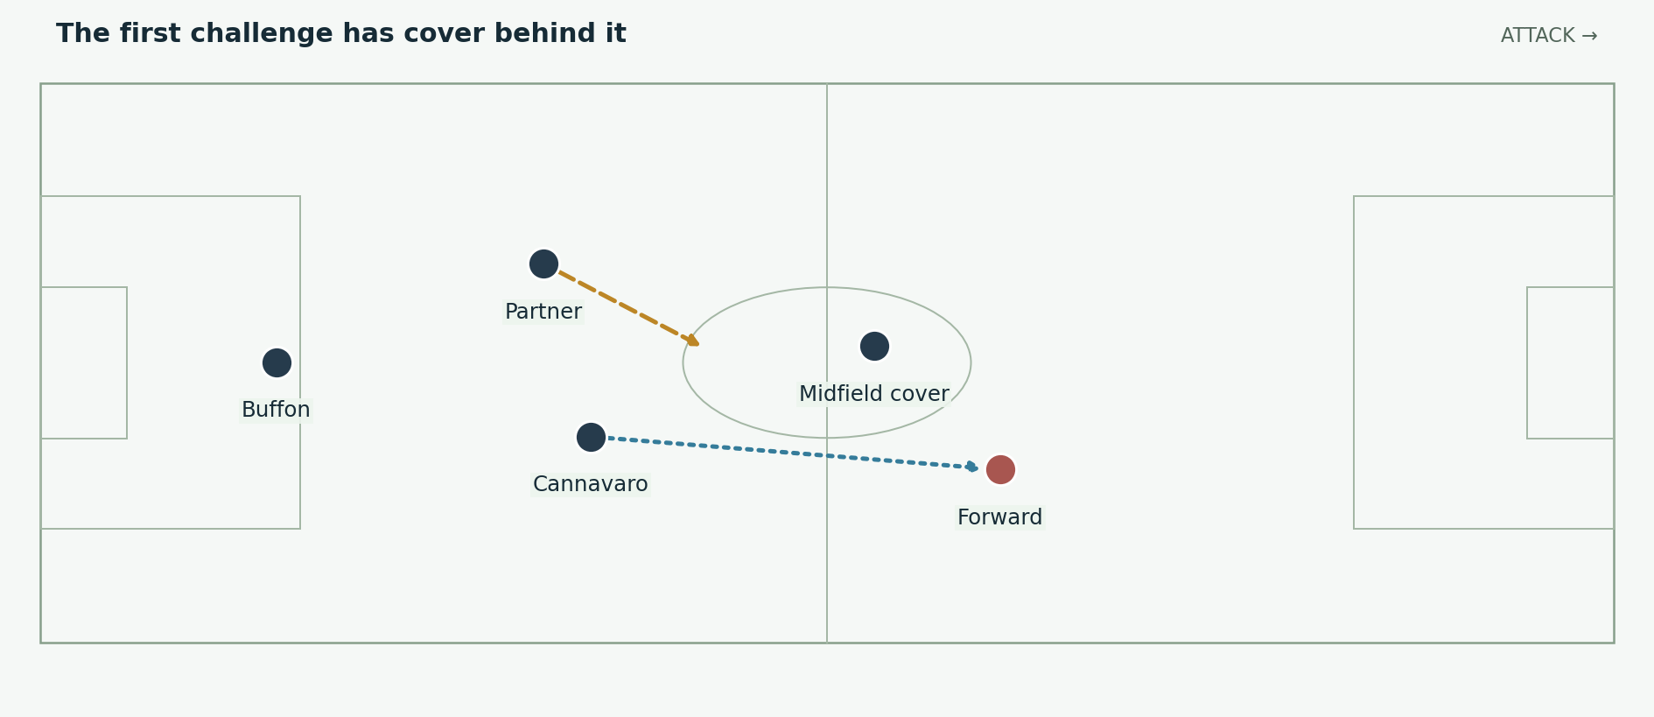
Figure 8. One centre-back can engage because a partner, midfield cover and goalkeeper protect the next action. The line’s depth changes with pressure on the ball. Positions and arrows are explanatory schematics, not tracking data.
Italy conceded only an own goal against the USA and Zidane’s penalty in the final. No opponent scored a non-penalty goal credited to an opposing player. That exceptional record supports the importance of the defensive unit, but it does not prove Italy conceded no dangerous chances. [I1; I2]

Anticipation and coordination
Cannavaro had to identify whether a pass could be intercepted or whether stepping forward would open a route behind him. His partner needed to read the same action and adjust. A clearance or interception can look individual in a highlight, although its feasibility depends on the cover that permits the defender to leave his starting position.
The midfield’s distance matters. If the gap ahead of the defenders becomes too large, an opponent can receive, turn and choose a pass before a centre-back arrives. Compactness lets a midfielder challenge from one direction while a defender protects another. It also gives the team a better chance of collecting the ball after the duel.

Buffon completes the system
A goalkeeper must still solve situations the outfield unit cannot prevent. Positioning, readiness and the choice to hold or advance all affect the shot he faces. Italy’s defensive explanation should include Buffon’s saves alongside the outfield organisation. The clean sheet is the result of both, rather than a substitute for describing either.

10 The USA draw and the cost of disruption
Gilardino scored from a Pirlo free-kick, Zaccardo then put the ball into his own net, and De Rossi was dismissed. The USA subsequently lost Mastroeni and Pope, leaving Italy with ten players against nine. The match nevertheless ended 1–1. These changing numbers make a standard eleven-player tactics board misleading after the dismissals. [I5]
Problem | Why it matters
Loss of a central midfielder | The team must rebuild coverage and passing outlets while the match continues.
Own goal from a defensive clearance | A dangerous delivery can produce damage without an opponent making the final touch.
Numerical advantage later in the game | More players do not automatically create an open passing lane or a well-timed penalty-area run.
Opponent defending with fewer players | The attacking team still needs to stretch the block and protect against a direct escape.

A complete team still has imperfect matches
This draw is useful because it prevents the defensive record from becoming a myth of effortless control. Italy’s technical and defensive qualities did not remove the effects of discipline, pressure and a disjointed game. The team had to keep enough organisation to avoid losing while struggling to turn the situation into a winner.

What not to infer
The later title does not retroactively make every decision in this match correct. A dismissal is a cost the team must absorb. The stronger conclusion is that Italy recovered its tournament direction and found a workable balance after the disruption. The subsequent choices are evidence of adaptation, not a reason to ignore the original problem.
For analysis, divide the match by the dismissals. State the player numbers at each moment before explaining the shape. That simple step prevents a diagram of one phase being used as evidence for a different numerical situation.

11 Australia and the ten man problem
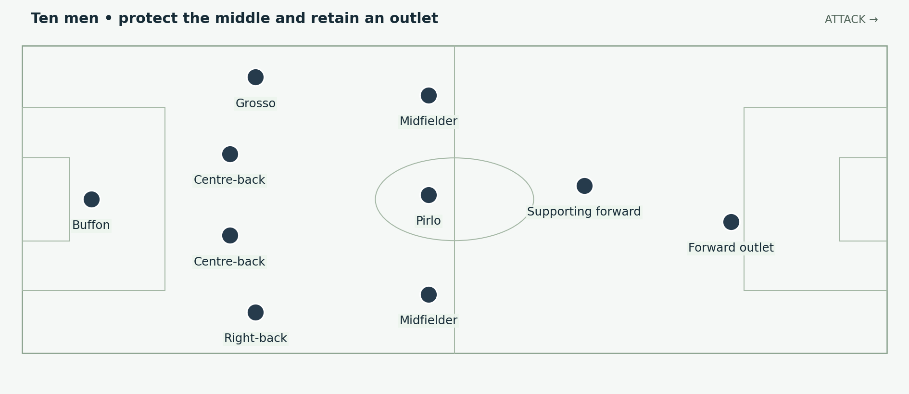
Figure 9. A generic ten-player reference after restoring a back four. It explains the defensive task rather than asserting fixed positions for every minute against Australia. Positions and arrows are explanatory schematics, not tracking data.
Materazzi was sent off early in the second half. Lippi brought Barzagli on for Toni to restore the central defence. Totti later replaced Del Piero and converted the stoppage-time penalty after Grosso’s advance into the area drew the decision. Italy won 1–0. [I10; I11]

Reduce the space the opponent can use
With ten players, trying to pressure every defender equally can pull the team apart. A compact unit can instead prioritise the middle, shift toward the ball and ask the opponent to attack through less direct routes. That does not remove danger; it makes the defenders’ next challenge more manageable.
Keeping an outlet remains important. If every clearance immediately returns, the team faces another attack before it can recover. A forward who can occupy a defender, collect a pass or win a foul gives teammates time to move away from their own penalty area.

The winning episode and its limits
The penalty decision was disputed. It should be described as the decisive awarded penalty rather than offered as proof that Italy had tactically dominated Australia. Grosso’s willingness to advance gave the match a late attacking episode; Totti then executed the kick. Defensive survival, an isolated attack and the referee’s decision all belong in the account. [I11]

12 Ukraine and the complete full back performance
Italy’s 3–0 quarter-final win combined an early Zambrotta strike with two Toni goals. Totti’s service supplied a headed finish, and Zambrotta later reached a delivery position for a close-range completion. Ukraine also had threatening spells and chances against the woodwork. The winning margin should retain that context. [I9]
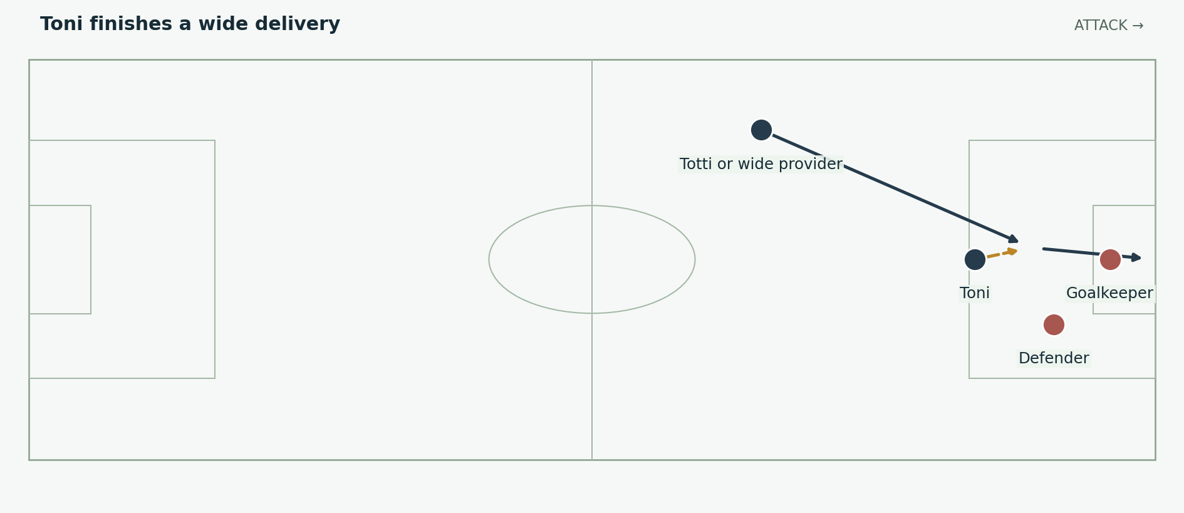
Figure 10. A striker attacks the delivery corridor while the provider sees his movement. Inspired by the quarter-final, with illustrative locations. Positions and arrows are explanatory schematics, not tracking data.

Why the target matters
A striker’s presence can turn wide possession into an immediate chance. The provider does not need to dribble into the box himself if the target already occupies the defender and can meet a delivery. The runner’s timing must agree with the passer’s touch; reaching the space too soon lets the defence settle, while arriving late wastes the cross.

The score changes the available choices
An early lead can encourage the opponent to commit more players and leave more room for later attacks. Italy could combine defensive concentration with opportunities to extend the advantage. That is different from asserting that a team simply retreats after scoring. The coach must decide when retention, a direct release or an additional forward run has the best value.
This match is an effective antidote to a purely defensive description of Italy. The full-back could score and provide, and the centre-forward could finish more than one type of service. Those contributions came from players with different roles within the same balanced structure.

13 Germany and an ambitious extra time
The semi-final was 0–0 after ninety minutes. Italy and Germany both created threats, and extra time contained further chances before Grosso and Del Piero scored at the end. Italy’s performance included attacking intent, not merely a wait for penalties. [I3; I7]
Substitution | Change in available threat
Gilardino replaces Toni | A new central forward and a different movement profile.
Iaquinta replaces Camoranesi | A forward runner from the right-sided area.
Del Piero replaces Perrotta | An additional creative finisher around the remaining forwards.
The personnel changes are recorded by FIFA; the role descriptions are tactical interpretation. [I7]

More forwards need connected support
Adding attacking players does not itself make a team more dangerous. They need a route to receive, and the players behind them must still protect the next turnover. The value lies in combining different movements: one forward can approach the ball, another can carry toward the area and another can wait for the final pass.
A fatigued defence must then make more handover decisions. If a defender follows the approaching forward, he opens a space. If he stays, the receiver may turn. A supporting runner can attack the gap between those choices, particularly when the passer delays until the defender has committed.

Opponent context
Germany were without the suspended Torsten Frings. That matters to the starting conditions, although it does not justify claiming that his absence alone decided the match. Italy still had to defend German attacks and create the final opening. The result followed the actions performed on the pitch under those conditions. [I7]

14 Pirlo finds Grosso for the first goal
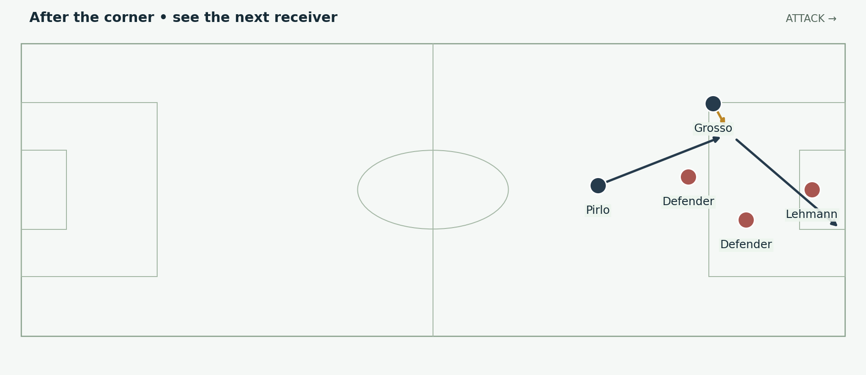
Figure 11. The late semi-final opener: the recycled corner reaches Pirlo, who finds Grosso for a first-time left-foot finish. Exact player locations are illustrative. Positions and arrows are explanatory schematics, not tracking data.
After a corner was only partly cleared, Pirlo received outside the area and found Grosso. The left-back curled the ball past Lehmann for the breakthrough in the 119th minute. The action shows why a set-piece phase continues after the first delivery is defended. [I3; I7]

The passer changes the defender’s attention
The defender nearest the ball must account for a shot and a forward pass. If the carrier waits for that defender to commit, a lane can appear beside him. A runner arriving into the lane can receive facing goal, while a stationary attacker may still be closely marked. Pirlo’s value is the selection of the receiver at the moment the route becomes useful.

Why a full back can be the finisher
At the end of a corner sequence, normal formation lines are already altered. A player who began as a defender can remain in an advanced zone and become the next attacker. Grosso’s role in this episode demonstrates that Italy’s goal threat extended beyond its forwards. The team’s positional balance should be assessed for the phase being played, rather than judged by the player’s label.

Three pauses for the viewer
Pause the first clearance, the moment Pirlo controls and the moment the pass leaves his foot. Mark the defenders drawn toward him and Grosso’s receiving route. Resume at normal speed for the finish. This exposes the decision-making that a highlight beginning with the shot would conceal.

15 Cannavaro starts the final counterattack
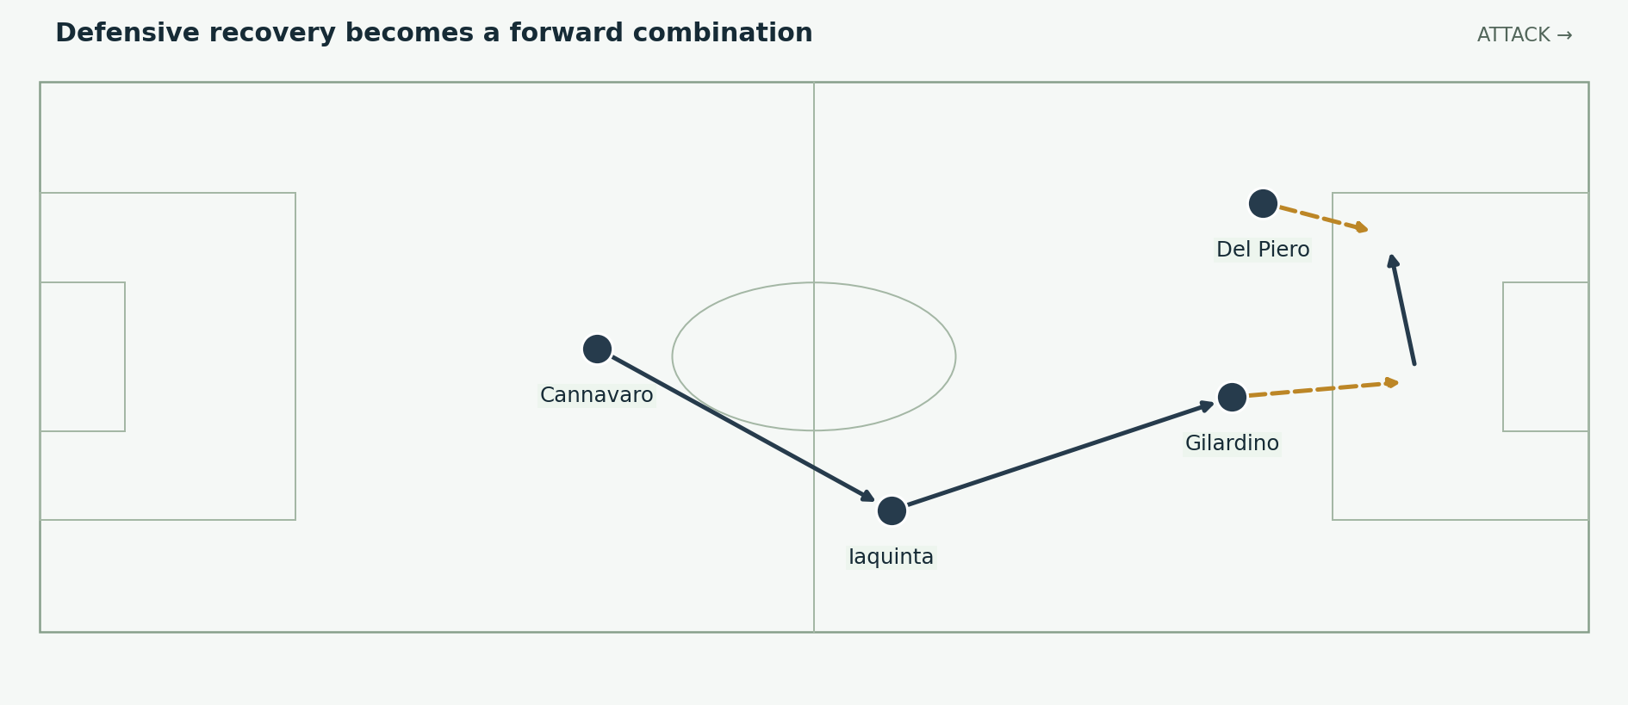
Figure 12. The second semi-final goal connects Cannavaro’s recovery to Iaquinta, Gilardino’s carry and Del Piero’s finish. The arrows are a simplified sequence. Positions and arrows are explanatory schematics, not tracking data.
Germany attacked after conceding. Cannavaro regained possession, Iaquinta connected forward, and Gilardino carried the move before releasing Del Piero. The substitute finished to make the result safe. FIFA’s retrospective describes the chain; the tactical lesson is the connection between winning the ball and retaining the quality of the next action. [I7]

The first pass must preserve the opportunity
A recovery alone does not create a successful counterattack. The ball winner must find an outlet before the opponent can surround him again. The outlet must then recognise whether the next pass should release a runner or invite a carry. Italy’s sequence combines those tasks instead of treating the turnover as an automatic goal chance.
Gilardino’s carry made the defender choose. Closing him could expose Del Piero; holding the passing lane could allow the carrier to continue. The final pass is valuable because the run and the carry create that dilemma together. It is more informative to explain the defender’s choice than to call the move simply fast.

A defensive team can still attack intelligently
The move began with the captain’s defensive action and ended with two attacking substitutes combining. That relationship captures the team’s completeness. Security and attack were connected stages of one sequence. Lippi’s substitutions supplied the receiving and finishing options that let the defensive recovery become a decisive second goal.

16 The final demands a different kind of control
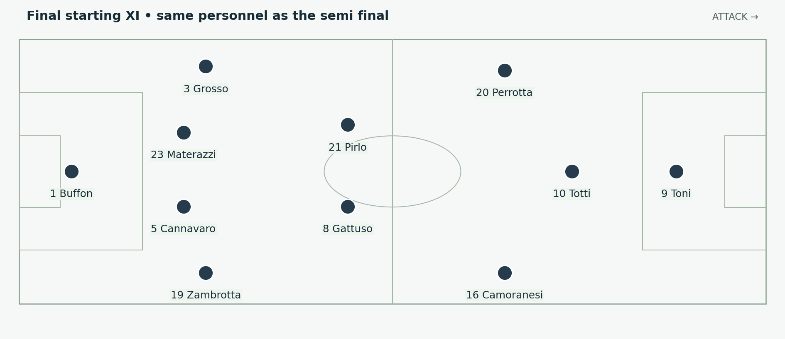
Figure 13. Italy’s actual final starters. Nesta was unavailable; Materazzi partnered Cannavaro. Totti began behind Toni. Positions and arrows are explanatory schematics, not tracking data.
France scored through Zidane’s early penalty, and Materazzi equalised from Pirlo’s corner in the 19th minute. Italy threatened from dead balls, including a Toni header against the bar. France also developed dangerous attacks, and the game remained level through extra time. [I8; I12]

Responding without abandoning the structure
Conceding early asks a team to increase its attacking output without creating an avoidable second problem. Italy could use set-piece quality and aerial targets rather than send every midfielder beyond the ball immediately. A corner offers a structured attacking episode in which designated targets can challenge close to goal.

Why the central duel changed
France’s midfield and attacking receivers could threaten the spaces around Italy’s central pair. A defender stepping out needed support behind him; a midfielder tracking too far back could leave the next receiver free. The unit had to manage those distances while still finding a route to relieve pressure.
Lippi replaced Totti with Iaquinta and Perrotta with De Rossi around the hour, then introduced Del Piero for Camoranesi later. The substitutions redistributed creative work, forward running and central coverage. They should be shown as changes to the final’s working team, not confused with the original starting diagram. [I8]

The final was not a ninety minute exhibition
Both sides had chances, and the match required extra time and a shoot-out. The title confirms Italy’s outcome, while the tactical analysis must still describe the periods when France presented difficult problems. A complete team can be tested without every phase favouring it.

17 The set piece and the shoot out
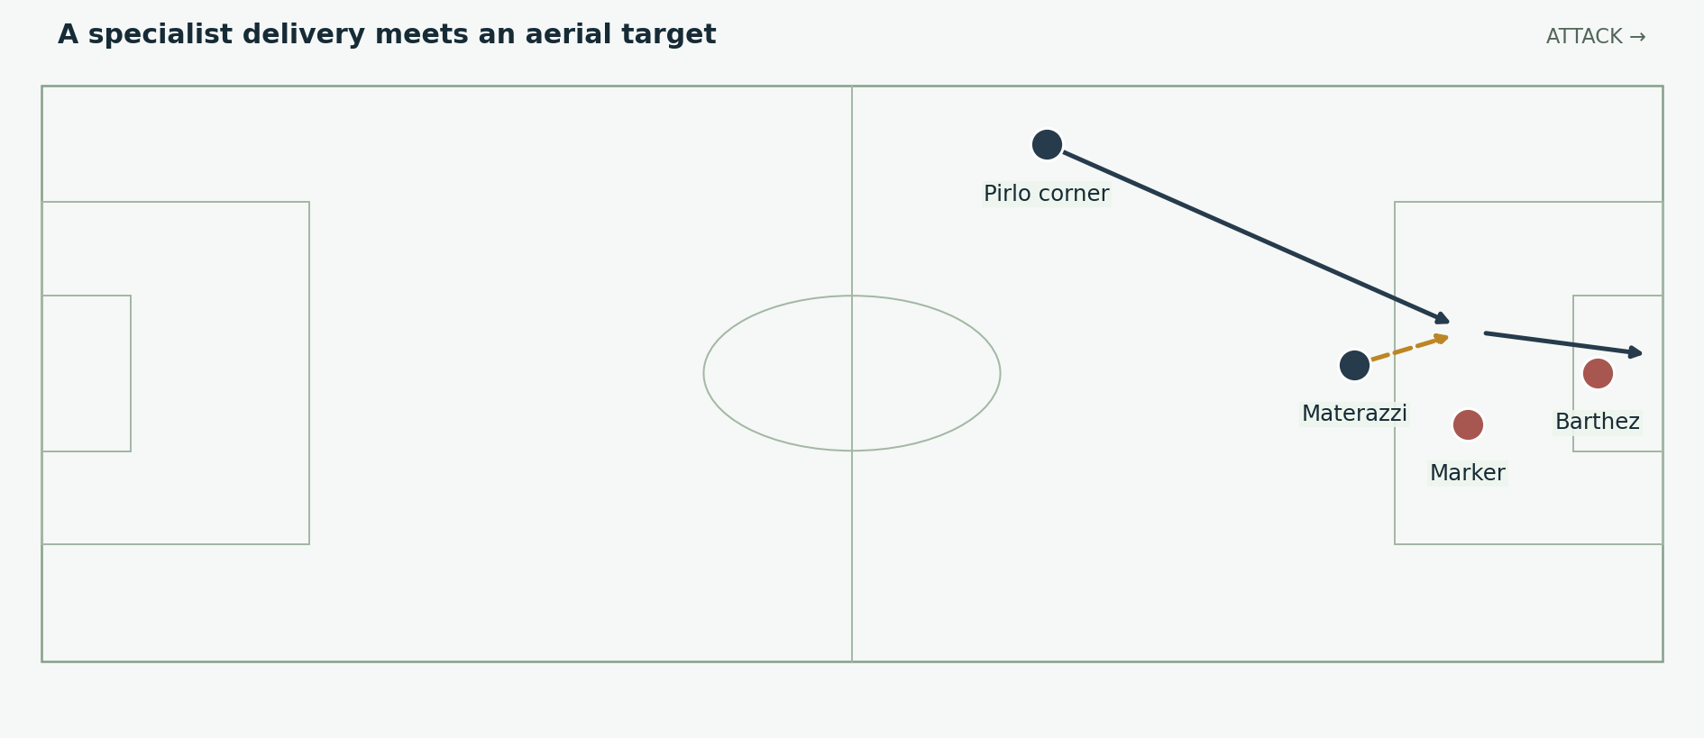
Figure 14. Materazzi’s equaliser: an outswinging Pirlo corner and an attacking header. This is a teaching reconstruction, not a measured flight path. Positions and arrows are explanatory schematics, not tracking data.
Materazzi’s header supplied the final’s equaliser. It joined a delivery specialist and an aerial target in a repeatable type of scoring situation. The practical mechanism is the meeting of service, starting separation and the timing of the jump; the goal should not be explained through height alone. [I12]

A shoot out is its own contest
Italy converted all five kicks: Pirlo, Materazzi, De Rossi, Del Piero and Grosso. Trezeguet struck the bar, and Italy won 5–3. Those kicks are separate from the 1–1 match score and from Italy’s twelve tournament goals. [I8; I12]
Penalty execution involves the chosen placement, approach, striking action and response to the goalkeeper. The tournament’s defensive structure does not guarantee success in that contest. A rigorous report therefore treats the shoot-out as a decisive final test rather than an inevitable reward for good defending.

Keep the major incident in proportion
Zidane was dismissed late in extra time after head-butting Materazzi. State the event and its effect on player numbers. It does not explain the earlier equaliser, the previous ninety minutes or all five Italian kicks. Building the whole final around that incident would remove most of the football that brought the teams to penalties. [I12]

18 Why the team was complete and how to explain it
Quality | Concrete evidence | Narration point
Defensive depth | Materazzi contributes after Nesta’s injury | The unit survives a major personnel loss.
Creative levels | Pirlo deeper and Totti ahead | The next pass has receivers at different distances.
Full-back threat | Grosso against Germany; Zambrotta against Ukraine | Wide defenders can decide an attacking phase.
Attacking alternatives | Ten different tournament scorers | A single goalscorer is not the only finishing route.
Changes under pressure | Australia with ten men; Germany in extra time | The working arrangement can change while tasks remain clear.

Suggested opening narration
“Italy conceded only twice in 2006, but the champions were more than a defensive wall. Pirlo could choose the next route from deep. Totti could connect near the penalty area. Grosso and Zambrotta could turn a defender’s starting role into an attacking finish. Lippi’s team was complete because those different strengths worked together, and because the squad could adjust when the tournament became difficult.”

Suggested sequence for a ten minute video
Begin with the later XI, then briefly show the Ghana starting variation. Explain Pirlo and Gattuso, followed by Totti, the wide midfielders and the full-backs. Use the USA and Australia matches to show the cost of disruption. Spend the central section on the two Germany goals. Finish with the final’s set piece and shoot-out, making clear that they are separate scoring contests.

The conclusion the evidence supports
Italy had elite defending, but its title also required creative decisions, forward runs, bench contributions and finishing. “Perfect” is most useful here as a description of complementary qualities and adaptation. It should not imply that opponents created no chances or that every coaching choice worked immediately. The specific match sequences show how a balanced team found different ways to win.

19 Sources and evidence notes
Recorded results, lineups and selected match events are supported by the linked sources below. Tactical explanations of space, roles and decisions are analytical interpretations. All figures are original teaching schematics, not measured tracking coordinates. Accessed 3 October 2026.
[I1] FIFA • Italy conquer the world as Germany wins friends
[I2] FIFA • Italian ecstasy in Berlin • tournament statistics
[I3] UEFA • Azzurri break German hearts • 4 July 2006
[I4] La Gazzetta dello Sport • Italy Ghana match sheet • 12 June 2006
[I5] UEFA • Three sent off as USA hold Azzurri • 17 June 2006
[I6] FIFA • Czech Republic Italy • lineup and substitute scorers
[I7] FIFA • Azzurri late show dashes German dreams • semi-final record
[I8] DFB Data Center • Italy France • players and substitutions
[I9] UEFA • Two for Toni as Ukraine bow out • 30 June 2006
[I10] FBref • Italy Australia • match events and substitutions
[I11] ABC • Last-gasp penalty breaks Australian hearts • 27 June 2006
[I12] UEFA • Italy prevail after shoot-out drama • 9 July 2006
Event times use standard match-minute labels where available. A formation is a reference arrangement; possession, recovery runs and substitutions change the working shape. Shoot-out goals are excluded from tournament scoring totals.

