Spain 2010
World Cup Tactical Analysis
  - Possession control and decisive actions in a complete team
Detailed English edition • Formations • Player roles • Match sequences • Content script

The central argument
Spain’s first world title was built on connected positioning and control of the ball, but its decisive moments also required finishing, a set piece and outstanding saves. Vicente del Bosque combined Busquets and Xabi Alonso behind Xavi, gave Iniesta freedom to connect and penetrate, and changed the attack as the tournament progressed. Villa supplied five goals, while Puyol and Iniesta decided the last two matches.
The useful explanation of this “perfect team” is how its different qualities supported one another. Short passing reduced some opponents’ attacking opportunities, the midfield protected the defenders, and the bench added different ways of attacking. The opening defeat and narrow knockout wins make those relationships more important to understand.
Stage and date | Result | Main tactical test
Group • 16 June | Spain 0–1 Switzerland | Possession against a compact block
Group • 21 June | Spain 2–0 Honduras | A striker pair and Villa’s individual threat
Group • 25 June | Chile 1–2 Spain | Pressure and spaces beyond the first line
Last 16 • 29 June | Spain 1–0 Portugal | Changing the centre-forward profile
Quarter-final • 3 July | Paraguay 0–1 Spain | Pressure, penalties and persistence
Semi-final • 7 July | Germany 0–1 Spain | Pedro starts; a corner decides the game
Final • 11 July | Netherlands 0–1 Spain aet | Recovery against direct threats and extra-time changes
Totals calculated from the match results: 8 goals scored, 2 conceded, 6 wins and 1 defeat. Five clean sheets. All four knockout matches finished 1–0. [S1]

01 The opening XI and its central density
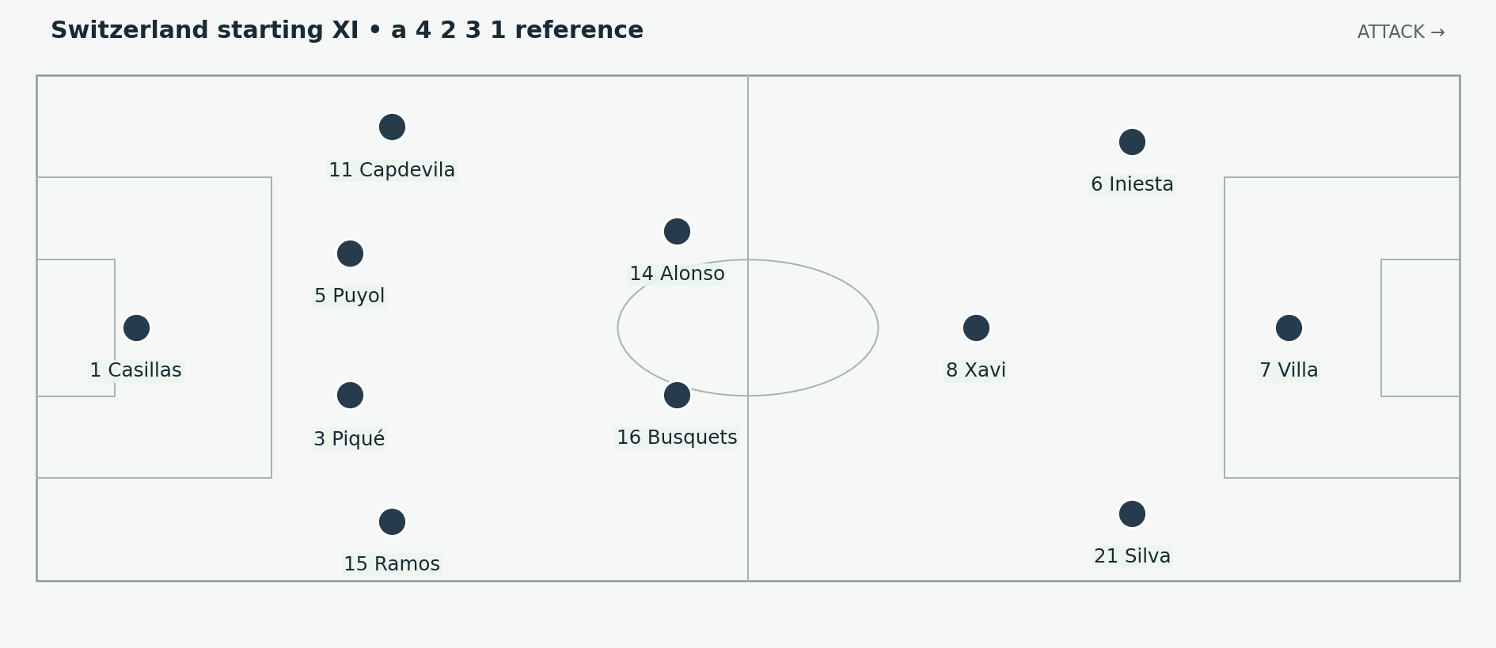
Figure 1. Villa leads the line with Silva and Iniesta beginning wider, Xavi connecting centrally and Busquets plus Alonso deeper. Spain attack to the right; the lower touchline is their right side. Positions and arrows are explanatory schematics, not tracking data.
Spain began against Switzerland with Villa at centre-forward. Silva and Iniesta supplied the wider attacking positions, while Xavi worked ahead of Busquets and Alonso. Ramos and Capdevila were the full-backs, with Piqué and Puyol centrally. Torres started on the bench. The opening personnel are confirmed by FIFA’s match account and appearance record. [S1; S2]

The idea behind the central numbers
Several midfield receivers gave the ball carrier short options. If one opponent pressed, another Spanish player could become available nearby. The team could use a supporting pass to change the angle and then find someone beyond the pressure. Progress did not have to come from one player dribbling past the entire midfield.
Central density also needed an outside route. If the wide attackers came inside and the full-backs stayed deep, the opposing defence could narrow without conceding a useful space elsewhere. The attack therefore required timing between the inward receiver and the player who preserved or created width.

The opening result is part of the explanation
Switzerland won 1–0 through Gelson Fernandes after a direct forward ball and a scramble. Spain failed to convert its possession into a goal. That match demonstrates that a technically strong structure still needs penetration, finishing and protection against the opponent’s escape route. [S3]

02 Honduras and Chile change the attacking reference
Torres started the next four matches: Honduras, Chile, Portugal and Paraguay. Villa could begin from the left and move toward goal, with Iniesta returning after missing the Honduras game. Pedro then replaced Torres in the starting XI against Germany and remained a starter for the final. The appearance record distinguishes these stages clearly. [S1; S4]
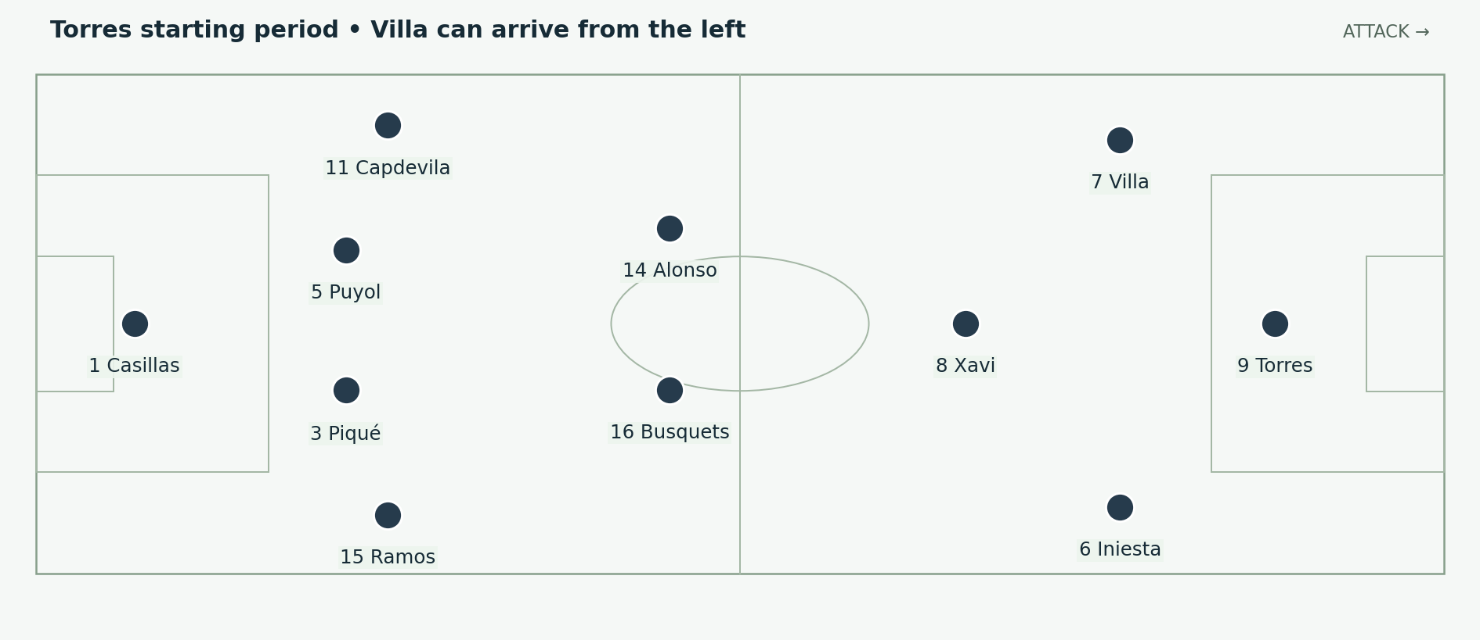
Figure 2. A reference for the Chile and early knockout starting personnel. Torres supplies a central forward; Villa begins left and Iniesta begins right, with freedom to move inside. Positions and arrows are explanatory schematics, not tracking data.

Two forwards can occupy different spaces
Selecting Torres and Villa did not require both to stand next to each other between the centre-backs. Torres could remain the central reference while Villa approached from a wider angle. A defender then had to track the inside run without losing the responsibility to protect the touchline.
This could create a useful diagonal route for Villa, especially if a midfielder had drawn attention inside. The run also had to connect with the passer’s touch. Arriving too early could leave Villa stationary beside a defender; arriving too late could waste the moment when the lane was open.

The group recovery
Spain beat Honduras 2–0 and Chile 2–1 to finish first in the group. The wins restored the route to the knockout phase, but they should not be treated as a return to one fixed attack for the rest of the competition. Del Bosque continued changing the available profiles, including using Llorente against Portugal and Pedro from the semi-final. [S1; S5]

03 Busquets and Alonso provide different support
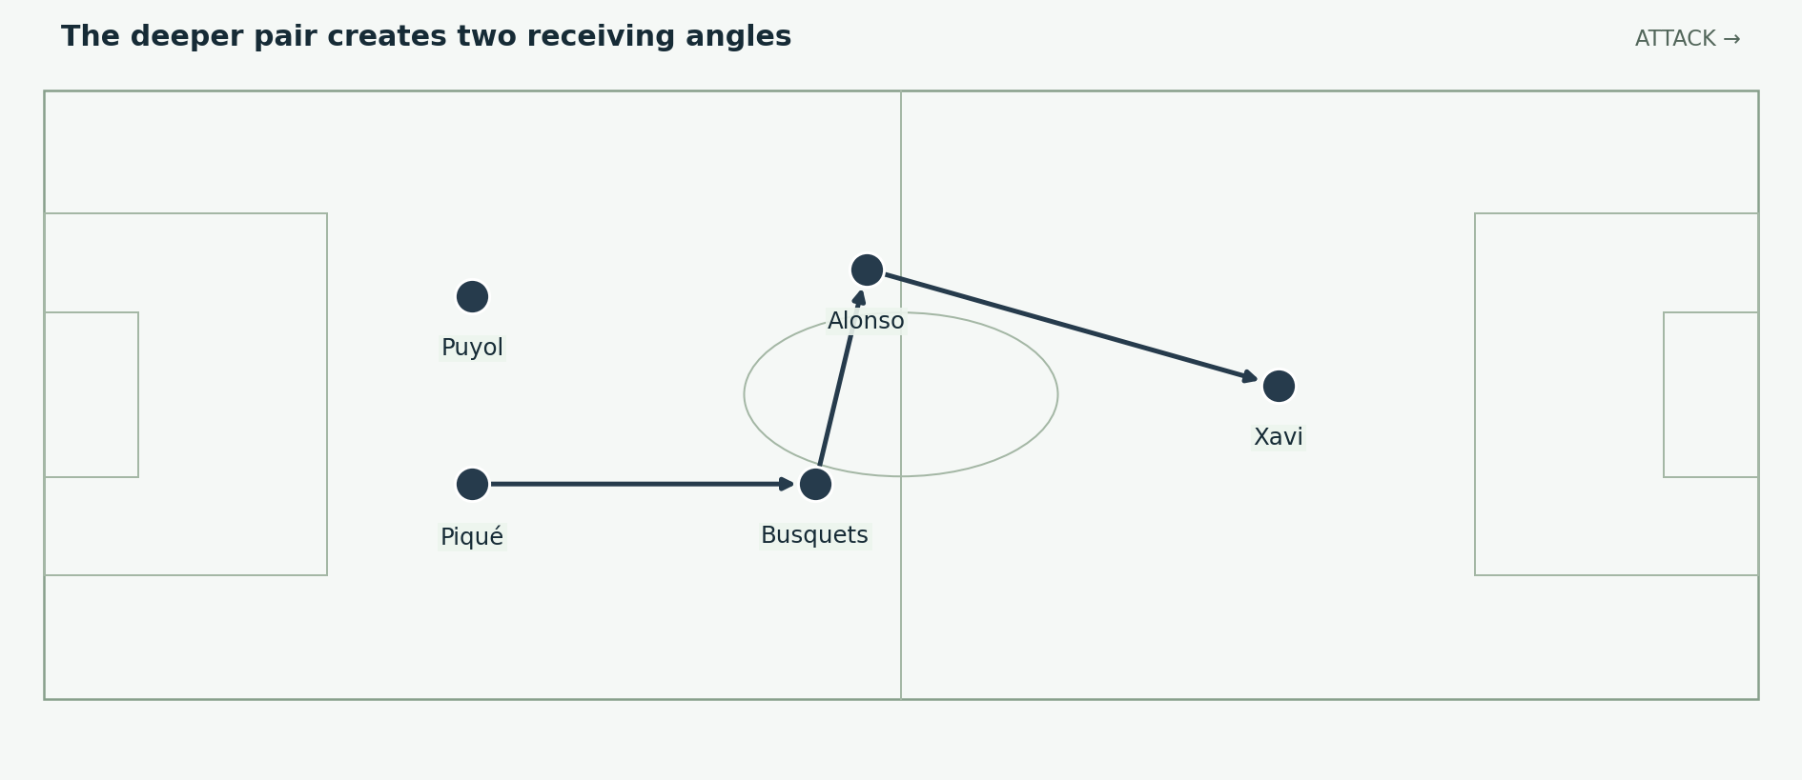
Figure 3. A double-pivot reference. The deeper midfielders can move to different heights and angles rather than remain side by side on every pass. Positions and arrows are explanatory schematics, not tracking data.
Busquets could offer a close central connection, use a short layoff and protect the area in front of the defenders. Alonso offered another deep passing angle and the option to change sides or play farther forward. The combination gave Spain security and distribution, provided they did not receive on the same line behind the same opponent.

A second pivot changes the defenders’ choices
If an opposing forward blocked the pass to one midfielder, the other could move outside that shadow. The centre-back then had an alternative to forcing the marked pass. A small positional adjustment could make the opponent either follow the new receiver or allow Spain to carry forward.
The arrangement also let Xavi begin higher. He did not have to be the only player returning to collect from the back line. Receiving beyond the first pressure could give him a better view of the forward options and reduce the number of opponents between the ball and the penalty area.

The cost and its solution
Two deep midfielders can make an attack secure but short of runners ahead of the ball. Spain needed the wide forwards, Xavi or a full-back to supply that next movement. The double pivot worked as part of a wider division of tasks. Treating it as an automatically defensive selection misses the attacking freedom its support could provide.

04 Triangles turn a short pass into progress
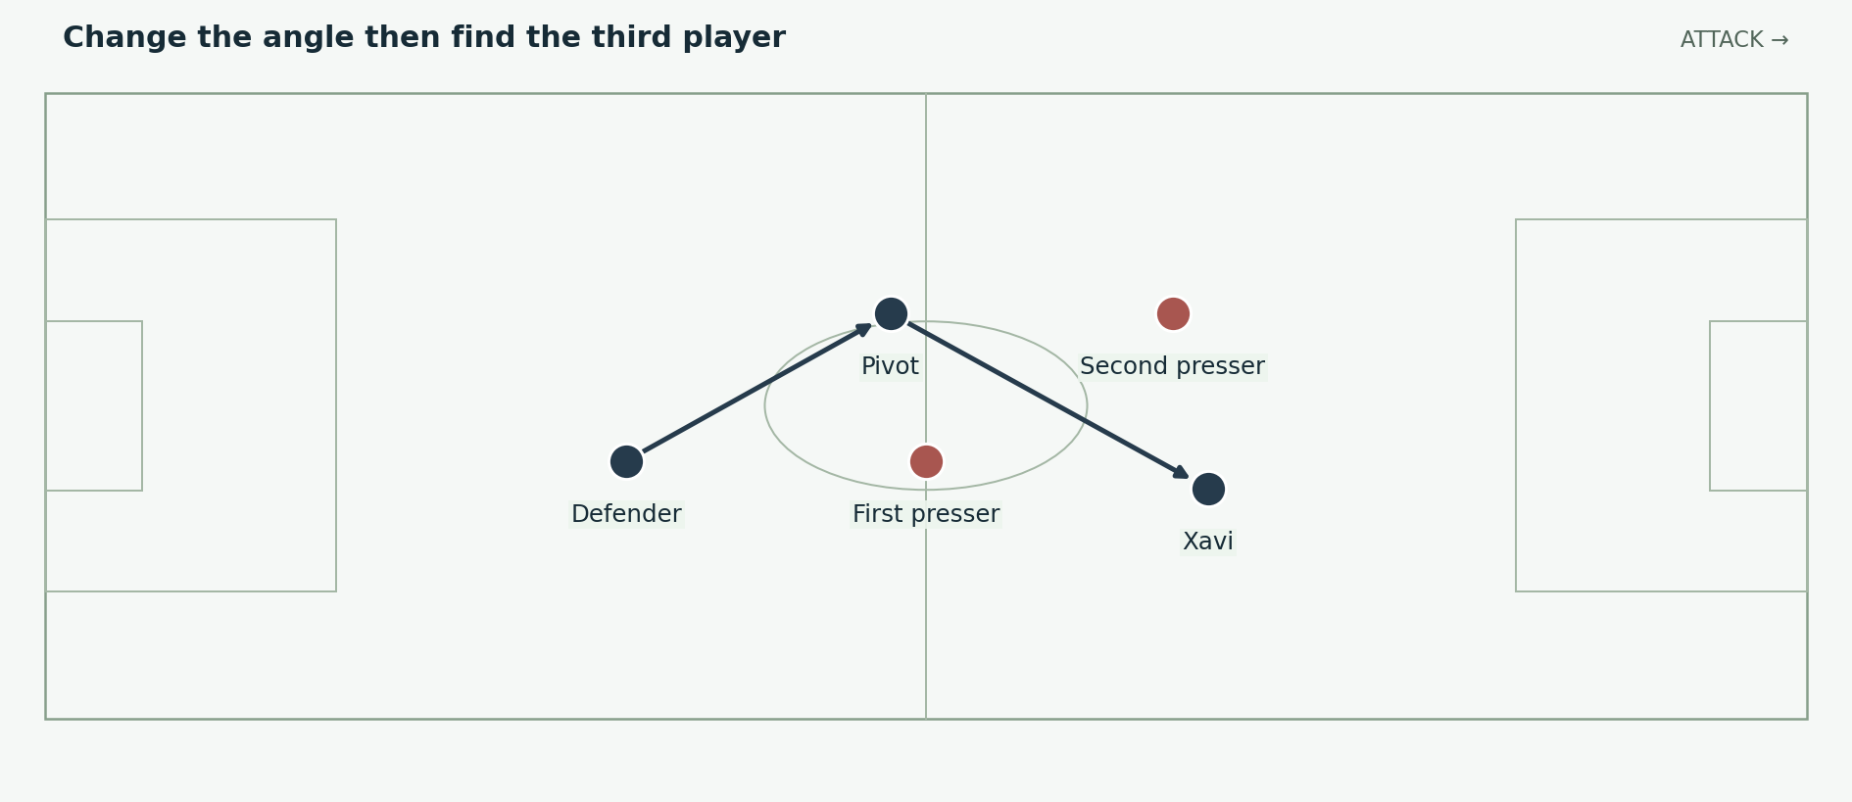
Figure 4. A third-player route: the first receiver redirects the ball toward someone beyond the immediate pressure. The positions illustrate a mechanism, not a specific match event. Positions and arrows are explanatory schematics, not tracking data.
A triangle matters because it gives the receiver more than one exit. If the opponent closes the straight forward pass, the diagonal support may remain visible. That support can release another player quickly, before the press has time to turn and cover the new angle. The shortness of the passes is useful because it enables the coordinated sequence.

Position before technique
One-touch passing is not useful merely because it uses fewer touches. The receiver needs to know where the next player is, and the next player must be placed outside the challenger’s reach. If those positions are wrong, a rushed layoff can deliver the ball directly to the opponent.
Spain’s central players could frequently offer those supporting angles. The carrier could use them to avoid an unnecessary duel, draw the opponent toward the ball and then progress through the space the opponent left. The route becomes more valuable when a forward or full-back has already begun the movement beyond it.

How to draw it clearly
Use only three Spanish players and the nearest two pressers. Show the first challenger closing the original carrier, then the redirecting pass. Add the next receiver last. This makes the reason for the short combination visible. An image containing every player and every possible arrow can obscure the actual relationship being taught.

05 Xavi controls the next decision
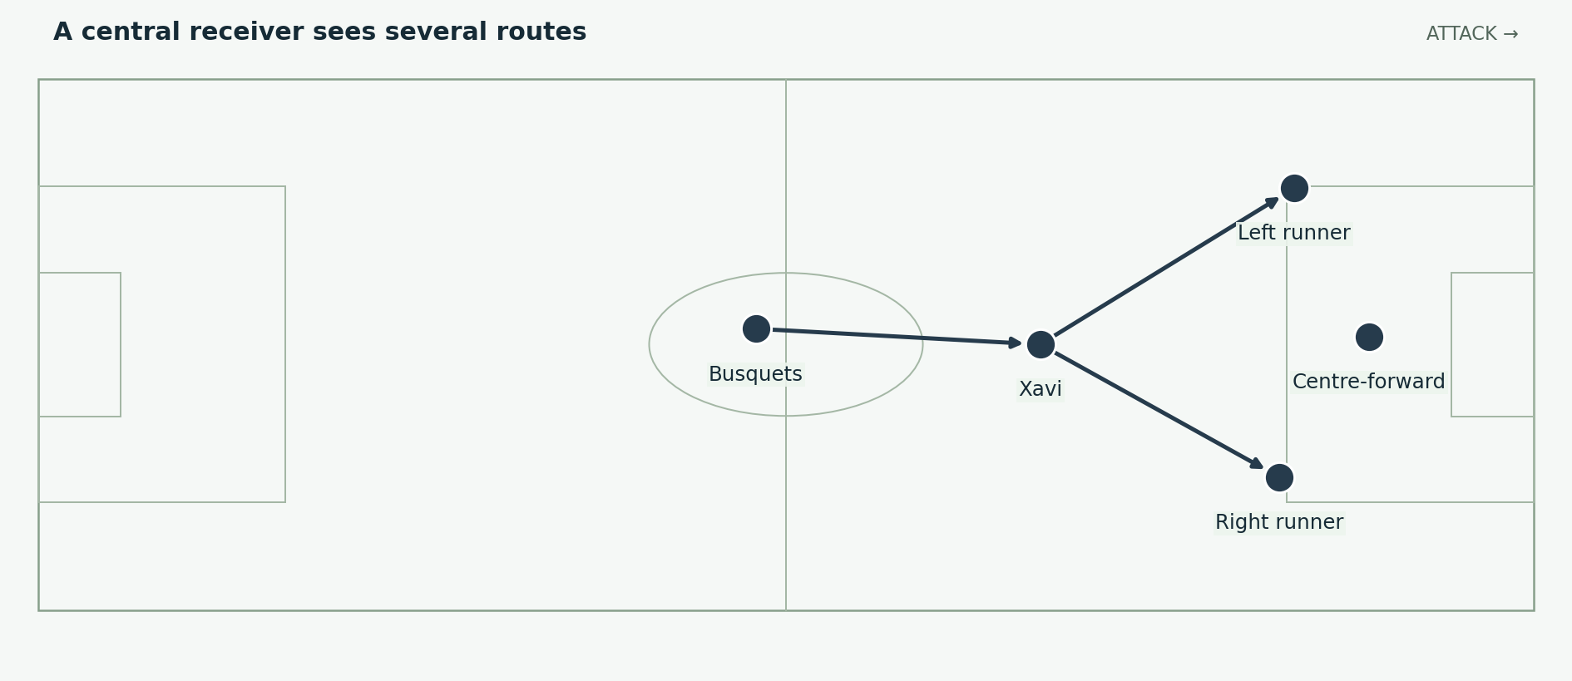
Figure 5. Xavi’s position can connect deep support to more than one forward route. The diagram shows choices rather than simultaneous passes. Positions and arrows are explanatory schematics, not tracking data.
Xavi’s role was to connect circulation to the next useful action. He could support deeper possession, receive between lines or combine near the box. The decision depended on the opponent’s spacing. A forward pass into a closed receiver was not necessarily better than a sideways pass that opened a more useful lane on the next touch.

Scanning changes the speed of the attack
A player who has already located teammates and pressure can choose before the ball reaches him. That makes a controlled first touch or a quick release possible. If he must look around only after receiving, the defence gains time to close the options. The attack’s speed therefore begins with observation and positioning, not simply with running faster.
The supporting players also matter. Xavi can find a runner only if that runner leaves the defender at the right moment. He can switch play effectively only if someone preserves width on the far side. His decision-making connects those movements; it does not replace them.

A concrete tournament anchor
The Portugal winner included Xavi’s flick into Villa’s route. The mechanism is a central connection that turns the receiver toward a finishing opportunity. For a narrated breakdown, pause before the flick and identify Villa’s movement. Showing the pass without the receiving run would explain only half of the combination. [S5]

06 Iniesta can connect or break the line himself
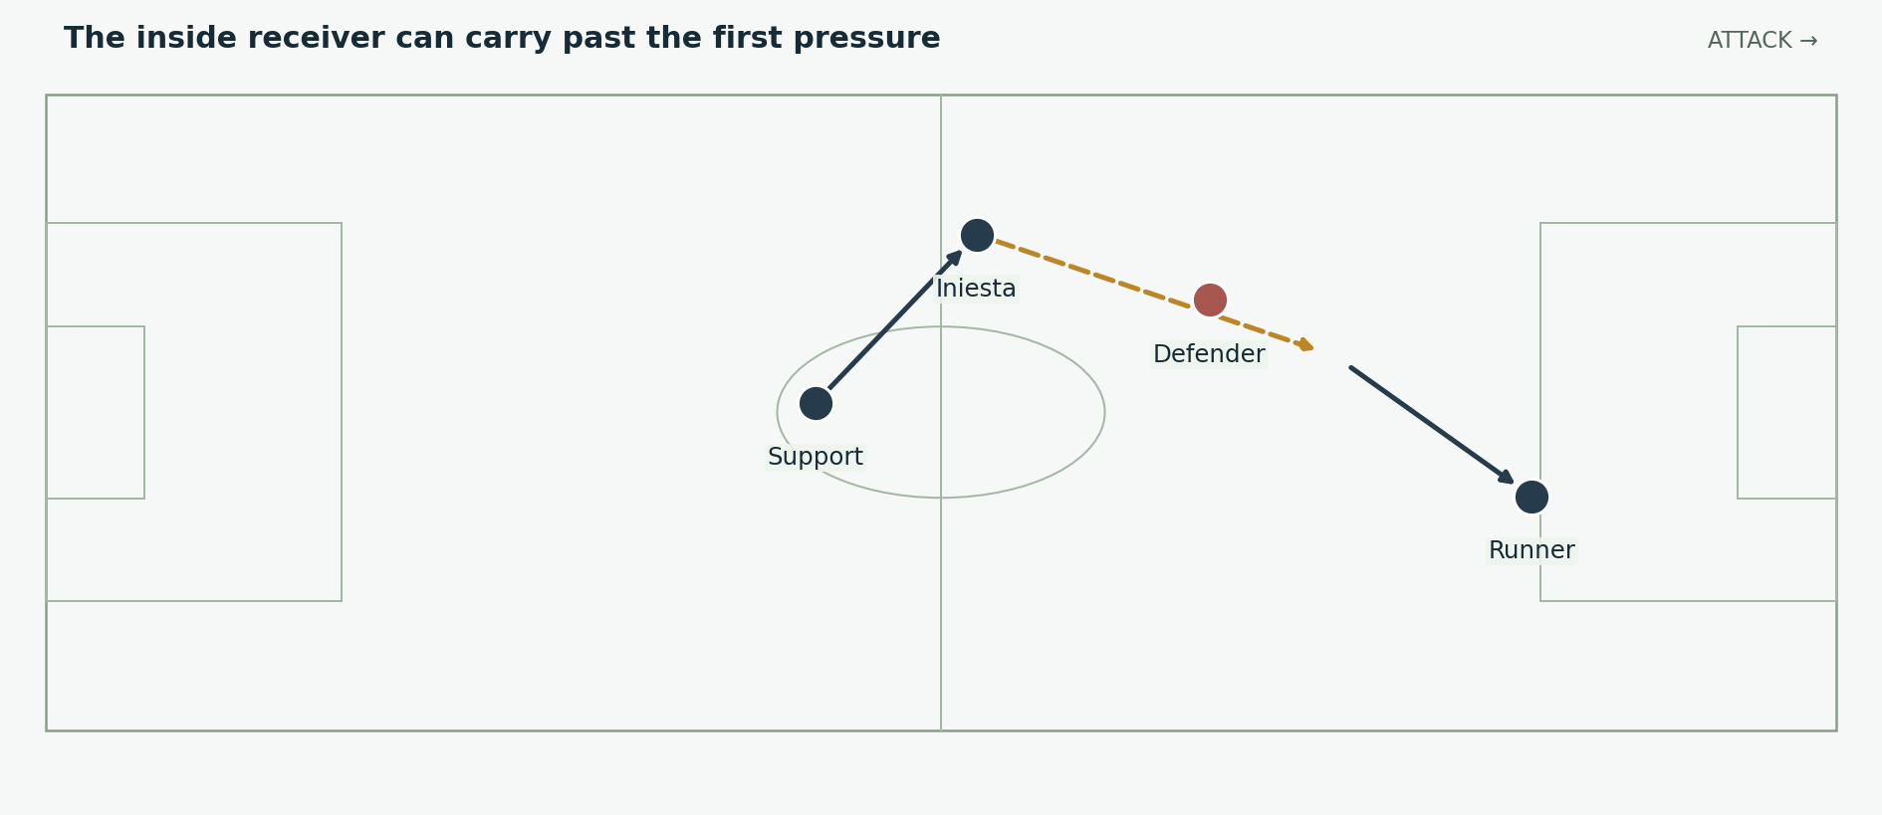
Figure 6. A generalised Iniesta action: receive from an angle, carry inside and release a teammate. A carry and a pass can solve different stages of the same attack. Positions and arrows are explanatory schematics, not tracking data.
Iniesta offered something different from pure circulation. He could receive with an opponent close, change direction and carry the ball across a defensive line. That forced a second defender to choose whether to step toward him, and the choice could free the teammate who received the subsequent pass.

Why carrying can complement passing
A block may remain compact if the ball travels only in front of it. A controlled carry can make one defender leave that line, changing the geometry of the next pass. The key is to carry far enough to provoke a response while keeping the ability to release before the next challenger arrives.
The receiver must also have support behind him. If Iniesta’s forward path closes, a teammate offering a safe pass prevents every ambitious carry from ending in a turnover. Spain’s close passing relationships allowed an individual action to sit inside a collective structure.

Starting wide is not a permanent restriction
Iniesta’s wide starting role often let him approach the central space from an angle. Remaining on the touchline at all times would have wasted that possibility. A full-back or another forward could supply the width when he moved inside. The team needed to exchange those tasks clearly rather than asking one player to be both the permanent winger and the central creator.

07 Villa supplies the finishing edge
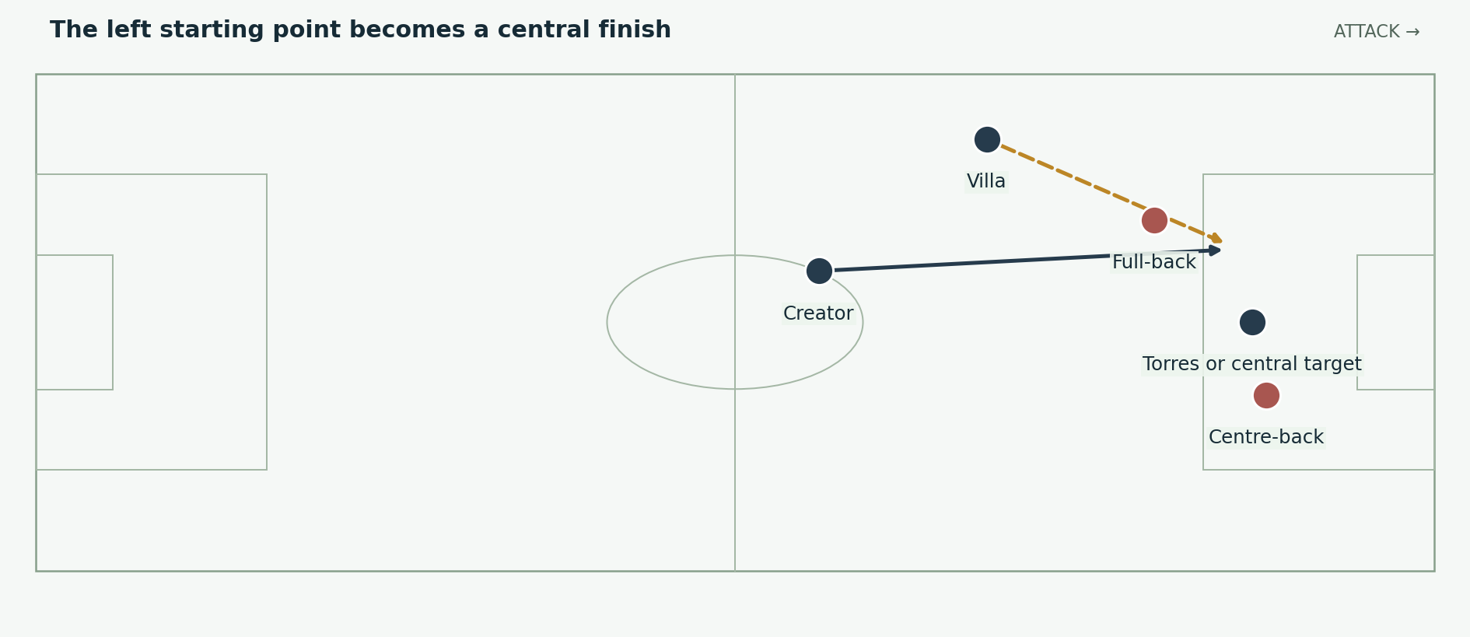
Figure 7. Villa can attack diagonally from the left while a central forward occupies defenders. His starting width and finishing position are different tasks. Positions and arrows are explanatory schematics, not tracking data.
Villa scored five of Spain’s eight goals: two against Honduras and one each against Chile, Portugal and Paraguay. Iniesta scored two and Puyol one. The scoring distribution shows how much Spain depended on Villa’s edge before the last two rounds. [S1]

A forward receives facing the opportunity
A diagonal run can make the defender turn while the attacker continues toward goal. It may also let the passer deliver into the runner’s stride rather than toward a stationary target’s feet. The advantage depends on the runner staying available long enough for the passing lane to appear.
Villa could contribute from a central or wider starting position. Those are different routes to the same responsibility: reaching a useful finishing space. A team with several passing specialists still needs someone prepared to attack that space repeatedly, including after a save or a shot against the post.

The rebound is part of finishing
Against Portugal, Villa scored at the second attempt. Against Paraguay, he finished the rebound from an initial effort against the post. A finisher must remain involved after the first action and adjust to a ball whose direction has changed. The goal can depend on his anticipation outside the first shooter’s path. [S5; S6; S7]
For a video, compare his starting location with his location when the final shot is taken. The distance and direction between the two points explain the role more clearly than a generic label such as left winger.

08 Ramos and Capdevila keep outside routes available
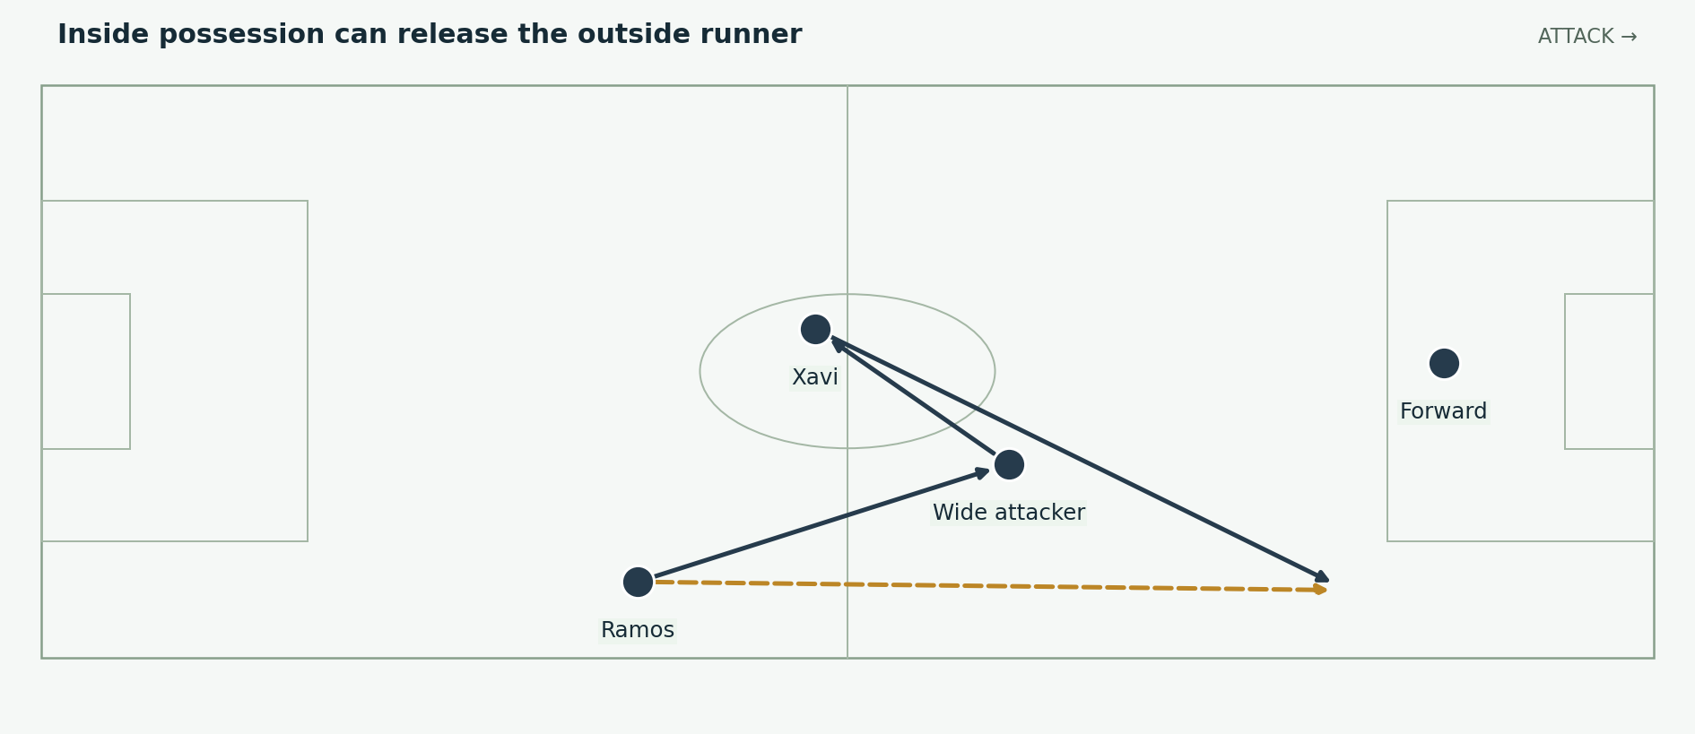
Figure 8. A right-side overlap pattern. Ramos’s movement can preserve width when the attacking receiver comes inside. It is an explanatory possibility, not an exact goal reconstruction. Positions and arrows are explanatory schematics, not tracking data.
The full-backs gave Spain an option outside the central passing network. Ramos could advance, combine and deliver from the right. Capdevila could support the left while maintaining a connection to the defence. The two players did not need to make identical runs for the team to be balanced.

The outside run creates a choice
If the opposing full-back follows the inside attacker, he may concede the lane for the overlap. If he remains wide, the inside receiver may find a pocket. An opposing midfielder can assist, but that movement can then open a lane for Xavi or another central player. The useful pattern links those choices.
An overlap without the right timing can be wasteful. If the run begins before the passer can look up, the defender may simply follow and settle. If it begins after the receiver has already been surrounded, the ball may never reach it. Supporting movement must agree with the carrier’s situation.

Delivery is not the only reward
The runner may draw a defender and leave space for a shot or an inside pass. Spain could therefore use width to improve central actions as well as to produce crosses. The final included early Ramos attacking involvement and later headed chances, showing the full-back’s varied threat. [S8]

09 Possession has a defensive structure behind it
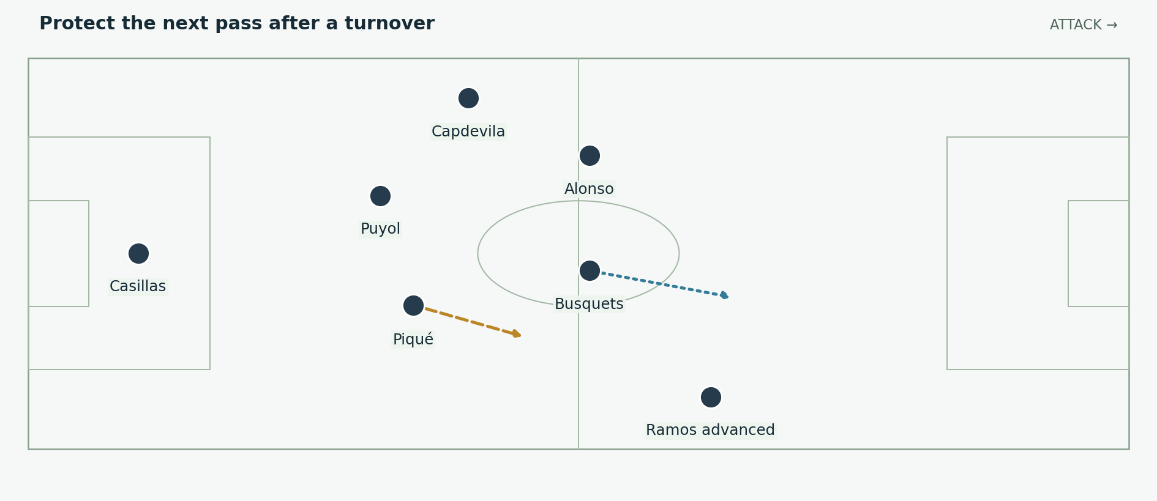
Figure 9. The players behind an attack prepare for a loss of possession. Their distances matter even while the opponent has no ball. Positions and arrows are explanatory schematics, not tracking data.
Spain’s possession could reduce the opponent’s time to attack. But the team also needed a plan for the moment possession ended. Busquets and Alonso could occupy central recovery spaces, the centre-backs could protect depth, and the far-side defender could remain connected rather than advance blindly.

Pressure and depth must agree
A high back line works better when the opposing passer cannot comfortably look up. If the initial challenge is missed, the defenders must recognise the new risk. Holding high while the passer has time can let one accurate ball turn control into a race toward Casillas.
Nearby players may try to recover possession immediately. That attempt is strongest when they close both the carrier and his next outlets. If they chase the same ball separately, a simple pass can escape them and remove several players from the next defensive phase.

The goalkeeper remains essential
Possession does not remove the need for saves. Paraguay’s penalty and Robben’s final opportunities required Casillas to resolve situations the outfield structure had not prevented. Spain’s five clean sheets are an outcome of the whole unit, including those interventions. [S6; S8]
A useful teaching image shows the positions behind the ball before the loss. Then add the opponent’s first forward route. The viewer can see why an apparently quiet supporting position becomes important as soon as the attack breaks down.

10 Portugal and Llorente change the problem
Portugal made the last-16 match difficult and generated threats from wide areas. Del Bosque replaced Torres with Llorente, whose immediate headed chance tested Eduardo. Villa then scored after Xavi’s flick, finishing at the second attempt. Spain won 1–0. [S5]
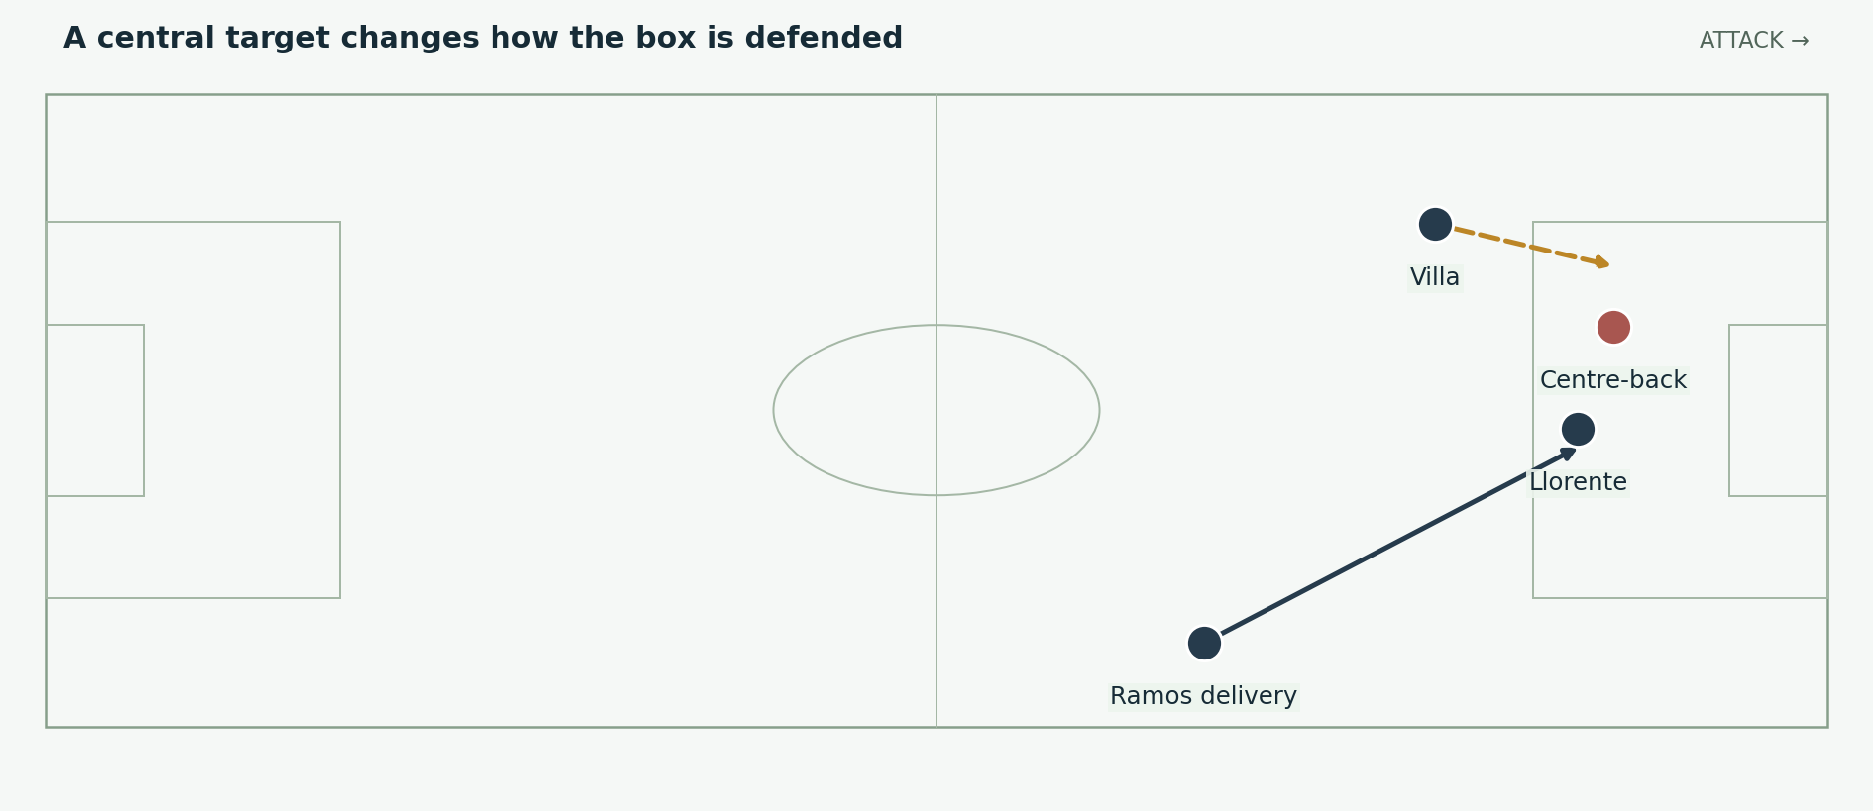
Figure 10. Llorente adds an aerial and central reference while Villa remains a neighbouring threat. The image illustrates the changed attacking profile. Positions and arrows are explanatory schematics, not tracking data.

A substitute can change the defender’s priorities
A defender dealing with a stronger aerial target may have to stay closer to that striker and protect the delivery. This can alter the space around him for another forward. The benefit is not limited to the substitute scoring: occupying or drawing a defender can improve the next teammate’s opportunity.
This does not mean the substitution alone caused the goal. The finishing move still needed the central combination, Villa’s timing and his reaction after the first save. The clearer conclusion is that Spain could add a different attacking reference when the initial arrangement was not producing enough penetration.

What this says about the team’s identity
Spain did not abandon its passing game by selecting a target striker. It added a way to make wide service and penalty-area occupation more threatening. A coherent style can contain several finishing routes. That flexibility is part of the complete-team argument and helps distinguish the real campaign from an idealised account of short passes alone.

11 Paraguay tests patience and goalkeeper judgement
Casillas saved Cardozo’s penalty. Soon afterwards Alonso converted a penalty that had to be retaken, then Villar saved the second attempt. Spain eventually won through Villa after an effort against the post. The quarter-final demonstrates how individual execution and unstable episodes can decide a match that a tactics board portrays as controlled. [S6]
Recorded event | Tactical or practical lesson
Paraguay wins a penalty | A strong defensive record still includes moments requiring the goalkeeper to repair a dangerous situation.
Spain’s retaken penalty is saved | An attacking opportunity must be executed correctly; possession cannot guarantee the next action.
A late attacking move produces a rebound | Supporting players must stay involved after the initial shot.
The result remains a narrow 1–0 | Control should be explained through the match’s actual threats, not assumed from the winner’s identity.

A difficult opponent can close the easy routes
When forward receivers are hurried or marked closely, the deeper carrier may have time but no clean route into the next line. The team needs changed angles, a receiver who can turn or a run beyond the pressure. Passing repeatedly between safe defenders may retain possession without improving the attack.

Changing the available movement
Fàbregas came on for Torres, and Pedro later replaced Alonso. Those changes supplied different movements around and beyond midfield. They also required the remaining players to redistribute defensive support. The match record is the basis for the personnel change; the significance lies in how the next receivers and runners can challenge a compact opponent. [S7]
A disciplined explanation preserves both parts of this match: the attacking adjustment and the goalkeeper’s decisive contribution. Removing the penalty episodes would make the story easier, but less accurate.

12 Pedro starts against Germany
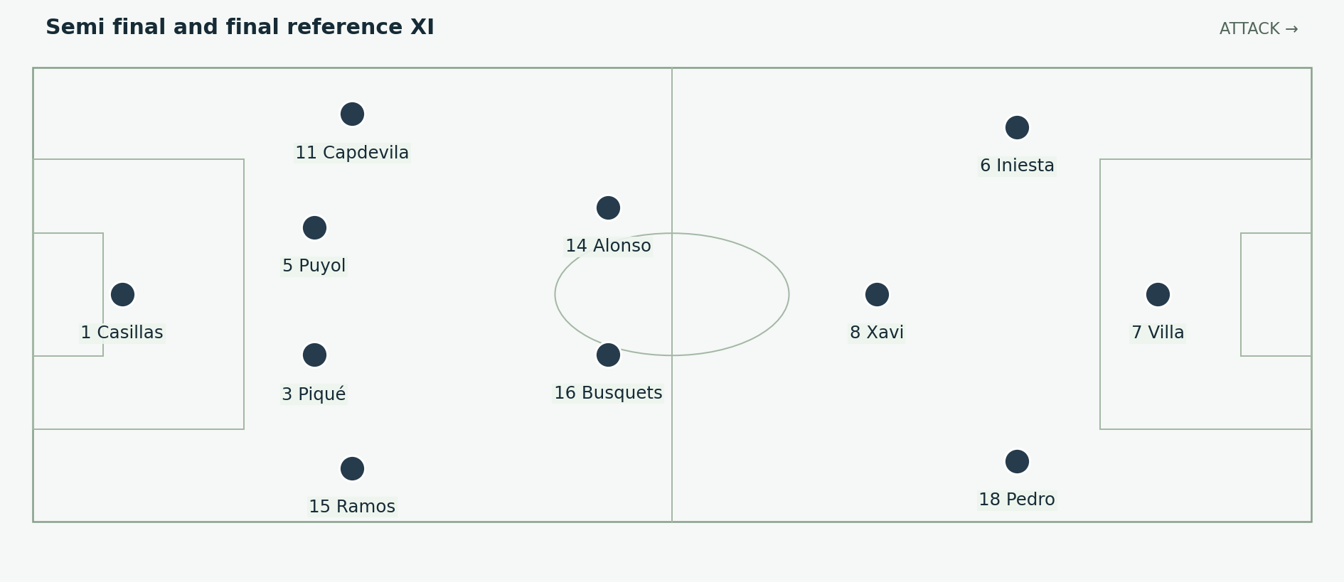
Figure 11. Pedro replaces Torres as a starter. Villa leads the line, Iniesta begins from the left and Pedro provides a right-sided reference; Xavi remains ahead of the deeper pair. Positions and arrows are explanatory schematics, not tracking data.
Against Germany, del Bosque started Pedro in place of Torres and used Villa centrally. The DFB match record confirms the XI, and UEFA’s contemporary report describes Pedro’s early combination with Villa. Spain won 1–0 through Puyol’s header. [S4; S9]

Why an outside forward can improve central play
An attacker who threatens beyond the full-back can make the defence protect width and depth. That may create more room for a central midfielder to receive. The forward also gives the carrier an option that is different from another player approaching the ball’s feet.
Villa as the central reference could then focus on finding a finishing route between or around the centre-backs. Iniesta retained the option to connect from the left. The shape gave Spain a combination of central passing and forward movement, rather than simply replacing one famous striker with a less famous winger.

The opponent’s conditions matter
Germany had scored heavily in the previous rounds but still had to find opportunities against Spain’s possession and compact support. Spain nevertheless needed Casillas to save a Kroos effort before the winner. The account should therefore distinguish territorial control from an absence of German danger. [S9]
The figure is best used before the match sequence. Explain which player now threatens the right side and which now leads the line. Then show how Germany’s defenders and midfielders respond. That connects selection to behaviour rather than treating the lineup as a list of names.

13 A corner decides the semi final
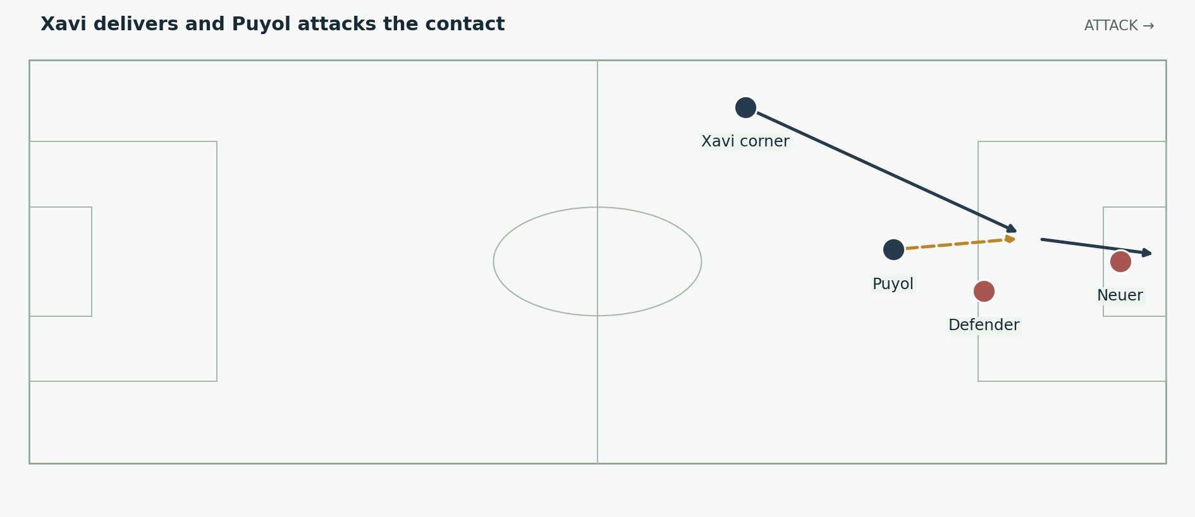
Figure 12. The 73rd-minute winner in simplified form. Puyol meets Xavi’s corner with an attacking header. Exact flight and starting positions are illustrative. Positions and arrows are explanatory schematics, not tracking data.
Puyol scored from Xavi’s corner in the 73rd minute. Spain’s decisive action therefore came from a set piece rather than the open-play passing pattern most commonly associated with the team. The delivery and the attacking run made that different route possible. [S4; S9]

The run changes the aerial contest
A runner arriving at speed may challenge a defender whose attention is divided between the ball and other attackers. The timing of the run determines whether he meets the delivery while moving toward goal or reaches the area too early and waits. The passer must put the ball where that momentum can become a controlled contact.
A corner also temporarily changes the responsibilities of a centre-back. Puyol’s normal defensive reference becomes an attacking target, while players outside the box must prepare for the clearance and the counterattack. The set-piece structure has its own balance; it cannot be described solely through the regular formation.

Why this belongs in the complete team story
Possession helped Spain maintain pressure and create attacking episodes. A specialist delivery and a defender’s finishing action supplied the goal. These mechanisms supported each other. Calling the winner an exception to Spain’s football would hide how a complete team can use several methods to solve the same match.

14 The final and the limits of possession control
Spain kept the semi-final starters against the Netherlands. The match was physical and fragmented, and both teams had chances. Robben’s running and Sneijder’s passing created major threats, while Spain needed extra time to score. The starting XI confirms Pedro, not Torres, at kick-off. [S8; S10]
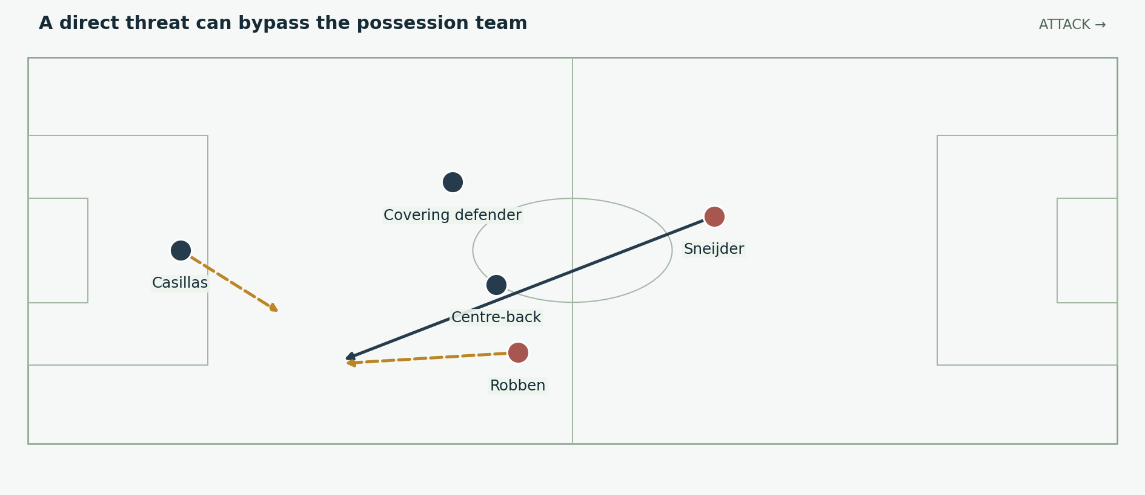
Figure 13. A Dutch forward route inspired by the final. The opponent attacks left; Spain’s own attacking direction remains right. One pass can test the space behind the line. Positions and arrows are explanatory schematics, not tracking data.

A receiver does not need a long possession spell
A well-timed run and an accurate release can threaten even when the opponent has spent much of the match without the ball. The defensive line must read pressure on the passer and the runner’s starting position. A brief lapse can produce a clearer chance than a longer, less penetrative attack.
Casillas denied Robben in a major one-on-one. His decision about when to advance and how to stay ready for the shot became as important as the passing network ahead of him. The final’s clean sheet therefore belongs to goalkeeper execution as well as outfield control. [S8]

Explain the contest fairly
Spain also had opportunities, including Ramos headed chances. The match was not a simple story of relentless possession followed by an inevitable winner. It was a difficult contest in which both sides threatened, and Spain’s changed attack ultimately found the decisive action. [S8]

15 The substitutes alter width and midfield depth
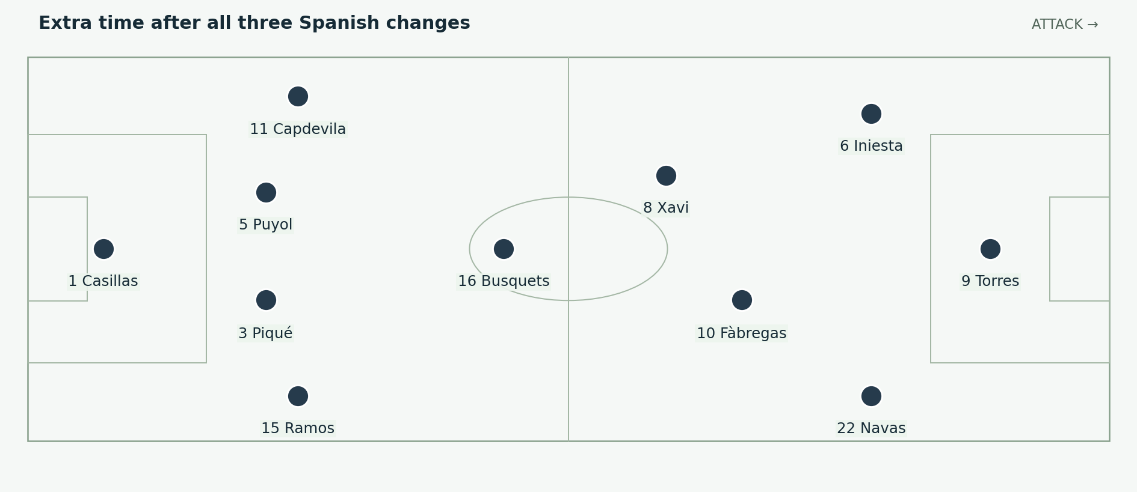
Figure 14. A functional 4–3–3 reference after Navas, Fàbregas and Torres enter. Busquets is the deepest midfield reference; the advanced roles remain fluid. Positions and arrows are explanatory schematics, not tracking data.
Change | New possibility
Navas for Pedro • 60 minutes | More direct touchline running and one-against-one width.
Fàbregas for Alonso • 87 minutes | A midfielder who can arrive farther forward and connect near the box.
Torres for Villa • start of the second extra-time period | A fresh central forward who can attack depth and join the final move.
The DFB final record supplies the substitutions and timings. The role descriptions interpret the changed options. [S10]

The midfield becomes a different triangle
Replacing Alonso with Fàbregas changes more than a name. Busquets becomes a clearer deepest reference while Xavi and Fàbregas can work higher in different moments. The remaining players must then protect the central space if those two join an attack. A forward-minded substitute redistributes defensive work as well as adding a receiving option.

Width helps the central receivers
Navas could force the opponent to defend the outside route. That can make the next central pass easier by drawing a challenger away. The final assist came from Fàbregas, but the supporting structure and the evolving positions around him form part of the action. The goal should be connected to the changes without claiming each substitute had one predetermined task on every possession.

16 Fàbregas finds Iniesta for the winning goal
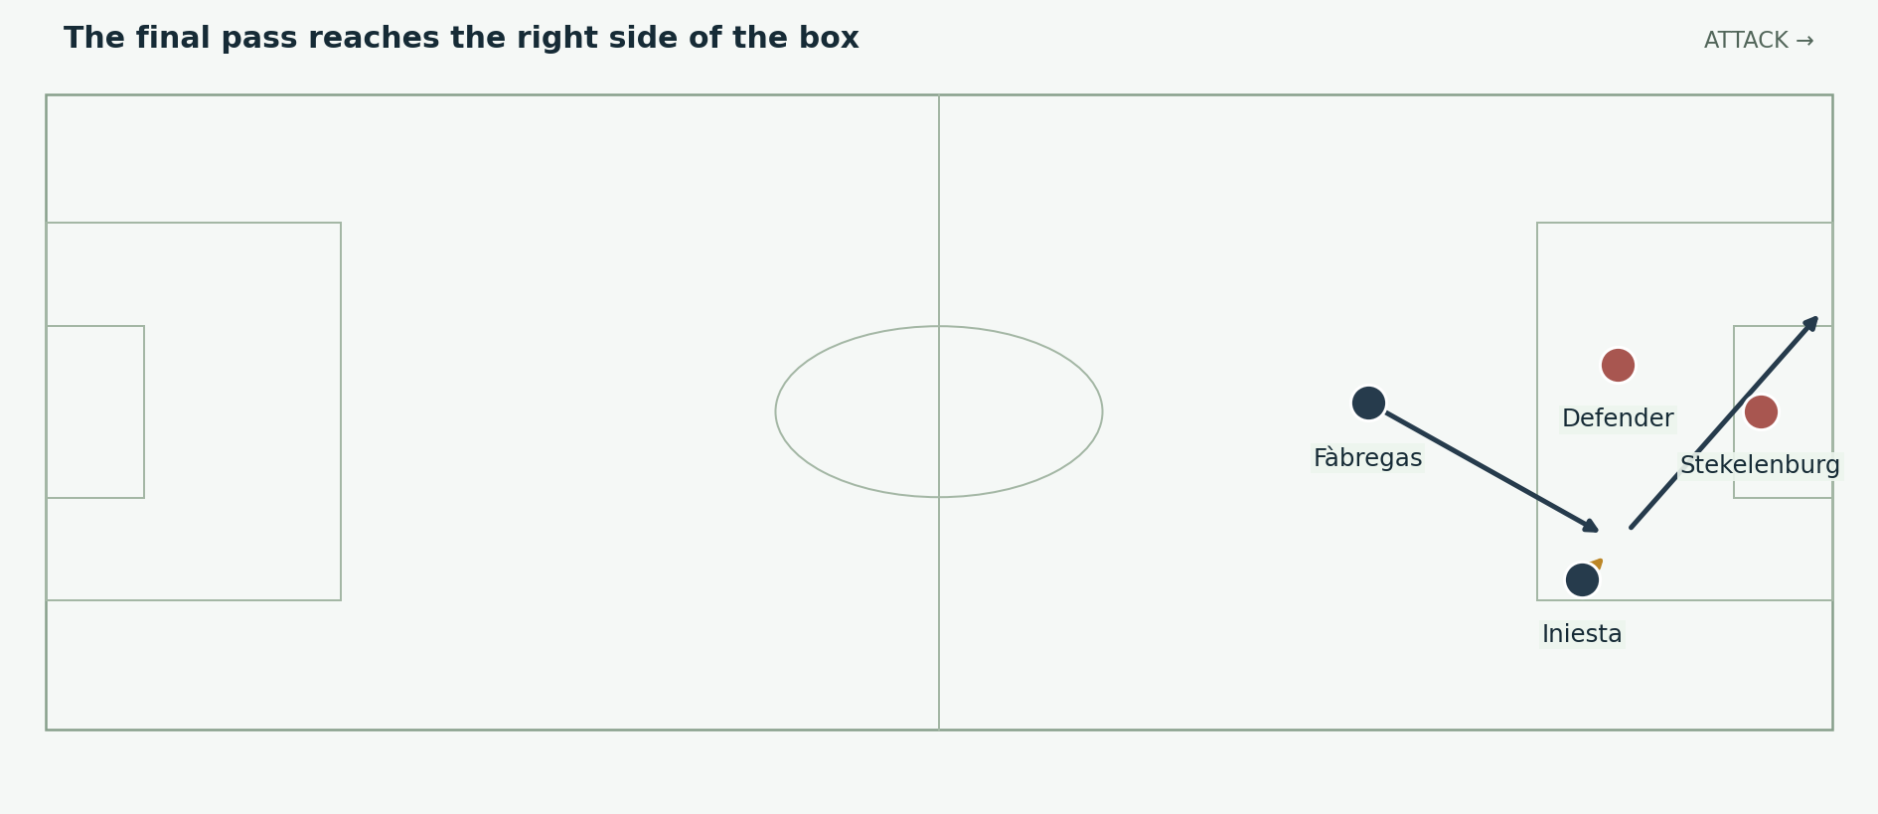
Figure 15. The 116th-minute winner: Fàbregas finds Iniesta, who finishes across the goalkeeper. The image isolates the final connection rather than claiming to reproduce the entire build-up. Positions and arrows are explanatory schematics, not tracking data.
Iniesta scored in the 116th minute after Fàbregas found him on the right side of the area. Heitinga had been dismissed earlier in extra time, leaving the Netherlands with ten men. The numerical situation belongs in the context of the winning move. [S8; S10; S11]

A central creator can be the receiver beyond him
Iniesta had spent much of the campaign connecting from a wider starting position. In the winning episode he became the advanced receiver and finisher. This is an important exchange of roles: a creative midfielder does not always have to make the final pass; he can also be the player who attacks the space it reaches.
Fàbregas needed to identify the receiving lane before the defence closed it. Iniesta needed to be available on the useful side of the defender and prepare his next action. The finish followed the pass quickly enough to make the goalkeeper respond to a shot rather than wait for a second defensive recovery.

Keep the build up and final action distinct
For a video, show the complete attacking episode at normal speed, then use this sparse diagram to isolate the last pass. Mark Iniesta’s receiving space and the direction of the finish. A diagram crowded with every preceding touch would weaken the explanation of why the final connection mattered.
The goal represents both technical precision and adaptation. A substitute supplied the assist, and a player whose usual role involved creation delivered the finish. Spain’s identity remained recognisable while the working attack changed.

17 What the eight goals tell us and what they do not
Measure or event | Useful interpretation | Limit
Eight tournament goals | Finishing efficiency mattered in narrow matches. | It does not show the quality of every chance created.
Five goals by Villa | A major share of early attacking success depended on one finisher. | The other players’ movement and service remain part of those goals.
Four 1–0 knockout wins | The team repeatedly protected a small advantage or found one decisive goal. | The opponents still created dangerous situations.
Five clean sheets | The unit conceded few goals. | A clean sheet includes saves and missed opposing chances.
An opening defeat | The preferred approach encountered a serious problem. | One result alone does not establish that the whole approach was ineffective.

The complete team argument
Spain combined technical receivers, a protective midfield, capable defenders, a decisive goalkeeper and forwards who offered different movements. The strongest explanation shows the relation between them: possession requires useful receivers; forward freedom requires cover; narrow victories require both a goal and the protection of the other end.

The pressure points
The attack could become crowded if too many players approached the ball and too few threatened behind. A turnover could expose the line if the passer had time. The campaign also placed substantial scoring responsibility on Villa. These are practical limitations, not a reason to dismiss the title or describe every win as luck.
The term “perfect team” is useful when it points toward complementary tasks and reliable adaptation. It becomes misleading if it suggests Spain won every game comfortably or relied only on short passes. The actual tournament includes an opening loss, a target-striker substitution, a headed set piece and goalkeeper interventions.

18 Narration and comparison with the other champions
Team | Characteristic balance | A sequence that explains it
Italy 2006 | Deep creativity, defensive cover and full-back attacks | Pirlo finding Grosso after a recycled corner.
Spain 2010 | Possession connections, protected midfield and precise finishing | Fàbregas finding Iniesta after the final’s attacking changes.
Germany 2014 | Varied progression, complementary runners and adaptable personnel | Schürrle crossing for substitute Götze in the final.
The comparison concerns mechanisms, not a ranking across different tournaments. Each team’s decisive action joined players with different roles. The Italy and Germany examples are match anchors for comparison; the detailed analysis in this document focuses on Spain. [S12; S13]

Suggested opening narration
“Spain scored only eight goals at the 2010 World Cup, yet won the last four matches without conceding. The explanation is not simply that they passed better than everyone else. Their midfield made the next pass available and protected the defenders behind it. Villa gave the attack its finishing edge, while Puyol, Iniesta and Casillas supplied decisive actions when the margin was smallest.”

Suggested sequence for a ten minute video
Begin with the final XI and the opening defeat. Explain the double pivot, Xavi’s receiving options and Iniesta’s ability to carry inside. Show Villa’s diagonal threat and the full-back lanes. Use Llorente against Portugal to establish attacking variety. Follow with the Paraguay penalties, Pedro’s semi-final start and Puyol’s corner goal. Finish with Robben’s chances, Spain’s substitutions and the Fàbregas–Iniesta connection.

Suggested closing narration
“The champions had a clear identity, but they could change the way a chance was created. The same team could use a short combination, an outside delivery, an aerial target or a midfielder arriving to finish. Their control mattered because it was connected to protection and to the players who could decide the final action.”

19 Sources and evidence notes
Recorded results, lineups and selected match events are supported by the linked sources below. Tactical explanations of space, roles and decisions are analytical interpretations. All figures are original teaching schematics, not measured tracking coordinates. Accessed 3 October 2026.
[S1] FIFA • 2010 technical report • Spain team profile and match records
[S2] FIFA • Spain Switzerland • opening lineup and match account
[S3] UEFA • Spain stunned by Switzerland • 16 June 2010
[S4] DFB Data Center • Germany Spain • semi-final starters and events
[S5] UEFA • Villa strike seals victory for Spain • 29 June 2010
[S6] RFEF • Nine years since the Paraguay quarter-final • penalty sequence
[S7] FIFA • 2010 technical report • Paraguay Spain match record
[S8] UEFA • Iniesta earns Spain World Cup crown • 11 July 2010
[S9] UEFA • Puyol puts Spain through to final • 7 July 2010
[S10] DFB Data Center • Netherlands Spain • final starters and substitutions
[S11] FIFA • Andrés Iniesta in the 2010 final • winning action
[S12] UEFA • Azzurri break German hearts • Italy comparison sequence
[S13] UEFA • Götze goal wins Germany the World Cup • Germany comparison
Event times use standard match-minute labels where available. A formation is a reference arrangement; possession, recovery runs and substitutions change the working shape. Shoot-out goals are excluded from tournament scoring totals.

