Why Spain Collapsed at the 2014 World Cup
Detailed English research document with starting formations, phase diagrams, match chronology and narration guidance

The central argument
Spain did not lose their technical ability overnight. In Brazil, their passing structure, attacking movements and defensive protection stopped reinforcing one another consistently. The Netherlands exploited the space behind them; Chile disrupted their connections and punished decisive openings. Individual errors and the changing scoreline then magnified those problems.
This document expands the earlier article into a practical resource for a football video, article or presentation. It explains who occupied each role, what the opponent tried to change, how the main goals developed, and which conclusions the evidence can support. The analysis focuses on the two defeats that ended Spain’s title defence.
Date in Brazil | Fixture | Consequence
13 June 2014 | Spain 1–5 Netherlands | Opening defeat; Spain still had two matches to recover.
18 June 2014 | Spain 0–2 Chile | Eliminated after two matches.
23 June 2014 | Australia 0–3 Spain | Third place in Group B; three points, four scored, seven conceded.

Match results and final group position: [S1].

How to read the evidence
Record means a documented result, player selection or match event. Analysis explains the tactical significance of that record. A proposed alternative is explicitly hypothetical. Source codes refer to the linked bibliography at the end.
All pitch graphics are original teaching diagrams. They show reference positions or selected relationships, not measured player coordinates or frame-by-frame video reconstructions. Left and right refer to the team’s attacking direction. Formation labels describe a useful starting reference; players changed position during play.

Reading route
Sections 1–4 establish Spain’s model and the opening matchup. Sections 5–9 examine the Netherlands game. Sections 10–14 explain the Chile game. Sections 15–17 cover Costa, the wider causes, the Australia comparison and possible alternatives. The final section provides a production outline and source notes.

1 What Spain were trying to preserve
Spain’s three-title sequence—Euro 2008, the 2010 World Cup and Euro 2012—was built around the ability to decide where and how a match unfolded. A useful explanation must begin with the whole mechanism, rather than treating short passing as a tactic that worked by itself. [S10]
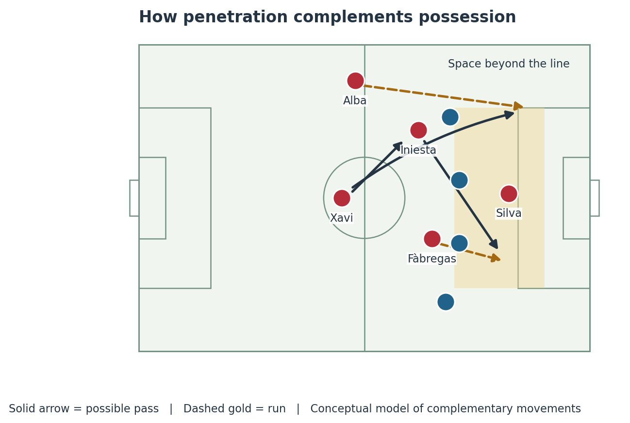
Figure 1. Complementary movements: a player connects between lines while another attacks beyond them. The paths illustrate the principle, not a single reconstructed goal.

Passing needed movement in different directions
A receiver coming toward the ball can draw a defender forward. A teammate running away from the ball can then attack the space that defender leaves. If everyone comes short, the defence can compress the same area. If everyone runs away, the passer loses the short connections needed to progress safely.

The 2012 final gives a concrete reference
Spain started that final with Fàbregas in the central attacking role. Their first goal combined Iniesta’s pass, Fàbregas’s run in the inside-right channel and Silva’s arrival. Alba’s goal followed a forward run linked with Xavi. These examples show that a team without a conventional starting striker could still attack depth. [S10]
The lesson for 2014 is about timing: keep the ball long enough to move the opponent, then recognise when to accelerate. Earlier Spain sides were not permanently slow, and their attackers were not required to remain in their nominal positions.

2 Spain against the Netherlands
13 June, Arena Fonte Nova, Salvador. Vicente del Bosque’s starting eleven can be drawn as a 4–2–3–1, with Xavi ahead of Busquets and Alonso. Some descriptions use 4–3–3 because the midfield and attacking lines overlapped. The personnel are documented; the diagram is a role-based reference. [S2]
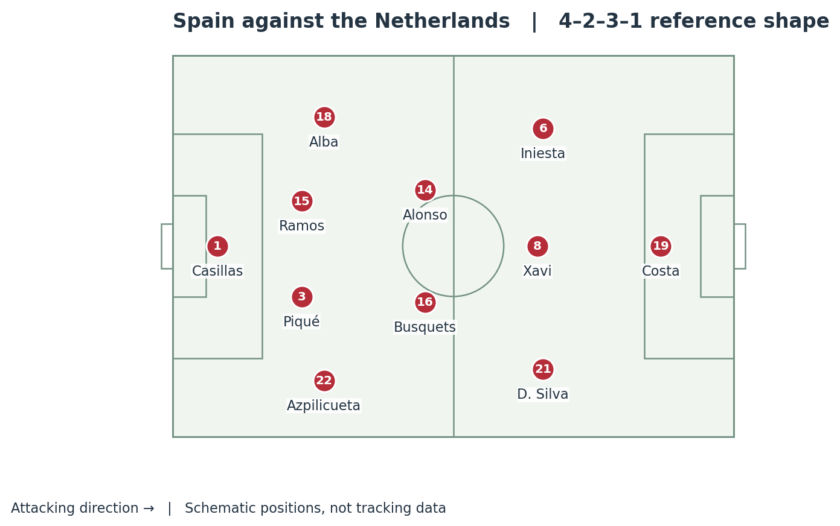
Figure 2. Spain’s opening-game starters. Iniesta and Silva could move inward; Xavi could drop to connect the build-up.
Unit | Players | Tactical responsibility
Back line | Alba, Ramos, Piqué, Azpilicueta | Progress the ball, support width and control space behind the attack.
Double pivot | Alonso and Busquets | Offer passing angles and protect the central route after a turnover.
Creative line | Iniesta, Xavi, Silva | Receive between lines, combine and release a runner.
Centre-forward | Diego Costa | Occupy centre-backs and threaten the channels or space beyond them.

The potential strength was a dense network of technically secure receivers. The potential weakness was congestion: when the creators moved toward the same central zones, someone still had to stretch the defence and someone had to secure the space behind the ball. Those jobs could not be abandoned merely because Spain were enjoying possession.

3 What the Dutch shape changed
Louis van Gaal organised three centre-backs with wing-backs, two deeper midfielders, Sneijder and two forwards. This can appear as 3–4–1–2 with the ball and 5–3–2 or 5–2–1–2 when the wing-backs recover. These labels describe related positions rather than three entirely separate teams. [S2, S4, S5]
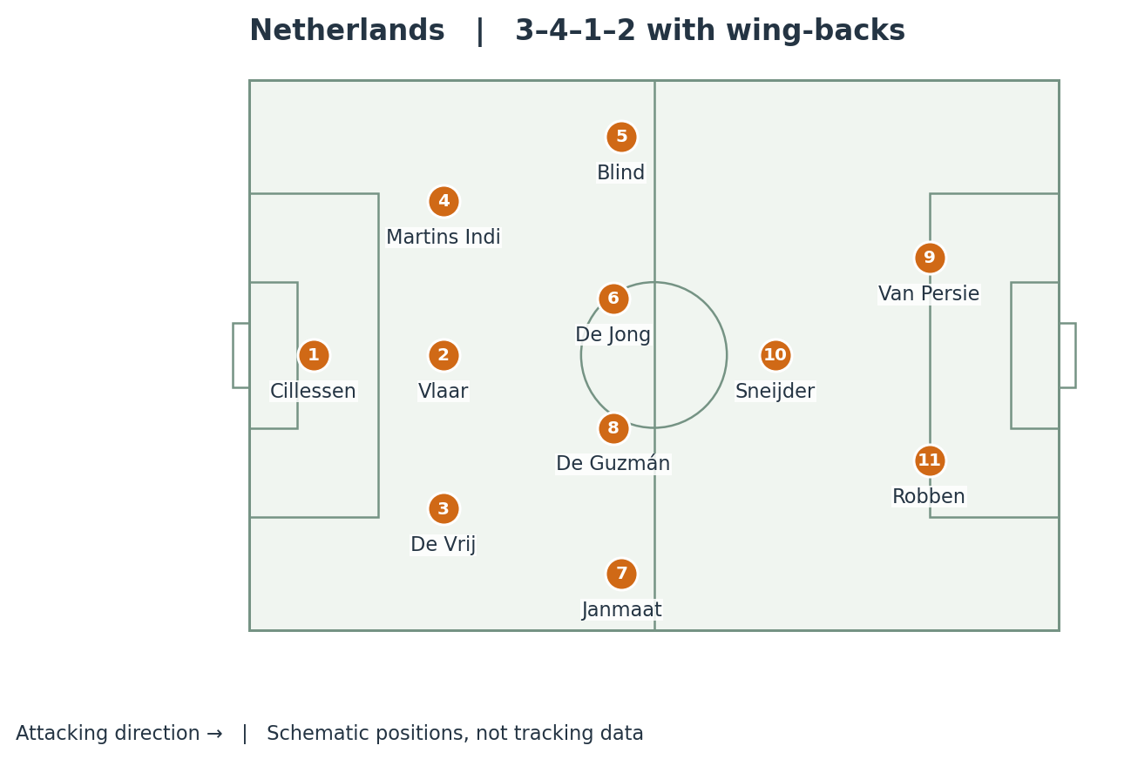
Figure 3. Dutch starting reference. Robben and Van Persie could exchange channels; Sneijder connected them to the rest of the team.

Why an extra centre-back mattered
Against a single central striker, a back three can leave one defender to cover while another engages. The outside centre-backs can also step toward an inside receiver if the rest of the line shifts behind them. This is a structural possibility, not a guarantee: a well-timed runner can still exploit the moment a defender moves out.

Why the forwards mattered just as much
Van Gaal later explained that he wanted to counterattack, draw Spain’s defenders higher, and use the delivery of Blind and Sneijder to release Robben and Van Persie. The plan depended on the quality of both pass and run. Merely adding a defender would not have created the same threat. [S4]
The Netherlands also applied pressure. Their approach should not be presented as ninety minutes of passive defending. The important combination was compact support behind the press and a credible forward option whenever Spain’s first pressure could be bypassed.

4 The attacking shape and its hidden cost
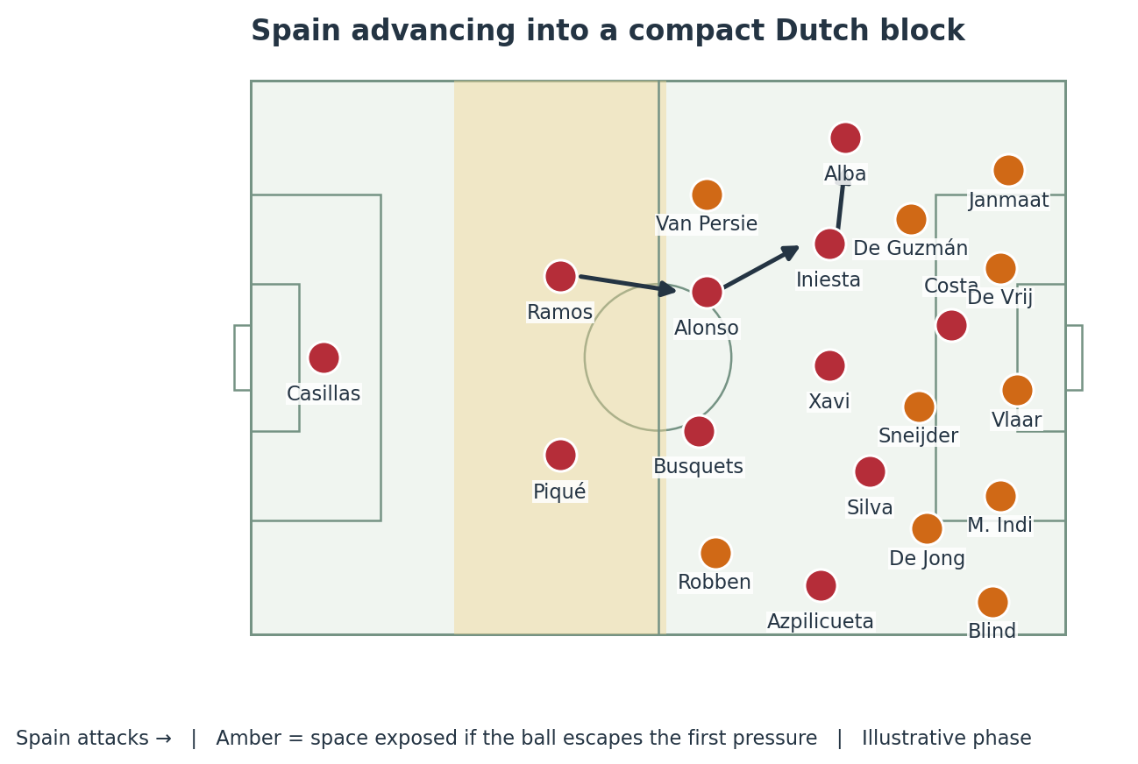
Figure 4. A conceptual Spanish attacking phase against a recovering Dutch block. It is deliberately a selected positional example, not an average-position map.

Why Spain pushed players forward
If Iniesta or Silva moved inside, a full-back could provide the outside route. If Costa occupied the last line, Xavi could connect the attack underneath him. The pivots had to move close enough to recycle possession, while the centre-backs advanced to reduce the distance to midfield. Each action made sense within a coordinated structure.

What had to happen when the ball was lost
The nearest players needed to delay or pressure the opponent’s first pass. Behind that pressure, the remaining defenders needed useful angles to intercept, cover or retreat. A compact attacking shape can support this response, but only if the ball is lost in a location the team is prepared to defend.

Why two Dutch forwards complicated the calculation
When both Spanish centre-backs had a forward to consider, neither could always leave his zone to chase the passer. A forward run could also force the full-back to choose between recovering centrally and defending the wide channel. The risk was therefore relational: the height of the back line had to match the quality of pressure in front of it.
For a video, first highlight the receiver of the turnover, then the nearest Spanish presser, then the runners. This makes the tactical problem clearer than simply colouring a large empty patch of grass and calling the whole team too attacking.

5 The first half was not a one-sided collapse

The sequence before the equaliser
Moment | Recorded event | Why it matters
Early first half | Robben released Sneijder; Casillas saved. | A warning that a runner could reach space beyond Spain’s midfield.
27th minute | Alonso converted a penalty after Costa was fouled. | Spain had created a forward connection, not just harmless passing.
Before half-time | Iniesta found Silva, whose chipped attempt was saved. | A second example of penetration before the Dutch equaliser.
44th minute | Van Persie headed in Blind’s delivery. | The Netherlands reached half-time level.

Event sequence: [S2, S3].

What Spain did successfully
The penalty move is especially important when evaluating Costa. Xavi released him into the area, where the striker drew the challenge. That does not prove complete integration, but it disproves the claim that his movement could never connect with Spain’s midfield. Silva’s chance similarly shows that Spain could find a runner through the Dutch defensive structure.
Opta’s retrospective records 332 completed Spanish passes to 135 Dutch passes in the first half. Its expected-goals model gives Spain a 1.40–0.50 advantage at the interval. Expected goals are model estimates of chance quality, not a claim that a particular score was owed to either team. [S5]

What the eventual score can hide
A 5–1 result encourages a retrospective story in which the winning plan was flawless from the first minute. That is too neat. Spain had a plausible route to a stronger lead, while the Netherlands survived difficult passages and remained dangerous enough to punish a lapse.
The correct tension for narration is that Spain’s possession still generated real opportunities, yet did not remove the opponent’s threat. Those two observations can both be true. The later collapse should be explained as a developing match, not projected backward onto every first-half action.

Suggested narration
“At one-nil, Spain were not simply passing for the sake of passing. They had already released Costa, and Iniesta would soon put Silva through. But at the other end, the Dutch only needed the passer and runner to connect once. The match was about to expose the difference between controlling the ball and protecting the space.”

6 Blind and the two passes that changed the game
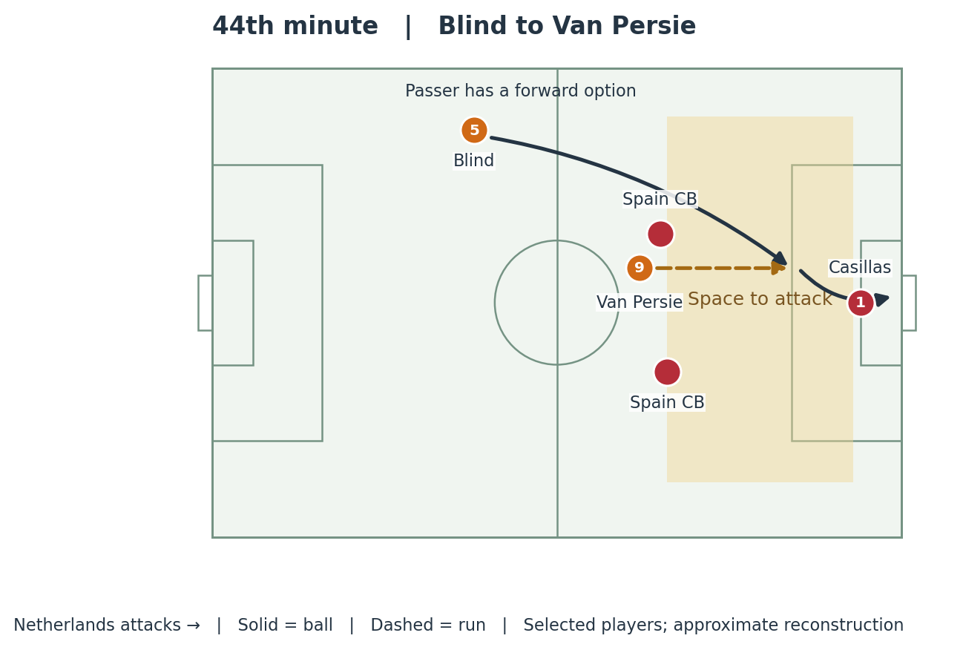
Figure 5. The 44th-minute equaliser. Only the main passer, runner and defensive relationship are shown; spacing is illustrative.

The equaliser
Record: Blind delivered from the left and Van Persie met the ball with a looping diving header over Casillas. Spain’s lead disappeared just before the interval. [S2, S3]
Analysis: the ball travelled over the midfield contest. That is why central numerical superiority did not automatically protect Spain. Once the passer could see a forward run, the relevant contest became the timing of the run against the defensive line and the goalkeeper’s position.
The finish also mattered. A difficult header converted a threatening delivery into an exceptional goal. It would be inaccurate to describe every similar pass as an inevitable concession. Tactics created access; execution determined the outcome.

The second goal repeated the access route
In the 53rd minute, Blind again delivered behind the defence. Robben controlled the ball, moved inside Piqué and finished. The repetition makes the left-sided passing route analytically important, while the receiving action and finish were different. [S3]
For the on-screen explanation, freeze the conceptual picture when Blind can face forward. Ask two questions: who is preventing the delivery, and what depth should the defenders hold if nobody can? Those are linked decisions. Blaming a high line without looking at pressure on the passer leaves half the mechanism unexplained.

7 Robben and defending while turning
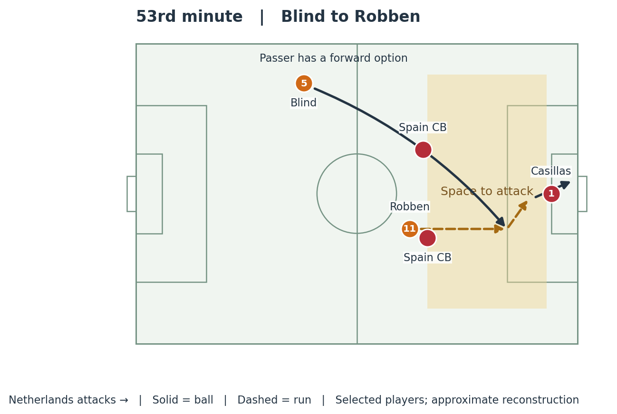
Figure 6. The 53rd-minute goal as a selected relationship. The diagram separates the delivery, forward movement and action after control.

Receiving beyond a line changes the defender’s task
A defender facing the ball can see the attacker and step forward. Once a pass reaches behind him, he may need to turn, accelerate and recover while also deciding whether the goalkeeper is coming. That transition costs time, even for an elite defender. A technically clean first touch can make the recovery substantially harder.
Robben’s threat was therefore more than straight-line speed. He could use the run to gain access, then change direction after receiving. The defender had to respect both the route toward goal and the possibility of an inside move. Support distances became crucial because a second defender could otherwise block that second action.

The fifth goal showed the danger at a different game state
At 4–1, Sneijder’s forward pass released Robben into a long sprint; the move ended with him going around Casillas and scoring. [S2] Spain were then chasing a heavily adverse score. Their late exposure should not be treated as identical to the positional conditions at 0–0.
A useful comparison is the task facing the defence, rather than an unsupported measurement of the space: in both cases, an attacker could move toward Spain’s goal before the defenders had restored a secure covering relationship. In the late counterattack, the chase was especially visible.
Avoid the widely repeated “37 km/h world record” claim. The Opta retrospective notes that the initial speed report was corrected. The tactical explanation does not require an exact sprint-speed figure. [S5]

8 Why the match became five goals
Dutch goal | Recorded route | Primary analytical category
44′ Van Persie | Blind delivery and a diving header | Direct pass behind the line; exceptional finish
53′ Robben | Blind delivery, control and inside move | Direct access plus individual execution
64′ De Vrij | Sneijder free-kick reached the far post | Set-piece defending
72′ Van Persie | Casillas miscontrolled a back-pass | Individual technical error and forward pressure
80′ Robben | Sneijder released a long forward run | Open-field counterattack in a distorted game state

Scorers, minutes and routes: [S2, S3]. The categories in the final column are analytical labels.

The third and fourth goals require separate explanations
A free-kick delivery asks defenders and goalkeeper to manage a different problem from a turnover near halfway. They must judge the flight, opponents’ runs and the far-post area. The fourth goal instead arose from a failed first touch under the threat of an alert striker. Calling both goals examples of a weak midfield press would obscure their immediate causes.

The substitutions did not stop the escalation
At roughly 62 minutes, Spain replaced Alonso and Costa with Torres and Pedro; the Dutch replaced De Guzmán with Wijnaldum. Fàbregas later replaced Silva. [S2] Removing a deeper midfielder changed the available balance, but the second goal had already been conceded. The substitutions cannot explain the original vulnerability.
A team behind in the score may accept more risk to recover. That can increase the frequency or severity of later chances against it. When analysing the final score, distinguish the problem that first created danger from the additional exposure created by chasing the game.

Rest defence in one precise definition
Rest defence is the positioning maintained during an attack to control what happens if possession changes. It includes the nearest pressure, central screening and depth behind that screen. A back line is not protected simply because two midfielders appear in front of it on the team sheet.
Spain’s defeat was a combination of routes into danger, finishing quality, set-piece failure, an individual mistake and late-game exposure. That is a stronger explanation than either “Casillas caused everything” or “tiki-taka caused everything.”

9 The defensive principle underneath the defeat
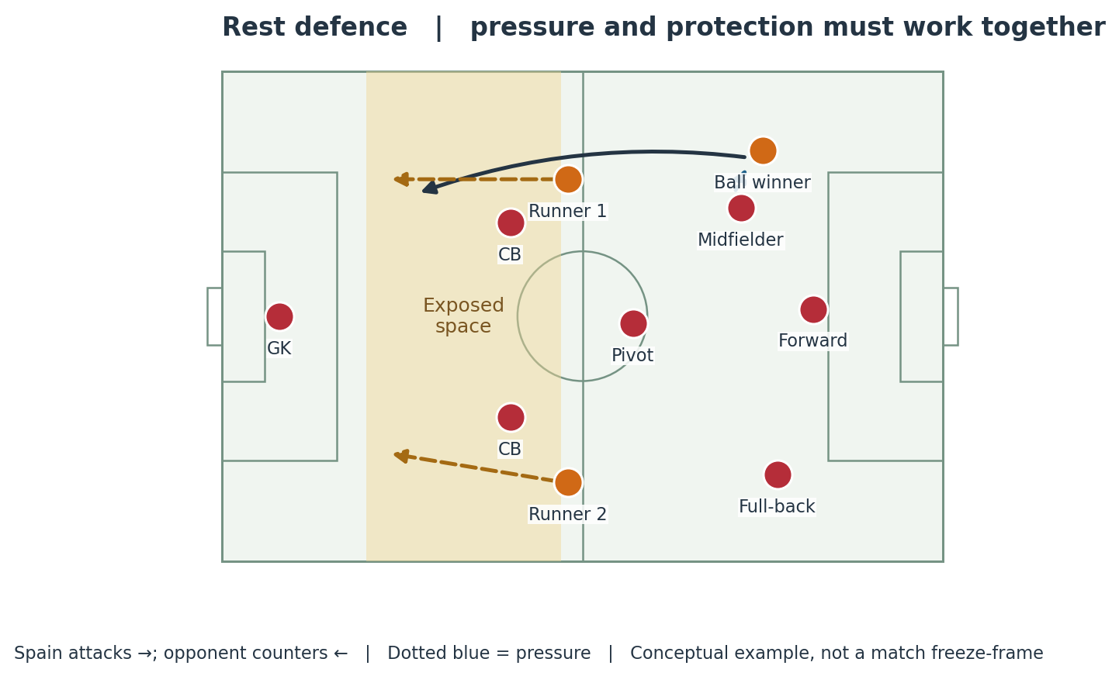
Figure 7. Generic rest-defence model. This isolates the pressure–cover relationship rather than claiming every Spanish turnover had this exact shape.

Pressure buys time for the back line
If the nearest player prevents a clean forward pass, the defenders can squeeze up, intercept a slow ball or reorganise. If that pressure is beaten, the same high positions become much harder to defend. The back line then needs to judge the danger early and recover before the pass, rather than reacting only when the runner has escaped.

Cover is about access to space
A spare defender is useful only if he is close enough and correctly positioned to influence the next action. A pivot is useful only if he can screen the relevant passing lane or reach the receiver. Counting defenders without examining their angles can create a false impression of security.

Why this also affects attacking confidence
When players fear the next counterattack, they may hesitate to attempt the riskier pass or run that would break the opposing block. If they instead force the pass without coordinated protection, the team can become even more exposed. Good attacking play therefore needs a credible defensive arrangement behind it.
This framework also explains why “drop the defence deeper” is an incomplete solution. A deeper line can reduce space behind it, but enlarge the gap to midfield. The team must move together or it merely trades one vulnerable zone for another. The appropriate depth depends on ball pressure, opponent movement and score.

10 The team Spain selected against Chile
18 June, Maracanã, Rio de Janeiro. Spain needed at least a draw to remain mathematically alive after the Netherlands had beaten Australia earlier that day. Del Bosque changed two starters: Javi Martínez came in for Piqué, and Pedro replaced Xavi. [S1, S6, S7]
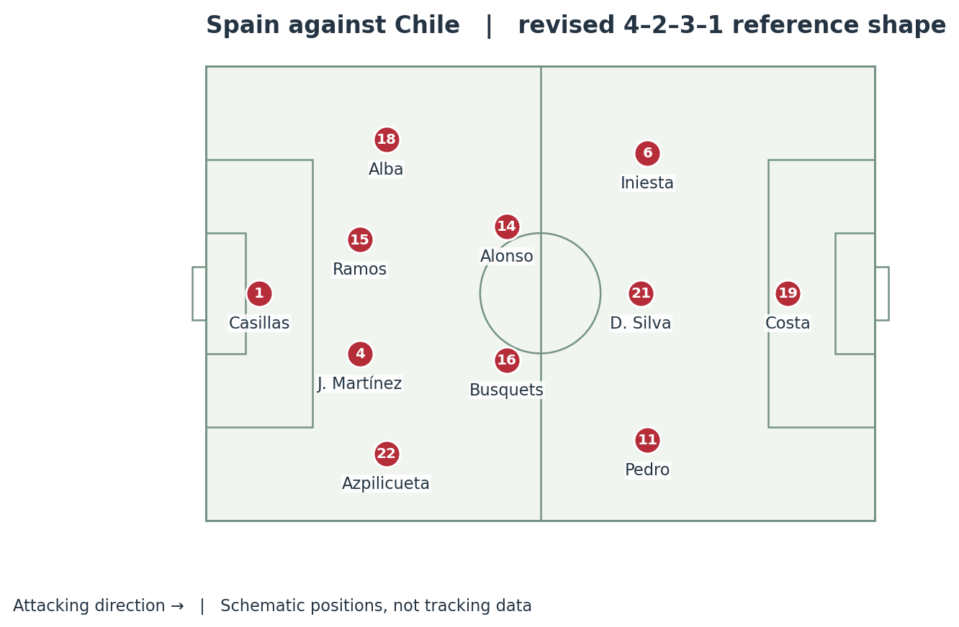
Figure 8. Spain’s Chile-game starters. Silva is shown centrally and Pedro to the right as a reference; the attacking players rotated.

What the changes could offer
Pedro provided a forward prepared to run beyond the ball and work from a wide starting position. Silva could connect centrally, while Iniesta could come inside from the left. Martínez changed the defensive personnel. None of these selections, by itself, guaranteed different collective distances or a more effective response to pressure.

What remained familiar
Busquets and Alonso still formed the deeper midfield partnership, Costa still led the line, and the full-backs still needed to connect the flanks with the central creators. Spain retained the challenge of progressing through a crowded middle while supplying a striker ahead of it.
This is why the original article’s generic chain—Piqué to Busquets to Xavi—must not be used as an actual Chile-game lineup graphic. Piqué and Xavi did not start that match. The general concept of disrupting midfield connections remains useful, but the personnel on screen must match the fixture being discussed.

11 Chile pressed through connected roles
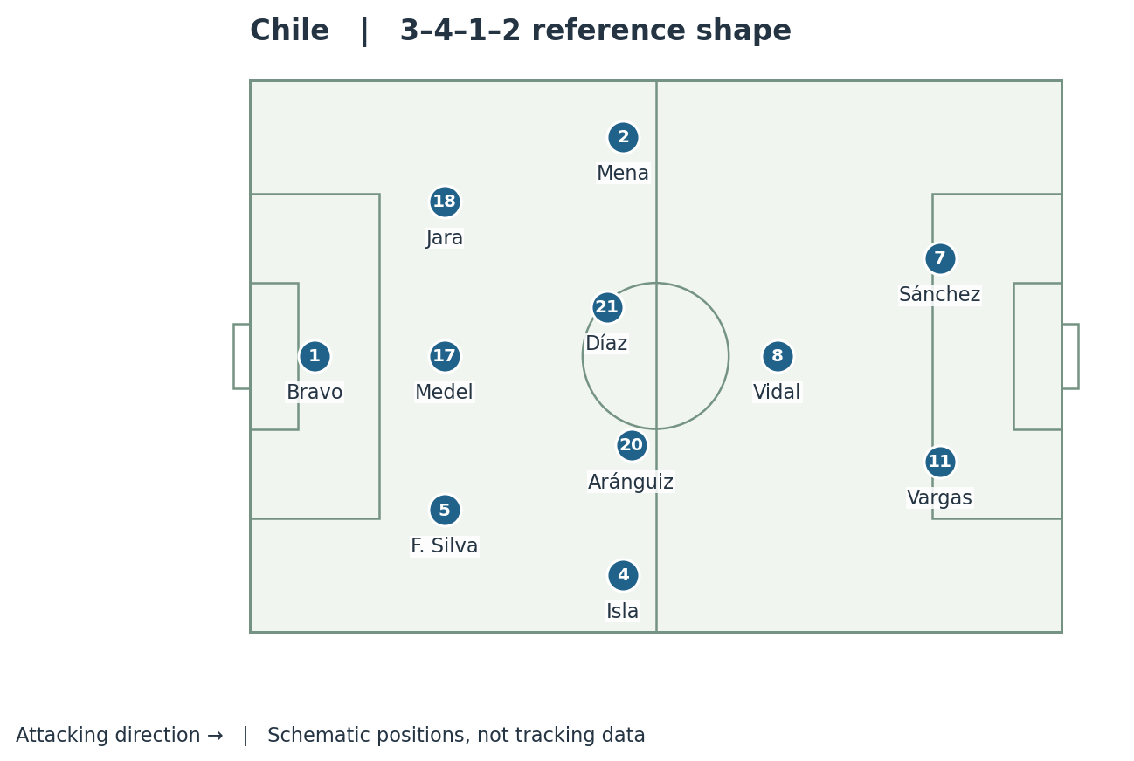
Figure 9. Chile’s starters arranged as a 3–4–1–2 reference. Díaz, Aránguiz and Vidal could move to different heights; the shape was not static. Personnel: [S6].

The front of the structure
Sánchez and Vargas gave Chile threats who could work toward defenders and then attack quickly in the other direction. Vidal operated between the forward line and midfield in this reference model. The purpose of such a staggered arrangement is to pressure the ball while making the easiest central pass less attractive.

The players behind the first pressure
Aránguiz could move forward to engage or support, while Díaz offered central balance. Isla and Mena supplied width and could advance toward Spain’s full-backs. Behind them, Francisco Silva, Medel and Jara provided the three-defender base. The key question is not whether the drawing is called 3–4–1–2 or 3–5–2, but who covers the space when a teammate leaves it.

Intensity needed organisation
Running hard at the ball alone would have opened passing lanes. An effective press requires one player to approach, another to discourage the release pass, and the covering line to move close enough to contest the next receiver. Spain’s preferred short combinations become more difficult when every option faces an immediate next problem.
These responsibilities are an analytical model of the matchup, not a claim that each Chilean followed one named opponent for the entire match. Players exchanged opponents as the ball and Spanish receivers moved. Presenting the press as fixed man-marking pairs would overstate the evidence.

12 How the press could trap a receiver
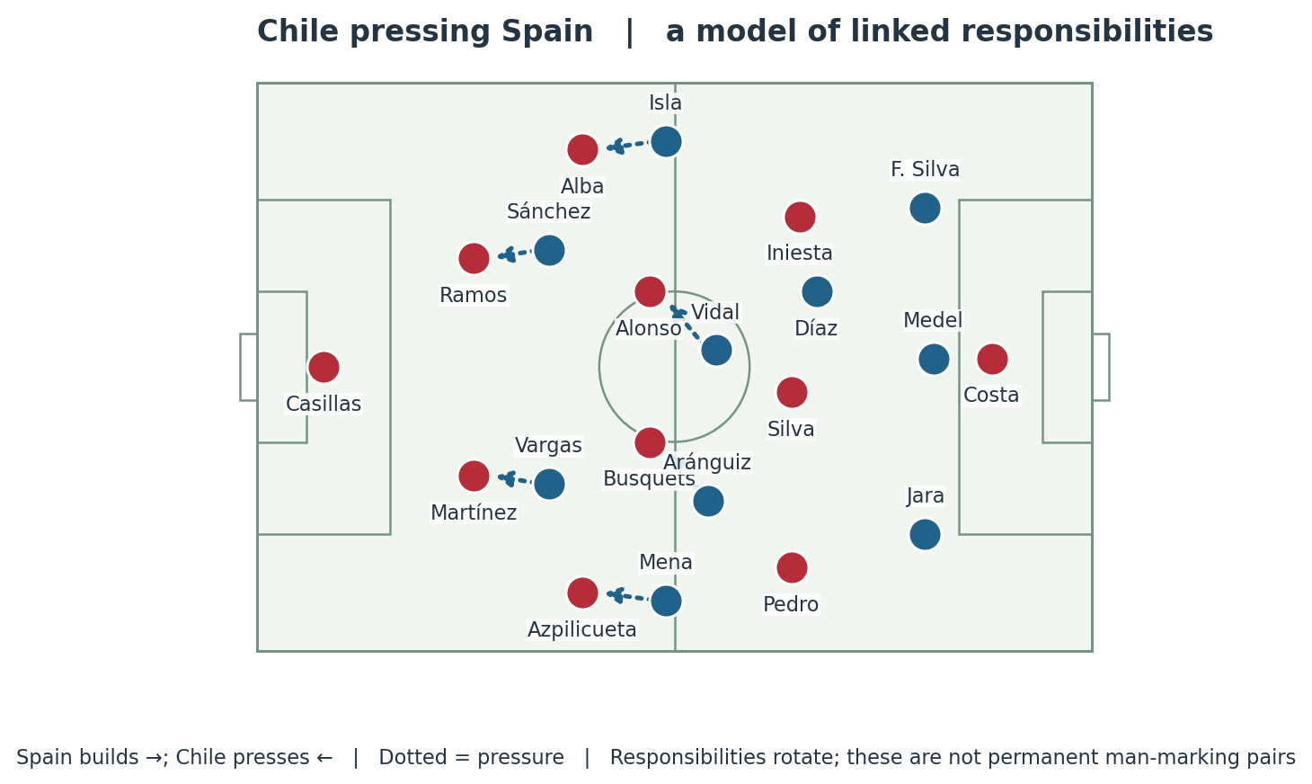
Figure 10. An explanatory pressing model with selected responsibilities. It shows how pressure can be connected, not a traced broadcast frame.

First action and second action
Suppose a Spanish centre-back receives facing his own goal or near the touchline. A Chilean forward can approach on an angle that reduces the inside passing route. The next Chilean player must then be ready if the ball reaches a pivot. If Spain escape that pressure with one pass, the whole mechanism must shift rather than leaving the initial presser isolated.

The full-back is not automatically an escape
A pass outside may appear safe because the full-back is initially unmarked. But if the wing-back can jump while the near-side centre-back covers the space behind him, the receiver may face immediate pressure with the touchline limiting his options. A return pass, an inside combination or a first-time ball beyond the presser becomes important.

Where Spain could theoretically hurt this structure
Aggressive pressure creates risks for the pressing side. A third-player combination can bypass a marker; a well-timed switch can reach the far side before the block travels; a direct pass can find Costa with a supporting runner close enough to contest the next ball. These are possible solutions, not proof that Spain executed them consistently.
The coaching explanation is therefore specific: Chile tried to make the next pass and next reception difficult. Spain needed coordinated support before the receiver became trapped. Telling the story only as “Chile wanted chaos” misses the decisions that made their pressure useful.

13 Chile scored in two different ways
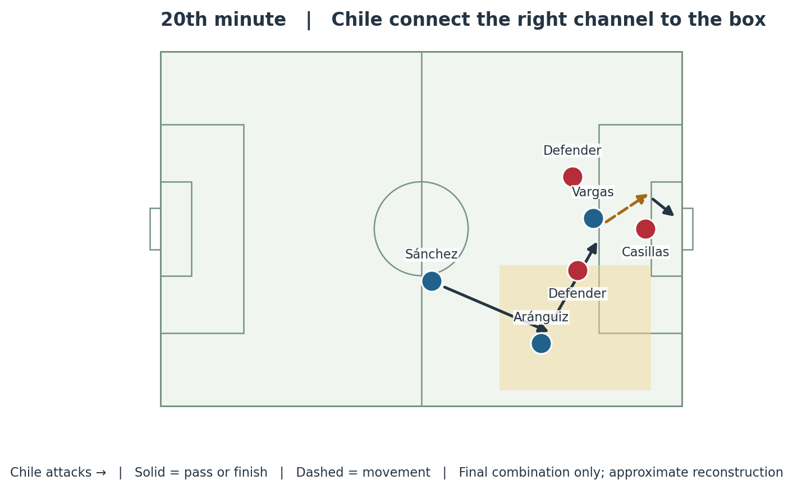
Figure 11. The final combination for Vargas’s opener: Sánchez to the right-side runner, Aránguiz across the box, Vargas finishing. Based on the UEFA match account [S7].

The opening goal in the 20th minute
Record: Sánchez fed Aránguiz down the right. Aránguiz played across to Vargas, who moved the ball past Casillas and finished. [S7] Analysis: the forward pass and supporting run forced Spain to defend more than the ball carrier. The square pass then changed the direction of the threat before the defence could recover a stable relationship.
For narration, separate the move into access, support and finish. Access gets the ball into a useful channel. Support gives the receiver an immediate teammate to find. The final action defeats the goalkeeper. This is more informative than saying simply that Spain lacked effort.

The second goal before half-time
Aránguiz scored after Casillas punched Sánchez’s free-kick into an area Chile could attack. This was a set-piece second-ball sequence, not a repeat of the first goal. [S7] The immediate lesson is that the phase is not finished when the goalkeeper first touches the ball; the next contact still has to be defended.
This document uses 43′ for the goal, following the PZPN event record [S6]. Published accounts use different minute conventions or descriptions; locate the sequence just before half-time when matching footage. An exact video timecode depends on the recording used.

14 Spain changed players but not the result
Moment | Spain’s change | What it could alter
Half-time | Koke for Alonso | A different midfield profile and potentially more forward support.
64′ | Torres for Costa | A fresh striker and a different timing of forward movement.
76′ | Cazorla for Pedro | Another technical receiver and shooting option.

Substitution record: [S6]. Tactical possibilities in the final column are interpretation, not quotations of Del Bosque’s instructions.

There were chances to change the game
Spain created opportunities for Costa and Busquets early in the second half, but did not score. The RFEF account also notes that Chile later strengthened their control of the midfield despite Spain holding possession. [S8] This distinction matters: the attack was unsuccessful, but it was not literally incapable of producing a chance.

A change of personnel needs a change of relationship
Adding a runner can help only if the passer recognises the run and can release the ball. Adding another creator can help only if he receives with useful support and space. A fresh striker may find the same isolation if the midfield remains too far away or reaches him after the opening has closed.
At two goals down, Spain needed both urgency and enough security to avoid another concession. Those demands can conflict. More players ahead of the ball may increase attacking presence while weakening protection against the next transition. Slower circulation may improve ball retention while using time the trailing team cannot afford.

Chile did not need to defend in one way throughout
A successful early press does not mean a team must sustain maximum pressure until the final whistle. With a lead, it can choose moments to engage and moments to protect space. The relevant question is whether Spain could consistently create better chances against the changing problem, not whether Chile maintained a single frozen formation.

What the players themselves acknowledged
In UEFA’s post-match account, Del Bosque described a timid first half and a change after the interval that failed to alter the result. Alonso reflected on the loss of the control Spain had felt in earlier tournaments. These comments support a discussion of collective performance; they do not establish laziness as a measured cause. [S9]

15 Diego Costa and the missing timing

Why selecting Costa made sense
Costa offered channel running, physical duels and a direct threat against the last line. A possession team can benefit from exactly those qualities: defenders who must track a forward run may leave more room for a creator underneath. The question was how Spain would connect the two types of movement.
His preparation was imperfect. He approached the tournament after a hamstring problem and an early exit from the Champions League final; the RFEF confirmed that its medical staff would treat him after reviewing his tests. He had also only entered the Spain team shortly before this tournament. [S11, S12, S13]

Three relationships needed to work
Relationship | Useful action | If the timing fails
Passer and runner | Release the pass as Costa attacks a channel. | The defence recovers while circulation continues.
Striker and support | A nearby teammate receives a lay-off or attacks the next ball. | Costa can be isolated even after receiving.
Depth and width | A wide threat prevents the whole defence narrowing toward Costa. | Several defenders can compress the same central route.

These are tactical principles, not a statistical claim that every Spanish attack followed the same pattern. Costa’s contribution to the penalty against the Netherlands is evidence that the connection could work. The broader criticism is that Spain did not reproduce useful connections reliably enough during the two decisive matches.

The false-nine comparison needs care
A false nine dropping into midfield creates an extra receiver and asks a centre-back whether to follow. A conventional striker staying higher asks a different question: can the defender allow him to run beyond? Both can work. Replacing one with the other changes the jobs around him, especially the movements of the wide attackers and the timing of midfield passes.
It is therefore too strong to call Costa intrinsically incompatible with Spain. A more defensible conclusion is that a relatively new attacking relationship, disrupted preparation and difficult opponents left Spain without a dependable enough solution when their familiar circulation stalled.

16 The wider causes and their limits

Experience and physical output
Several leaders of the successful cycle were older by 2014. That makes declining physical output a plausible part of the explanation, but age alone does not measure match intensity. A younger player can be late to pressure because the team’s distances are wrong; an older player can be effective if his position lets him arrive on time.
The original article’s phrase “the core could no longer reproduce the intensity” should be treated as an interpretation. This document does not have comparable tracking data proving an exact decline in sprinting, pressure speed or recovery distance across the 2008, 2010, 2012 and 2014 teams.

Predictability and limited variation
An opponent can defend a technically accurate pass if it arrives at an expected receiver who cannot turn. Variation comes from changes in speed, width, direction and movement beyond the defence. Spain still possessed those skills, but their execution did not generate enough advantage in the moments that decided these games.

Counterpressure and defensive distances
The first response after losing the ball has to connect with the players covering behind it. If one player presses while the others retreat or remain too far away, the opponent may escape into a better attacking situation. This is a collective timing problem, not merely a question of wanting the ball back.

Opponents were active contributors
Van Gaal’s direct options and Chile’s organised pressure should be credited as solutions to particular matchups. The opponents did not simply wait for Spain to become old or tired. They had different qualities and found different ways to make those qualities relevant.

Errors and emotion
A mistake can change a scoreline immediately; a string of setbacks can also change later decisions. Players may force the next pass, advance earlier or hesitate in a duel. That is a plausible feedback mechanism, but the match record does not let an analyst measure each player’s internal state. Describe visible decisions before assigning motives.

The strongest conclusion
Spain’s failure was multi-causal. Attacking relationships, pressure, defensive cover, execution and the score interacted. “Too much possession” is an incomplete diagnosis because possession can either create control or coexist with vulnerability, depending on those surrounding relationships.

17 Australia and possible alternatives

What the final match showed
Spain beat Australia 3–0, with goals from Villa, Torres and Mata. Iniesta helped release Juanfran for the first goal and supplied Torres for the second; Fàbregas provided the ball for Mata’s finish. Spain made seven changes from the Chile starting team. [S14]
The match offered useful examples of forward running connected to passing. It did not prove that using exactly that lineup earlier would have beaten the Netherlands or Chile. Both teams were already eliminated, the opponent was different, and Australia lacked the suspended Tim Cahill. Those conditions limit the comparison. [S14]

Adjustments a coach could consider
Possible adjustment | Intended benefit | Cost or uncertainty
Keep one full-back deeper | An additional covering position behind the attack. | Less width or fewer numbers on that side.
Recover earlier when the passer is free | Reduce the space available behind the defence. | Can open space between midfield and defence if the team does not move together.
Vary the first pass under pressure | Use an outside route, switch or direct ball. | Requires coordinated support; otherwise possession is surrendered.
Pair Costa’s run with a close supporting player | Improve the lay-off, second ball or combination. | May reduce occupation of another attacking zone.
Use more movement beyond the ball | Force defenders to turn and retreat. | Needs accurate timing and protection if the pass fails.

These are counterfactual options for explanation, not changes proven to guarantee a different result. Their value depends on personnel, training, score and the opponent’s response. They should be introduced as “Spain could have tried…” rather than “Spain would have won if…”.

The enduring lesson
A successful system needs its supporting behaviours to remain effective. Spain’s passing quality was still visible in Brazil, but the team could not consistently turn that quality into penetration and security at the same time. The opponents exploited that gap before Spain found a convincing response.

18 A structure for the finished content
The following is an editorial sequence, not an estimate of the length of a particular recording. Each segment gives the audience one question and a concrete visual answer.
Segment | Main question | Visual or evidence
Opening | How did the champions go out after two games? | Three-match results and the elimination after Chile.
The successful model | What made Spain’s passing dangerous? | Figure 1: a short connection and a run in the opposite direction.
Opening matchup | What changed when the Dutch used three centre-backs? | Figures 2–4: reference shapes and the two forward outlets.
First-half tension | Were Spain already failing completely? | Penalty move, Silva chance and the interval score.
The turning point | Why could Blind bypass the midfield? | Figures 5–6: passer, line, runner and goalkeeper.
The collapse | Were all five goals the same problem? | The five-goal classification table.
The second opponent | How did Chile make Spain uncomfortable? | Figures 8–10: changed starters and connected pressure.
Elimination | How did Chile turn pressure into a winning position? | Figure 11, then a separate second-ball explanation.
Diagnosis | What weakened around the passing? | Costa’s timing, rest defence and tactical variation.
Closing | What can we fairly conclude? | Possession, penetration and protection must work together.

Opening narration
“Spain arrived in Brazil with three consecutive major titles behind them. Five days after their first match, their World Cup defence was over. The easy explanation is that their possession football had become obsolete. The matches tell a more specific story: Spain could still move the ball, but they could no longer depend on the movements and protection around it.”

Closing narration
“The Netherlands showed what could happen behind Spain’s defensive line. Chile showed how uncomfortable the route through midfield could become. Neither result came from one universal trick. Spain’s opponents found different weaknesses, and Spain failed to restore the balance between keeping the ball, attacking space and defending the next action.”

Sources and verification notes
Sources were consulted for this revised edition on 3 October 2026. Match records and direct coaching comments establish the factual base. Tactical mechanisms, diagrams and proposed alternatives are original explanatory synthesis. No diagram is presented as a measured tracking-data output.
[S1] DFB Data Center. 2014 World Cup Group B results and final table
[S2] FIFA. WorldCupAtHome retrospective on Spain 1–5 Netherlands, 21 March 2020
[S3] UEFA. Spain dismantled by rampant Netherlands, 13 June 2014
[S4] FIFA. Interview with Louis van Gaal, 16 April 2019; discussion of his Spain-game plan
[S5] Opta Analyst. About That Game: Spain 1–5 Netherlands, 16 November 2022; first-half passing and model-based xG
[S6] Polish Football Association. Spain–Chile match record, 18 June 2014; starters, substitutions and goal minutes
[S7] UEFA. Chile loss condemns Spain to elimination, 18 June 2014; goal sequences and match progression
[S8] RFEF. Chile frena a España en Maracaná, 19 June 2014; Spanish federation match account
[S9] UEFA. Holders Spain lament sad ending, 19 June 2014; Del Bosque and players after elimination
[S10] UEFA. Spain overpower exhausted Italy to win UEFA EURO 2012 final, 1 July 2012
[S11] UEFA. Costa makes Spain cut, Navas left out, 31 May 2014; selection and injury context
[S12] UEFA. Diego Costa ready to give all for Spain, 4 March 2014; context before his Spain debut
[S13] RFEF. Medical statement on Diego Costa, 27 May 2014
[S14] UEFA. Villa helps Spain bow out with a convincing win, 23 June 2014; Australia match

Limits that matter for publication
Formation numbers vary with phase and interpretation. Goal minutes can differ by elapsed-time convention. The expected-goals figure is attributed to Opta’s model. No exact player speeds, pitch distances, pressure counts or psychological diagnoses have been invented. Match footage should be checked for the precise clip timing used in production.

