MOBA style games are definitely becoming a trend, however, there still hasn't been a decent game for smartphones within this sub-genre, and certainly not one that could ever come close to rivaling DOTA 2 or League of Legends. That being said, Mobile Legends has come up with a shameless but equally fun League of Legends clone with multi-player online gaming; and it should be said that it is up to par with its PC counterparts. The game lets you clash with up to 5 vs 5 players using tactical controls on your screen. It's up to you to wipe out enemy fortifications while controlling your hero and improving your own terrain. You'll also need to manage creating and training your minions. Mobile Legends is a Free-to-Play game, and luckily, it's monetization system is limited to aesthetic upgrades, which is why the real potential here is left unspoiled and laid visible on the battleground where victory will only be yours if you're a truly skilled player, not by buying your way up.

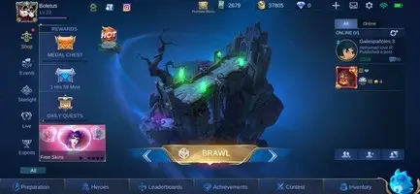

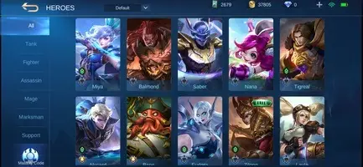
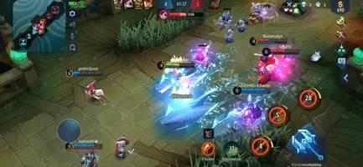

Pocket Troops is a strategy game where you play as a group of hard-as-nails soldiers where you fight against armies all around the world. Luckily, your soldiers are prepared for whatever comes their way. Battles in Pocket Troops are pretty simple. All you have to do is select who you want your main objective to be, and your soldiers will take care of the rest. And their attacks, as well as those of your enemies, depend primarily on the weapons they're using. The best part of Pocket Troops is between battles, when you can manage your soldiers. You can recruit new mercenaries, train the ones you already have, improve the installations, go to the infirmary, and much more. The most important part: having a group of soldiers ready to kill your enemies. Pocket Troops is a super fun strategy game with simple gameplay and great graphics. It's an entertaining game where tons of missions await.
And here, we used Photonengine for server.

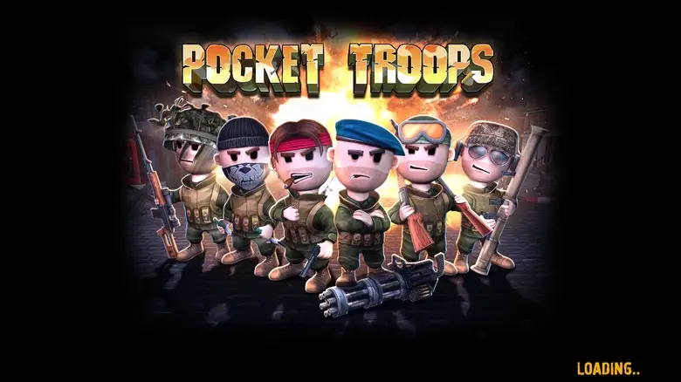

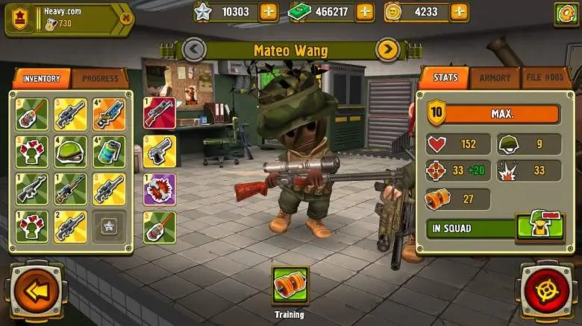

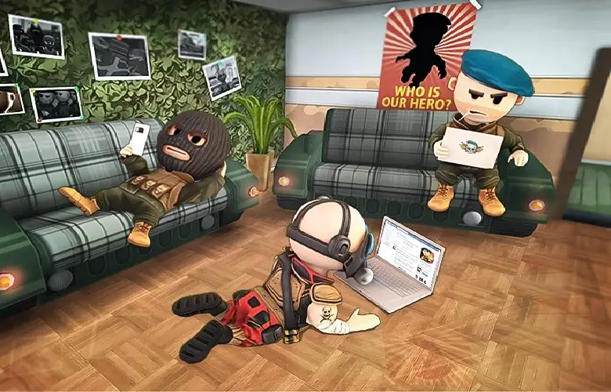

There are many Online Slots games available to play.
There's a slots game that will appeal to virtually everyone.
Finding your favorites will be an exciting, fun-filled journey of exploration.
If you're looking for somewhere to start, you might want to check some of our most popular Online Slots games in the developed by me games:
As a gambling master, I have a knack for getting wonderful payback rates.

Online services
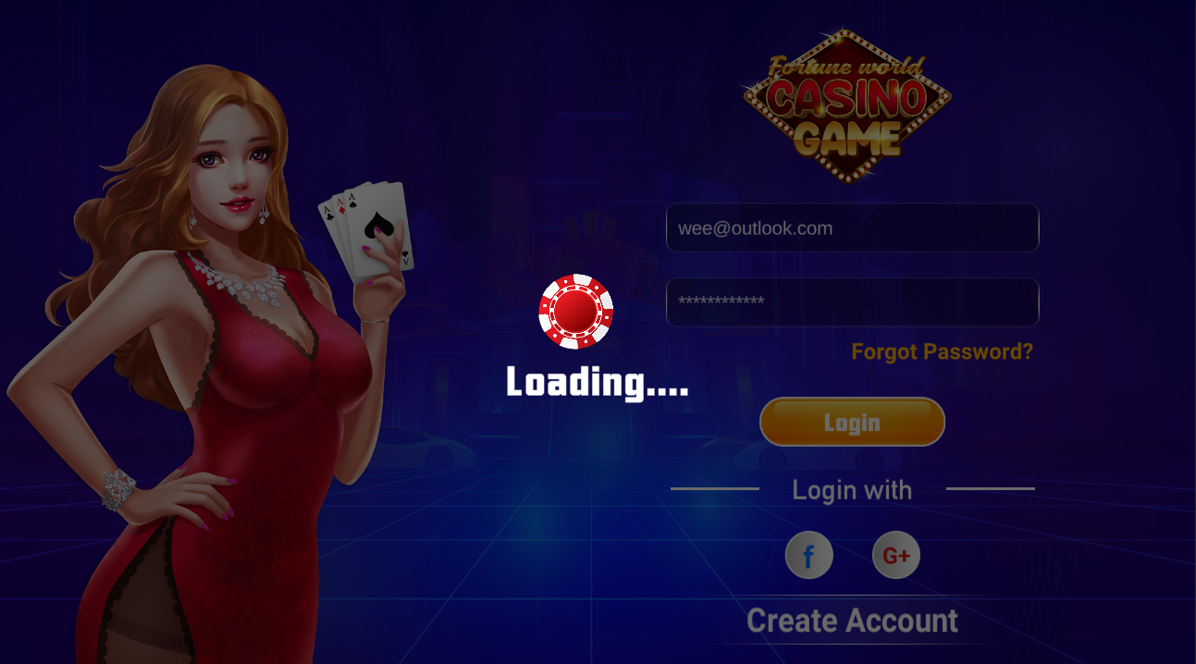

There are many Online Slots games available to play
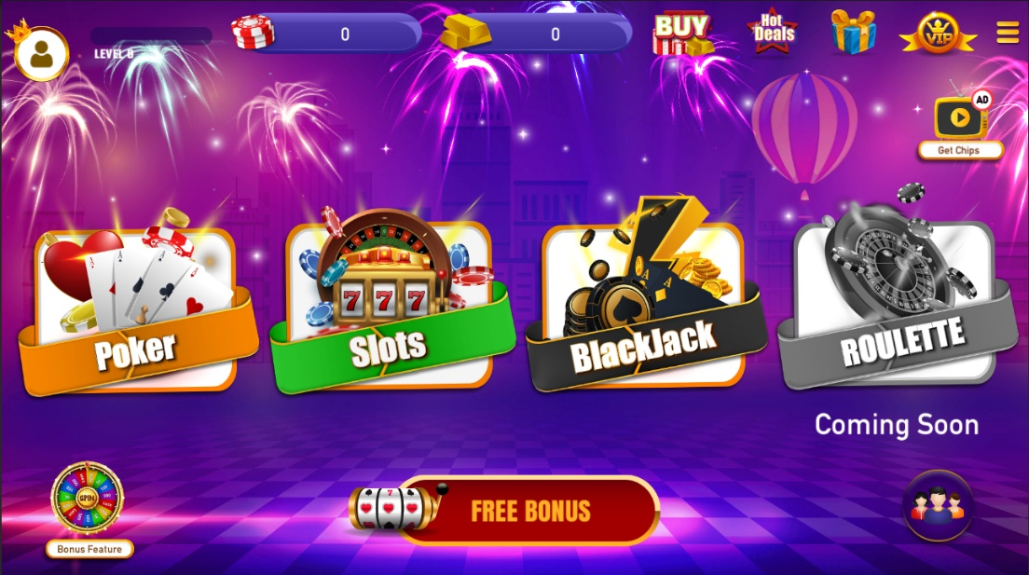
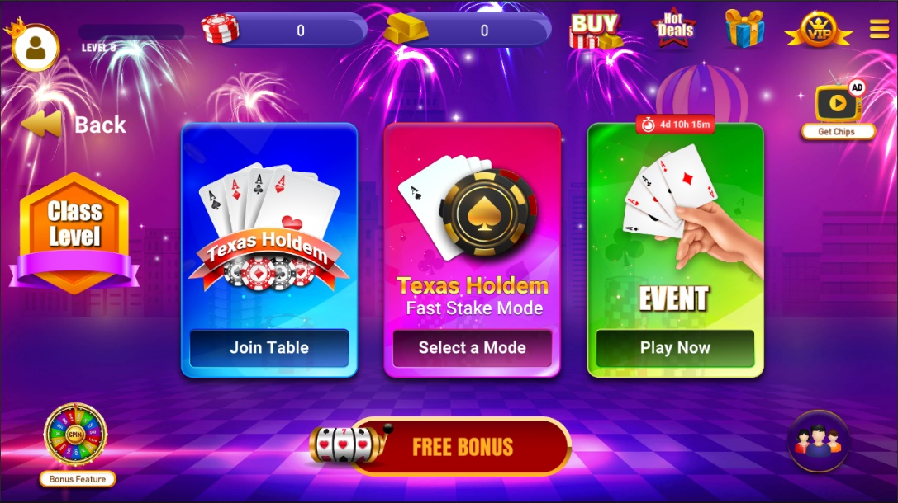
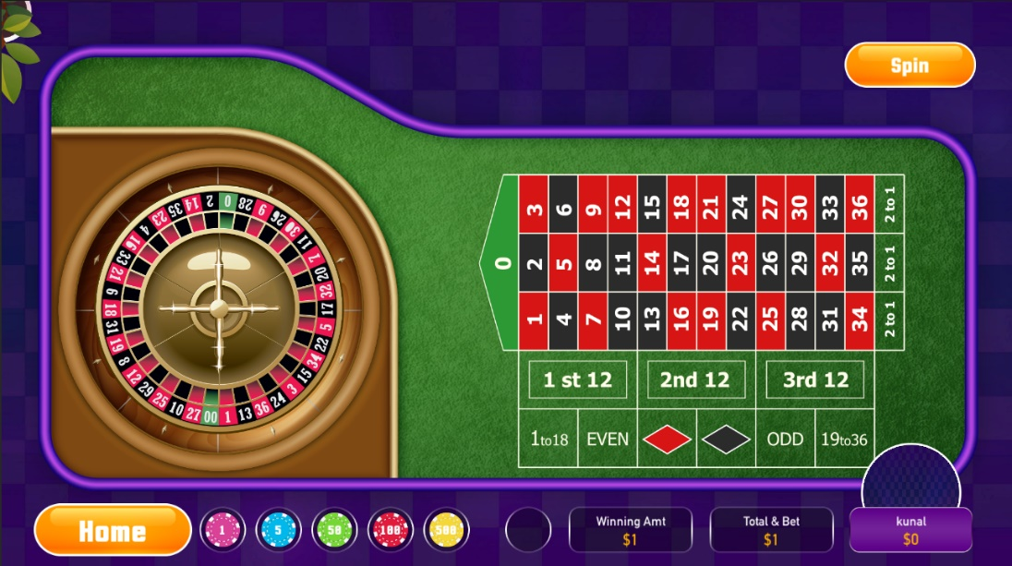

Safe Pay system
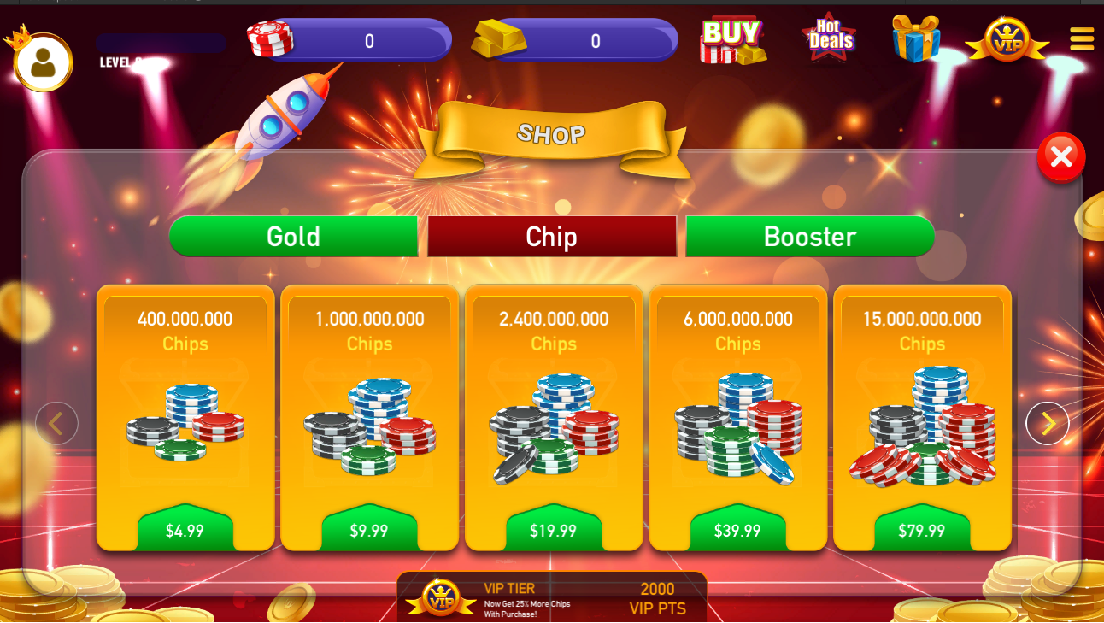

MercuryONE games are racing entertainment using NFT.
All parts of the battleship are registered and paid for as NFTs, and combine them to create or level up new battleships.
In the game, you can proceed with a normal life with a high degree of freedom in various cities using battleships, and you can race in designated arenas.
The racing method consists of the method of competing by participating directly, and the method of entering the currently prepared match as a spectator and placing bets on the match result.
This game is a new type of game that flexibly combines the latest NFT minning technology with a racing betting system.

NFT Racing Game

