|  |
| --- |
| System Requirement Specifications |
| The Client: Going Green |

**Revision History**

|  |  |  |  |
| --- | --- | --- | --- |
| **Date** | **Revision** | **Description** | **Author** |
|  | 1.0 | Initial Draft | Team |
|  |  |  |  |
|  |  |  |  |

Table of contents

1 Description 1

1.1 Objective 1

2 Assumptions 2

3 Requirements 3

3.1 Requirements Matrix 3

4 Issues 5

5 Other areas affected by this project 5

6 Implementation considerations 5

7 Appendix 5

7.1 Related Documents 5

7.2 Glossary 5

8 Change Log 7

# Description

## Objective

# The objective of this project is to design, develop, and deploy a carpooling application that aligns with The Client’s Green Initiative. This application will provide easy access to carpool options for The Client’s “members”.2 Assumptions

* Member Accessibility and Involvement
  + Members should be able to access this application to assist in successful transportation to and from work, and variances that might arise, while at the same time reducing their environmental impact.
  + The application should have an intuitive user interface in order to increase usage and therefore involvement in the Green Initiative.
* Necessary Member information will transfer from The Client Member database to one managed by CGI
  + Security of this information is a high concern for The Client.
  + In order to provide a reliable service (within reason), contingency plans should be in place for the server that hosts this database and the application backbone.
* The Application should ask, at minimum, the following:
  + Number of Commuters a Participant’s ride can accommodate
  + Type of Car
  + Communal Location to commute from, or meeting location
  + Work Arrival / Departure Times

# 3 Requirements

## 3.1 Requirements Matrix

| **Req Num** | **Requirement Description** |
| --- | --- |
|  | Users can log in using their work log in credentials |
|  | Users can register personal information (name, address, phone #) and vehicle information (vehicle type, # of passengers) |
|  | Users can edit their personal information and vehicle information |
|  | User can delete their profile/account |
|  | Users can create a new carpool (administrative/carpool leader) |
|  | Users can join an existing carpool |
|  | Users are able to join multiple carpools. (2 maximum – 1 for arrival and 1 for departure) |
|  | Nearby carpools are automatically displayed based on the user’s address |
|  | Users can view carpool information (departure times, meeting place if applicable, and carpool members) |
|  | Users can send a request to carpool leader to join carpool |
|  | Users can cancel a request to join |
|  | Carpool leaders can accept/reject user requests |
|  | Users can view a list of their carpools in a “My Carpools” home page |
|  | Users can message carpool members using MMS |
|  | Users can leave a carpool |
|  | Users can calculate the costs of the carpool through a calculator interface |
|  | Users can view carpool member information (name, address, phone #) |
|  | Users can view the carpool route (using Google Maps API or Apple Maps API) |
|  | Carpool routes will give directions to users |
|  | Users can designate which days each carpool member will drive |
|  | Users will receive a notification to remind them that they are driving the next day |
|  | Users can press a “Leaving Now” button to notify morning carpool riders when they depart from their home |

# Issues

1. Member information security

All personal data including member log in credentials, names, addresses, and phone numbers will be stored on CGI servers.

# Other areas affected by this project

1. Client member information will be transferred from their database to one hosted by CGI.

# Implementation considerations

This application will not be a web application. It will be a dedicated mobile application. Users can only access this application if they have an Android or iOS device.

Based on salaried expenses, it has been concluded that this project must be finished in 6 weeks using a $25,000 budget.

Furthermore, application development and testing each have a maximum time limit of 3 weeks.

# Appendix

## 7.1 Related Documents

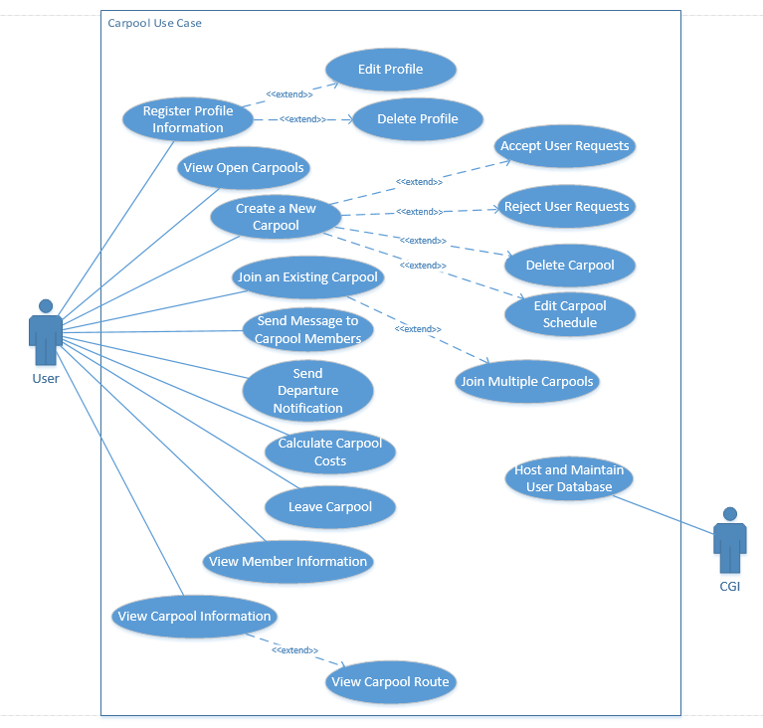**Carpool App Use Case Diagram**

**Carpool App Process Flow Diagram**

## 

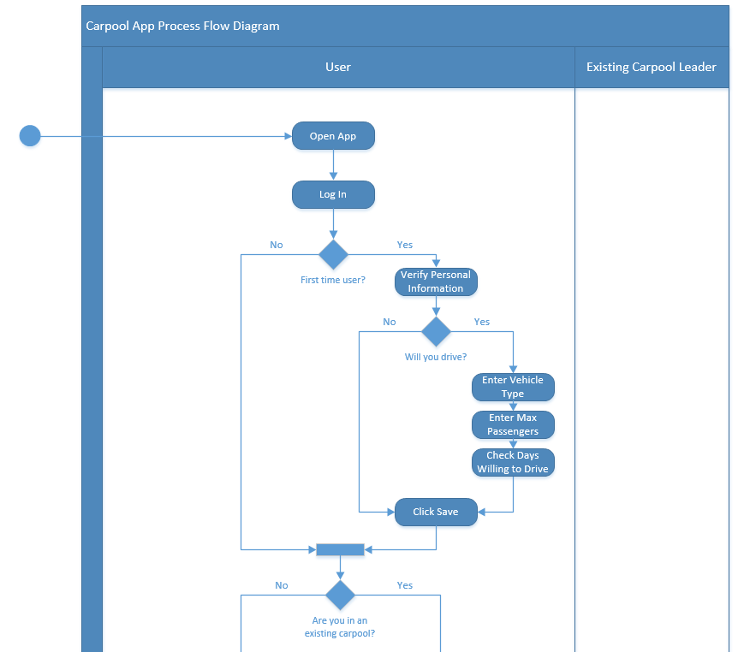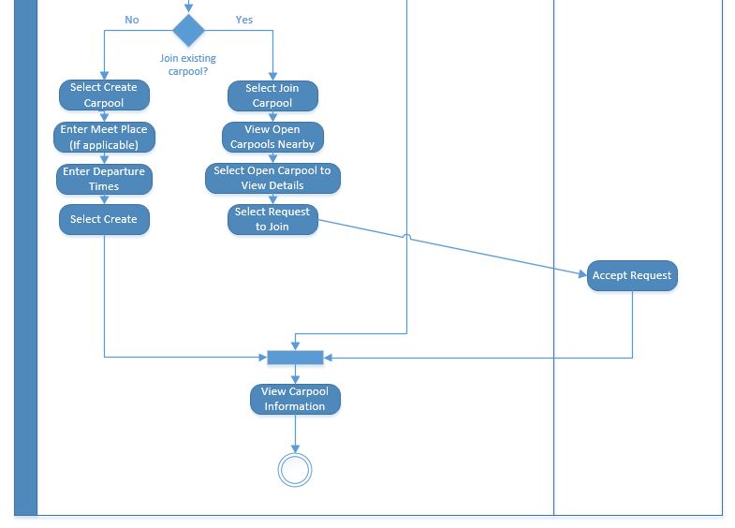

## Note: All other features of the application are completely optional. Further details can be found in the Functional Design document under Section 2.

## 7.2 Glossary

Administrative/Carpool Leader – The user who creates the carpool or is designated the carpool leader by the previous carpool leader. This user has the ability to accept or reject user requests to join the carpool and also controls the carpool schedule.

# API – Application Programming Interface

Departure Notification – A button that a driver can press that sends a notification to the riders that lets them know when the driver has left his location to pick them up.

MMS – Multimedia Message Service

# 8 Change Log

The Change Log contains changes made to the Requirements document after the document was marked as final.

|  |  |  |  |
| --- | --- | --- | --- |
| **Date** | **Author** | **Change** | **Areas Affected** |
|  |  |  |  |
|  |  |  |  |
|  |  |  |  |
|  |  |  |  |